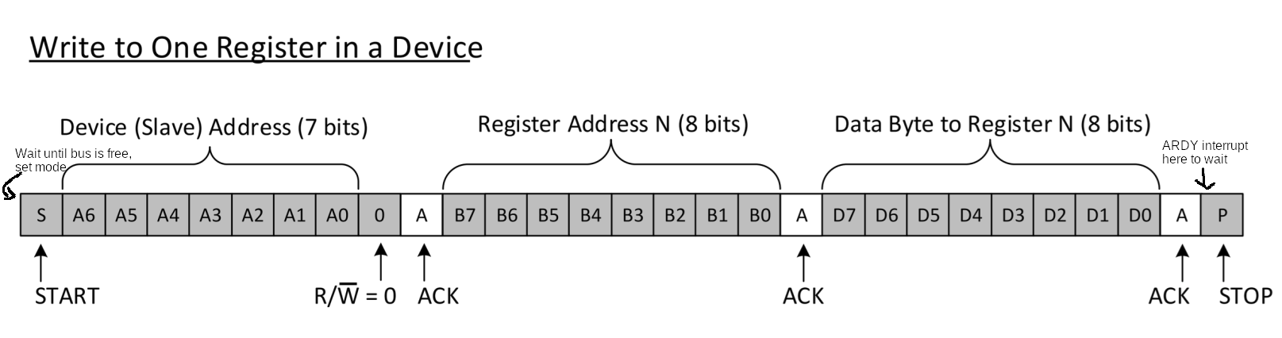
+ As when stop condition is happened, the master mode bit is cleared, so make sure only set master mode when stop condition is finished and the bus becomes free

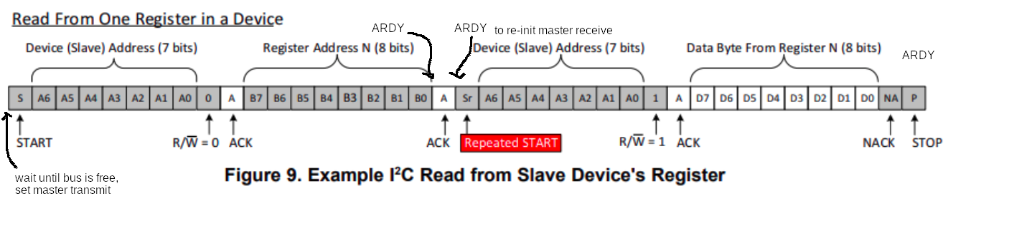
+ The same above
+ Instead of a small delay before ACK, make sure 1st ARDY bit is set to make sure the register register is sent completely (DCOUNT = 0)
+ 2nd ARDY is used as no STOP but REPEATED START and DCOUNT is 0 already

=> with ARDY location above, continuous I2C read/write operations work properly

