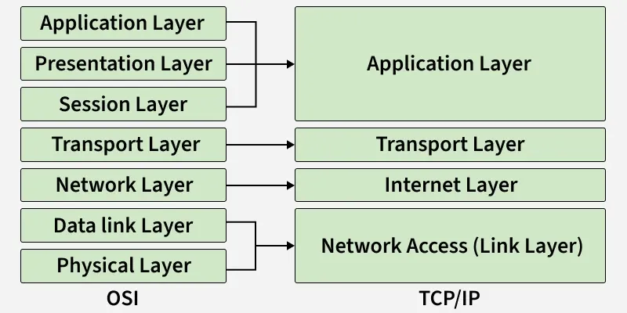
APPLICATION::
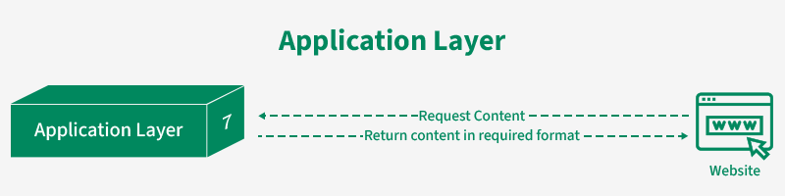

User application – networks
*[1]
Protocol: HTTP, DNS

TRANSPORT::
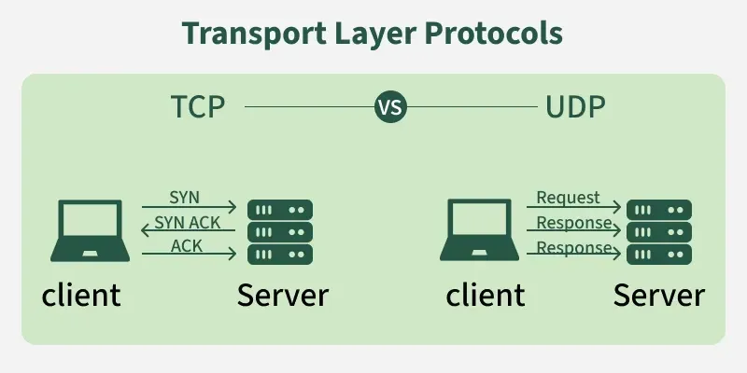

Delivery of data – devices
*[3]
+ TCP/UDP
+ Congestion ctrl
+ Service Point Addressing = Port Addressing

NETWORK::
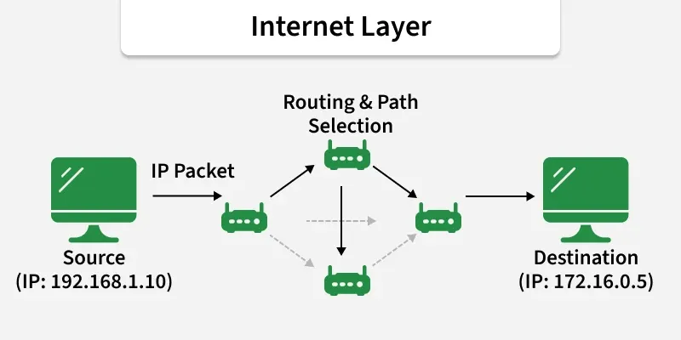

Addr, pkt, route – packets accross network
*[3]
+ Logical addr..ing
+ Frag + reassem…
+ Protocol: ICMP, ARP with IP

LINK::
within network – hardware (cable or wireless)
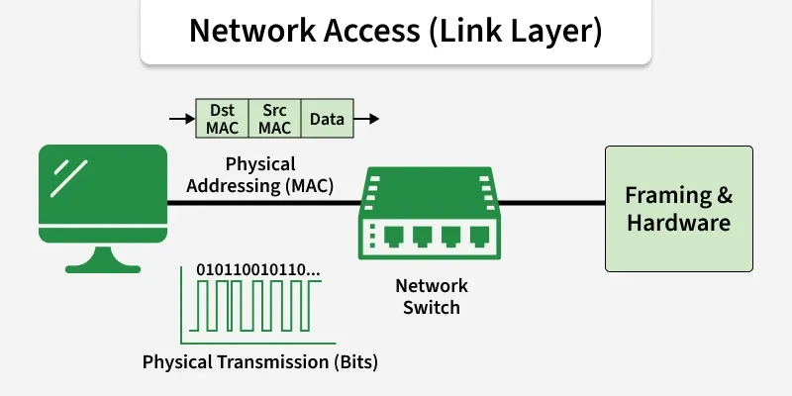

* [4]
+ MAC addr ...ing
+ Flow / Error ctrl

+ Carrer Sense
+ over physical media (cable or wireless)

