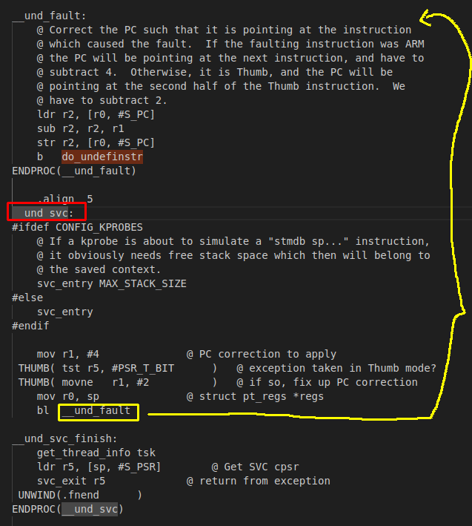

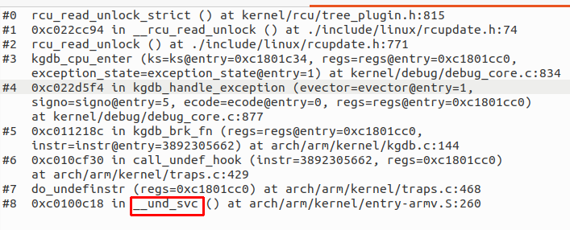
→ undefined instruction interrupt
(CPU state at 0xc1801cc0 is saved) check by print *(struct pt_regs *)0xc1801cc0

