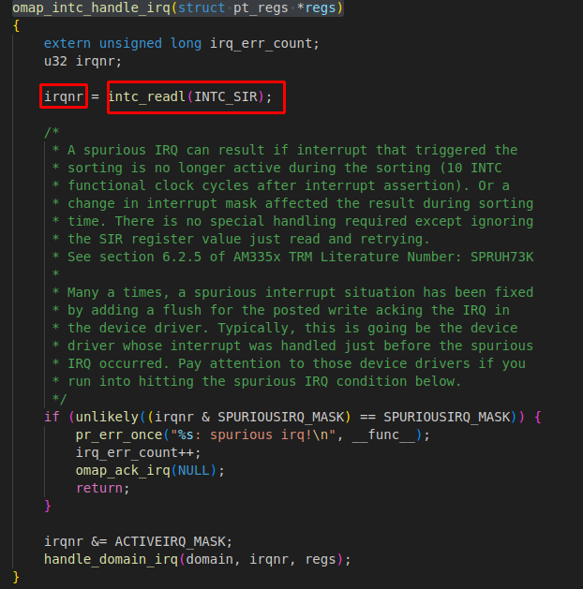
After handlers take control, it will trace which source raised interrupt:
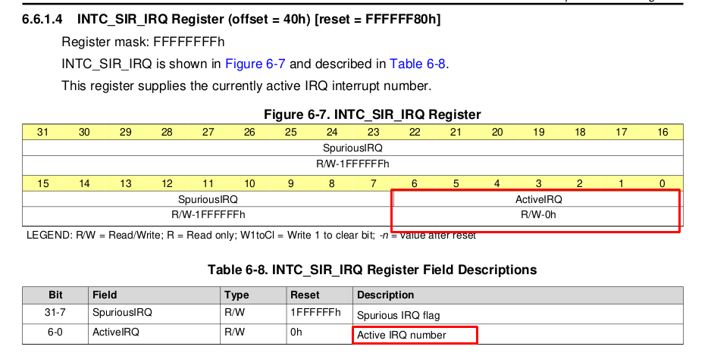
omap_intc_handle_irq → read :

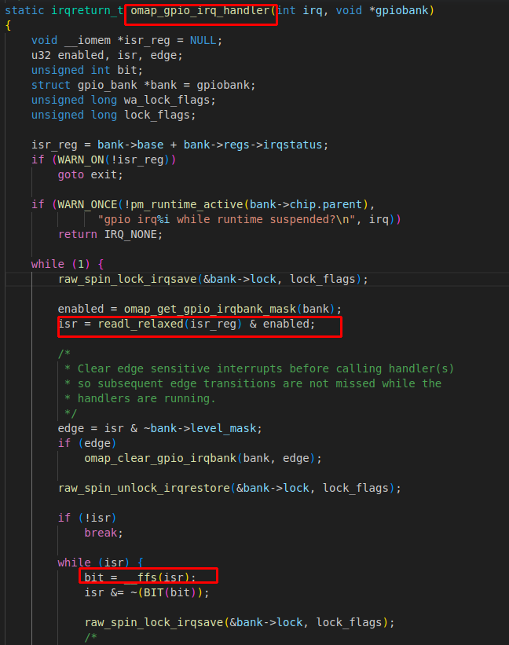
After getting the interrupt line from interrupt controller,
omap_gpio_irq_handler → read:
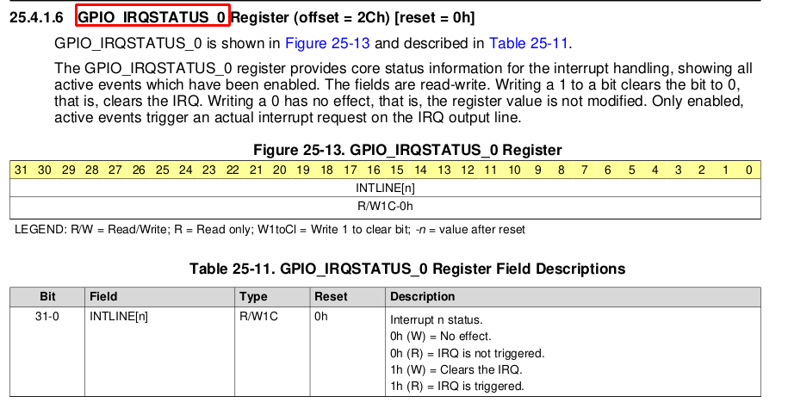

Finally, trace the individual source

