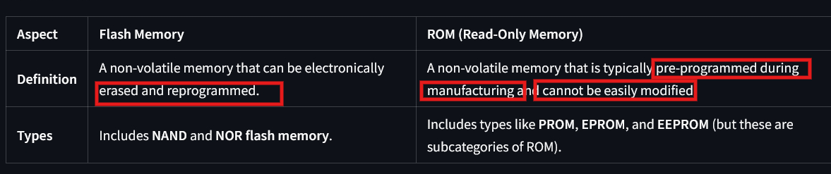
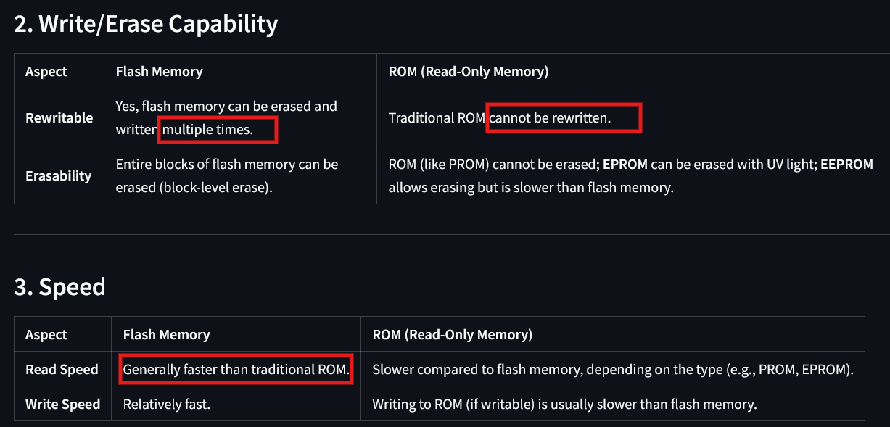
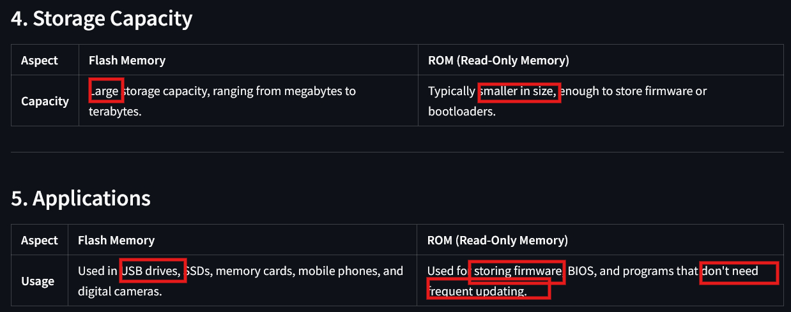
- Flash – more flexible

Past -> firmware, bootloader -> ROM
Now -> …………………………… -> Flash
