Buffer:
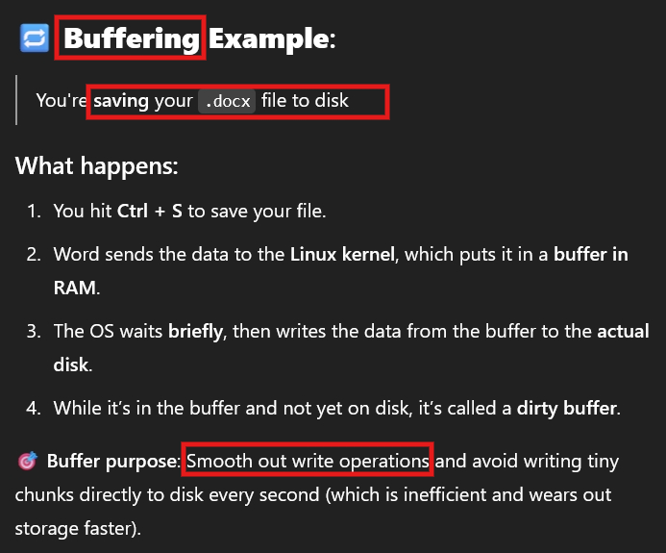

Cache:
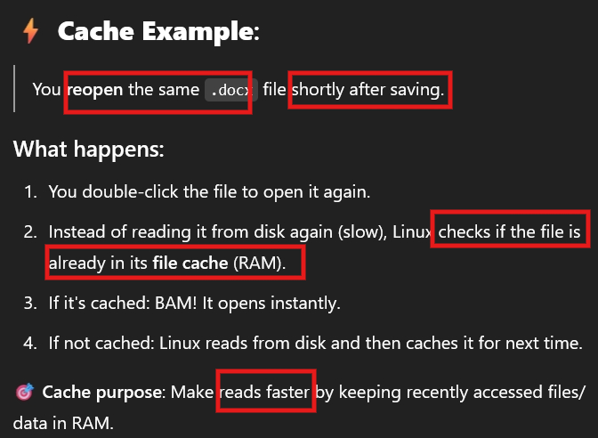

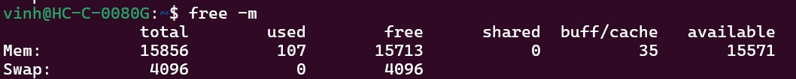
It means there are 35 bytes on SRAM for faster read and smooth write
The total space for Swap is 4095, it means the allowed swap space is up to 4096 bytes. If the swapped data is larger than 4096 bytes, the system can be broken

