========================== FIRMWARE ==============================
POST:
+ CPU, RAM
+ peripherals: keyboard, mouse
+ devices: SSD, network adapter

Boot order configuration:
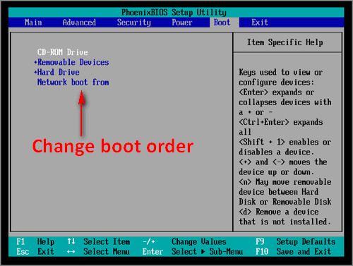
Usually -> Removable device (USB drive)
+ Look for a bootloader on bootable area (usually MBR)

========================== BOOTLOADER(GRUB) ==============================
Boot menu (optional: if multiple OS installed) -> user to choose:
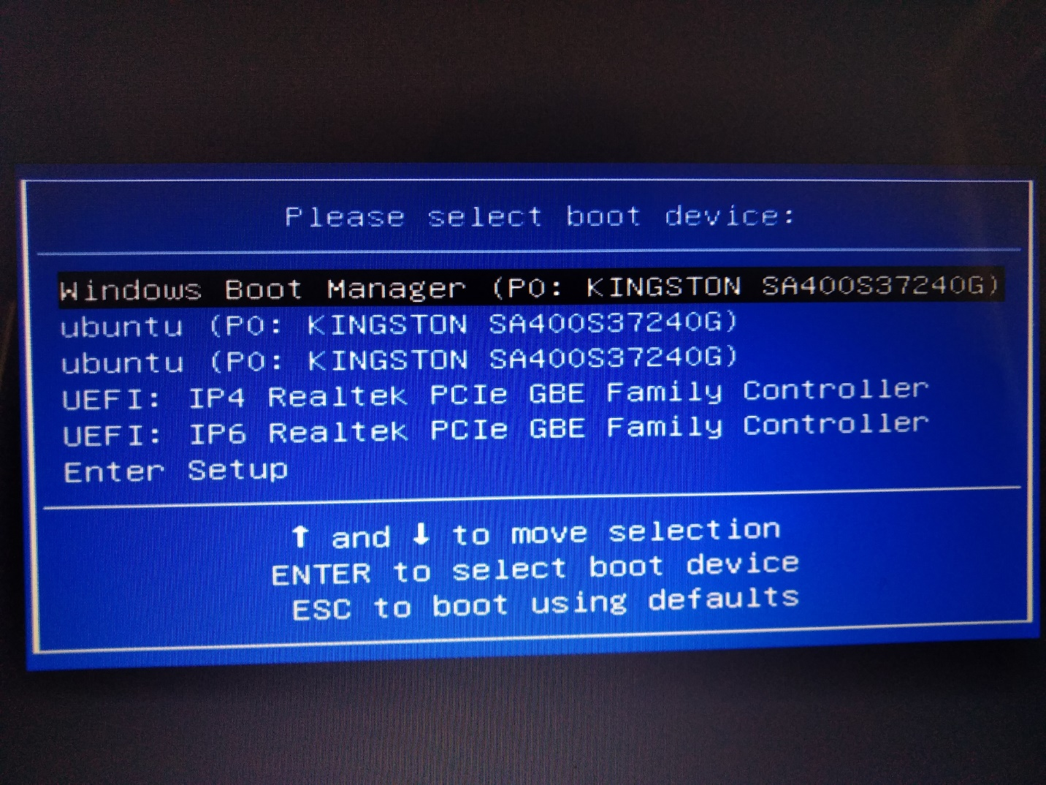

Grub.cfg:
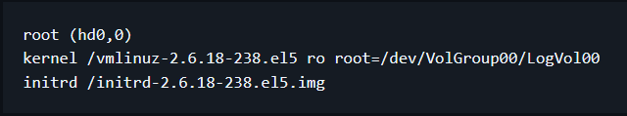
+ root (hd0, 0) – where compressed kernel + initrd image is located
+ ro root=/dev/VolGroup00/LogVol00 –
- where root filesystems (OS’s filesystems) - located
- Hey, kernel (after loaded) mount them read-only mode

- Loading kernel into executable zone (RAM – CPU accesses)
- Initrd into RAM (can be discared after that) as temporary root filesystems for kernel to mount them read-only mode

========================== KERNEL ==============================
+ Mount root filesystems in read-only mode
+ PID 1 - …

