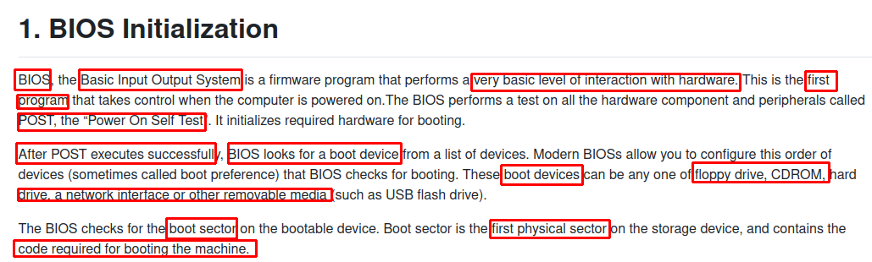
================================================================================

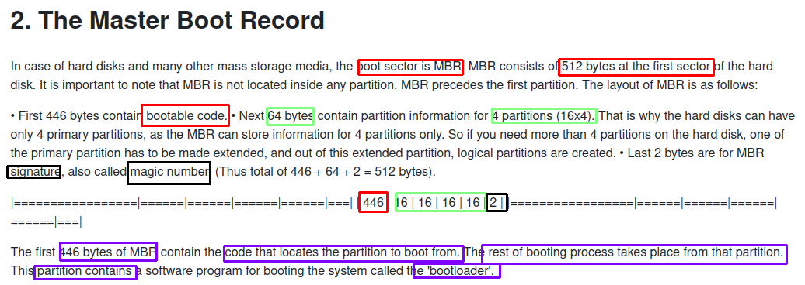

================================================================================

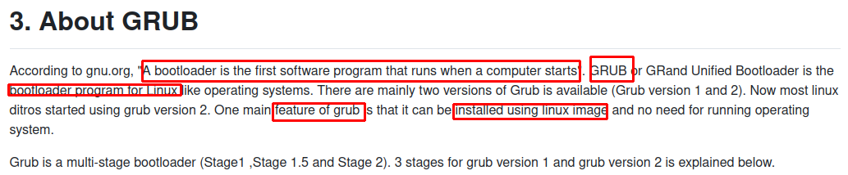
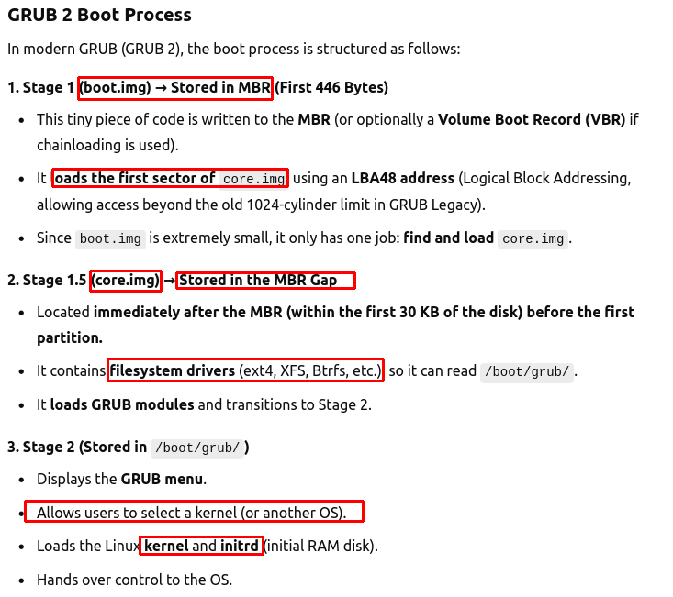
→ All kernel and initrd → boot/grub

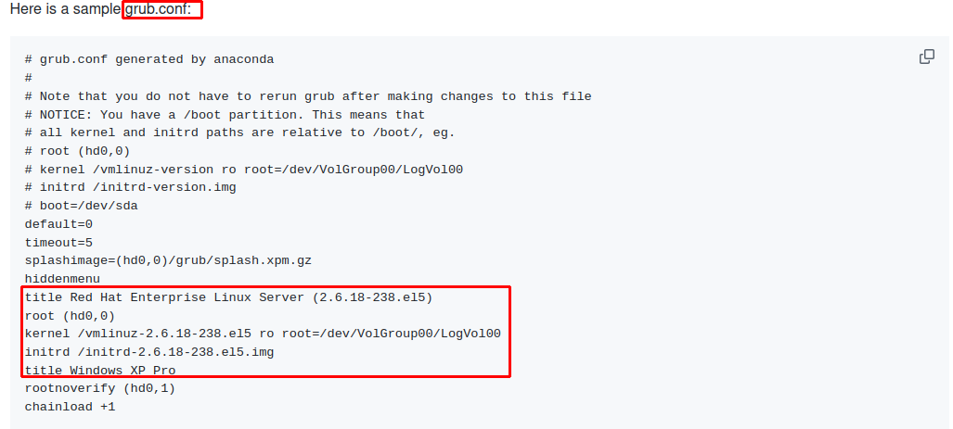
================================================================================

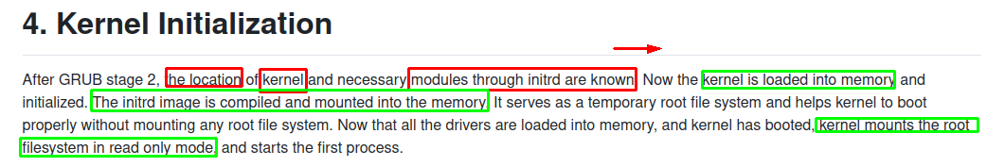
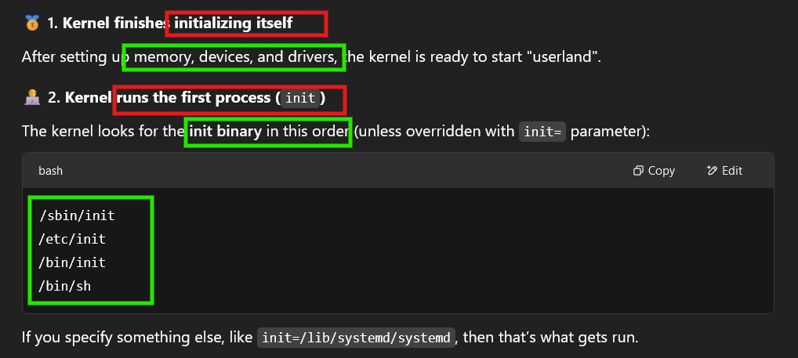
+ Additionally, kernel – mount root filesystems in ro mode

================================================================================

PID 1 (in sbin/init) → execute sequences in etc/inittab (Ex: sbin/init -> /lib/system/systemd)
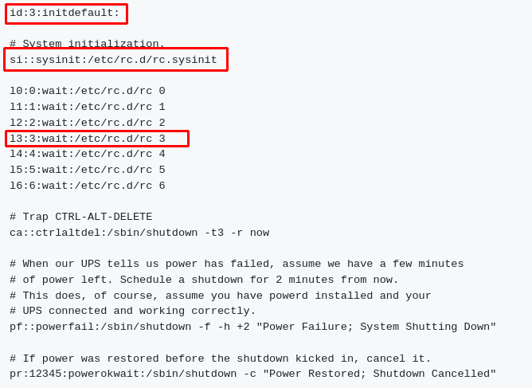
+ choose runlevel 3 as default (Full multiuser mode)
+ rc.sysinit →
+ set hostname

+ ENABLE RAID + LVM, SWAP

+ Mount filesystems (/dev, /proc, /sys), root filesystems (ro → rw) (via systemd-remount-fs.service – local-fs.target)

+ Configure kernel parameters in sysctl.cfg (**) by system-sysctl.service in basic.target
(**):
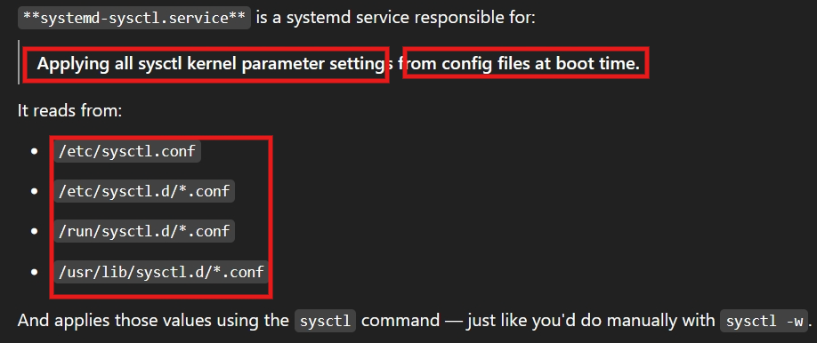
Ex: When I want Linux PC host acts as a gateway: In /etc/sysctl.conf -> uncomment net.ipv4.ip_forward=1
+ rc 3 → execute /etc/rc.d/rc3.d/ = start + manage services:
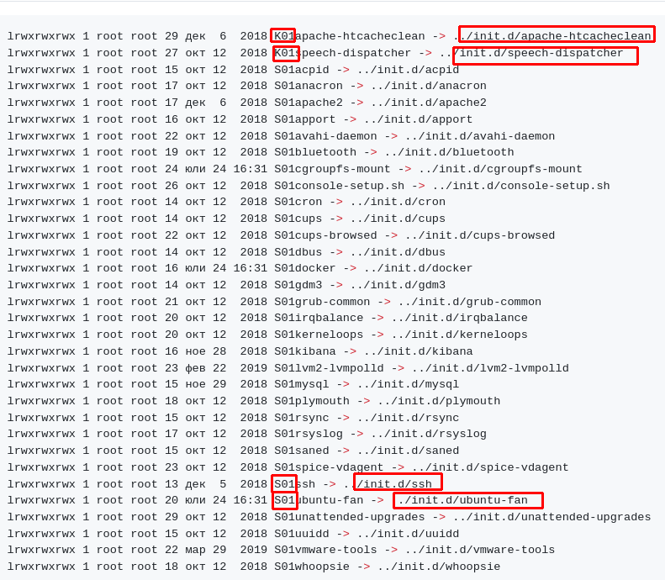
Ex:

/etc/rc.d/rc/local → optional for local setup

