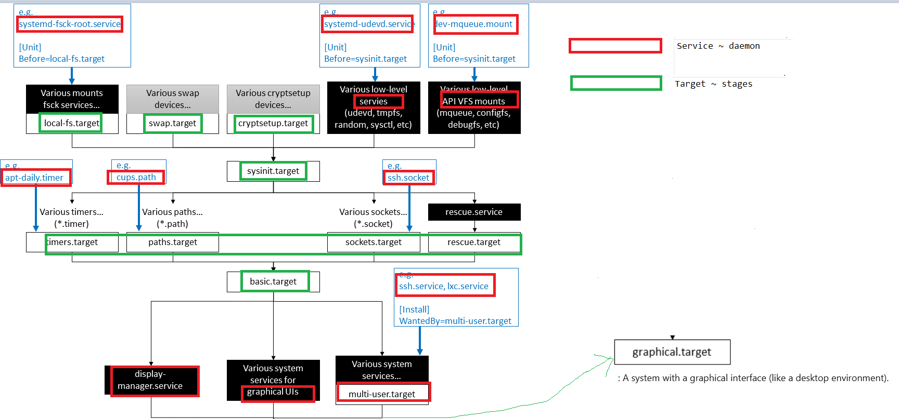

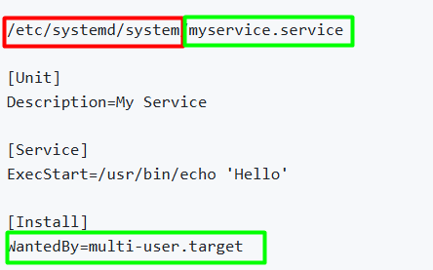
- When multi-user.target is reached -> use myservice.service
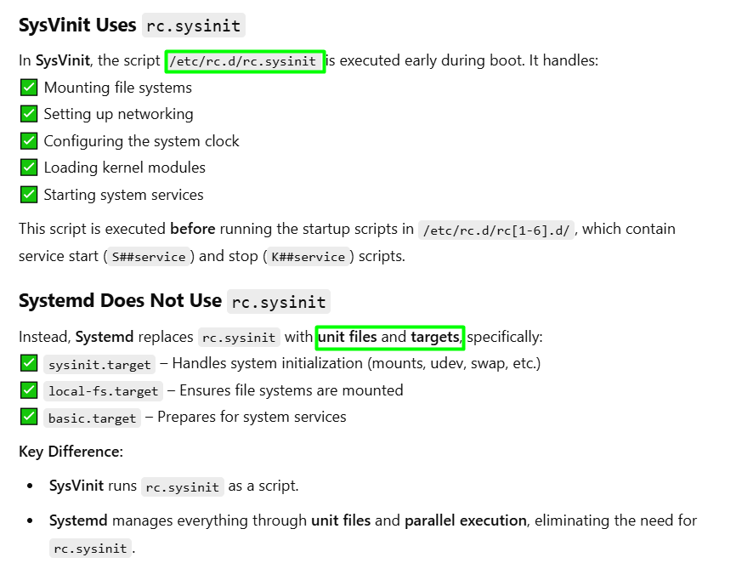
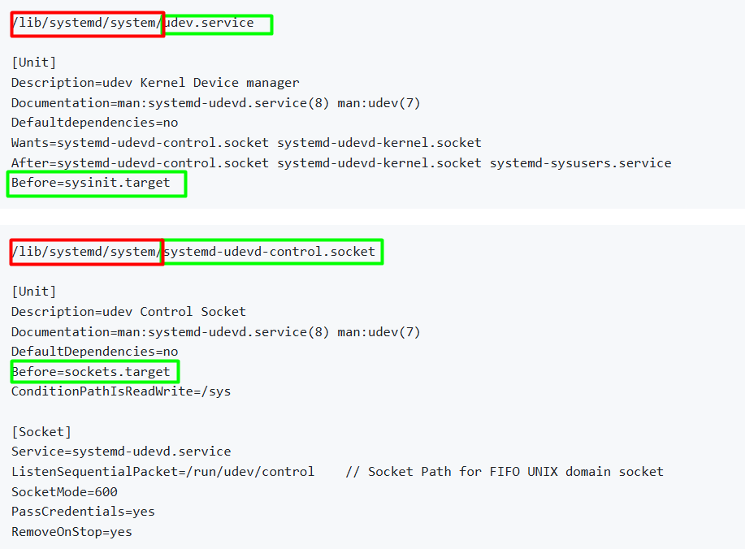
- Udev.service must be executed before sysinit.target
- System-udevd-control.socket must be executed before sockets.target
