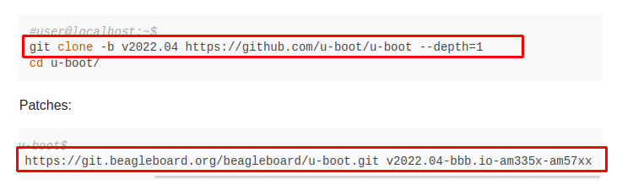

================================== Get the bootloader ======================

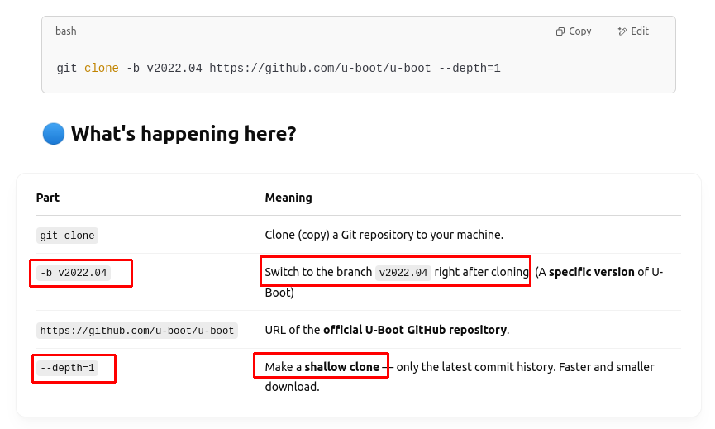
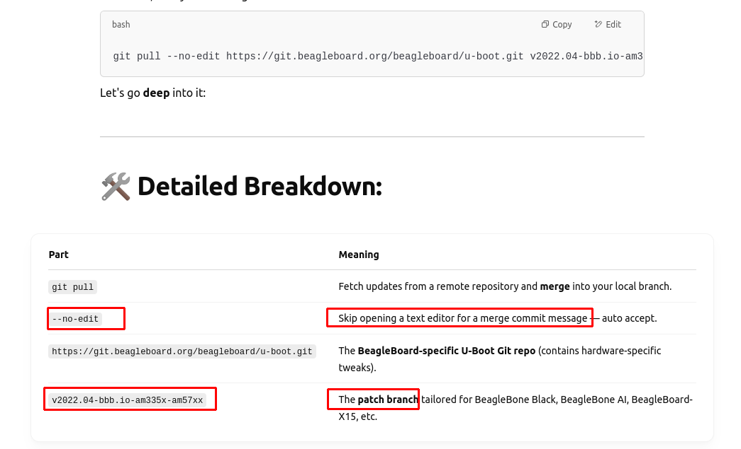
→ Overall:
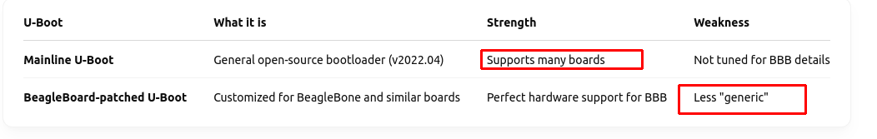
============================== Make U-boot =============================

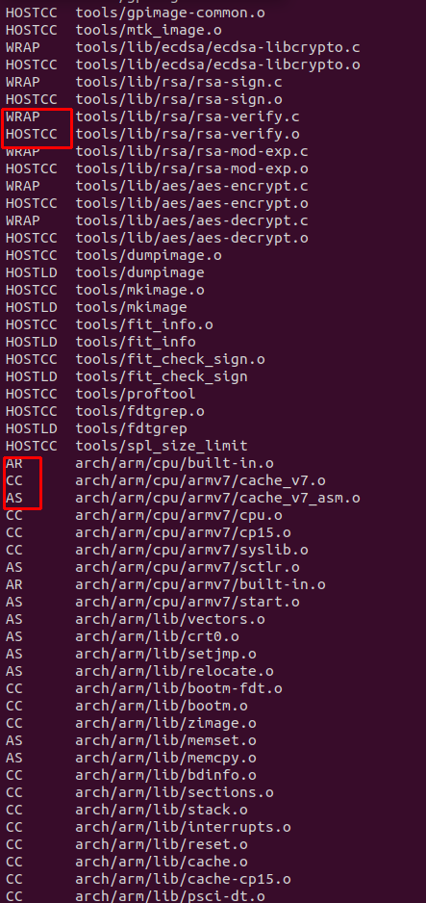

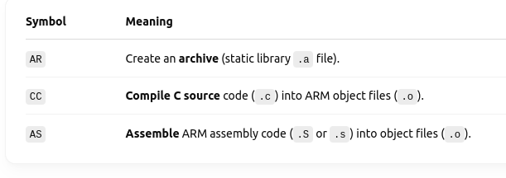
HOSTCC (x86_64) → build tools to help build the source for SoC BBB
CC → build the real image for SoC BBB

------ Output ------

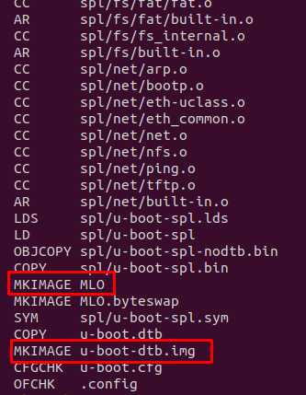

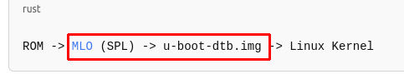

+ MLO (SPL)
+ u-boot-dtb.img (device tree embedded in it)

