===================== Diffference x86 – Arm =================================

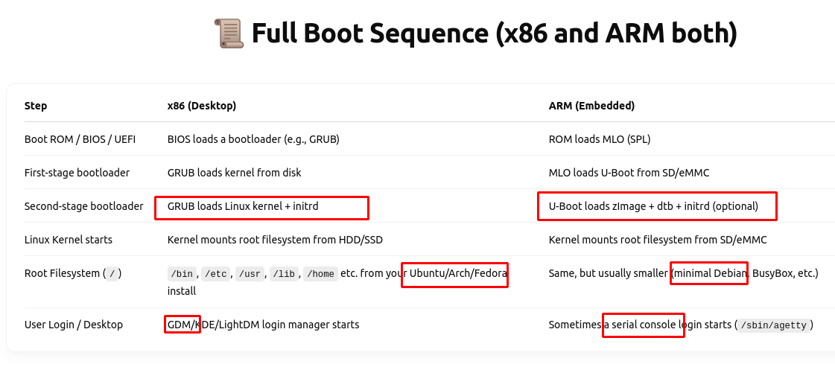
ISO – kernel + root filesystems embedded
BBB → the same (but need users to copy them into SD card manualy)
* root filesystems – OS – human use:
================

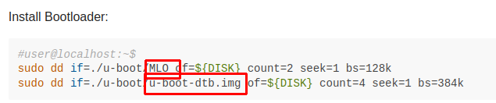
Copy MLO + u-boot-dtb.img → SD card

=========================== build_kernel.sh ===========================

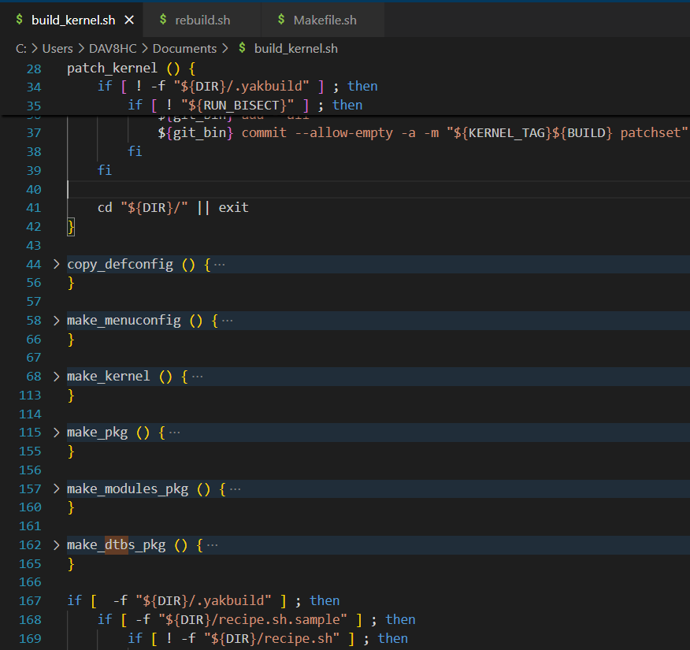

- Main purpose: Compile Kernel image, kernel modules (archives) and device tree binary (archives)

