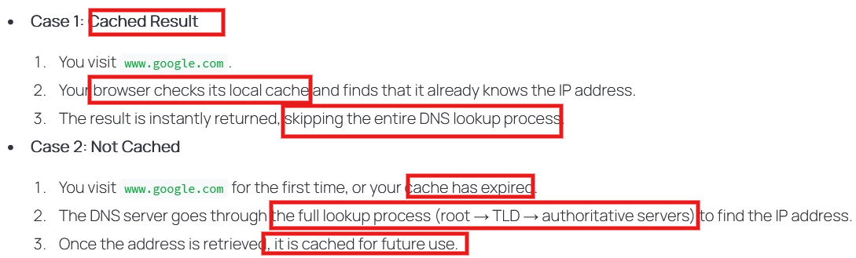
Case 2: the browser sends DNS queries to Recursive DNS Resolver (middle man between the browser and DNS system), … then it sends back the IP addres to the broswer
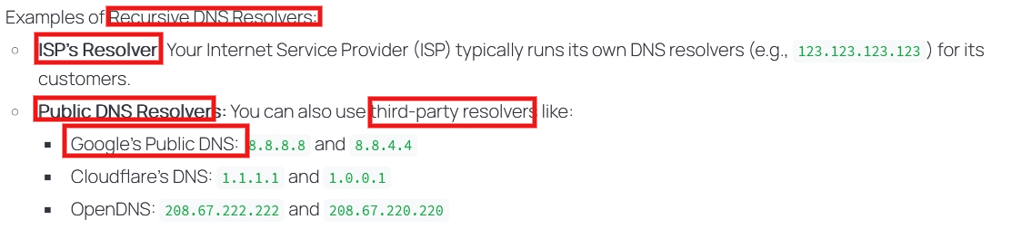

If found in the cache -> the browser return IP immediately
Else -> the browser sends DNS queries to Recursive DNS resolver

