1. PPL: in ROM
2. SPL: in SD card or eMMC
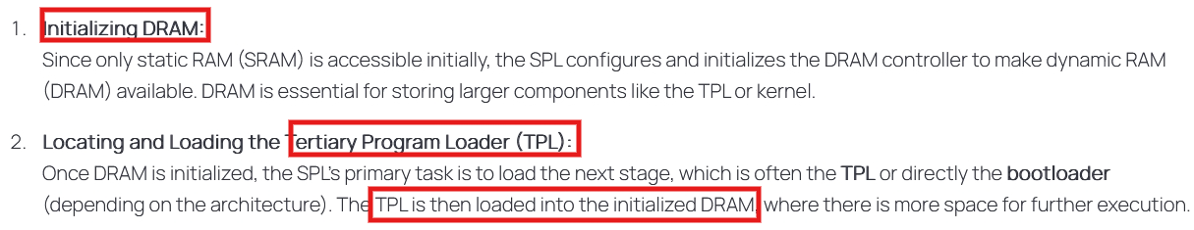
SPL = raw binary held by MLO file (Memory LOader)
TPL = bootloader (U-boot)
3. TPL (Bootloader U-boot) in SD card or eMMC:
Load kernel, initramfs, device tree
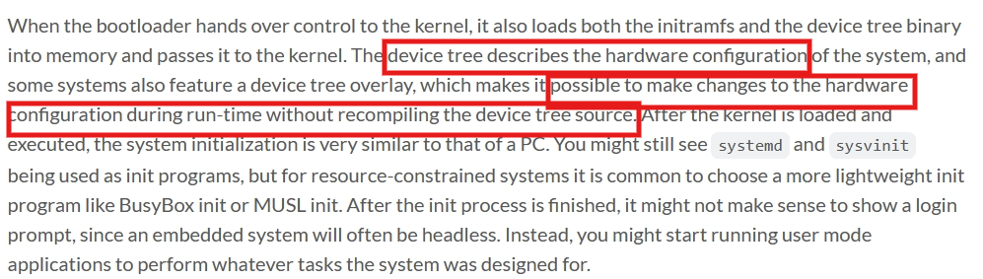
4. Init process:
