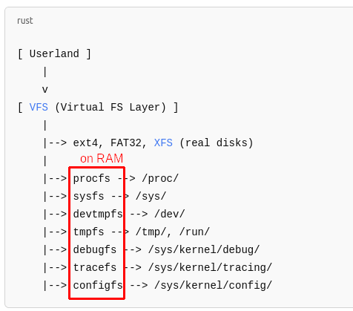

These are mounted virtually
======================== SOME FILESYSTEM===========================
//proc/devices → show all character devices
// sys/class → show all group types:
Ex: //sys/class/net → usb0, lo, ether0

