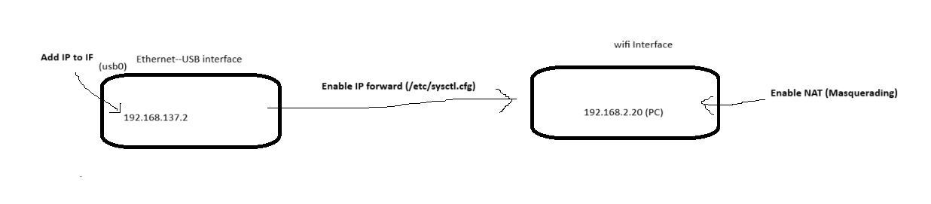
Step 1: Assign an IP to the USB Interface on the Linux PC
- Check ‘ip addr’ -> to identify the name of network interface
Step 2: Enable IP Forwarding on the Linux PC
Step 3: Set Up NAT (Masquerading) on the Linux PC
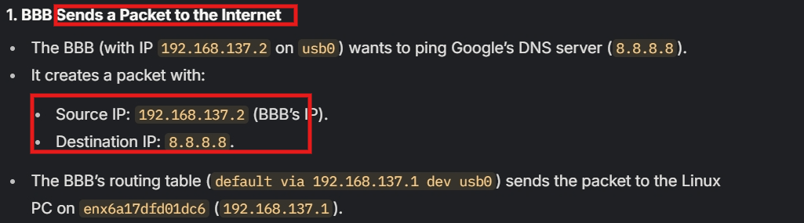
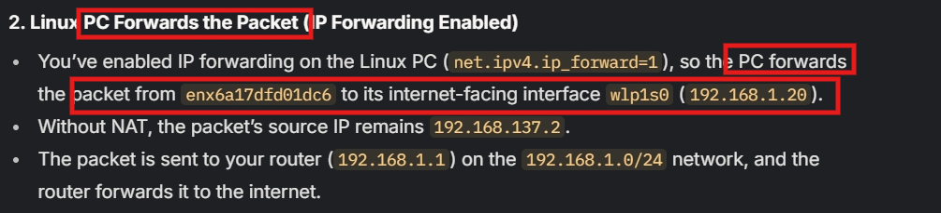
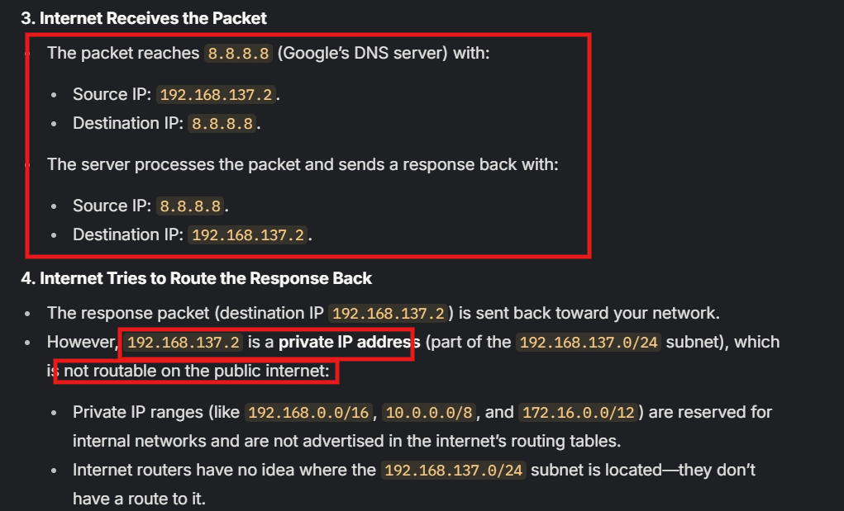
NAT -> Ip source from BBB like Ip source from Linux PC host

