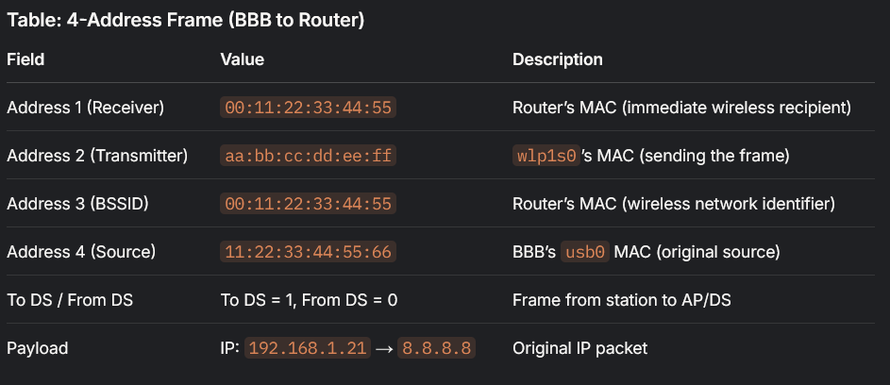
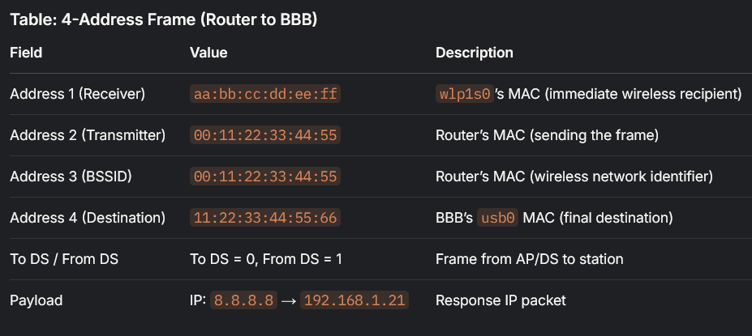

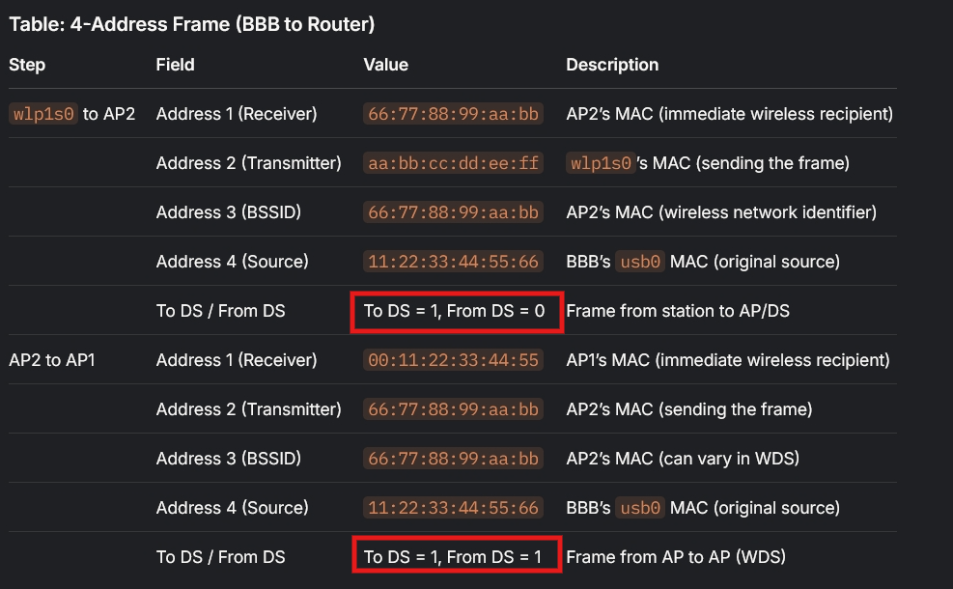
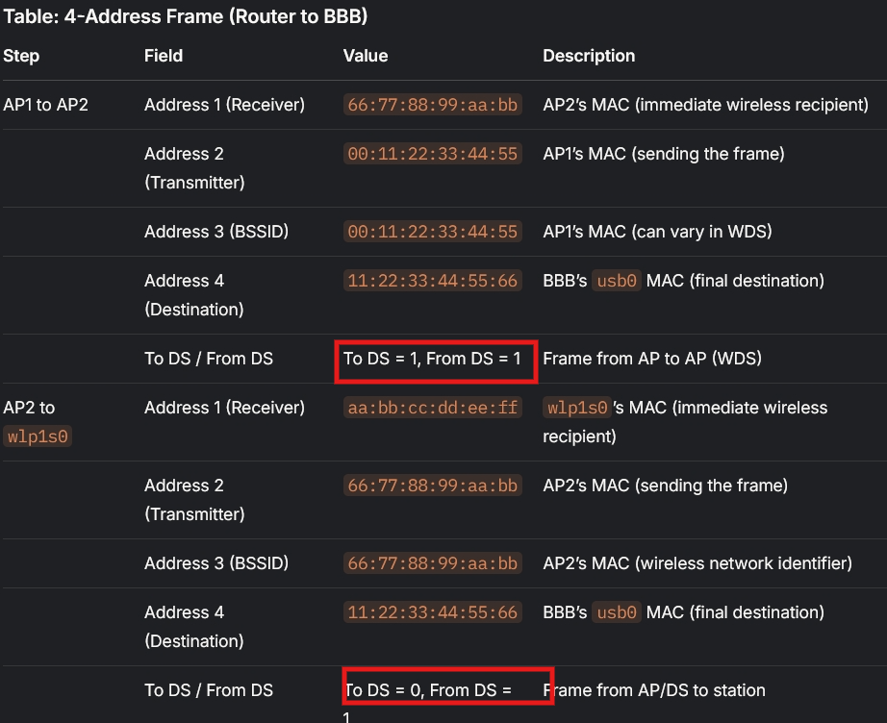
As usb0, enx…, wlp1s0 and gateway has the same subnet -> use MAC (Data-Link layer)
If 3-address mode -> there is no MAC address of usb0
If 4-address mode -> there is MAC address of usb0 -> ensures the frame (becoming Ethernet frame) can be relayed to the correct device beyond the immediate wireless hop (between Station (wlp1s0) and gateway).

+ 4-address mode -> wireless links, not wired ones
+ AP (Access Point) – A device provide wireless network (~ host)
+ Station – A device connects to wireless network (~ client)
+ WDS (wireless distribution system) – the wireless connection between APs

