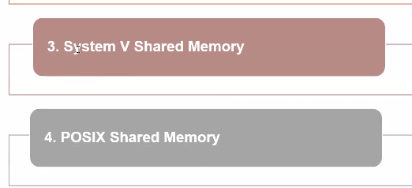
POSIX → Systemd

====================== IPC ====================================

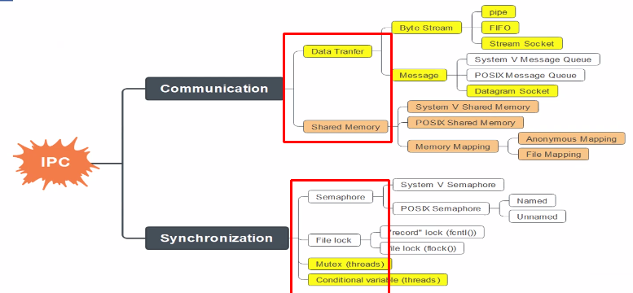

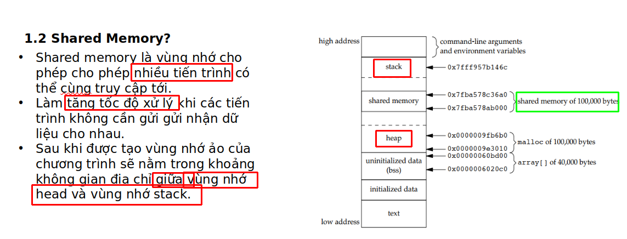

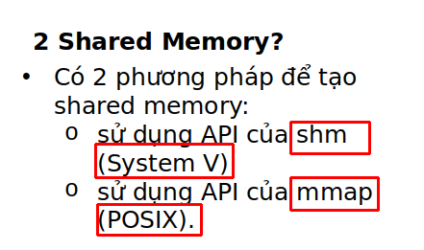

============================ Shared memory allocation ==================

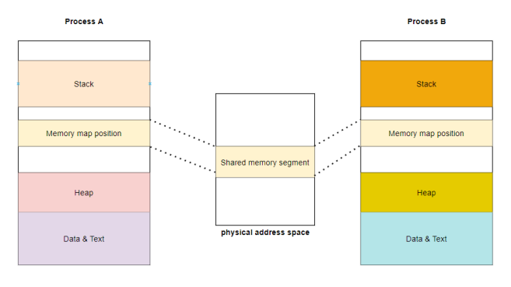

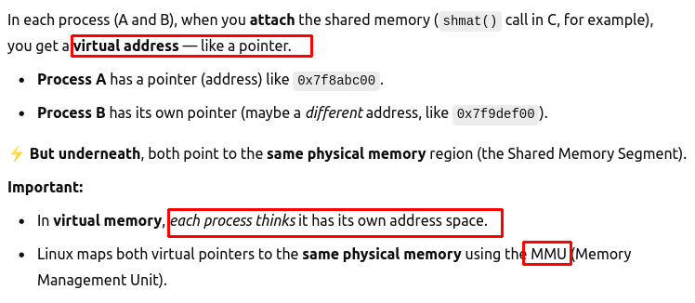
→ memory map position

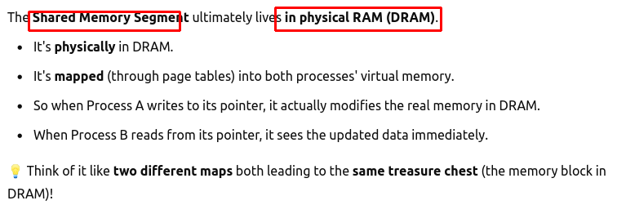
→ Real shared memory space is on DRAM

→ Need to free it after using

================================ Type ==================================

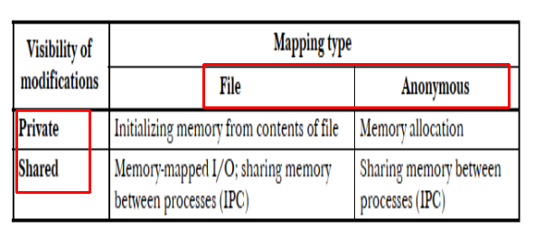
File – a common file between processes
Anonymous – DRAM memory between processes
Private – changes can not be seen by other processes
Shared - …

