res = platform_get_resource(pdev, IORESOURCE_MEM, 0);

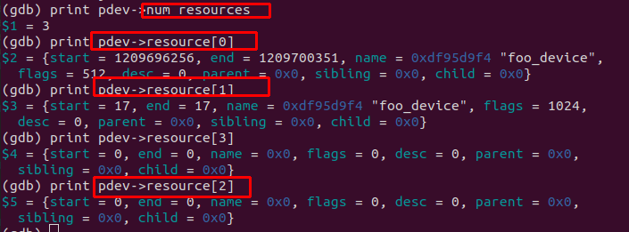
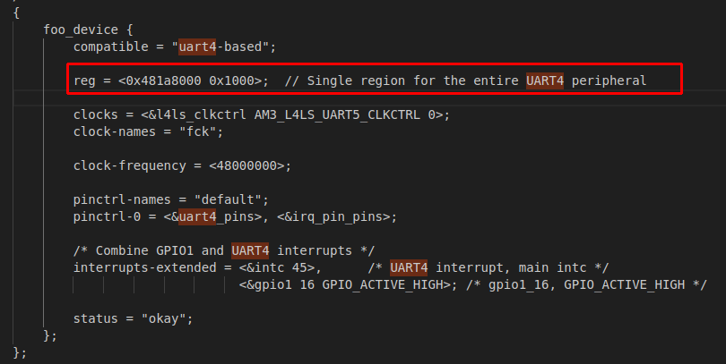
[0]: IORESOURCE_MEM
+ Start: 481A8000 - End: 481A8FFF
+ flag = 0x200 → IORESOURCE_MEM

[1]: ORESOURCE_IRQ
+ 17 = IRQ17 of uart 4
+ flag = 0x400 → ORESOURCE_IRQ

