data->clk = devm_clk_get(&pdev->dev, "fck");

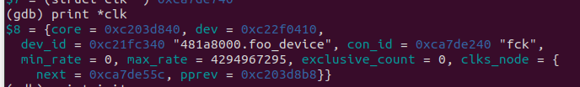
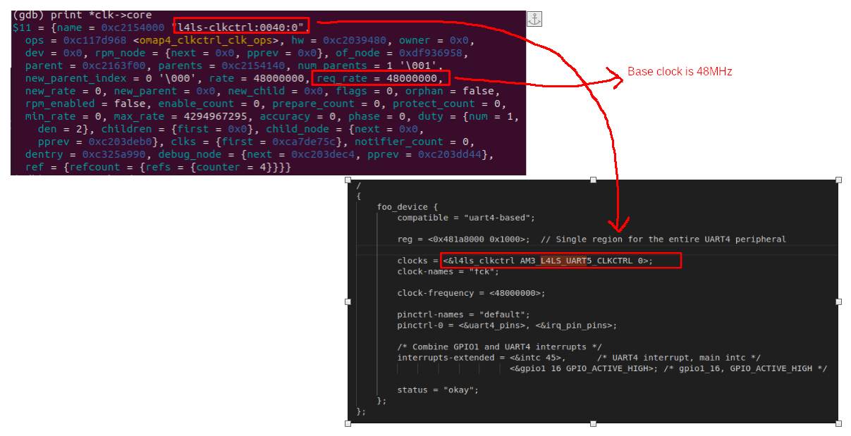
data→clk→core→reg_rate = 48 000 000

=> use to retrieve the clk (dev_id, con_id, core->reg_rate{the base clock})

================== Usage =====================
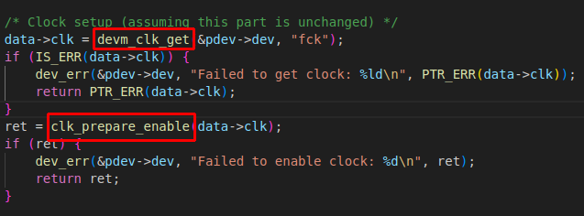

It MUST be enabled for the read action to registers (hw) to be valid

Else:

