============= Usage ==============
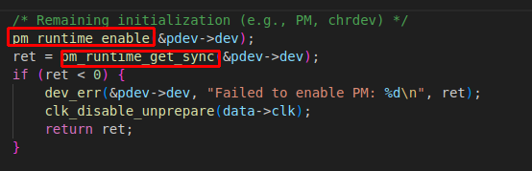

It’s OPTIONAL – runtime power management
Located in include/linux/pm_runtime.h

