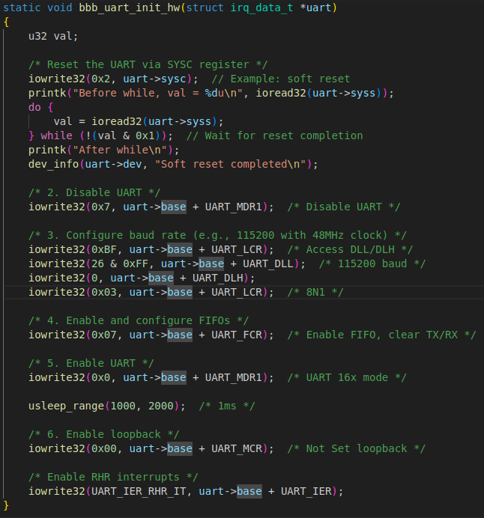

- Reset Uart4 → then wait it’s reseted
==
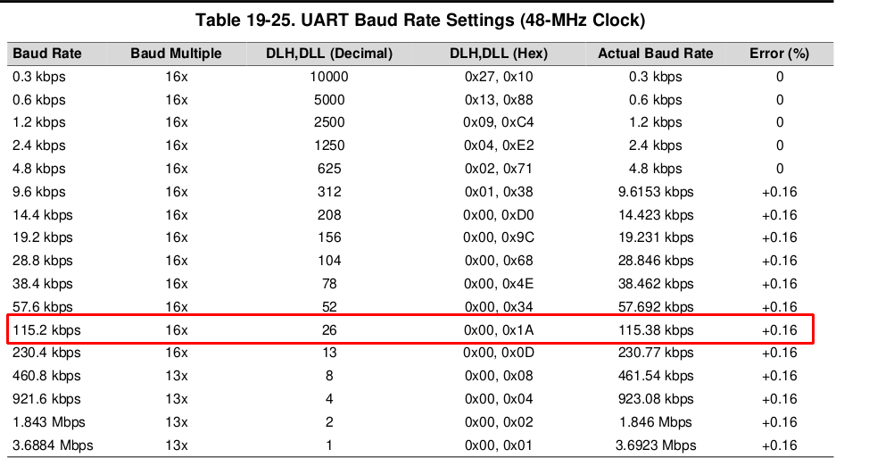
- baud rate = 115200 → DLL, DLH :

(UART_MDR1 → enable 16x mode)

- UART_LCR → configurable params (char length, parity bit, stop bit, divisor latch enabled)

==
- UART_FCR → FIFO enabled
- UART_IER → Interrupt enabled

======================== Handler ==================

