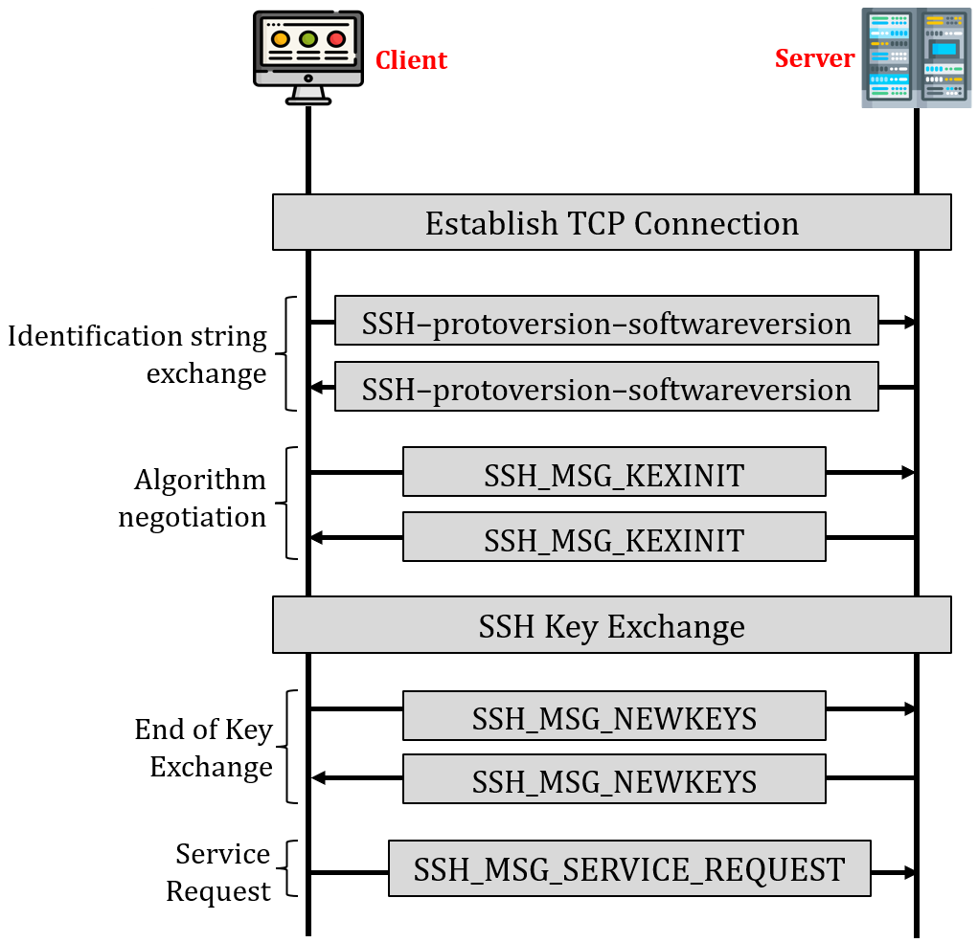
*Note:
SSH_MSG_KEXINIT: exchange algo available on both sides (mac, key, signature, compression)
SSH_MSG_NEWKETS → end of key exchange (as there is no data in payload)

===
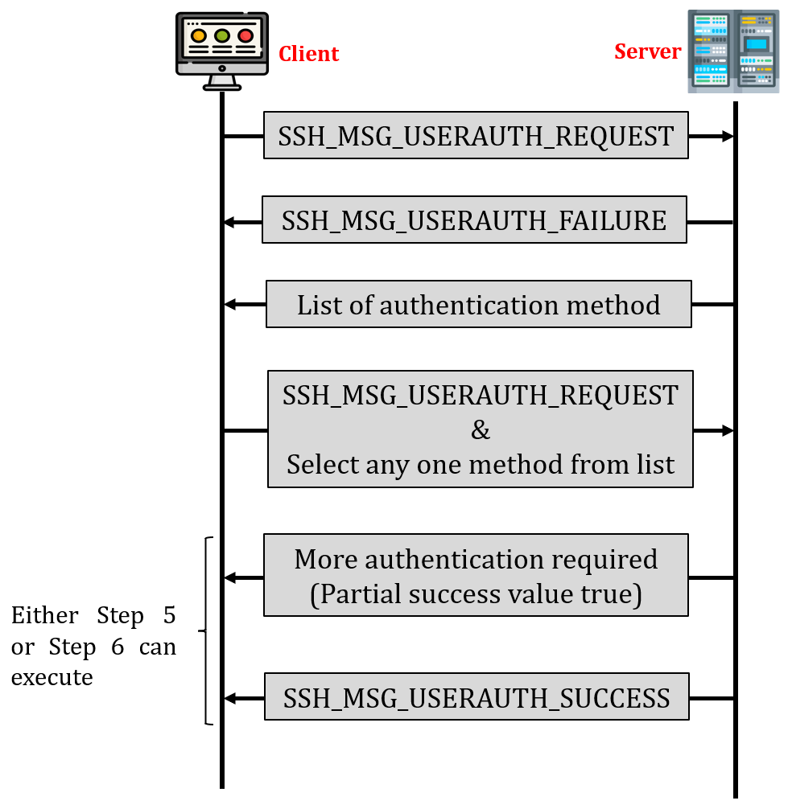
*Notes:
SSH_MSG_USERAUTH_FAILURE: ask password

===

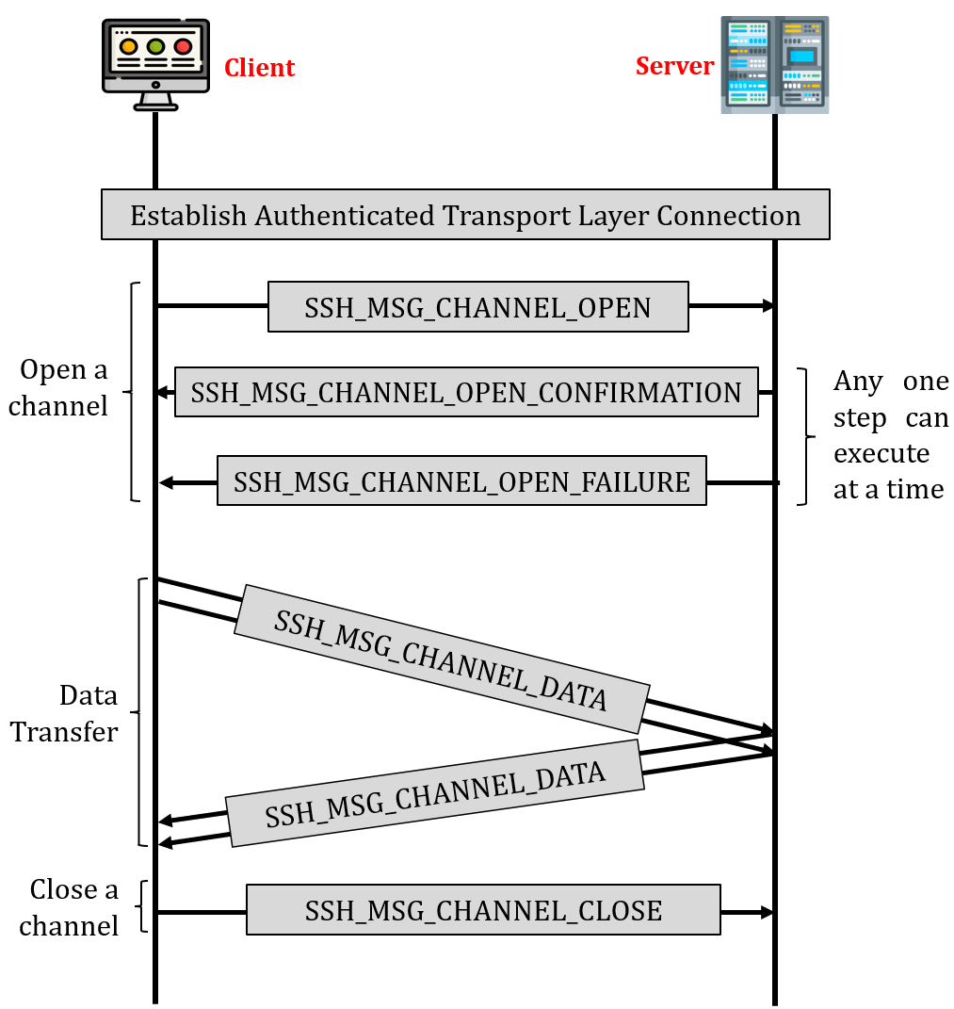
*Notes:
+ SSH_MSG_CHANNEL_DATA is the frame in which the bytes we type on terminal (in encrypted mode)
+ SSH_MSG_CHANNEL_DATA is exchanged to let the client display the byte on the terminal

