+ ps -aux
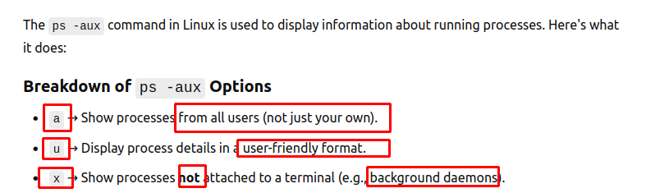
+ kill -l
List all the number of killing a process
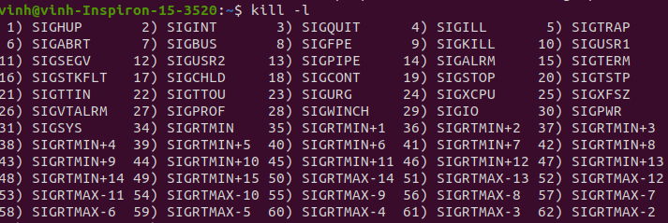
+ kill -<number> <PID>
Ex: kill -9 1019

+ int status, rv
rv = wait (&status)
→ wait until a child process finishes / is terminated, the parent process can continue exe after wait()

+ int status, rv
rv = wait (&status)
→ wait until a child process finishes / is terminated, the parent process can continue exe after wait()
=========================== Note ====================================
+ When a parent process has a child one → killing the parent one = killing the child process too >< not vice versa

+ A child process – a zombie = terminated but the parent – not read the exit status
- A child ‘s end > a parent’s end
- not enough time to call wait()/waitpid())
→ kill manually
→ kill the parent process
→ let the parent process call wait() / waitpid()

+ Safe to use fork() to avoid Zombie / Orphan process:
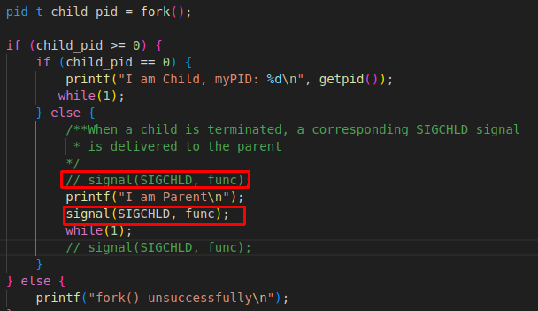
→ when the child process is terminated / finishes → it signals the parent process

