# IMAGES

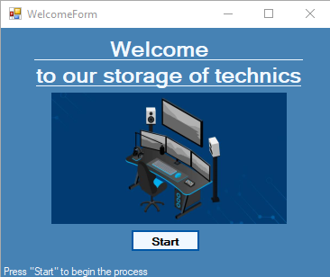

Figure B.1 – form of attachment

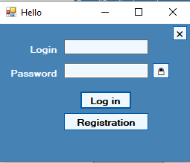

Figure B.2 – authorization form

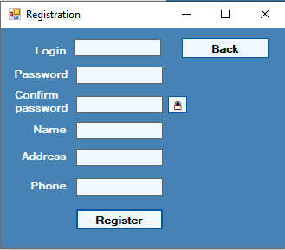

Figure B.3 – registration form

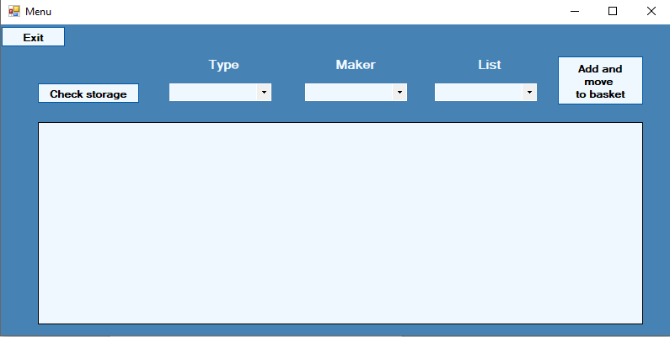

Figure B.4 – view of the workspace for reviewing information for maintenance

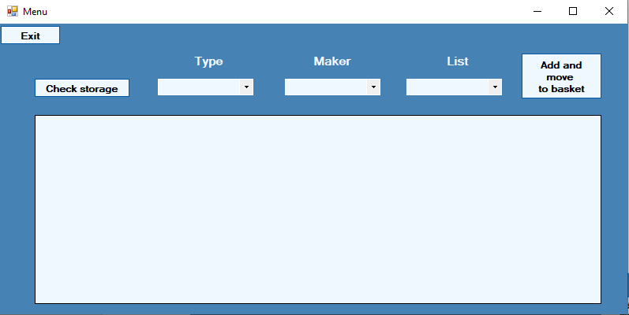

Figure B.5 – menu form for entering client activities

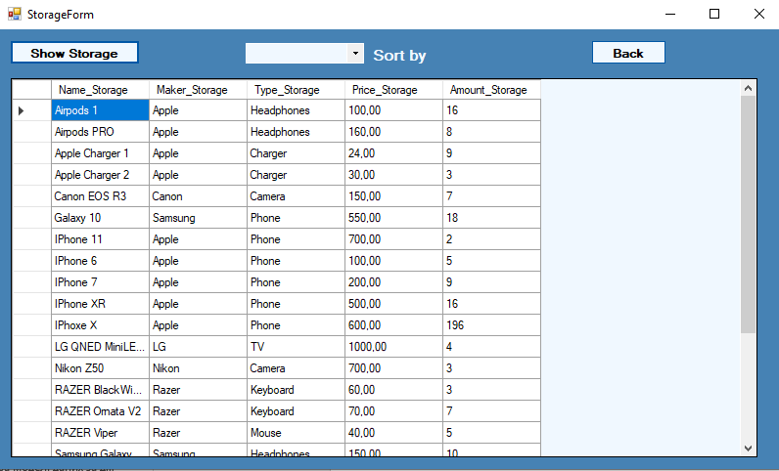

Figure B.6 – form for current warehouse data

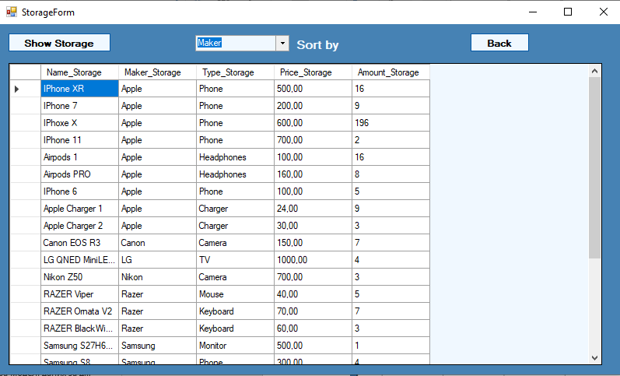

Figure B.7 – form for current warehouse data, sorted according to the product selection

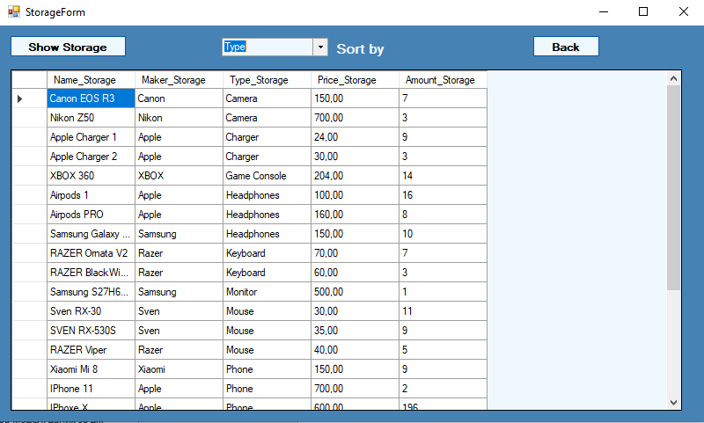

Figure B.8 – form for current warehouse data, sorted by product type

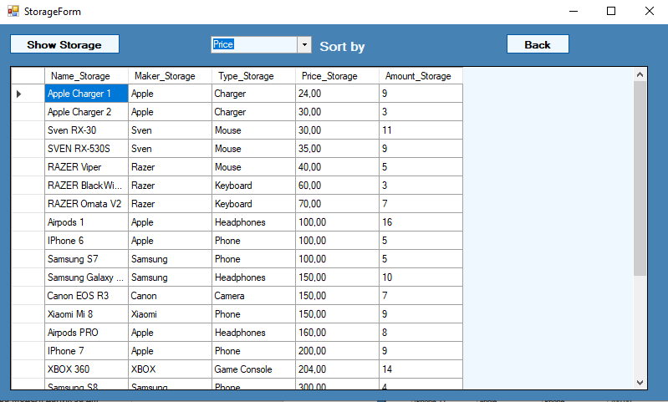

Figure B.9 – form for current warehouse data, sorted by product price

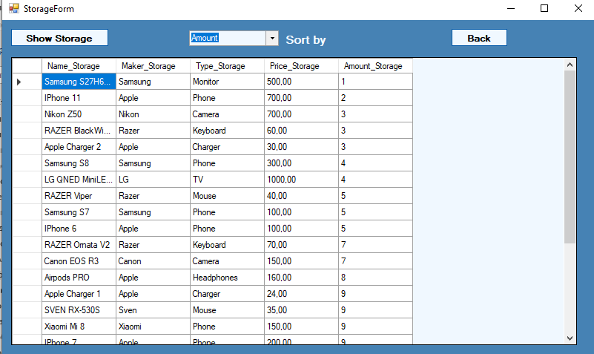

Figure B.10 – form for current warehouse data, sorted by quantity of goods

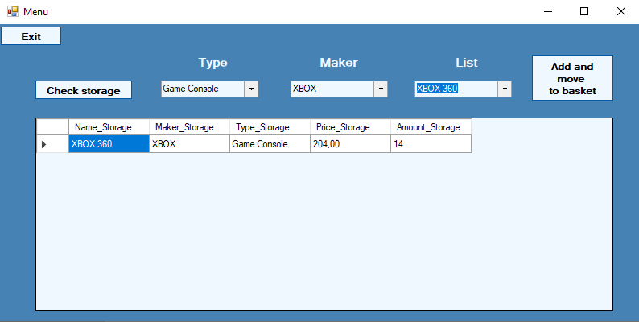

Figure B.11 – menu form with product selection and additional information

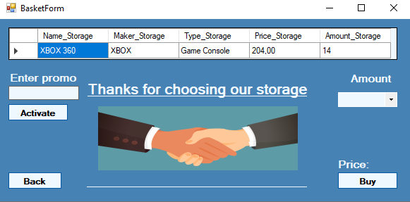

Figure B.12 – the form of the basket with the selected customer of the product

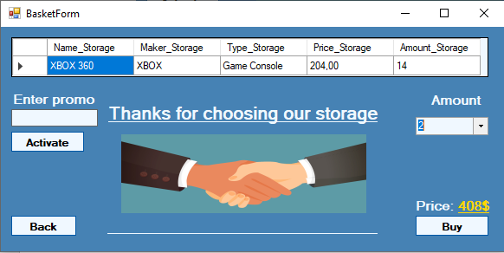

Figure B.13 – the form of the basket with the product selected by the customer and its quantity

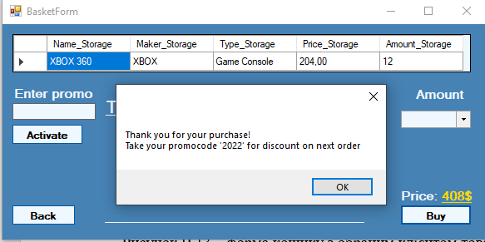

Figure B.14 – the form of the basket with the purchase of goods and providing the client with a promotional code for a discount on the next purchase

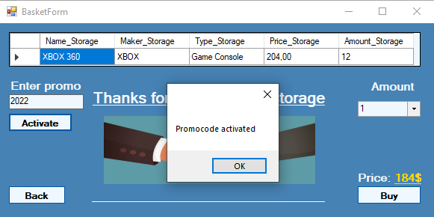

Figure B.15 – the form of the basket with an activated promotional code

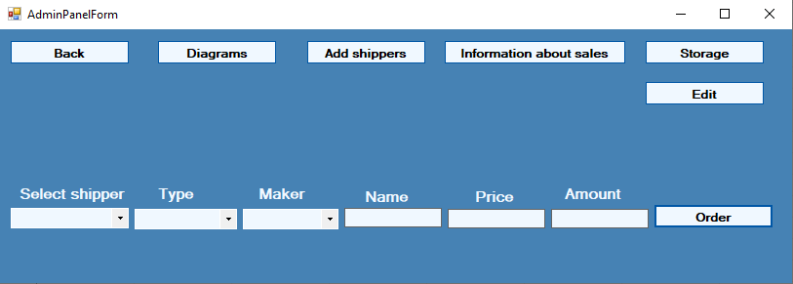

Figure B.16 – the administrator form, when logging in as an administrator

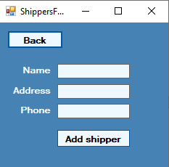

Figure B.17 – supplier addition form

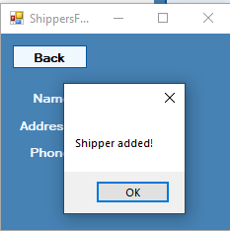

Figure B.18 – adding a supplier

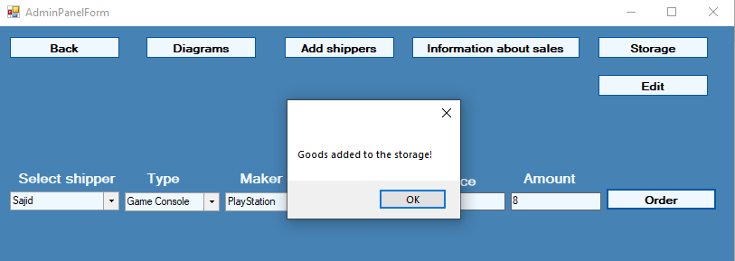

Figure B.19 – adding a new product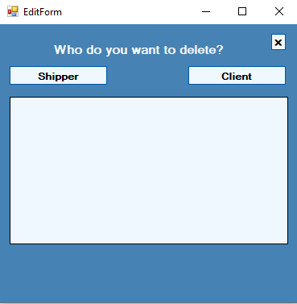

Figure B.20 – deletion form

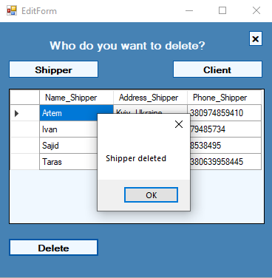

Figure B.21 - removal of the supplier

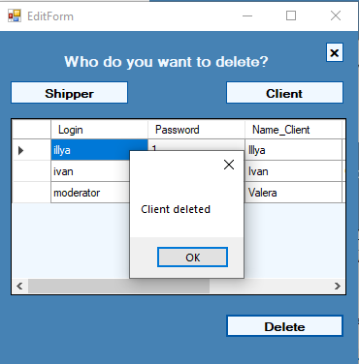

Figure B.22 - deleting the client

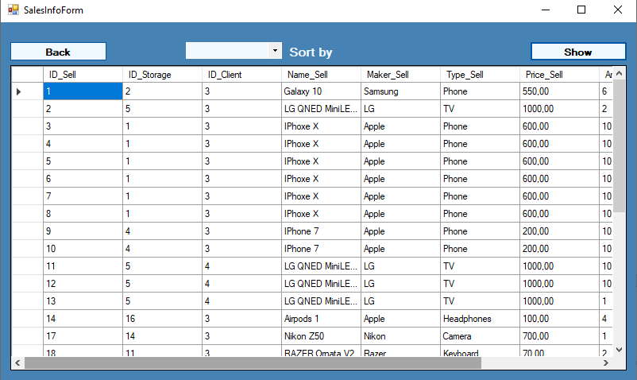

Figure B.23 – form of information on sales

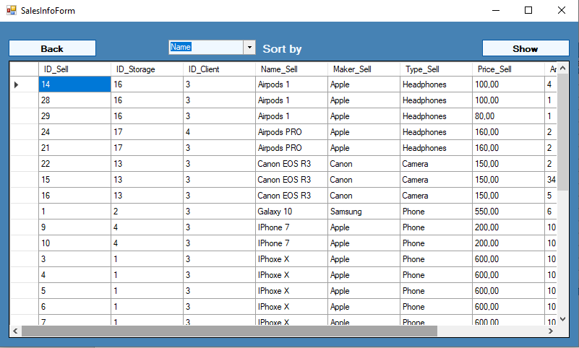Figure B.24 – form of information on sales, sorted by product name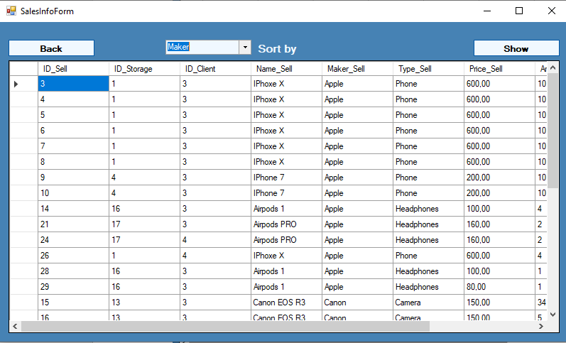 Figure B.25 – a form of information on sales, sorted by product manufacturer

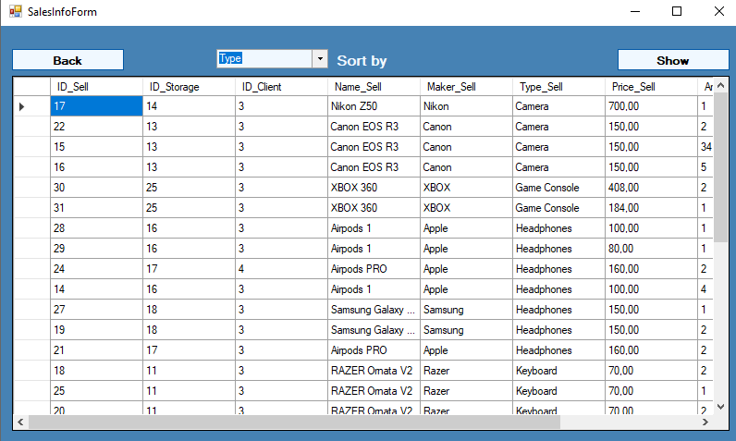Figure B.26 – a form of information on sales, sorted by product type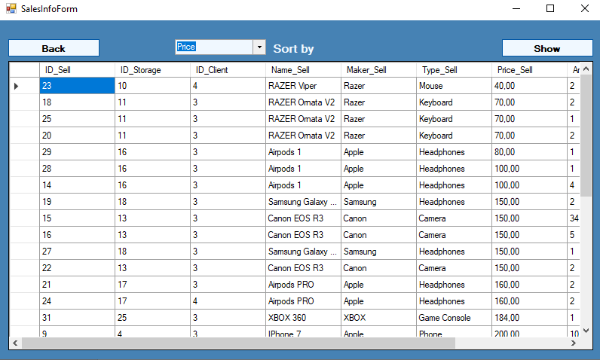

Figure B.27 – a form of information on sales, sorted by product price

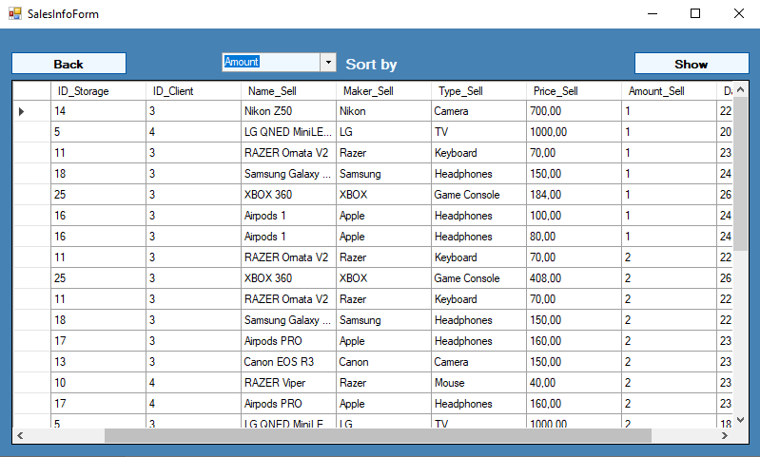

Figure B.28 – a form of information on sales, sorted by the number of sales of goods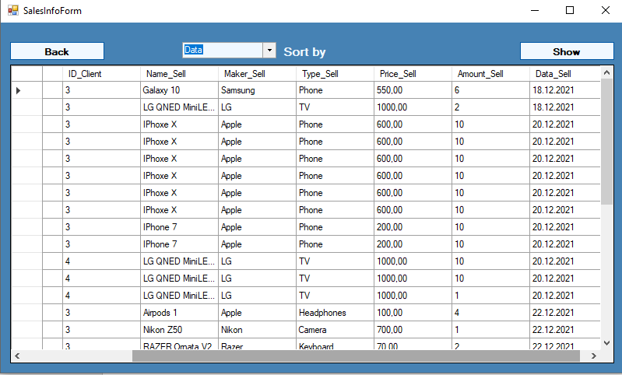

Figure B.29 – a form of information on sales, sorted by the date of sale of the product

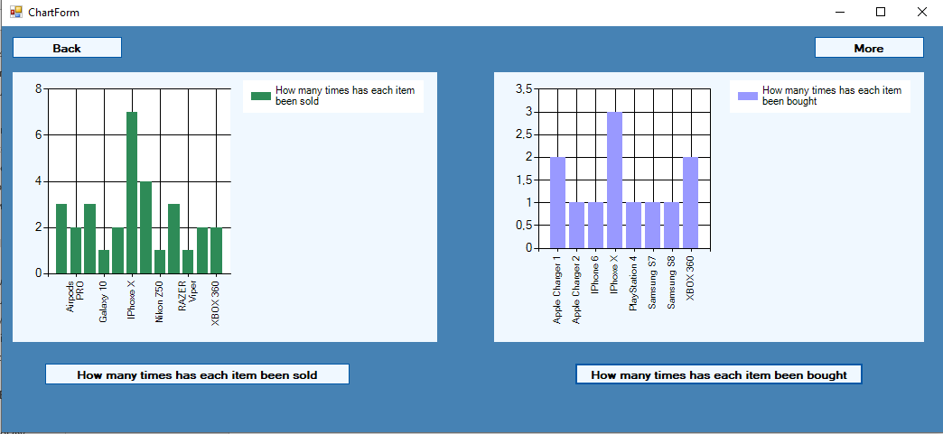

Figure B.30 is a form with charts of statistics on purchased and sold goods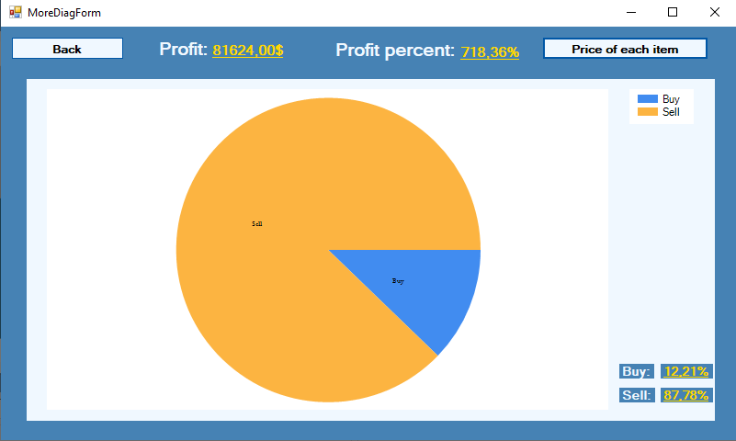

Figure B.31 is a form with a chart of statistics on buying and selling

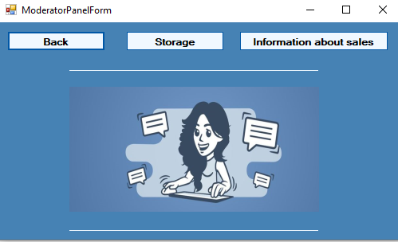

Figure B.32 – moderator form

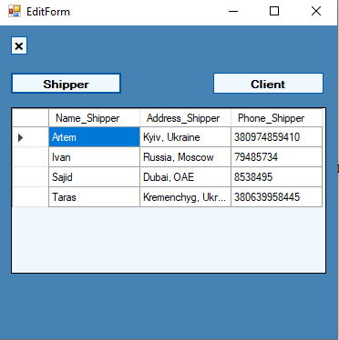

Figure B.33 – a form for viewing supplier accounts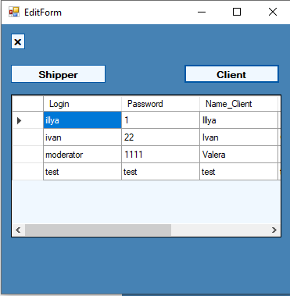

Figure B.34 – form for viewing customer accounts

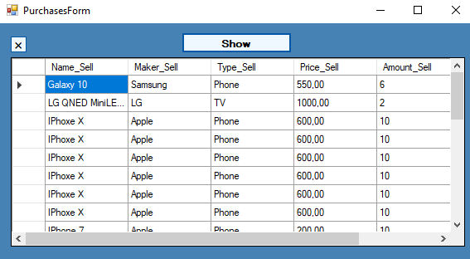

Figure B.35 – form for viewing customer purchases