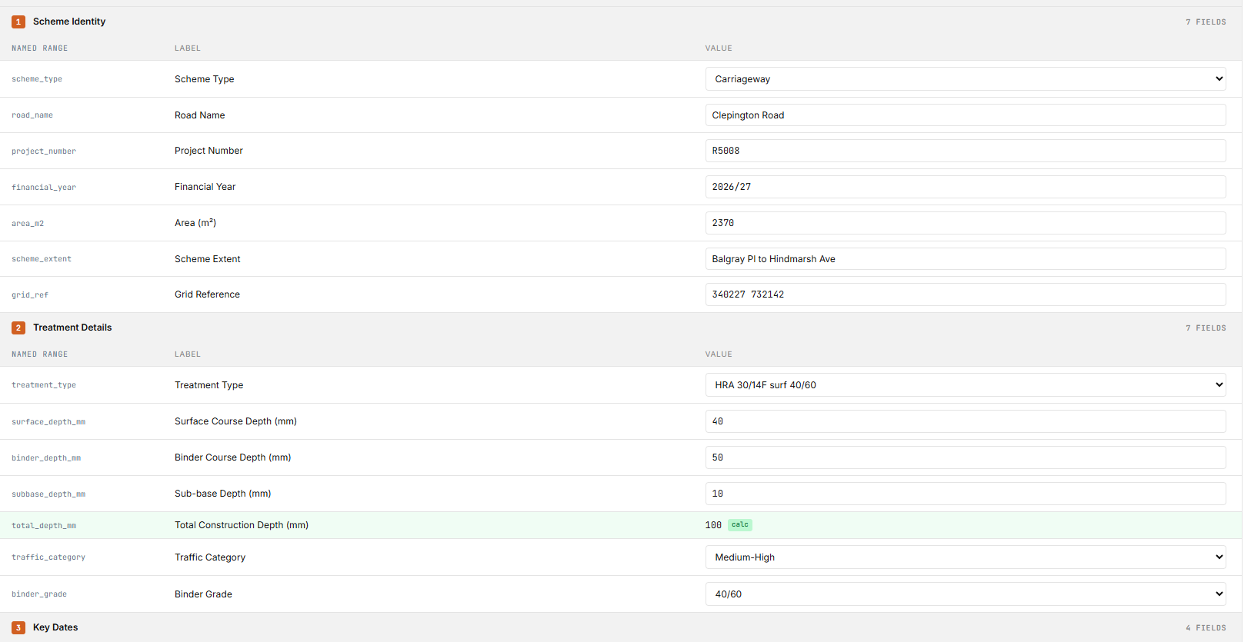 | FM701-10A DCC Category 2  PRE CONSTRUCTION INFORMATION & CONSTRUCTION PHASE PLAN
1.0 PRE CONSTRUCTION INFORMATION (to be completed by client)
1.1 Project details: {{PROJECT_TITLE}}
Name & address of client:  {{CLIENT_NAME_ADDRESS}}  Client Officer: {{CLIENT_OFFICER}}  Department: {{DEPARTMENT}}  Telephone: {{CLIENT_TELEPHONE}}  email: {{CLIENT_EMAIL}} |  | Designer (if not client): {{DESIGNER_NAME}}  on behalf of {{DESIGNER_HEAD_OF}}  Telephone: {{DESIGNER_TELEPHONE}}  email: {{DESIGNER_EMAIL}}  CDM Principal Designer (if required): {{CDM_PRINCIPAL_DESIGNER}}  on behalf of {{CDM_HEAD_OF}}
Client ref or Work/GVA order: {{CLIENT_REF_WORK_ORDER}} |  | Project Number: {{PROJECT_NUMBER}}
Contractor/Principal Contractor: {{CONTRACTOR_NAME}}
Address: {{CONTRACTOR_ADDRESS}}
Contact: {{CONTRACTOR_CONTACT}}
Telephone: {{CONTRACTOR_TELEPHONE}}
email: {{CONTRACTOR_EMAIL}}

Project Address: {{PROJECT_ADDRESS}}
(provide site plan, as appropriate)

Description of Work: {{DESCRIPTION_OF_WORK}}

Proposed Timescales: Start: {{START_DATE}} |  | Finish: {{FINISH_DATE}}
Occupier/tenant/owner on-site and their contact details: {{OCCUPIER_TENANT_DETAILS}}
(check potentially violent persons database)

Arrangements for security of the site: {{SECURITY_ARRANGEMENTS}}

Out of hours contact details: {{OUT_OF_HOURS_CONTACT}}
(client to advise)

Onsite Welfare Facilities :

Toilet: Yes/No Washing Facilities (hot and cold water): Yes/No Rest Facilities: Yes/No

Mains Drinking Water: Yes/No Heated Changing Room: Yes/No

Please note: any question answered No, is a matter for the contractor to include in 2.0 Construction Phase Plan

- Project specific hazards  - Client to highlight site hazards and provide details under headings. Note that this is not an exhaustive list  - Where appropriate, Client to provide existing Health & Safety File | Contractors RAMS reference
Working at height
- eg fragile roof materials, skylights or roof edges

Slips trips & falls
- eg any unusual slip or trip hazards

Excavations and services
- eg underground/hidden pipes/cables, or contaminated land or known ground conditions

Collapse of structures/materials
- eg fragile surfaces or load bearing walls/beams/parts of structure that contractor needs to be aware of

Health Hazards
- eg any client activities that could be hazardous to the contractor. Dust or ventilation issues
- COVID-19: The Construction Phase Plan to include risk assessments, method statements and procedures to protect all personnel working or attending site.

Exposure to asbestos
- Provide asbestos register and highlight location and type/condition of asbestos
- Provide survey information

Risks to members of the public, building users and others
- eg public/building users and access requirements.

Environmental policies
- eg location of skips

Other dangers on site that would not be readily known by contractor, eg
- Site rules and client permit to work systems
- Emergency fire evacuation procedures and fire assembly points
- Emergency vehicle access requirements
- Confined spaces
- Lighting levels
- Height restrictions
- Adjacent building/land use
- Water courses, drainage issues
  - Additional information provided by client:
eg other activities in the area which may affect the construction phase
Client to identify any site specific restriction on Contractor relating to COVID-19 and Scottish Government. eg. Care Homes, Schools etc.

2.0 CONSTRUCTION PHASE PLAN (To be completed and returned by Contractor/Principal Contractor)

2.1 Control measures for issues identified by Client in 1.2 & 1.3 above
(This should also include those additional hazards and risks identified by the contractor)

2.2 Updates to Construction Phase Plan:
Contractor to detail how you will keep the Construction Phase Plan updated during the construction phase and how this is communicated to your workforce, design team and client

2.3 Communications:
Contractor to detail how you are going to brief your employees/subcontractors, induct and keep everyone on site informed of safe working procedures and site rules during the course of the works.

2.4 Details of key members of Project Team

Out of hours contact details: {{CONTRACTOR_OUT_OF_HOURS}}

2.5 Site rules

We acknowledge receipt of the Pre Construction Information and have detailed above our control measures for the Construction Phase Plan.

Signed…………………………………………………………(Contractor) TO BE COMPLETED BY CONTRACTOR

Print name …………………………………………………….Date:…………………………………..

Proposed date for commencement of works:…………………………..

Construction Phase Plan considered sufficiently developed to allow works to commence on site

Signed………………………………………………………….(Client) TO BE COMPLETED BY CLIENT

Print name ……………………………………………………..Date:……………………………………

3.0 Post Contract
(To be completed and returned by Contractor/Principal Contractor)

We confirm that the following documents have been submitted to the client (tick as appropriate):

- Updated Health and Safety File
- Asbestos Management Survey records
- Fire stopping records
- Local Authority completion certificate
- Log of accidents, incidents, RIDDOR incidents
- Compliance certification
- Other, give details

Signed…………………………………………………………..(Contractor)

Print name ……………………………………………………..Date:……………………………………

The works were completed and signed off on:…………………………………………………………

Rev | Date | Description | Prepared | Reviewed | Approved
A | 1st June 2020 | COVID 19 provisions added | Stewart Cheyne | Andrew Lorimer | Neil Martin

