CHAPTER 1
INTRODUCTION
_____________________________________________________________________

  - Overview

Depression is a serious mental health disorder that negatively affects an individual’s emotional, cognitive, and behavioural well-being. It may lead to sadness, loss of interest, reduced productivity, anxiety, and social isolation. According to global health studies, depression has become one of the leading causes of mental health-related disabilities worldwide.
Traditional diagnosis methods mainly rely on questionnaires and clinical interviews conducted by mental health professionals. These approaches are often subjective and may fail to detect early signs of depression. Due to social stigma and lack of awareness, many individuals avoid seeking professional help.
Recent advancements in artificial intelligence and machine learning have enabled automated systems capable of analyzing human behaviour using digital data. Multimodal analysis combines information from text, speech, and facial expressions to improve the accuracy and reliability of depression detection systems.

  - Objectives of the Project

The main objectives of the proposed system are:
- To study behavioural and emotional indicators of depression across multiple communication modalities.
- To design and develop a multimodal system capable of analyzing text, speech, and facial expressions.
- To extract relevant and meaningful features from each modality for effective representation.
- To apply machine learning techniques for accurate classification of depressive and non-depressive states.
- To evaluate the performance of the proposed system using standard evaluation metrics.
- To develop a scalable framework that can assist mental health professionals in early-stage screening.

  - Problem Statement

Depression often remains undiagnosed because conventional diagnostic methods depend heavily on subjective assessments and self-reported information. These methods are time-consuming and may not always provide reliable results.
Digital communication data such as social media text, speech recordings, and facial expressions contain important emotional and behavioural cues related to mental health. However, existing systems generally focus on a single modality, limiting their effectiveness.
Therefore, there is a need for an automated and objective multimodal system capable of analyzing text, speech, and facial expressions together to improve depression detection accuracy and support timely intervention.

CHAPTER 2
LITERATURE REVIEW
_____________________________________________________________________

Depression detection using machine learning and deep learning has gained significant attention in recent years. Researchers have explored various approaches involving text analysis, speech processing, facial expression recognition, and multimodal fusion techniques.
Several studies have demonstrated that multimodal systems provide better accuracy compared to unimodal approaches because they capture multiple behavioural and emotional indicators simultaneously.
The following literature survey summarizes recent research work related to depression detection systems.

Table 2.1 Literature Survey
Author(s) | Title | Year | Dataset Used | Methodology | Research Gap
Squires et al. | Deep learning and machine learning in  psychiatry: a survey of current progress in  depression detection, diagnosis and treatment | 2023 | Multiple datasets reviewed  (DAIC-WOZ,  E-DAIC, AVEC, social media and clinical datasets) | Survey of machine learning and deep  learning techniques  applied to depression detection across text,  speech, and visual modalities | Highlights lack of standardized datasets,  uncertainty  handling, and  limited clinical  deployment of proposed models
Pinto et al. | Comprehensive review of depression detection  techniques based on machine learning | 2024 | Multiple datasets across EEG,  speech, text, and multimodal sources | Systematic review of ML-based depression detection techniques, feature extraction | Identifies fragmentation  across modalities and lack of unified
 | approach |  |  | methods, and classification models | multimodal frameworks
Marriwala et al. | A hybrid model for depression detection using deep learning | 2022 | DAIC-WOZ dataset | Hybrid deep learning architecture  combining CNN and  LSTM models for depression classification | Limited evaluation on cross-domain datasets and  exclusion of visual modality
Lifelo et al. | Uncertainty aware domain incremental learning for cross  domain depression detection | 2025 | CMDC, DAIC-WOZ,  MODMA, EATD datasets | Domain incremental learning framework with uncertainty  estimation to handle domain shift and catastrophic forgetting | High computational complexity and  limited focus on lightweight or real-time systems
Ahmed et al. | Taking All the Factors  We Need: A Multimodal  Depression  Classification With  Uncertainty  Approximation | 2023 | Multimodal clinical and social datasets  (e.g., DAIC-WOZ) | Multimodal fusion with uncertainty  approximation  techniques to improve robustness under missing or noisy data | Computationally intensive and lacks emphasis on deployment feasibility

CHAPTER 3
SYSTEM REQUIREMENTS
_____________________________________________________________________

Table 3.1 Hardware Requirements

Component | Specification
Processor | Intel i5/i7
RAM | Minimum 8 GB
Storage | 256 GB SSD
Webcam | Required
Microphone | Required

Table 3.2 Software Requirements

Software/Tool | Purpose
Python | Programming Language
TensorFlow | Deep Learning
Scikit-learn | Machine Learning
OpenCV | Computer Vision
Librosa | Audio Processing
NLTK/spaCy | NLP
Jupyter Notebook | Development
Google Colab | Cloud Execution

CHAPTER 4
SYSTEM DESIGN
_____________________________________________________________________

The proposed depression detection system follows a multimodal analysis approach that combines textual, audio, visual, and questionnaire-based information to estimate the mental health risk level of a user. The architecture is divided into two major sections:
- Browser (Client Side)
- Flask Server (Backend Processing)
The system integrates multiple independent models and combines their outputs using a late fusion strategy to generate a final depression risk score.

4.1 Browser (Client Side)
The browser section is responsible for collecting and processing user input data. Four different modalities are used for analysis.

1. STT/TTS – Interview Text
The first module handles speech-to-text (STT) and text-to-speech (TTS) operations.
Function:
- Converts user speech into textual format.
- Processes interview responses provided by the user.
- Extracts linguistic and emotional information from the text.

2. Web Audio API
The Web Audio API module processes the user’s voice recordings directly in the browser.
Features Extracted are Energy level of speech, Speaking pauses, Speech rhythm ,Voice intensity
Function:
The browser computes audio-related probabilities before sending them to the server.

3. face-api.js Module
This module performs facial expression analysis using the face-api.js library.
Functions: Face detection, Facial landmark identification, Emotion recognition

4. PHQ-8 Questionnaire
The PHQ-8 module collects responses from the Patient Health Questionnaire containing eight mental health-related questions.

4.2 Flask Server (Backend Processing)
The Flask server acts as the central processing unit of the system. Data received from the browser is analyzed using independent machine learning models.
The browser sends all multimodal data to the backend using a multipart POST request through the API endpoint:
/api/predict

1. Text Model
The text model processes interview text received from the browser.
Weight Assigned:
0.35
Function:
- Performs text classification
- Predicts depression probability from textual data

2. Audio Probability Model
The audio model processes acoustic features extracted using the Web Audio API.
Features Used:
- Speech energy
- Pause frequency
- Speaking rhythm
Weight Assigned:
0.15
Function:
Calculates depression probability based on speech characteristics.

3. Visual Model
The visual model analyzes facial expression probabilities generated using face-api.js.
Weight Assigned:
0.15
Function:
Predicts emotional state from facial behaviour and expressions.

4.PHQ-8 Score Processing
The PHQ-8 responses are processed separately. Total PHQ-8 score is calculated out of 24.
Weight Assigned:
0.35

4.3 Late Fusion Mechanism
The outputs from all four modalities are combined using a late fusion strategy. Late fusion combines the prediction probabilities generated independently by each model instead of combining raw features.

Modality | Weight
Text Model | 0.35
Audio Model | 0.15
Visual Model | 0.15
PHQ-8Score | 0.35

4. Risk Score Generation
The fused output generates a final depression risk score.
Risk Levels:
- Low Risk
- Moderate Risk
- High Risk
The system does not provide a medical diagnosis but only estimates the likelihood of depressive behaviour.

5. Advantages of Proposed Architecture
- Multimodal analysis improves prediction accuracy.
- Combines behavioural, emotional, and questionnaire-based information.
- Lightweight browser-side preprocessing reduces server load.
- Late fusion increases robustness and flexibility.
- Can support real-time depression risk assessment.

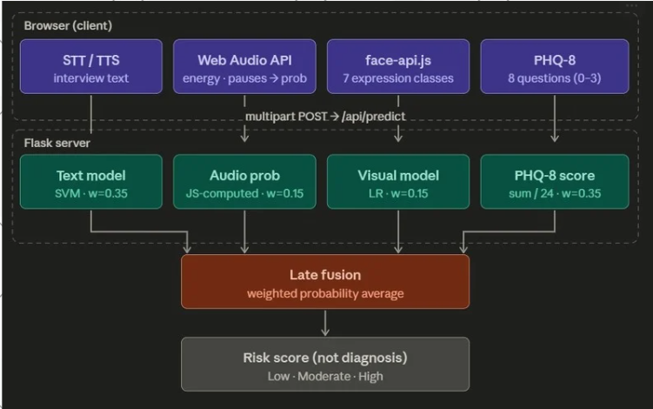

Figure 4.1 System Architecture

CHAPTER 5
METHODOLOGY
_____________________________________________________________________

The methodology describes the techniques and procedures used to implement the multimodal depression detection system. The proposed approach processes text, speech, and facial expression data independently and later combines them for classification.
The system uses machine learning and deep learning techniques to identify depressive behaviour from multimodal inputs.

Data Collection
Dataset Used: E-DAIC

Data Modalities:
- Text conversations
- Speech recordings
- Facial expression videos

Data Preprocessing
Preprocessing improves data quality and removes unwanted noise.

1. Text Preprocessing
Steps:
- Lowercase conversion
- Stop word removal
- Tokenization
- Lemmatization
- Noise removal
Libraries Used:
- NLTK
- spaCy
Text preprocessing helps improve NLP feature extraction.

2. Audio Preprocessing
Steps:
- Noise reduction
- Silence removal
- Audio normalization
- Segmentation
Tools Used:
- Librosa/ Audio API
Preprocessing improves speech feature quality.

3. Image/Video Preprocessing
Steps:
- Frame extraction
- Face detection
- Image resizing
- Normalization
Tools Used:
- FaceAPI
This process prepares visual data for emotion analysis.

Feature Extraction
Feature extraction converts raw data into meaningful numerical representations.

1. Text Feature Extraction
Features:
- TF-IDF vectors
- Sentiment polarity
- Word frequency
- Linguistic patterns
Techniques:
- NLP
- Sentiment analysis

2. Speech Feature Extraction
Features:
- Pitch
- Energy
- Speaking rate
- MFCC coefficients
- Pause duration
Speech characteristics reflect emotional conditions.

3. Facial Feature Extraction
Features:
- Facial landmarks
- Eye movement
- Smile intensity
- Emotion labels
These features help identify emotional states.
- Better contextual understanding
- Improved classification accuracy
- Robust prediction

CHAPTER 6
IMPLEMENTATION
_____________________________________________________________________

Implementation involves converting the proposed methodology into an executable software system. Python-based machine learning and deep learning frameworks are used to develop the multimodal depression detection system.

Programming Language:
- Python
Development Tools:
- Google Colab / Antigravity

Model Training Implementation
Steps:
- Dataset splitting
- Feature normalization
- Model selection
- Training
- Validation
Models:
- CNN
- LSTM
- Random Forest
- SVM

User Interface
The system may include:
- Data upload interface
- Prediction display
- Result visualization dashboard

Figure 6.1 UI

Figure 6.2

CHAPTER 7
RESULTS AND IMPACT
_____________________________________________________________________

The proposed system was evaluated using multimodal dataset to measure its effectiveness in depression detection.

7.1 Experimental Results

The system performance was evaluated using:
- Accuracy
- Precision
- Recall
- F1-score
The multimodal system achieved better performance compared to systems using a single modality.

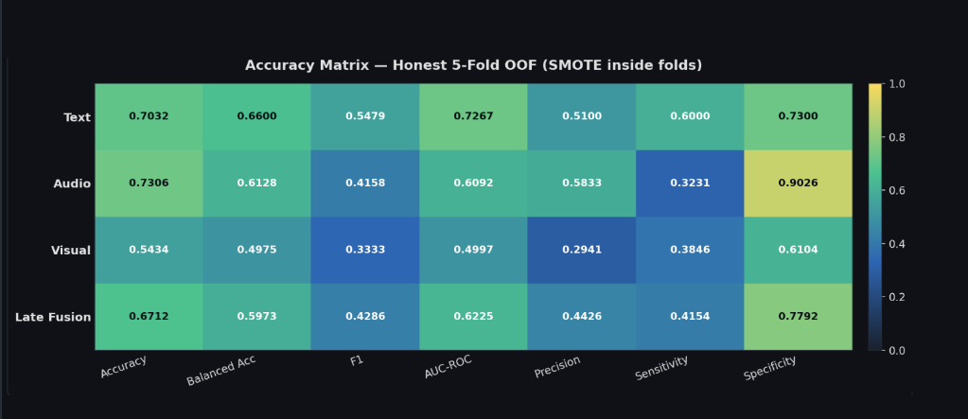

Figure 7.1 Accuracy Matrix

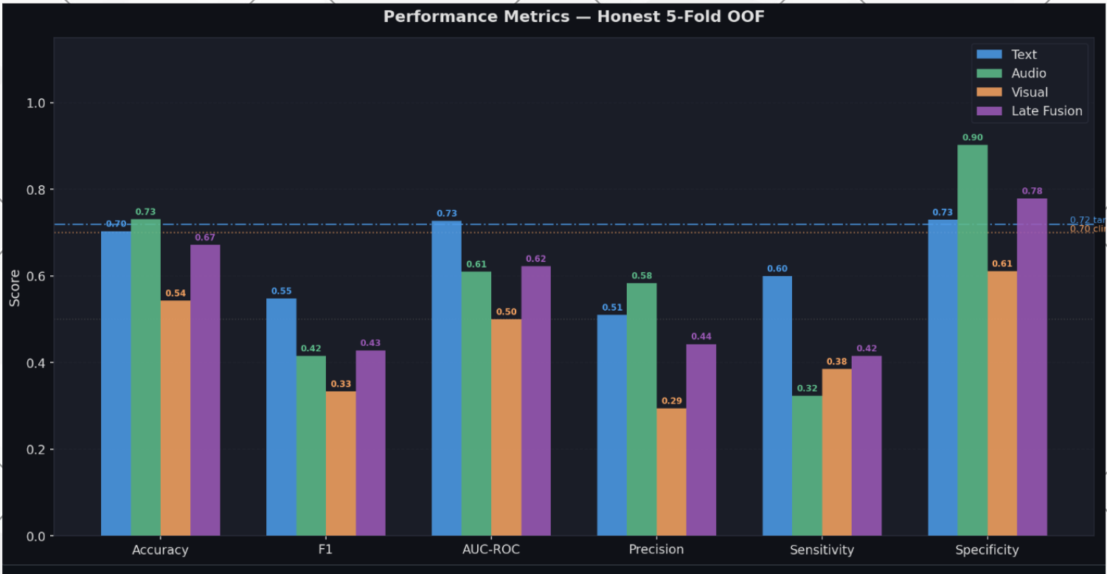

Figure 7.2 Performance Metrics

Confusion Matrix
The confusion matrix represents correct and incorrect classifications made by the model.

Figure 7.3 Confusion Matrix

7.2 Impact of the Proposed System
The proposed system can assist:
- Mental health professionals
- Early-stage depression screening
- Automated behavioural analysis
Benefits:
- Faster detection
- Objective assessment
- Reduced human bias
- Scalable analysis

CHAPTER 8
DISCUSSION
_____________________________________________________________________

This chapter discusses the effectiveness, limitations, and practical applicability of the proposed multimodal depression detection system.

8.1 Analysis of Results
The multimodal system demonstrated higher accuracy than unimodal systems because it combines information from multiple behavioural sources.
Text analysis captured linguistic indicators, speech analysis identified emotional tone, and facial expression analysis provided visual emotional cues.
The combination of these modalities improved overall classification performance.

8.2 Strengths of the Proposed System
- High prediction accuracy
- Robust multimodal learning
- Better emotional understanding
- Automated detection
- Scalable framework

8.3 Practical Challenges
- Feature synchronization across modalities
- Missing modality data
- Complex preprocessing
- High training time

CHAPTER 9
CONCLUSION AND FUTURE SCOPE
_____________________________________________________________________

The proposed multimodal depression detection system successfully combines text, speech, and facial expression analysis to identify depressive behaviour. The integration of multiple modalities improves prediction accuracy and system reliability compared to traditional unimodal approaches.
Machine learning and deep learning techniques were used to process and classify multimodal data effectively. The system demonstrates the potential of artificial intelligence in assisting mental health professionals with early-stage depression screening.
The proposed framework provides an objective, scalable, and efficient solution for automated depression detection.

9.1 Future Scope
The project can be enhanced in several ways to improve performance and real-world applicability.

Future Enhancements:
- Real-time depression monitoring
- Increasing accuracy by expanding the dataset by conducting more interviews and collecting more data
- Explainable AI techniques
- Improved uncertainty handling
Future research can further improve robustness, interpretability, and deployment feasibility of multimodal mental health systems.

REFERNCES
_____________________________________________________________________

1. Squires et al., “Deep learning and machine learning in psychiatry,” 2023.

2. Pinto et al., “Comprehensive review of depression detection techniques,” 2024.

3. Marriwala et al., “A hybrid model for depression detection using deep learning,” 2022.

4. Ahmed et al., “Multimodal Depression Classification,” 2023.

