CRP_Oddball_Modulation

8/17/2021

Normality was checked with QQ plots and/or histograms and homogeneity of variances was tested with levene’s test.

# Fig. 1 Relative Recall Position by SOA

* QQ plots do not show a normal distribution
* Plotted a histogram of the relative recall distribution and of the residuals of the following model: glmer(relativerecall ~ oddballtype * SOA + (1|subject), data = RR). I think I can run a different distribution family of the model to account for the non-normal distribution. I posted a question on a stats forum <https://stats.stackexchange.com/questions/540418/how-can-i-run-a-glm-on-a-left-skewed-not-normally-distributed-dv> and someone suggested using a ***binomial distribution*** however I do not understand why.
* How about the violation of homogeneity of variances, how can we deal with this?

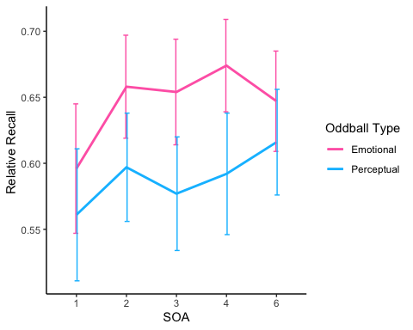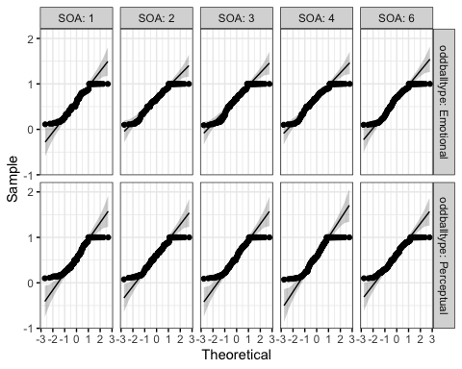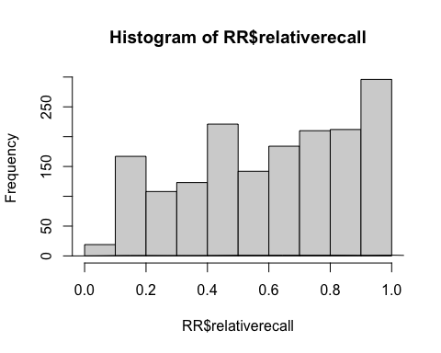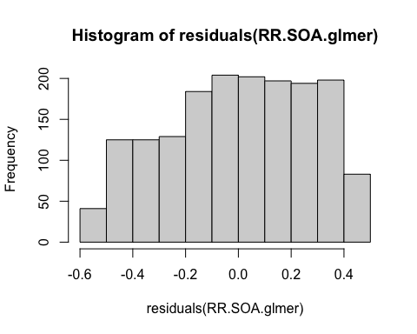

# Fig. 2B Conditional Response Probability Curves by Stimulus Onset Asynchrony

* QQ plots do not show a normal distribution, plotted a histogram of the data and a histogram of the residuals of the following model glmer(CRP ~ wordposition * direction * SOA + (1|subject), data = CRPSOA).
* How should we proceed to analyze this? Maybe with a different family of distributions in the glmer?

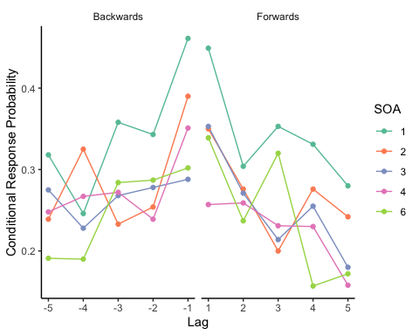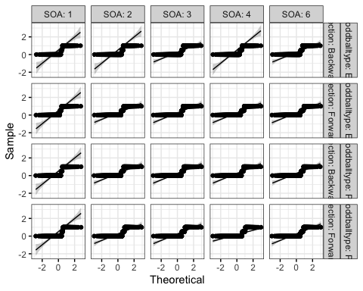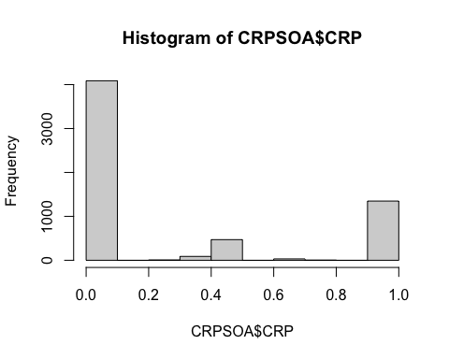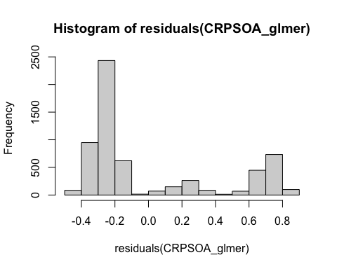

# Fig. 2C Amount of items recalled per SOA

* QQ plots and histograms look roughly OK
* Data analyzed with a glmer(total_recall_list~SOA+(1|subject), data=listrecallSOA) because I included each list per SOA per subject. I think if we wanted to run this as an ANOVA I would have to average them to get 1 averaged recall number per subject per SOA. What do you think is best?
  + I also ran the glmer to be able to easily plot the residual’s histogram

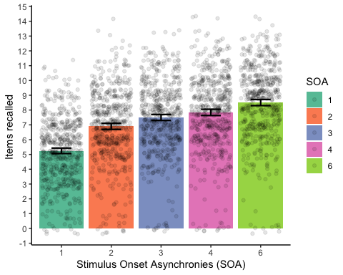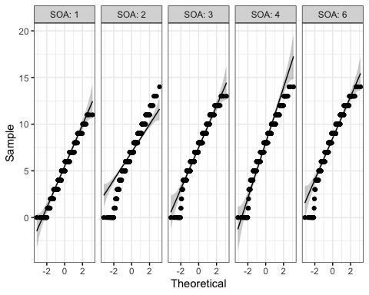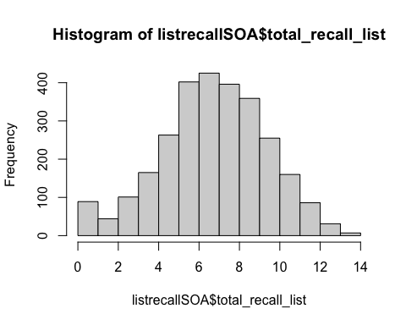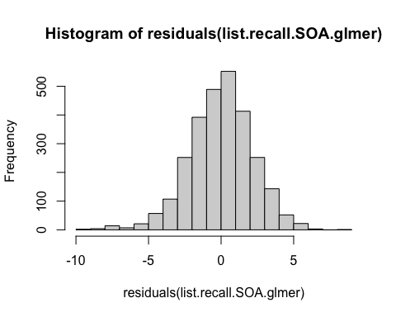

# Fig. 4 Condutional Response Probability Curves by SOA transitions *to* and *from* oddballs

Only focusing on emotional oddballs, collapsing accross lags ‘omitnan’

* Some QQ plots do not show a normal distribution

Data was analyzed with a glmer then, glmer(CRPmean ~ direction * transition * SOA + (1|subject), data = data_collapsed). - The histogram of the residual plot of the model looks ‘roughly’ normal–> is this analysis OK then?

