Oddballs, SOA-CRP Paper

This notebook summarizes the stats and figures.

## Probability of first recall

The graph below shows the probability of first recall.

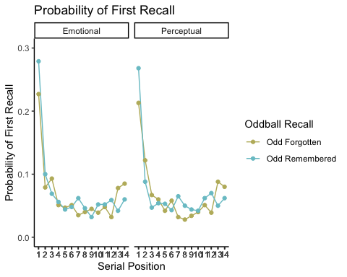

### Tests for normality

Shapiro-Wilk shows the data is not normally distributed so we also plotted QQ plots

## # A tibble: 56 x 6  
## oddballtype recall sp variable statistic p  
## <chr> <chr> <int> <chr> <dbl> <dbl>  
## 1 Emotional forgotten 1 pfr 0.926 4.85e- 4  
## 2 Emotional forgotten 2 pfr 0.811 4.76e- 8  
## 3 Emotional forgotten 3 pfr 0.837 2.72e- 7  
## 4 Emotional forgotten 4 pfr 0.677 3.97e-11  
## 5 Emotional forgotten 5 pfr 0.637 7.00e-12  
## 6 Emotional forgotten 6 pfr 0.687 6.33e-11  
## 7 Emotional forgotten 7 pfr 0.498 4.37e-14  
## 8 Emotional forgotten 8 pfr 0.583 8.40e-13  
## 9 Emotional forgotten 9 pfr 0.558 3.39e-13  
## 10 Emotional forgotten 10 pfr 0.608 2.24e-12  
## # … with 46 more rows

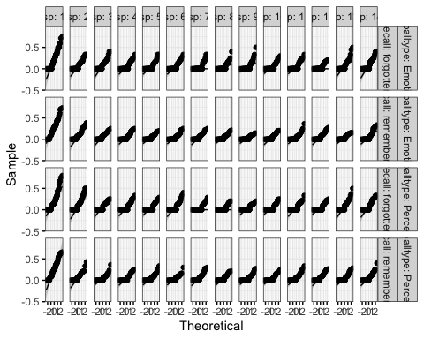

### Statistics

Repeated measures ANOVA results show a significant main effect of recall (all trials or only when the oddballs were recalled), a main effect of serial position and a significant interaction of recall x serial position.

## ANOVA Table (type III tests)  
##   
## Effect DFn DFd F p p<.05 ges  
## 1 oddballtype 1.00 69.00 0.061 8.05e-01 3.15e-07  
## 2 recall 1.00 69.00 7.147 9.00e-03 * 3.65e-04  
## 3 sp 3.82 263.26 61.183 2.28e-35 * 2.49e-01  
## 4 oddballtype:recall 1.00 69.00 0.184 6.70e-01 9.42e-07  
## 5 oddballtype:sp 8.54 589.06 0.988 4.47e-01 3.00e-03  
## 6 recall:sp 8.82 608.52 5.527 3.12e-07 * 1.60e-02  
## 7 oddballtype:recall:sp 8.44 582.31 0.802 6.07e-01 3.00e-03

## ANOVA Table (type III tests)  
##   
## $ANOVA  
## Effect DFn DFd F p p<.05 ges  
## 1 oddballtype 1 69 0.061 8.05e-01 3.15e-07  
## 2 recall 1 69 7.147 9.00e-03 * 3.65e-04  
## 3 sp 13 897 61.183 4.92e-114 * 2.49e-01  
## 4 oddballtype:recall 1 69 0.184 6.70e-01 9.42e-07  
## 5 oddballtype:sp 13 897 0.988 4.61e-01 3.00e-03  
## 6 recall:sp 13 897 5.527 9.77e-10 * 1.60e-02  
## 7 oddballtype:recall:sp 13 897 0.802 6.58e-01 3.00e-03  
##   
## $`Mauchly's Test for Sphericity`  
## Effect W p p<.05  
## 1 sp 0.000864 9.36e-50 *  
## 2 oddballtype:sp 0.073000 1.06e-06 *  
## 3 recall:sp 0.076000 2.23e-06 *  
## 4 oddballtype:recall:sp 0.059000 3.86e-08 *  
##   
## $`Sphericity Corrections`  
## Effect GGe DF[GG] p[GG] p[GG]<.05 HFe  
## 1 sp 0.293 3.82, 263.26 2.28e-35 * 0.313  
## 2 oddballtype:sp 0.657 8.54, 589.06 4.47e-01 0.758  
## 3 recall:sp 0.678 8.82, 608.52 3.12e-07 * 0.787  
## 4 oddballtype:recall:sp 0.649 8.44, 582.31 6.07e-01 0.748  
## DF[HF] p[HF] p[HF]<.05  
## 1 4.07, 280.59 1.59e-37 *  
## 2 9.85, 679.69 4.52e-01   
## 3 10.22, 705.52 4.46e-08 *  
## 4 9.72, 670.79 6.23e-01

Uncorrected t-tests of the main effects and the interaction:

## # A tibble: 1 x 10  
## .y. group1 group2 n1 n2 statistic df p p.adj p.adj.signif  
## * <chr> <chr> <chr> <int> <int> <dbl> <dbl> <dbl> <dbl> <chr>   
## 1 pfr forgotten remember… 1960 1960 -1.27 1959 0.206 0.206 ns

## # A tibble: 1 x 7  
## .y. group1 group2 effsize n1 n2 magnitude   
## * <chr> <chr> <chr> <dbl> <int> <int> <ord>   
## 1 pfr forgotten remembered -0.0286 1960 1960 negligible

## # A tibble: 2 x 4  
## recall count mean sd  
## <chr> <int> <dbl> <dbl>  
## 1 forgotten 1960 0.0680 0.107   
## 2 remembered 1960 0.0714 0.0997

## # A tibble: 91 x 10  
## .y. group1 group2 n1 n2 statistic df p p.adj  
## * <chr> <chr> <chr> <int> <int> <dbl> <dbl> <dbl> <dbl>  
## 1 pfr 1 2 280 280 11.3 279 9.05e-25 6.34e-24  
## 2 pfr 1 3 280 280 14.0 279 4.97e-34 4.52e-33  
## 3 pfr 1 4 280 280 16.0 279 3.09e-41 4.85e-40  
## 4 pfr 1 5 280 280 16.0 279 3.2 e-41 4.85e-40  
## 5 pfr 1 6 280 280 15.9 279 5.34e-41 6.94e-40  
## 6 pfr 1 7 280 280 15.9 279 6.23e-41 7.09e-40  
## 7 pfr 1 8 280 280 16.7 279 6.11e-44 1.85e-42  
## 8 pfr 1 9 280 280 16.8 279 4.15e-44 1.85e-42  
## 9 pfr 1 10 280 280 16.8 279 2.19e-44 1.85e-42  
## 10 pfr 1 11 280 280 15.4 279 3.34e-39 3.38e-38  
## # … with 81 more rows, and 1 more variable: p.adj.signif <chr>

## # A tibble: 91 x 7  
## .y. group1 group2 effsize n1 n2 magnitude  
## * <chr> <chr> <chr> <dbl> <int> <int> <ord>   
## 1 pfr 1 2 0.678 280 280 moderate   
## 2 pfr 1 3 0.836 280 280 large   
## 3 pfr 1 4 0.955 280 280 large   
## 4 pfr 1 5 0.954 280 280 large   
## 5 pfr 1 6 0.951 280 280 large   
## 6 pfr 1 7 0.950 280 280 large   
## 7 pfr 1 8 0.999 280 280 large   
## 8 pfr 1 9 1.00 280 280 large   
## 9 pfr 1 10 1.01 280 280 large   
## 10 pfr 1 11 0.921 280 280 large   
## # … with 81 more rows

## # A tibble: 14 x 11  
## sp .y. group1 group2 n1 n2 statistic df p p.adj  
## * <int> <chr> <chr> <chr> <int> <int> <dbl> <dbl> <dbl> <dbl>  
## 1 1 pfr forgotten remembered 140 140 -3.25 139 0.001 1 e-3  
## 2 2 pfr forgotten remembered 140 140 0.553 139 0.581 5.81e-1  
## 3 3 pfr forgotten remembered 140 140 2.30 139 0.023 2.3 e-2  
## 4 4 pfr forgotten remembered 140 140 0.0949 139 0.925 9.25e-1  
## 5 5 pfr forgotten remembered 140 140 -0.441 139 0.66 6.6 e-1  
## 6 6 pfr forgotten remembered 140 140 0.963 139 0.337 3.37e-1  
## 7 7 pfr forgotten remembered 140 140 -3.70 139 0.000314 3.14e-4  
## 8 8 pfr forgotten remembered 140 140 -1.71 139 0.09 9 e-2  
## 9 9 pfr forgotten remembered 140 140 0.222 139 0.825 8.25e-1  
## 10 10 pfr forgotten remembered 140 140 -0.972 139 0.333 3.33e-1  
## 11 11 pfr forgotten remembered 140 140 -0.863 139 0.389 3.89e-1  
## 12 12 pfr forgotten remembered 140 140 -3.74 139 0.000267 2.67e-4  
## 13 13 pfr forgotten remembered 140 140 3.73 139 0.000274 2.74e-4  
## 14 14 pfr forgotten remembered 140 140 2.05 139 0.042 4.2 e-2  
## # … with 1 more variable: p.adj.signif <chr>

## # A tibble: 14 x 8  
## .y. group1 group2 effsize sp n1 n2 magnitude   
## * <chr> <chr> <chr> <dbl> <int> <int> <int> <ord>   
## 1 pfr forgotten remembered -0.274 1 140 140 small   
## 2 pfr forgotten remembered 0.0468 2 140 140 negligible  
## 3 pfr forgotten remembered 0.195 3 140 140 negligible  
## 4 pfr forgotten remembered 0.00802 4 140 140 negligible  
## 5 pfr forgotten remembered -0.0373 5 140 140 negligible  
## 6 pfr forgotten remembered 0.0814 6 140 140 negligible  
## 7 pfr forgotten remembered -0.312 7 140 140 small   
## 8 pfr forgotten remembered -0.144 8 140 140 negligible  
## 9 pfr forgotten remembered 0.0187 9 140 140 negligible  
## 10 pfr forgotten remembered -0.0822 10 140 140 negligible  
## 11 pfr forgotten remembered -0.0730 11 140 140 negligible  
## 12 pfr forgotten remembered -0.316 12 140 140 small   
## 13 pfr forgotten remembered 0.316 13 140 140 small   
## 14 pfr forgotten remembered 0.173 14 140 140 negligible

## Relative Recall Position

We then calculated the relative recall position of both emotional and perceptual oddballs.

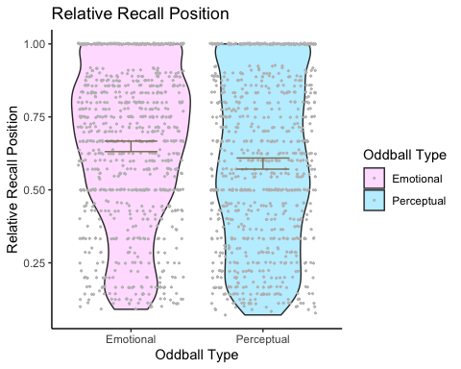

##   
## Wilcoxon rank sum test with continuity correction  
##   
## data: relativerecall by oddballtype  
## W = 395538, p-value = 2.428e-05  
## alternative hypothesis: true location shift is not equal to 0

## # A tibble: 1 x 7  
## .y. group1 group2 effsize n1 n2 magnitude  
## * <chr> <chr> <chr> <dbl> <int> <int> <ord>   
## 1 relativerecall Emotional Perceptual 0.215 850 832 small

## # A tibble: 2 x 5  
## oddballtype variable n relativerecall ci  
## <chr> <chr> <dbl> <dbl> <dbl>  
## 1 Emotional relativerecall 850 0.649 0.018  
## 2 Perceptual relativerecall 832 0.59 0.019

## E and E-1 recall positions

E is the sp recall position of emotional oddballs and the y axis is the sp recall positions of E - E-1. Therefore:

E - E-1 —> a + result (forwards i.e E-1 to E) vs. a - result (backwards i.e E to E-1).

In conclusion, when emotional oddballs were recalled early on, the neutral items preceding them (E-1) were recalled after recalling E (E to E-1). However, when emotional oddballs are recalled later on, recall goes forwards i.e E-1–>E.

## E E.1  
## 1 3 2  
## 2 4 3  
## 3 8 7  
## 4 3 2  
## 5 3 2  
## 6 6 5

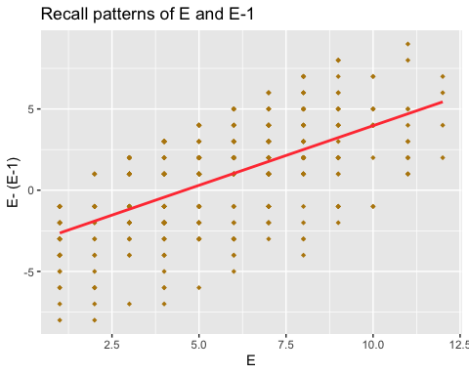

## Normalized Recall

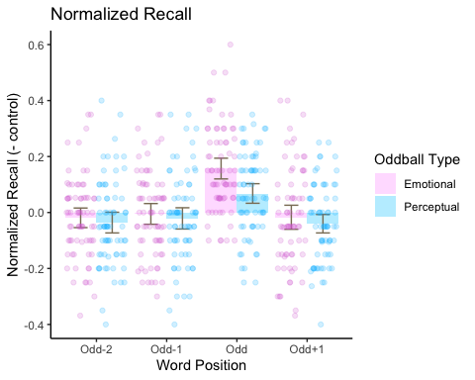

### Statistics

We first checked for normality with Shapiro-Wilk test and QQ plots.

## # A tibble: 8 x 5  
## oddballtype wordposition variable statistic p  
## <chr> <chr> <chr> <dbl> <dbl>  
## 1 E m1 normrec 0.976 0.198   
## 2 E m2 normrec 0.975 0.182   
## 3 E odd normrec 0.966 0.0551  
## 4 E p1 normrec 0.979 0.274   
## 5 P m1 normrec 0.976 0.188   
## 6 P m2 normrec 0.979 0.304   
## 7 P odd normrec 0.975 0.180   
## 8 P p1 normrec 0.976 0.200

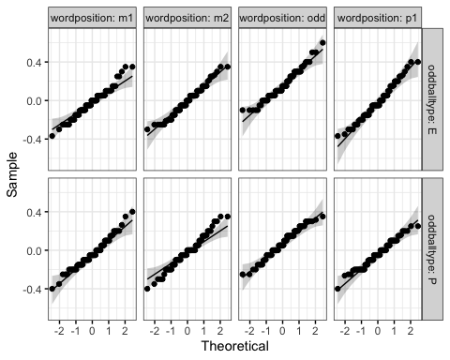

We then conducted a RM ANOVA which showed a significant main effect of word position and a significant interaction of oddball type x word position.

## ANOVA Table (type III tests)  
##   
## $ANOVA  
## Effect DFn DFd F p p<.05 ges  
## 1 oddballtype 1 69 3.440 6.80e-02 0.014  
## 2 wordposition 3 207 55.195 2.95e-26 * 0.129  
## 3 oddballtype:wordposition 3 207 3.614 1.40e-02 * 0.010  
##   
## $`Mauchly's Test for Sphericity`  
## Effect W p p<.05  
## 1 wordposition 0.955 0.686   
## 2 oddballtype:wordposition 0.940 0.524   
##   
## $`Sphericity Corrections`  
## Effect GGe DF[GG] p[GG] p[GG]<.05 HFe  
## 1 wordposition 0.973 2.92, 201.33 1.31e-25 * 1.020  
## 2 oddballtype:wordposition 0.960 2.88, 198.65 1.50e-02 * 1.006  
## DF[HF] p[HF] p[HF]<.05  
## 1 3.06, 211.18 2.95e-26 *  
## 2 3.02, 208.21 1.40e-02 *

## ANOVA Table (type III tests)  
##   
## Effect DFn DFd F p p<.05 ges  
## 1 oddballtype 1 69 3.440 6.80e-02 0.014  
## 2 wordposition 3 207 55.195 2.95e-26 * 0.129  
## 3 oddballtype:wordposition 3 207 3.614 1.40e-02 * 0.010

Follow-up uncorrected t-tests showed that the oddball was better recalled than words in any of the other serial positions and that emotional oddballs were better recalled than perceptual oddballs.

## # A tibble: 6 x 10  
## .y. group1 group2 n1 n2 statistic df p p.adj p.adj.signif  
## * <chr> <chr> <chr> <int> <int> <dbl> <dbl> <dbl> <dbl> <chr>   
## 1 norm… m1 m2 140 140 -1.17 139 2.44e- 1 3.12e- 1 ns   
## 2 norm… m1 odd 140 140 -10.8 139 5.34e-20 3.2 e-19 ****   
## 3 norm… m1 p1 140 140 0.113 139 9.1 e- 1 9.1 e- 1 ns   
## 4 norm… m2 odd 140 140 -9.50 139 8.38e-17 1.68e-16 ****   
## 5 norm… m2 p1 140 140 1.13 139 2.6 e- 1 3.12e- 1 ns   
## 6 norm… odd p1 140 140 10.4 139 4.08e-19 1.22e-18 ****

## # A tibble: 6 x 7  
## .y. group1 group2 effsize n1 n2 magnitude   
## * <chr> <chr> <chr> <dbl> <int> <int> <ord>   
## 1 normrec m1 m2 -0.0988 140 140 negligible  
## 2 normrec m1 odd -0.909 140 140 large   
## 3 normrec m1 p1 0.00955 140 140 negligible  
## 4 normrec m2 odd -0.803 140 140 large   
## 5 normrec m2 p1 0.0956 140 140 negligible  
## 6 normrec odd p1 0.880 140 140 large

## # A tibble: 4 x 11  
## wordposition .y. group1 group2 n1 n2 statistic df p p.adj  
## * <chr> <chr> <chr> <chr> <int> <int> <dbl> <dbl> <dbl> <dbl>  
## 1 m1 normrec E P 70 70 0.782 69 0.437 0.437   
## 2 m2 normrec E P 70 70 0.526 69 0.601 0.601   
## 3 odd normrec E P 70 70 3.93 69 0.0002 0.0002  
## 4 p1 normrec E P 70 70 0.851 69 0.398 0.398   
## # … with 1 more variable: p.adj.signif <chr>

## # A tibble: 4 x 8  
## .y. group1 group2 effsize wordposition n1 n2 magnitude   
## * <chr> <chr> <chr> <dbl> <chr> <int> <int> <ord>   
## 1 normrec E P 0.0934 m1 70 70 negligible  
## 2 normrec E P 0.0629 m2 70 70 negligible  
## 3 normrec E P 0.470 odd 70 70 small   
## 4 normrec E P 0.102 p1 70 70 negligible

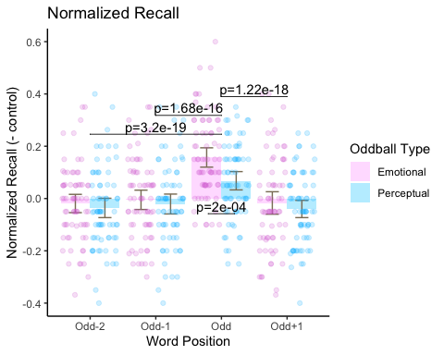

## Contingency Analyses of the oddballs and oddball-1 items

Contingency analyses of E and E-1 as well as P and P-1 items were conducted to investigate whether recalling the oddball came at cost of recalling its items preceding it.

### E and E-1

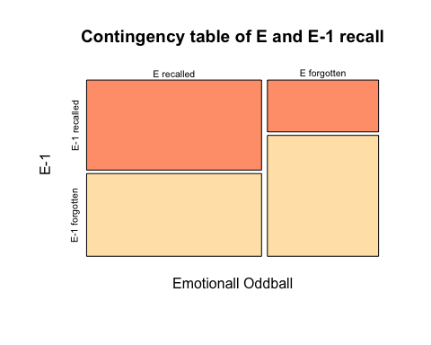

## NULL

##   
## Pearson's Chi-squared test  
##   
## data: eem1_contingency  
## X-squared = 65.717, df = 1, p-value = 5.204e-16

### P and P-1

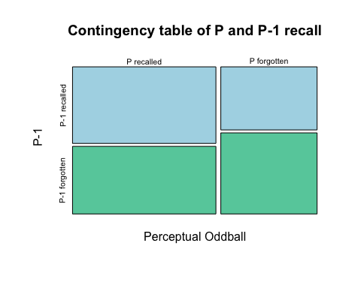

## NULL

##   
## Pearson's Chi-squared test  
##   
## data: ppm1_contingency  
## X-squared = 11.762, df = 1, p-value = 0.0006046

### E-1 and E+1

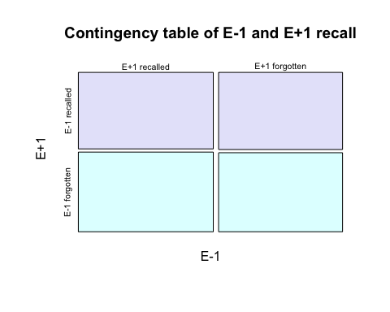

## NULL

##   
## Pearson's Chi-squared test  
##   
## data: em1ep1_contingency  
## X-squared = 0.013685, df = 1, p-value = 0.9069

## Normalized Recall by SOA

We then calculated normalized recall by stimulus onset assynchronies (SOA) which could be at 1, 2, 3, 4 or 6 seconds.

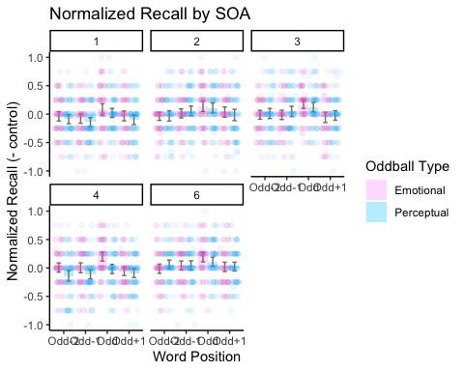

### Statistics

We tested for normality with Shapiro-Wilk test and QQ plots.

## # A tibble: 40 x 6  
## oddballtype wordposition SOA variable statistic p  
## <chr> <chr> <int> <chr> <dbl> <dbl>  
## 1 E m1 1 normrec 0.949 0.00681  
## 2 E m1 2 normrec 0.933 0.00104  
## 3 E m1 3 normrec 0.945 0.00401  
## 4 E m1 4 normrec 0.941 0.00252  
## 5 E m1 6 normrec 0.947 0.00499  
## 6 E m2 1 normrec 0.937 0.00164  
## 7 E m2 2 normrec 0.938 0.00176  
## 8 E m2 3 normrec 0.953 0.0105   
## 9 E m2 4 normrec 0.941 0.00242  
## 10 E m2 6 normrec 0.935 0.00123  
## # … with 30 more rows

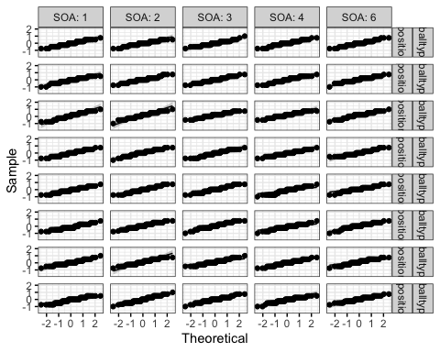

We then conducted a RM ANOVA which showed a significant main effect of word position, SOA and a significant oddball type x word position interaction.

## ANOVA Table (type III tests)  
##   
## $ANOVA  
## Effect DFn DFd F p p<.05 ges  
## 1 oddballtype 1 69 3.328 7.20e-02 0.003  
## 2 wordposition 3 207 55.868 1.69e-26 * 0.029  
## 3 SOA 4 276 3.869 4.00e-03 * 0.013  
## 4 oddballtype:wordposition 3 207 3.545 1.50e-02 * 0.002  
## 5 oddballtype:SOA 4 276 1.503 2.01e-01 0.006  
## 6 wordposition:SOA 12 828 1.208 2.72e-01 0.003  
## 7 oddballtype:wordposition:SOA 12 828 1.136 3.27e-01 0.002  
##   
## $`Mauchly's Test for Sphericity`  
## Effect W p p<.05  
## 1 wordposition 0.955 0.684   
## 2 SOA 0.922 0.793   
## 3 oddballtype:wordposition 0.932 0.446   
## 4 oddballtype:SOA 0.930 0.843   
## 5 wordposition:SOA 0.245 0.133   
## 6 oddballtype:wordposition:SOA 0.274 0.281   
##   
## $`Sphericity Corrections`  
## Effect GGe DF[GG] p[GG] p[GG]<.05 HFe  
## 1 wordposition 0.973 2.92, 201.34 7.64e-26 * 1.020  
## 2 SOA 0.964 3.86, 266.16 5.00e-03 * 1.029  
## 3 oddballtype:wordposition 0.954 2.86, 197.42 1.70e-02 * 0.999  
## 4 oddballtype:SOA 0.961 3.85, 265.34 2.03e-01 1.025  
## 5 wordposition:SOA 0.832 9.98, 688.78 2.82e-01 0.984  
## 6 oddballtype:wordposition:SOA 0.846 10.15, 700.69 3.32e-01 1.004  
## DF[HF] p[HF] p[HF]<.05  
## 1 3.06, 211.19 1.69e-26 *  
## 2 4.11, 283.89 4.00e-03 *  
## 3 3, 206.86 1.60e-02 *  
## 4 4.1, 282.96 2.01e-01   
## 5 11.81, 814.61 2.73e-01   
## 6 12.05, 831.17 3.27e-01

## ANOVA Table (type III tests)  
##   
## Effect DFn DFd F p p<.05 ges  
## 1 oddballtype 1 69 3.328 7.20e-02 0.003  
## 2 wordposition 3 207 55.868 1.69e-26 * 0.029  
## 3 SOA 4 276 3.869 4.00e-03 * 0.013  
## 4 oddballtype:wordposition 3 207 3.545 1.50e-02 * 0.002  
## 5 oddballtype:SOA 4 276 1.503 2.01e-01 0.006  
## 6 wordposition:SOA 12 828 1.208 2.72e-01 0.003  
## 7 oddballtype:wordposition:SOA 12 828 1.136 3.27e-01 0.002

We followed-up with uncorrected post-hoc t-tests.

* The oddballs were better recalled than any other words.
* Significant differences in recall between SOAs 1 v. 2, 1 v. 3, 1 v. 6, 2 v.4, 3 v.4 and 4 v. 6.
* Emotional oddballs were better recalled than perceptual oddballs

## # A tibble: 6 x 10  
## .y. group1 group2 n1 n2 statistic df p p.adj p.adj.signif  
## * <chr> <chr> <chr> <int> <int> <dbl> <dbl> <dbl> <dbl> <chr>   
## 1 norm… m1 m2 700 700 -1.11 699 2.69e- 1 3.23e- 1 ns   
## 2 norm… m1 odd 700 700 -11.0 699 4.64e-26 2.78e-25 ****   
## 3 norm… m1 p1 700 700 0.115 699 9.09e- 1 9.09e- 1 ns   
## 4 norm… m2 odd 700 700 -9.44 699 5.59e-20 1.12e-19 ****   
## 5 norm… m2 p1 700 700 1.16 699 2.47e- 1 3.23e- 1 ns   
## 6 norm… odd p1 700 700 10.8 699 3.85e-25 1.16e-24 ****

## # A tibble: 6 x 7  
## .y. group1 group2 effsize n1 n2 magnitude   
## * <chr> <chr> <chr> <dbl> <int> <int> <ord>   
## 1 normrec m1 m2 -0.0418 700 700 negligible  
## 2 normrec m1 odd -0.416 700 700 small   
## 3 normrec m1 p1 0.00433 700 700 negligible  
## 4 normrec m2 odd -0.357 700 700 small   
## 5 normrec m2 p1 0.0438 700 700 negligible  
## 6 normrec odd p1 0.407 700 700 small

## # A tibble: 10 x 10  
## .y. group1 group2 n1 n2 statistic df p p.adj p.adj.signif  
## * <chr> <chr> <chr> <int> <int> <dbl> <dbl> <dbl> <dbl> <chr>   
## 1 normr… 1 2 560 560 -3.78 559 1.72e-4 4.65e-4 ***   
## 2 normr… 1 3 560 560 -3.76 559 1.86e-4 4.65e-4 ***   
## 3 normr… 1 4 560 560 -1.01 559 3.13e-1 3.48e-1 ns   
## 4 normr… 1 6 560 560 -5.11 559 4.35e-7 4.35e-6 ****   
## 5 normr… 2 3 560 560 0.0958 559 9.24e-1 9.24e-1 ns   
## 6 normr… 2 4 560 560 2.90 559 4 e-3 8 e-3 **   
## 7 normr… 2 6 560 560 -1.20 559 2.29e-1 2.86e-1 ns   
## 8 normr… 3 4 560 560 2.81 559 5 e-3 9 e-3 **   
## 9 normr… 3 6 560 560 -1.40 559 1.62e-1 2.31e-1 ns   
## 10 normr… 4 6 560 560 -4.03 559 6.26e-5 3.13e-4 ***

## # A tibble: 10 x 7  
## .y. group1 group2 effsize n1 n2 magnitude   
## * <chr> <chr> <chr> <dbl> <int> <int> <ord>   
## 1 normrec 1 2 -0.160 560 560 negligible  
## 2 normrec 1 3 -0.159 560 560 negligible  
## 3 normrec 1 4 -0.0426 560 560 negligible  
## 4 normrec 1 6 -0.216 560 560 small   
## 5 normrec 2 3 0.00405 560 560 negligible  
## 6 normrec 2 4 0.123 560 560 negligible  
## 7 normrec 2 6 -0.0509 560 560 negligible  
## 8 normrec 3 4 0.119 560 560 negligible  
## 9 normrec 3 6 -0.0592 560 560 negligible  
## 10 normrec 4 6 -0.170 560 560 negligible

## # A tibble: 4 x 11  
## wordposition .y. group1 group2 n1 n2 statistic df p p.adj  
## * <chr> <chr> <chr> <chr> <int> <int> <dbl> <dbl> <dbl> <dbl>  
## 1 m1 normr… E P 350 350 0.680 349 0.497 4.97e-1  
## 2 m2 normr… E P 350 350 0.527 349 0.598 5.98e-1  
## 3 odd normr… E P 350 350 3.34 349 0.000914 9.14e-4  
## 4 p1 normr… E P 350 350 0.836 349 0.404 4.04e-1  
## # … with 1 more variable: p.adj.signif <chr>

## # A tibble: 4 x 8  
## .y. group1 group2 effsize wordposition n1 n2 magnitude   
## * <chr> <chr> <chr> <dbl> <chr> <int> <int> <ord>   
## 1 normrec E P 0.0364 m1 350 350 negligible  
## 2 normrec E P 0.0282 m2 350 350 negligible  
## 3 normrec E P 0.179 odd 350 350 negligible  
## 4 normrec E P 0.0447 p1 350 350 negligible

### Total recalled items per list per SOA

The goal of this is to check whether the total recalled items per list per SOA increases as SOA increases. 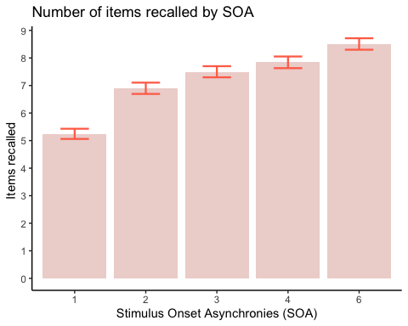

## Contingency Analyses by SOA in **Emotional** Lists

##   
## Pearson's Chi-squared test  
##   
## data: ESOA1  
## X-squared = 7.355, df = 1, p-value = 0.006688

##   
## Pearson's Chi-squared test  
##   
## data: ESOA2  
## X-squared = 38.722, df = 1, p-value = 4.886e-10

##   
## Pearson's Chi-squared test  
##   
## data: ESOA3  
## X-squared = 4.552, df = 1, p-value = 0.03288

##   
## Pearson's Chi-squared test  
##   
## data: ESOA4  
## X-squared = 7.1488, df = 1, p-value = 0.007501

##   
## Pearson's Chi-squared test  
##   
## data: ESOA6  
## X-squared = 7.1488, df = 1, p-value = 0.007501

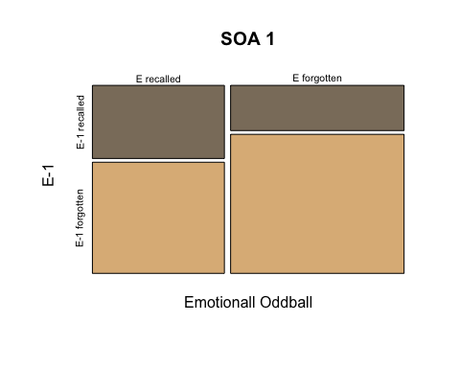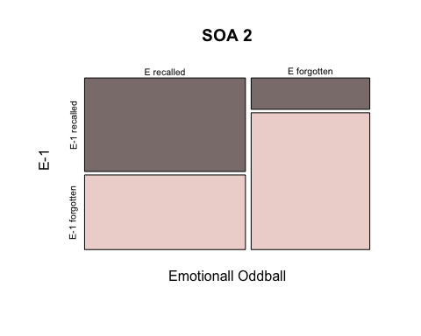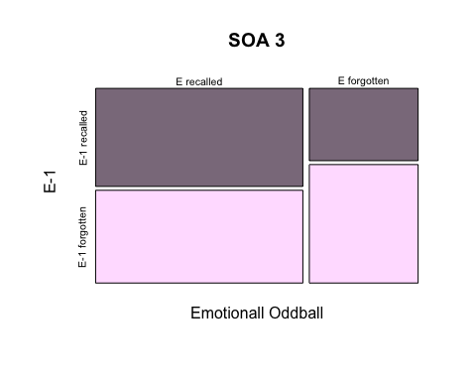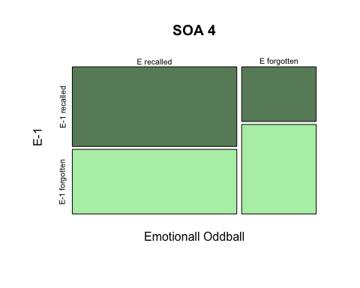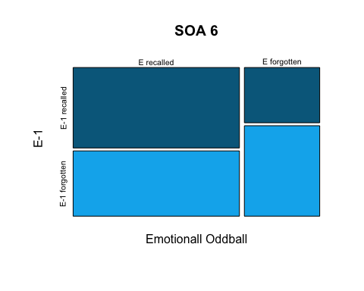

## Contingency Analyses by SOA in **Perceptual** Lists

##   
## Pearson's Chi-squared test  
##   
## data: PSOA1  
## X-squared = 0.50014, df = 1, p-value = 0.4794

##   
## Pearson's Chi-squared test  
##   
## data: PSOA2  
## X-squared = 3.7124, df = 1, p-value = 0.05401

##   
## Pearson's Chi-squared test  
##   
## data: PSOA3  
## X-squared = 0.46109, df = 1, p-value = 0.4971

##   
## Pearson's Chi-squared test  
##   
## data: PSOA4  
## X-squared = 2.9893, df = 1, p-value = 0.08381

##   
## Pearson's Chi-squared test  
##   
## data: PSOA6  
## X-squared = 2.9893, df = 1, p-value = 0.08381

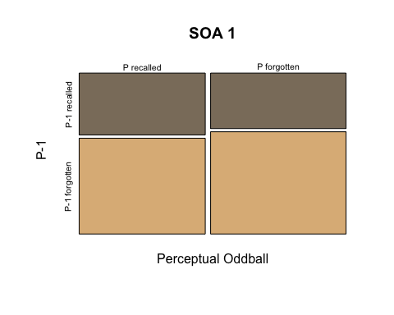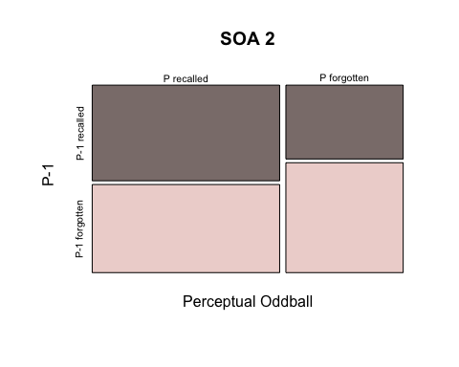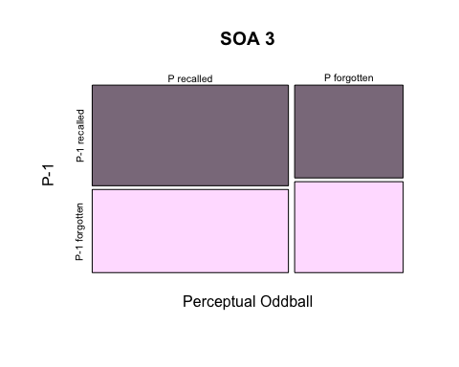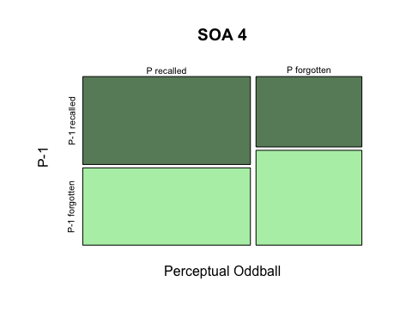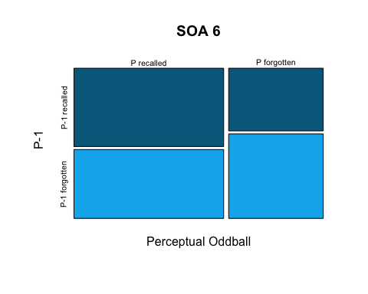

## Conditional Response Probability Analyses

We next conducted conditional response probability analyses (CRP).

### CRP in all the data

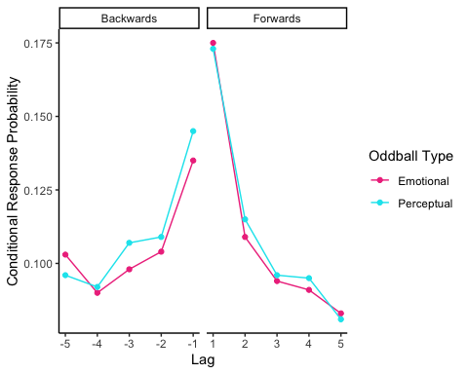 #### Statistics

We created QQ plots of the data

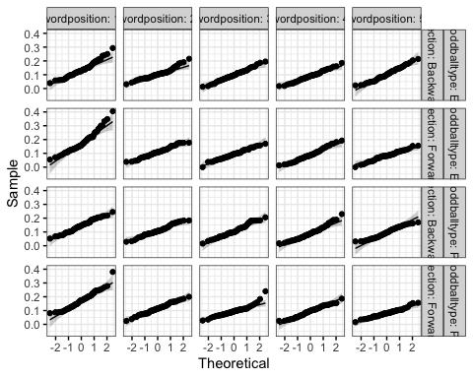

RM-ANOVA showed a significant main effect of oddball type, word position and a significant word position x direction interaction.

## ANOVA Table (type III tests)  
##   
## $ANOVA  
## Effect DFn DFd F p p<.05 ges  
## 1 oddballtype 1 69 4.068 4.80e-02 * 0.001000  
## 2 wordposition 4 276 105.011 3.07e-54 * 0.268000  
## 3 direction 1 69 1.614 2.08e-01 0.001000  
## 4 oddballtype:wordposition 4 276 0.932 4.46e-01 0.002000  
## 5 oddballtype:direction 1 69 0.252 6.17e-01 0.000152  
## 6 wordposition:direction 4 276 13.583 4.03e-10 * 0.044000  
## 7 oddballtype:wordposition:direction 4 276 0.538 7.08e-01 0.002000  
##   
## $`Mauchly's Test for Sphericity`  
## Effect W p p<.05  
## 1 wordposition 0.547 5.68e-06 *  
## 2 oddballtype:wordposition 0.931 8.47e-01   
## 3 wordposition:direction 0.576 2.47e-05 *  
## 4 oddballtype:wordposition:direction 0.812 1.22e-01   
##   
## $`Sphericity Corrections`  
## Effect GGe DF[GG] p[GG] p[GG]<.05  
## 1 wordposition 0.738 2.95, 203.77 9.51e-41 *  
## 2 oddballtype:wordposition 0.966 3.86, 266.66 4.43e-01   
## 3 wordposition:direction 0.764 3.06, 210.95 3.07e-08 *  
## 4 oddballtype:wordposition:direction 0.898 3.59, 247.98 6.89e-01   
## HFe DF[HF] p[HF] p[HF]<.05  
## 1 0.775 3.1, 213.88 1.23e-42 *  
## 2 1.031 4.12, 284.45 4.46e-01   
## 3 0.804 3.21, 221.83 1.49e-08 *  
## 4 0.954 3.82, 263.29 6.99e-01

## ANOVA Table (type III tests)  
##   
## Effect DFn DFd F p p<.05  
## 1 oddballtype 1.00 69.00 4.068 4.80e-02 *  
## 2 wordposition 2.95 203.77 105.011 9.51e-41 *  
## 3 direction 1.00 69.00 1.614 2.08e-01   
## 4 oddballtype:wordposition 4.00 276.00 0.932 4.46e-01   
## 5 oddballtype:direction 1.00 69.00 0.252 6.17e-01   
## 6 wordposition:direction 3.06 210.95 13.583 3.07e-08 *  
## 7 oddballtype:wordposition:direction 4.00 276.00 0.538 7.08e-01   
## ges  
## 1 0.001000  
## 2 0.268000  
## 3 0.001000  
## 4 0.002000  
## 5 0.000152  
## 6 0.044000  
## 7 0.002000

Follow up uncorrected t-tests showed:

* A contiguity effect (lag of 1 had a higher CRP)
* A forwards effect for lags 1 and 5

## # A tibble: 1 x 10  
## .y. group1 group2 n1 n2 statistic df p p.adj p.adj.signif  
## * <chr> <chr> <chr> <int> <int> <dbl> <dbl> <dbl> <dbl> <chr>   
## 1 CRP E P 700 700 -1.40 699 0.161 0.161 ns

## # A tibble: 1 x 7  
## .y. group1 group2 effsize n1 n2 magnitude   
## * <chr> <chr> <chr> <dbl> <int> <int> <ord>   
## 1 CRP E P -0.0531 700 700 negligible

## # A tibble: 10 x 10  
## .y. group1 group2 n1 n2 statistic df p p.adj  
## * <chr> <chr> <chr> <int> <int> <dbl> <dbl> <dbl> <dbl>  
## 1 CRP 1 2 280 280 11.9 279 1.08e-26 2.7 e-26  
## 2 CRP 1 3 280 280 13.8 279 2.22e-33 7.4 e-33  
## 3 CRP 1 4 280 280 15.6 279 9.43e-40 9.43e-39  
## 4 CRP 1 5 280 280 15.1 279 6.09e-38 3.04e-37  
## 5 CRP 2 3 280 280 3.40 279 7.72e- 4 1 e- 3  
## 6 CRP 2 4 280 280 5.42 279 1.27e- 7 2.12e- 7  
## 7 CRP 2 5 280 280 5.78 279 2 e- 8 4 e- 8  
## 8 CRP 3 4 280 280 2.04 279 4.3 e- 2 4.7 e- 2  
## 9 CRP 3 5 280 280 2.61 279 1 e- 2 1.2 e- 2  
## 10 CRP 4 5 280 280 0.372 279 7.1 e- 1 7.1 e- 1  
## # … with 1 more variable: p.adj.signif <chr>

## # A tibble: 10 x 7  
## .y. group1 group2 effsize n1 n2 magnitude   
## * <chr> <chr> <chr> <dbl> <int> <int> <ord>   
## 1 CRP 1 2 0.711 280 280 moderate   
## 2 CRP 1 3 0.825 280 280 large   
## 3 CRP 1 4 0.930 280 280 large   
## 4 CRP 1 5 0.900 280 280 large   
## 5 CRP 2 3 0.203 280 280 small   
## 6 CRP 2 4 0.324 280 280 small   
## 7 CRP 2 5 0.345 280 280 small   
## 8 CRP 3 4 0.122 280 280 negligible  
## 9 CRP 3 5 0.156 280 280 negligible  
## 10 CRP 4 5 0.0223 280 280 negligible

## # A tibble: 5 x 11  
## wordposition .y. group1 group2 n1 n2 statistic df p p.adj  
## * <int> <chr> <chr> <chr> <int> <int> <dbl> <dbl> <dbl> <dbl>  
## 1 1 CRP Backwa… Forwar… 140 140 -5.11 139 1.04e-6 1.04e-6  
## 2 2 CRP Backwa… Forwar… 140 140 -1.15 139 2.51e-1 2.51e-1  
## 3 3 CRP Backwa… Forwar… 140 140 1.82 139 7.1 e-2 7.1 e-2  
## 4 4 CRP Backwa… Forwar… 140 140 -0.314 139 7.54e-1 7.54e-1  
## 5 5 CRP Backwa… Forwar… 140 140 4.15 139 5.73e-5 5.73e-5  
## # … with 1 more variable: p.adj.signif <chr>

## # A tibble: 5 x 8  
## .y. group1 group2 effsize wordposition n1 n2 magnitude   
## * <chr> <chr> <chr> <dbl> <int> <int> <int> <ord>   
## 1 CRP Backwards Forwards -0.432 1 140 140 small   
## 2 CRP Backwards Forwards -0.0974 2 140 140 negligible  
## 3 CRP Backwards Forwards 0.154 3 140 140 negligible  
## 4 CRP Backwards Forwards -0.0265 4 140 140 negligible  
## 5 CRP Backwards Forwards 0.351 5 140 140 small

### CRP in trials in which the oddballs were remembered v. forgotten

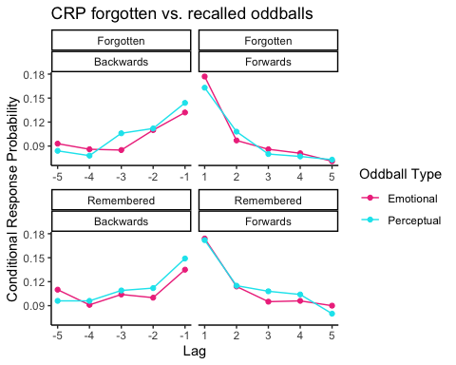

#### Statistics

We evaluated normality with QQ plots.

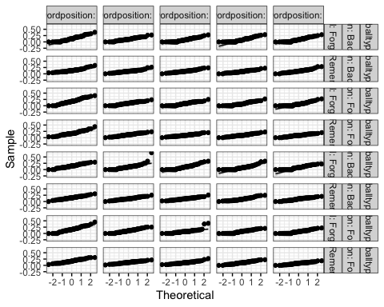

RM ANOVA showed a significant main effect of word position, recall type (i.e oddball recalled vs. not) and a significant word position x direction interaction.

## ANOVA Table (type III tests)  
##   
## $ANOVA  
## Effect DFn DFd F p p<.05  
## 1 oddballtype 1 68 0.906 3.45e-01   
## 2 wordposition 4 272 96.752 4.37e-51 *  
## 3 direction 1 68 0.341 5.61e-01   
## 4 recall 1 68 43.327 7.95e-09 *  
## 5 oddballtype:wordposition 4 272 1.509 2.00e-01   
## 6 oddballtype:direction 1 68 0.549 4.61e-01   
## 7 wordposition:direction 4 272 10.204 1.03e-07 *  
## 8 oddballtype:recall 1 68 0.771 3.83e-01   
## 9 wordposition:recall 4 272 1.096 3.59e-01   
## 10 direction:recall 1 68 1.189 2.79e-01   
## 11 oddballtype:wordposition:direction 4 272 1.144 3.36e-01   
## 12 oddballtype:wordposition:recall 4 272 0.434 7.84e-01   
## 13 oddballtype:direction:recall 1 68 0.093 7.61e-01   
## 14 wordposition:direction:recall 4 272 0.453 7.70e-01   
## 15 oddballtype:wordposition:direction:recall 4 272 1.266 2.84e-01   
## ges  
## 1 1.30e-04  
## 2 1.41e-01  
## 3 1.75e-04  
## 4 8.00e-03  
## 5 2.00e-03  
## 6 1.66e-04  
## 7 1.80e-02  
## 8 1.34e-04  
## 9 2.00e-03  
## 10 4.20e-04  
## 11 2.00e-03  
## 12 7.79e-04  
## 13 2.48e-05  
## 14 6.31e-04  
## 15 2.00e-03  
##   
## $`Mauchly's Test for Sphericity`  
## Effect W p p<.05  
## 1 wordposition 0.671 0.002 *  
## 2 oddballtype:wordposition 0.820 0.155   
## 3 wordposition:direction 0.662 0.001 *  
## 4 wordposition:recall 0.780 0.057   
## 5 oddballtype:wordposition:direction 0.795 0.086   
## 6 oddballtype:wordposition:recall 0.957 0.967   
## 7 wordposition:direction:recall 0.714 0.008 *  
## 8 oddballtype:wordposition:direction:recall 0.760 0.033 *  
##   
## $`Sphericity Corrections`  
## Effect GGe DF[GG] p[GG]  
## 1 wordposition 0.810 3.24, 220.23 7.13e-42  
## 2 oddballtype:wordposition 0.922 3.69, 250.73 2.04e-01  
## 3 wordposition:direction 0.810 3.24, 220.34 1.24e-06  
## 4 wordposition:recall 0.884 3.53, 240.36 3.56e-01  
## 5 oddballtype:wordposition:direction 0.890 3.56, 241.97 3.35e-01  
## 6 oddballtype:wordposition:recall 0.979 3.92, 266.35 7.80e-01  
## 7 wordposition:direction:recall 0.857 3.43, 233.19 7.41e-01  
## 8 oddballtype:wordposition:direction:recall 0.879 3.52, 239.08 2.86e-01  
## p[GG]<.05 HFe DF[HF] p[HF] p[HF]<.05  
## 1 * 0.855 3.42, 232.55 4.58e-44 *  
## 2 0.981 3.92, 266.89 2.01e-01   
## 3 * 0.855 3.42, 232.67 6.85e-07 *  
## 4 0.938 3.75, 255.16 3.58e-01   
## 5 0.945 3.78, 256.98 3.36e-01   
## 6 1.047 4.19, 284.67 7.84e-01   
## 7 0.908 3.63, 247.07 7.52e-01   
## 8 0.933 3.73, 253.71 2.85e-01

## ANOVA Table (type III tests)  
##   
## Effect DFn DFd F p p<.05  
## 1 oddballtype 1.00 68.00 0.906 3.45e-01   
## 2 wordposition 3.24 220.23 96.752 7.13e-42 *  
## 3 direction 1.00 68.00 0.341 5.61e-01   
## 4 recall 1.00 68.00 43.327 7.95e-09 *  
## 5 oddballtype:wordposition 4.00 272.00 1.509 2.00e-01   
## 6 oddballtype:direction 1.00 68.00 0.549 4.61e-01   
## 7 wordposition:direction 3.24 220.34 10.204 1.24e-06 *  
## 8 oddballtype:recall 1.00 68.00 0.771 3.83e-01   
## 9 wordposition:recall 4.00 272.00 1.096 3.59e-01   
## 10 direction:recall 1.00 68.00 1.189 2.79e-01   
## 11 oddballtype:wordposition:direction 4.00 272.00 1.144 3.36e-01   
## 12 oddballtype:wordposition:recall 4.00 272.00 0.434 7.84e-01   
## 13 oddballtype:direction:recall 1.00 68.00 0.093 7.61e-01   
## 14 wordposition:direction:recall 3.43 233.19 0.453 7.41e-01   
## 15 oddballtype:wordposition:direction:recall 3.52 239.08 1.266 2.86e-01   
## ges  
## 1 1.30e-04  
## 2 1.41e-01  
## 3 1.75e-04  
## 4 8.00e-03  
## 5 2.00e-03  
## 6 1.66e-04  
## 7 1.80e-02  
## 8 1.34e-04  
## 9 2.00e-03  
## 10 4.20e-04  
## 11 2.00e-03  
## 12 7.79e-04  
## 13 2.48e-05  
## 14 6.31e-04  
## 15 2.00e-03

Post-hoc uncorrected t-tests showed:

* A contiguity effect
* A significant difference in CRPs in lists in which the oddball was recalled v. not
* A significant forward effect at lags 1 and 5

## # A tibble: 10 x 10  
## .y. group1 group2 n1 n2 statistic df p p.adj  
## * <chr> <chr> <chr> <int> <int> <dbl> <dbl> <dbl> <dbl>  
## 1 CRP 1 2 560 560 10.9 559 2.08e-25 5.2 e-25  
## 2 CRP 1 3 560 560 13.8 559 1.82e-37 6.07e-37  
## 3 CRP 1 4 560 560 15.7 559 2.23e-46 2.23e-45  
## 4 CRP 1 5 560 560 15.5 558 3.05e-45 1.52e-44  
## 5 CRP 2 3 560 560 3.31 559 1 e- 3 1 e- 3  
## 6 CRP 2 4 560 560 5.53 559 4.95e- 8 8.25e- 8  
## 7 CRP 2 5 560 560 5.72 558 1.78e- 8 3.56e- 8  
## 8 CRP 3 4 560 560 2.12 559 3.4 e- 2 3.8 e- 2  
## 9 CRP 3 5 560 560 2.72 558 7 e- 3 8 e- 3  
## 10 CRP 4 5 560 560 0.517 558 6.05e- 1 6.05e- 1  
## # … with 1 more variable: p.adj.signif <chr>

## # A tibble: 10 x 7  
## .y. group1 group2 effsize n1 n2 magnitude   
## * <chr> <chr> <chr> <dbl> <int> <int> <ord>   
## 1 CRP 1 2 0.463 560 560 small   
## 2 CRP 1 3 0.583 560 560 moderate   
## 3 CRP 1 4 0.664 560 560 moderate   
## 4 CRP 1 5 0.655 560 560 moderate   
## 5 CRP 2 3 0.140 560 560 negligible  
## 6 CRP 2 4 0.234 560 560 small   
## 7 CRP 2 5 0.242 560 560 small   
## 8 CRP 3 4 0.0897 560 560 negligible  
## 9 CRP 3 5 0.115 560 560 negligible  
## 10 CRP 4 5 0.0219 560 560 negligible

## # A tibble: 1 x 10  
## .y. group1 group2 n1 n2 statistic df p p.adj p.adj.signif  
## * <chr> <chr> <chr> <int> <int> <dbl> <dbl> <dbl> <dbl> <chr>   
## 1 CRP Forgot… Rememb… 1400 1400 -4.47 1398 8.62e-6 8.62e-6 ****

## # A tibble: 1 x 7  
## .y. group1 group2 effsize n1 n2 magnitude   
## * <chr> <chr> <chr> <dbl> <int> <int> <ord>   
## 1 CRP Forgotten Remembered -0.119 1400 1400 negligible

## # A tibble: 5 x 11  
## wordposition .y. group1 group2 n1 n2 statistic df p p.adj  
## * <int> <chr> <chr> <chr> <int> <int> <dbl> <dbl> <dbl> <dbl>  
## 1 1 CRP Backwa… Forwar… 280 280 -4.70 279 4.18e-6 4.18e-6  
## 2 2 CRP Backwa… Forwar… 280 280 -0.0660 279 9.47e-1 9.47e-1  
## 3 3 CRP Backwa… Forwar… 280 280 1.90 279 5.8 e-2 5.8 e-2  
## 4 4 CRP Backwa… Forwar… 280 280 -0.297 279 7.67e-1 7.67e-1  
## 5 5 CRP Backwa… Forwar… 280 280 3.64 278 3.3 e-4 3.3 e-4  
## # … with 1 more variable: p.adj.signif <chr>

## # A tibble: 5 x 8  
## .y. group1 group2 effsize wordposition n1 n2 magnitude   
## * <chr> <chr> <chr> <dbl> <int> <int> <int> <ord>   
## 1 CRP Backwards Forwards -0.281 1 280 280 small   
## 2 CRP Backwards Forwards -0.00395 2 280 280 negligible  
## 3 CRP Backwards Forwards 0.114 3 280 280 negligible  
## 4 CRP Backwards Forwards -0.0177 4 280 280 negligible  
## 5 CRP Backwards Forwards 0.218 5 280 280 small

## Transitions ***to*** and ***from*** the oddballs

We next evaluated whether CRP changed in transitions to and from the oddballs.

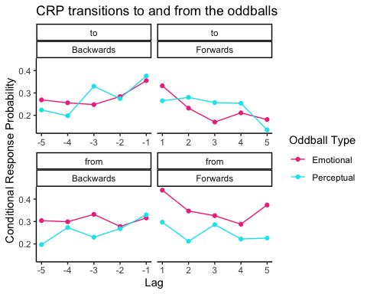

#### Statistics

We evaluated normality with QQ plots

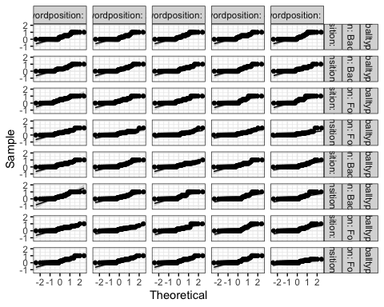

A RM ANOVA showed a significant effect of word position and a significant oddball type x transition interaction.

## ANOVA Table (type III tests)  
##   
## $ANOVA  
## Effect DFn DFd F p p<.05  
## 1 oddballtype 1 9 0.276 0.612   
## 2 wordposition 4 36 3.499 0.016 *  
## 3 direction 1 9 4.628 0.060   
## 4 transition 1 9 0.146 0.711   
## 5 oddballtype:wordposition 4 36 0.745 0.568   
## 6 oddballtype:direction 1 9 2.724 0.133   
## 7 wordposition:direction 4 36 1.255 0.305   
## 8 oddballtype:transition 1 9 14.348 0.004 *  
## 9 wordposition:transition 4 36 2.073 0.105   
## 10 direction:transition 1 9 2.981 0.118   
## 11 oddballtype:wordposition:direction 4 36 0.928 0.459   
## 12 oddballtype:wordposition:transition 4 36 1.217 0.321   
## 13 oddballtype:direction:transition 1 9 1.142 0.313   
## 14 wordposition:direction:transition 4 36 0.406 0.803   
## 15 oddballtype:wordposition:direction:transition 4 36 1.959 0.122   
## ges  
## 1 0.000372  
## 2 0.039000  
## 3 0.020000  
## 4 0.000859  
## 5 0.009000  
## 6 0.007000  
## 7 0.009000  
## 8 0.020000  
## 9 0.018000  
## 10 0.008000  
## 11 0.011000  
## 12 0.016000  
## 13 0.003000  
## 14 0.005000  
## 15 0.021000  
##   
## $`Mauchly's Test for Sphericity`  
## Effect W p p<.05  
## 1 wordposition 0.398 0.668   
## 2 oddballtype:wordposition 0.670 0.967   
## 3 wordposition:direction 0.235 0.310   
## 4 wordposition:transition 0.212 0.258   
## 5 oddballtype:wordposition:direction 0.299 0.457   
## 6 oddballtype:wordposition:transition 0.497 0.826   
## 7 wordposition:direction:transition 0.424 0.714   
## 8 oddballtype:wordposition:direction:transition 0.251 0.347   
##   
## $`Sphericity Corrections`  
## Effect GGe DF[GG] p[GG]  
## 1 wordposition 0.733 2.93, 26.4 0.030  
## 2 oddballtype:wordposition 0.857 3.43, 30.87 0.550  
## 3 wordposition:direction 0.574 2.29, 20.65 0.310  
## 4 wordposition:transition 0.637 2.55, 22.92 0.139  
## 5 oddballtype:wordposition:direction 0.593 2.37, 21.34 0.425  
## 6 oddballtype:wordposition:transition 0.826 3.3, 29.72 0.322  
## 7 wordposition:direction:transition 0.757 3.03, 27.26 0.752  
## 8 oddballtype:wordposition:direction:transition 0.604 2.42, 21.75 0.159  
## p[GG]<.05 HFe DF[HF] p[HF] p[HF]<.05  
## 1 * 1.126 4.51, 40.55 0.016 *  
## 2 1.449 5.8, 52.18 0.568   
## 3 0.781 3.12, 28.11 0.309   
## 4 0.909 3.64, 32.72 0.112   
## 5 0.819 3.28, 29.48 0.446   
## 6 1.361 5.44, 49 0.321   
## 7 1.184 4.74, 42.64 0.803   
## 8 0.842 3.37, 30.31 0.135

## ANOVA Table (type III tests)  
##   
## Effect DFn DFd F p p<.05  
## 1 oddballtype 1 9 0.276 0.612   
## 2 wordposition 4 36 3.499 0.016 *  
## 3 direction 1 9 4.628 0.060   
## 4 transition 1 9 0.146 0.711   
## 5 oddballtype:wordposition 4 36 0.745 0.568   
## 6 oddballtype:direction 1 9 2.724 0.133   
## 7 wordposition:direction 4 36 1.255 0.305   
## 8 oddballtype:transition 1 9 14.348 0.004 *  
## 9 wordposition:transition 4 36 2.073 0.105   
## 10 direction:transition 1 9 2.981 0.118   
## 11 oddballtype:wordposition:direction 4 36 0.928 0.459   
## 12 oddballtype:wordposition:transition 4 36 1.217 0.321   
## 13 oddballtype:direction:transition 1 9 1.142 0.313   
## 14 wordposition:direction:transition 4 36 0.406 0.803   
## 15 oddballtype:wordposition:direction:transition 4 36 1.959 0.122   
## ges  
## 1 0.000372  
## 2 0.039000  
## 3 0.020000  
## 4 0.000859  
## 5 0.009000  
## 6 0.007000  
## 7 0.009000  
## 8 0.020000  
## 9 0.018000  
## 10 0.008000  
## 11 0.011000  
## 12 0.016000  
## 13 0.003000  
## 14 0.005000  
## 15 0.021000

Post-hoc uncorrected t-tests showed:

* A contiguity effect
* A significant difference in transitions from emotional oddballs vs. perceptual oddballs

## # A tibble: 10 x 10  
## .y. group1 group2 n1 n2 statistic df p p.adj p.adj.signif  
## * <chr> <chr> <chr> <int> <int> <dbl> <dbl> <dbl> <dbl> <chr>   
## 1 CRP 1 2 560 560 3.44 506 6.36e-4 2 e-3 **   
## 2 CRP 1 3 560 560 3.75 492 1.96e-4 6.53e-4 ***   
## 3 CRP 1 4 560 560 4.29 479 2.14e-5 1.07e-4 ***   
## 4 CRP 1 5 560 560 4.63 482 4.7 e-6 4.7 e-5 ****   
## 5 CRP 2 3 560 560 -0.122 489 9.03e-1 9.03e-1 ns   
## 6 CRP 2 4 560 560 1.38 474 1.67e-1 2.39e-1 ns   
## 7 CRP 2 5 560 560 1.61 477 1.08e-1 1.8 e-1 ns   
## 8 CRP 3 4 560 560 1.02 461 3.07e-1 3.84e-1 ns   
## 9 CRP 3 5 560 560 2.29 468 2.3 e-2 4.5 e-2 *   
## 10 CRP 4 5 560 560 0.575 458 5.65e-1 6.28e-1 ns

## # A tibble: 10 x 7  
## .y. group1 group2 effsize n1 n2 magnitude   
## * <chr> <chr> <chr> <dbl> <int> <int> <ord>   
## 1 CRP 1 2 0.153 560 560 negligible  
## 2 CRP 1 3 0.169 560 560 negligible  
## 3 CRP 1 4 0.196 560 560 negligible  
## 4 CRP 1 5 0.211 560 560 small   
## 5 CRP 2 3 -0.00550 560 560 negligible  
## 6 CRP 2 4 0.0635 560 560 negligible  
## 7 CRP 2 5 0.0736 560 560 negligible  
## 8 CRP 3 4 0.0476 560 560 negligible  
## 9 CRP 3 5 0.106 560 560 negligible  
## 10 CRP 4 5 0.0269 560 560 negligible

## # A tibble: 2 x 11  
## transition .y. group1 group2 n1 n2 statistic df p p.adj  
## * <chr> <chr> <chr> <chr> <int> <int> <dbl> <dbl> <dbl> <dbl>  
## 1 from CRP E P 700 700 4.47 573 9.42e-6 9.42e-6  
## 2 to CRP E P 700 700 -0.436 615 6.63e-1 6.63e-1  
## # … with 1 more variable: p.adj.signif <chr>

## # A tibble: 2 x 8  
## .y. group1 group2 effsize transition n1 n2 magnitude   
## * <chr> <chr> <chr> <dbl> <chr> <int> <int> <ord>   
## 1 CRP E P 0.187 from 700 700 negligible  
## 2 CRP E P -0.0176 to 700 700 negligible

## # A tibble: 2 x 11  
## oddballtype .y. group1 group2 n1 n2 statistic df p p.adj  
## * <chr> <chr> <chr> <chr> <int> <int> <dbl> <dbl> <dbl> <dbl>  
## 1 E CRP from to 700 700 4.19 584 0.0000325 3.25e-5  
## 2 P CRP from to 700 700 -0.206 611 0.837 8.37e-1  
## # … with 1 more variable: p.adj.signif <chr>

## # A tibble: 2 x 8  
## .y. group1 group2 effsize oddballtype n1 n2 magnitude   
## * <chr> <chr> <chr> <dbl> <chr> <int> <int> <ord>   
## 1 CRP from to 0.173 E 700 700 negligible  
## 2 CRP from to -0.00834 P 700 700 negligible

## Transitions ***to*** and ***from*** the oddballs by SOA

We looked at CRP curves in transitions to and from oddballs by SOA.

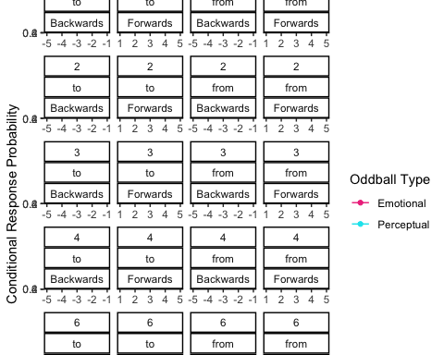

#### Statistics

We evaluated normality with QQ plots

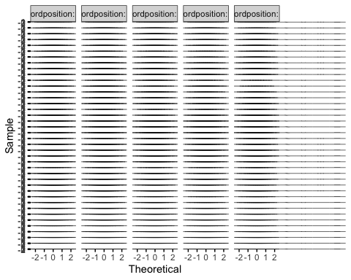

## Analysis of Deviance Table (Type III Wald chisquare tests)  
##   
## Response: CRP  
## Chisq Df Pr(>Chisq)   
## (Intercept) 17.4235 1 2.991e-05 ***  
## oddballtype 0.5594 1 0.454516   
## wordposition 0.0366 1 0.848332   
## direction 2.7240 1 0.098851 .   
## transition 0.7371 1 0.390582   
## SOA 0.3463 1 0.556220   
## oddballtype:wordposition 1.0952 1 0.295318   
## oddballtype:direction 9.3925 1 0.002179 **   
## wordposition:direction 2.3718 1 0.123543   
## oddballtype:transition 0.3512 1 0.553454   
## wordposition:transition 0.2257 1 0.634700   
## direction:transition 0.0003 1 0.987187   
## oddballtype:SOA 0.2443 1 0.621088   
## wordposition:SOA 0.0063 1 0.936489   
## direction:SOA 0.6665 1 0.414261   
## transition:SOA 1.3865 1 0.239000   
## oddballtype:wordposition:direction 8.1723 1 0.004253 **   
## oddballtype:wordposition:transition 0.0711 1 0.789736   
## oddballtype:direction:transition 1.0471 1 0.306182   
## wordposition:direction:transition 0.0092 1 0.923743   
## oddballtype:wordposition:SOA 0.1277 1 0.720876   
## oddballtype:direction:SOA 5.2205 1 0.022322 *   
## wordposition:direction:SOA 1.3069 1 0.252954   
## oddballtype:transition:SOA 0.6426 1 0.422765   
## wordposition:transition:SOA 0.7671 1 0.381119   
## direction:transition:SOA 0.6865 1 0.407361   
## oddballtype:wordposition:direction:transition 1.6726 1 0.195915   
## oddballtype:wordposition:direction:SOA 5.8152 1 0.015888 *   
## oddballtype:wordposition:transition:SOA 0.4280 1 0.512962   
## oddballtype:direction:transition:SOA 0.0655 1 0.798013   
## wordposition:direction:transition:SOA 0.0000 1 0.995077   
## oddballtype:wordposition:direction:transition:SOA 0.8388 1 0.359735   
## ---  
## Signif. codes: 0 '***' 0.001 '**' 0.01 '*' 0.05 '.' 0.1 ' ' 1

## # A tibble: 1 x 10  
## .y. group1 group2 n1 n2 statistic df p p.adj p.adj.signif  
## * <chr> <chr> <chr> <int> <int> <dbl> <dbl> <dbl> <dbl> <chr>   
## 1 CRP E P 7000 7000 2.98 1421 0.003 0.003 **

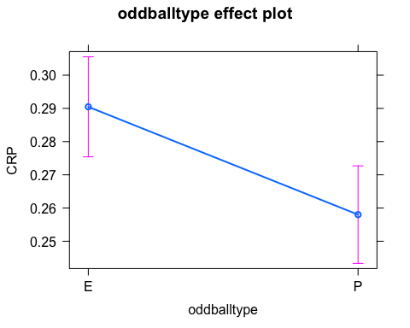

## # A tibble: 1 x 7  
## .y. group1 group2 effsize n1 n2 magnitude   
## * <chr> <chr> <chr> <dbl> <int> <int> <ord>   
## 1 CRP E P 0.0790 7000 7000 negligible

## # A tibble: 10 x 10  
## .y. group1 group2 n1 n2 statistic df p p.adj p.adj.signif  
## * <chr> <chr> <chr> <int> <int> <dbl> <dbl> <dbl> <dbl> <chr>   
## 1 CRP 1 2 2800 2800 4.03 798 6.1 e-5 3.05e-4 ***   
## 2 CRP 1 3 2800 2800 3.29 691 1 e-3 3 e-3 **   
## 3 CRP 1 4 2800 2800 3.76 665 1.83e-4 6.1 e-4 ***   
## 4 CRP 1 5 2800 2800 4.38 669 1.35e-5 1.35e-4 ***   
## 5 CRP 2 3 2800 2800 0.267 717 7.9 e-1 7.9 e-1 ns   
## 6 CRP 2 4 2800 2800 1.24 662 2.14e-1 3.06e-1 ns   
## 7 CRP 2 5 2800 2800 2.62 693 9 e-3 1.8 e-2 *   
## 8 CRP 3 4 2800 2800 0.500 661 6.17e-1 6.86e-1 ns   
## 9 CRP 3 5 2800 2800 1.80 662 7.3 e-2 1.21e-1 ns   
## 10 CRP 4 5 2800 2800 1.11 662 2.66e-1 3.32e-1 ns

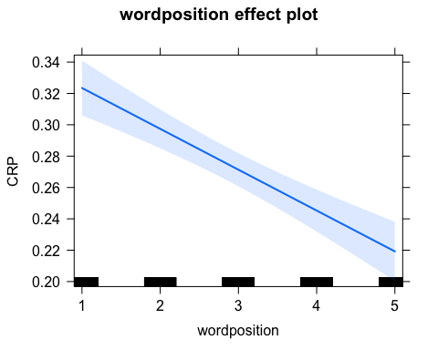

## # A tibble: 10 x 7  
## .y. group1 group2 effsize n1 n2 magnitude   
## * <chr> <chr> <chr> <dbl> <int> <int> <ord>   
## 1 CRP 1 2 0.143 2800 2800 negligible  
## 2 CRP 1 3 0.125 2800 2800 negligible  
## 3 CRP 1 4 0.146 2800 2800 negligible  
## 4 CRP 1 5 0.169 2800 2800 negligible  
## 5 CRP 2 3 0.00996 2800 2800 negligible  
## 6 CRP 2 4 0.0483 2800 2800 negligible  
## 7 CRP 2 5 0.0994 2800 2800 negligible  
## 8 CRP 3 4 0.0195 2800 2800 negligible  
## 9 CRP 3 5 0.0698 2800 2800 negligible  
## 10 CRP 4 5 0.0432 2800 2800 negligible

## # A tibble: 2 x 11  
## transition .y. group1 group2 n1 n2 statistic df p p.adj  
## * <chr> <chr> <chr> <chr> <int> <int> <dbl> <dbl> <dbl> <dbl>  
## 1 from CRP E P 3500 3500 3.36 618 0.000837 0.000837  
## 2 to CRP E P 3500 3500 0.903 802 0.367 0.367   
## # … with 1 more variable: p.adj.signif <chr>

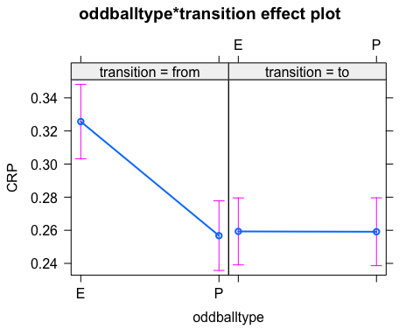

## # A tibble: 2 x 8  
## .y. group1 group2 effsize oddballtype n1 n2 magnitude   
## * <chr> <chr> <chr> <dbl> <chr> <int> <int> <ord>   
## 1 CRP from to 0.149 E 3500 3500 negligible  
## 2 CRP from to -0.0313 P 3500 3500 negligible

## # A tibble: 2 x 11  
## direction .y. group1 group2 n1 n2 statistic df p p.adj  
## * <chr> <chr> <chr> <chr> <int> <int> <dbl> <dbl> <dbl> <dbl>  
## 1 Backwards CRP E P 3500 3500 1.67 640 0.095 0.095  
## 2 Forwards CRP E P 3500 3500 2.53 780 0.012 0.012  
## # … with 1 more variable: p.adj.signif <chr>

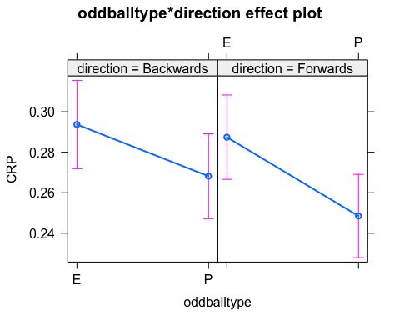

## # A tibble: 2 x 8  
## .y. group1 group2 effsize direction n1 n2 magnitude   
## * <chr> <chr> <chr> <dbl> <chr> <int> <int> <ord>   
## 1 CRP E P 0.0661 Backwards 3500 3500 negligible  
## 2 CRP E P 0.0905 Forwards 3500 3500 negligible

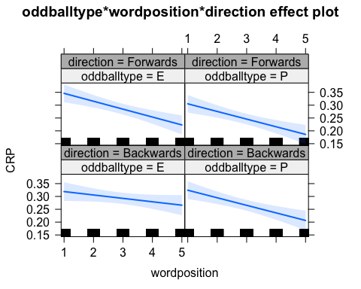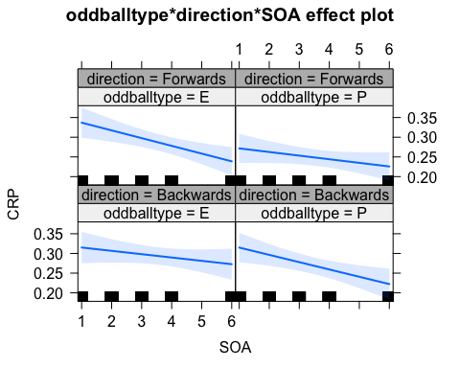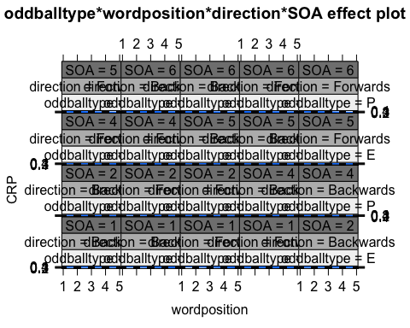

## Correlation between lag +1 after and E-1 Normalized recall

## Get the E-1 recall values

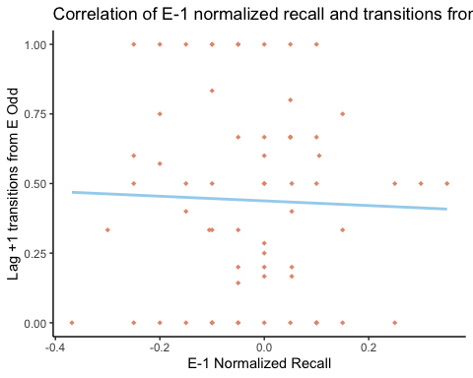

##   
## Spearman's rank correlation rho  
##   
## data: corrplot$V1 and corrplot$V2  
## S = 47491, p-value = 0.7648  
## alternative hypothesis: true rho is not equal to 0  
## sample estimates:  
## rho   
## -0.03782232

## Effects of Valence and Arousal

#### Valence and Arousal on memory (Spanish)

Look at whether there is an effect of valence and arousal on memory for emotional items in the present sample.

setwd("/Users/albaperis/Desktop/Alba/PhD UPM /Von Restroff WP3/Paper_github/Odd_SOA_CRP/Raw_Results")  
arval<-read.csv('arvalrec_R.csv')  
arval<-as.data.frame(arval)  
arval$recall <- as.factor(arval$recall)  
  
#remove E-1   
arval2<-as.data.frame(subset(arval, wordposition=='E'))  
  
arval.glm<-glm(recall~valencemean+arousalmean, family=binomial, data=arval2) #binomial fits a log reg  
Anova(arval.glm)

## Analysis of Deviance Table (Type II tests)  
##   
## Response: recall  
## LR Chisq Df Pr(>Chisq)   
## valencemean 15.2067 1 9.636e-05 ***  
## arousalmean 4.0746 1 0.04353 *   
## ---  
## Signif. codes: 0 '***' 0.001 '**' 0.01 '*' 0.05 '.' 0.1 ' ' 1

plot(allEffects(arval.glm)) #plot all the effects

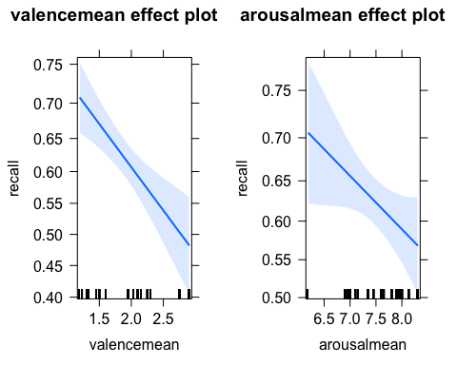

#try with summary  
#summary(arval.glm)  
#plot(effect('valencemean',arval.glm)) #plot 1 effect  
  
  
#arval.glmer<-glmer(recall~valencemean+arousalmean +(1|subject)+(1|word), family=binomial, data=arval2) #binomial fits a log reg  
#Anova(arval.glmer)  
#plot(effect('valencemean',arval.glmer))  
  
  
#arval.glm.stats<-summary(arval.glm)$coef  
#arval.glm.stats  
  
#ggplot(arval2, aes(x=valencemean, y=arousalmean, color=recall))+  
# geom_line(lwd=2)

#### Predict E-1 recall as a function of valence and arousal on E recall

setwd("/Users/albaperis/Desktop/Alba/PhD UPM /Von Restroff WP3/Paper_github/Odd_SOA_CRP/Raw_Results")  
Em1arval<-read.csv('Em1arvalrec_R.csv')  
Em1arval<-as.data.frame(Em1arval)  
  
Em1arval$E <- as.factor(Em1arval$E)  
Em1arval$Em1 <- as.factor(Em1arval$Em1)  
e_noe <- glm(Em1 ~ valencemean+arousalmean, data = Em1arval, family= binomial)  
e_0 <- glm(Em1 ~ valencemean + E + arousalmean, data = Em1arval, family = binomial) #only me  
e_1 <- glm(Em1 ~ valencemean*E + arousalmean*E, data= Em1arval, family=binomial) #interactions  
anova(e_noe,e_0,e_1) #is the model with the me different from the one with interactions? No. (Deviance>0.05) and the AIC is lower for e_0 (see if summary())

## Analysis of Deviance Table  
##   
## Model 1: Em1 ~ valencemean + arousalmean  
## Model 2: Em1 ~ valencemean + E + arousalmean  
## Model 3: Em1 ~ valencemean * E + arousalmean * E  
## Resid. Df Resid. Dev Df Deviance  
## 1 1247 1712.0   
## 2 1246 1651.3 1 60.709  
## 3 1244 1650.8 2 0.528

Anova(e_0, type = 3)

## Analysis of Deviance Table (Type III tests)  
##   
## Response: Em1  
## LR Chisq Df Pr(>Chisq)   
## valencemean 0.277 1 0.5989   
## E 60.709 1 6.618e-15 ***  
## arousalmean 0.030 1 0.8628   
## ---  
## Signif. codes: 0 '***' 0.001 '**' 0.01 '*' 0.05 '.' 0.1 ' ' 1

plot(allEffects(e_0))

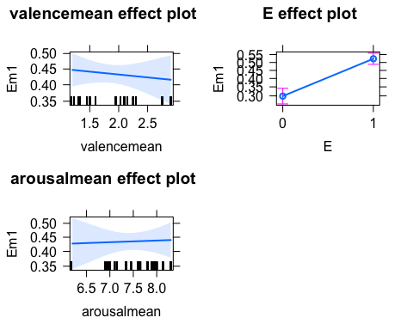

#Anova(e_1,type=3)  
#summary(e_1)  
#plot(allEffects(e_0))  
  
#test<-glm(Em1~E+arousalmean+valencemean, data=Em1arval, family=binomial)  
#Anova(test)  
#summary(test)  
  
#e_recalled <- subset(Em1arval, E==1)  
#e_1_erecalled <- glm(Em1 ~ valencemean + arousalmean,data= e_recalled, family=binomial)  
#summary(e_1_erecalled)  
  
#Darya's code:  
#e_1_erecalled <- glm(recall_e_1 <- valencemean + arousal,data= e_recalled, family=binomia)  
  
#setwd("/Users/albaperis/Desktop/Alba/PhD UPM /Von Restroff WP3/Paper_github/Odd_SOA_CRP/Raw_Results")  
#darya <- read.csv('darya_R.csv')  
#darya$Erecall <- factor(darya$Erecall)  
#gmixed0<- glmer(Em1recall ~ valencemean+Erecall + (1|subject), data = darya, family=binomial)  
#gmixed1<- glmer(Em1recall ~ valencemean*Erecall + (1|subject), data = darya, family=binomial)  
#anova(gmixed0,gmixed1)

#### Valence and Arousal English v. Spanish

Compare whether there are differences in valence and arousal between the spanish and english version of the items (note that values were obtained from different papers with a different amount of raters each)