1. **Design 4-bit binary asynchronous counter**

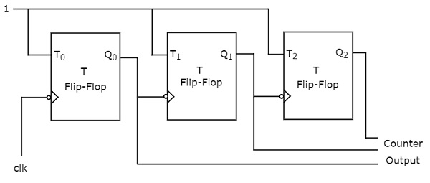

* This is an example picture of asynchronous counter.
* It is called asynchronous because all Flip Flops don’t get same clock.
* The output of T flip flop toggles for every positive edge of clock when t is high. Hence it can be used in counter.
* I made a behavioral Verilog code for t flip-flop and used 4 instances of it to make the 4-bit counter.
* As the counter is 4-bit, the simulation can be seen counting from 0 to 15 and it wraps around.
* We can reverse the counter (up or down) by inverting the triggering clock edge (posedge clk to negedge clk) or also by making qbar as clock for following flip flops.