Modbus OT Security Lab
Demonstrating and Mitigating the Lack of Authentication in Modbus TCP
Syed Umar | OT / ICS Cybersecurity | github.com/TheSyedUmar

1. Goal
Modbus TCP, the protocol many industrial PLCs use, has no authentication and no encryption. This lab builds a small simulated factory inside virtual machines, proves that any computer on the network can read and change PLC values without a password, and then mitigates the problem with a firewall rule that permits only one trusted host to reach the controller.

2. Lab setup
Four components were built in Oracle VirtualBox on isolated internal networks, so no real network was touched at any point.
Component | Role | Network / IP
pfSense CE 2.7.2 | Firewall separating the IT and OT zones | LAN 192.168.10.1, OPT1 192.168.20.1
OpenPLC Runtime v3 | Simulated PLC running tank-level logic, Modbus on port 502 | ot-net, 192.168.20.10
Client (Ubuntu) | Operator/attacker host running a Python Modbus client | it-net, 192.168.10.100
tcpdump | Packet capture on the PLC to record Modbus traffic | on the PLC machine
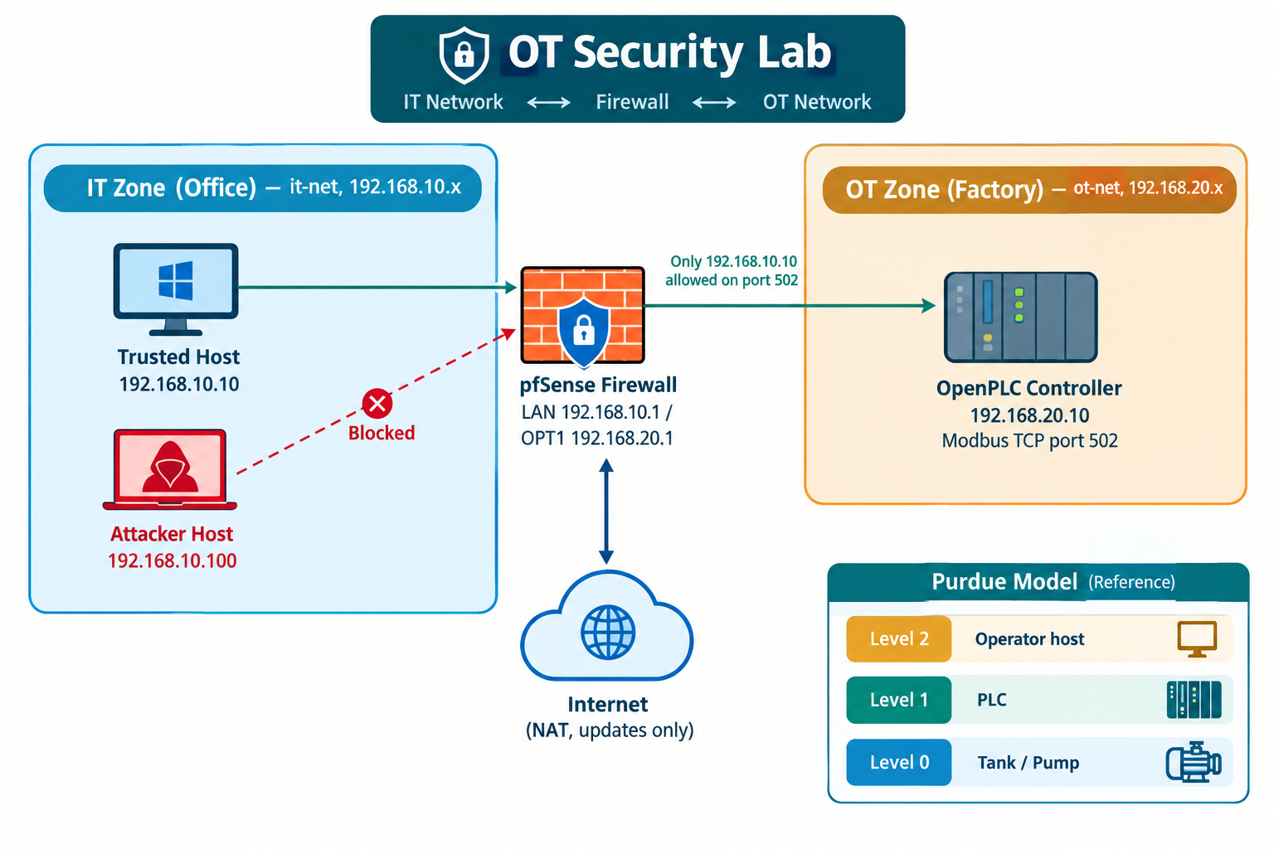
Figure 1. Network architecture: IT and OT zones joined only through the pfSense firewall.

Figure 2. The virtual machines: pfSense firewall, client, and the OpenPLC PLC, all running.

3. What I did
- Built the pfSense firewall with three interfaces (WAN via NAT, LAN = it-net, OPT1 = ot-net) and set static addresses for the two zones.
- Installed OpenPLC on the OT host, wrote a Structured Text tank program (level in a holding register, pump on a coil), compiled it, and started the Modbus server on port 502.
- From the untrusted client, ran a Python (pymodbus) script that connects to the PLC, reads the tank level, and writes a new value.
- Captured the exchange on the PLC with tcpdump to show the raw Modbus traffic.
- Added a pfSense rule on OPT1 allowing only the trusted host (192.168.10.10) to reach the PLC on port 502, with a block-and-log rule for everything else, then re-ran the attack.
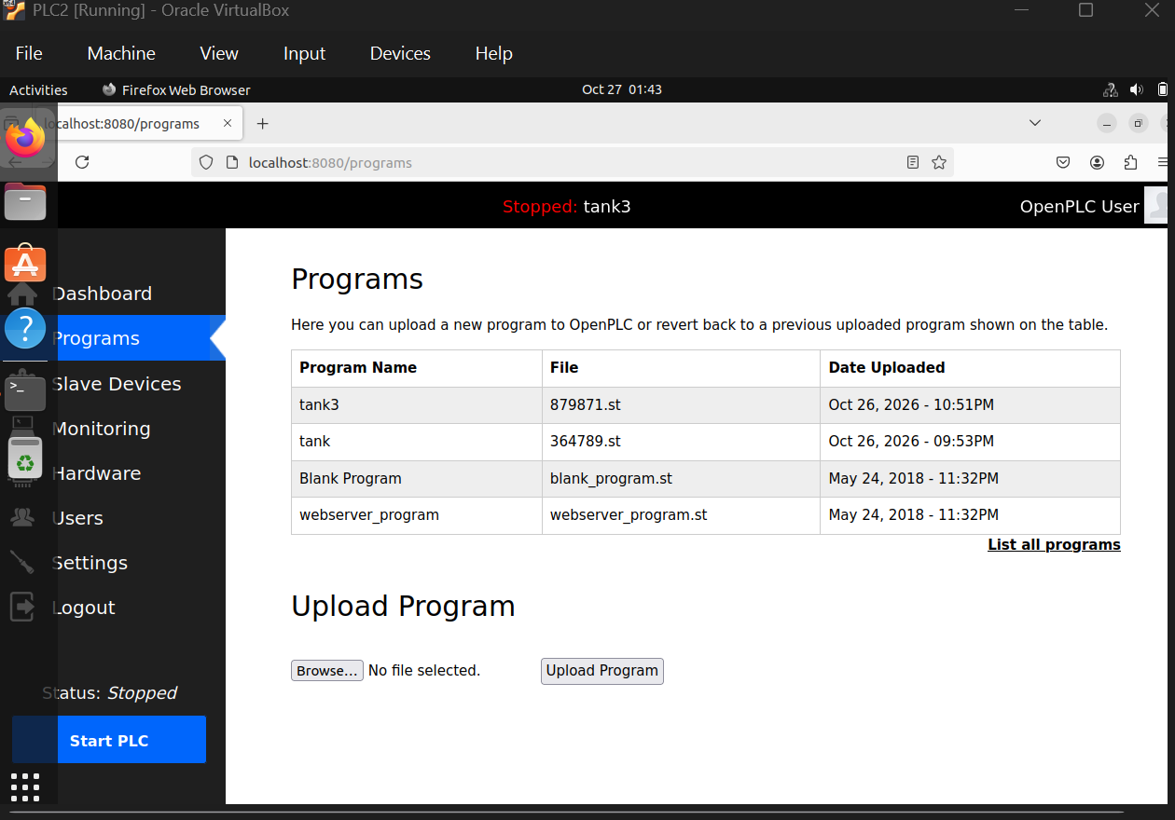
Figure 3. OpenPLC with the compiled tank program loaded on the PLC.

4. What I found (the problem)
Before the firewall rule, the untrusted client connected to the PLC and read and changed its tank level with no authentication of any kind. The script output:
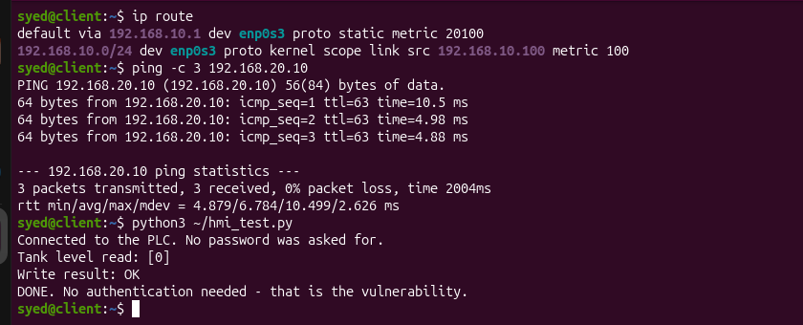
Figure 4. The attack succeeds: the client reads and writes the PLC with no password ("Write result: OK").
tcpdump on the PLC confirmed the traffic: a TCP session on port 502 between the untrusted client (192.168.10.100) and the PLC (192.168.20.10), carrying Modbus read and write commands, with no login anywhere in the exchange.
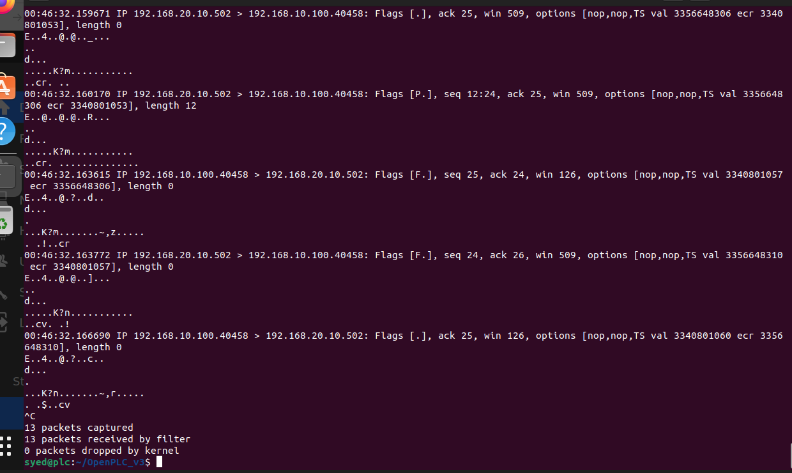
Figure 5. tcpdump capture on the PLC showing Modbus traffic (port 502) between 192.168.10.100 and 192.168.20.10, with no authentication.

5. The fix
A pfSense rule on the OPT1 interface was added to permit only the trusted host 192.168.10.10 to reach 192.168.20.10 on TCP port 502, followed by a block-and-log rule for all other sources.
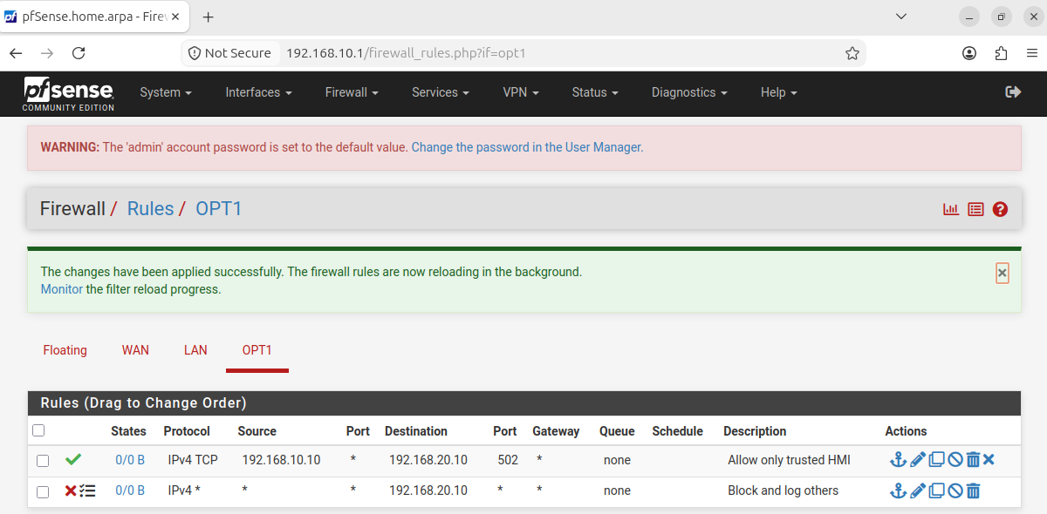
Figure 6. pfSense OPT1 rules: allow only the trusted HMI on port 502, block and log everything else.
After applying the rules and clearing firewall states, the same script from the untrusted client (192.168.10.100) was blocked, while the trusted host could still reach the PLC:
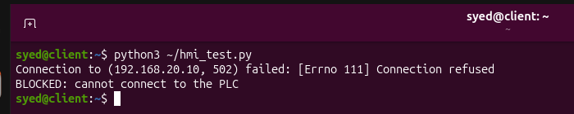
Figure 7. After the firewall rule, the same attack from the untrusted host is blocked ("Connection refused").
This demonstrates network segmentation as a compensating control for an insecure protocol.

6. Standards mapping
Concept | Where it appears in this lab
Purdue model | Tank/pump = Level 0, OpenPLC = Level 1, operator host = Level 2, office host on the IT side; the firewall sits between the levels.
IEC 62443 zones & conduits | OT zone (PLC) and IT zone (office) are separated; the pfSense rule is the single controlled conduit allowing only one host on port 502.
NIST CSF - Identify | Assets listed: PLC, operator host, firewall, Modbus port 502.
NIST CSF - Protect | The firewall rule restricting who can reach the PLC.
NIST CSF - Detect | tcpdump and the pfSense firewall log reveal unexpected writes and blocked attempts.

7. Limitations and next steps
- An IP address can be spoofed; a single-IP allow rule is a starting control, not full protection.
- If the trusted host itself is compromised, commands can still be sent through it.
- Modbus remains unencrypted, so anyone on the network path can read the traffic.
- A real plant would add VLAN segmentation, VPN for remote access, deep inspection that permits only Modbus reads, and monitoring that alerts on unusual write commands.
- This is a small home lab intended to demonstrate the concept, not a production design.
All testing was performed inside the author's own virtual machines. No real or third-party systems were accessed.

