Alan Chan 010063326

# Python Stock Profile Calculator – UI

Environment:

* OS: Mac
* Python Version 2.7
* Packages needed: click, flask

The UI version of this calculator requires two python packages – click and flask. Use *sudo pip install click* and *sudo pip install flask* to install the packages. Run the following command to start the server up:



As you can see from the figure above, the server is up and waiting for new request. Now go to a web browser and put in localhost:5000 or localhost:5000/index to go to the form page. Once all the fields are filled, click submit button to submit the data to the server.

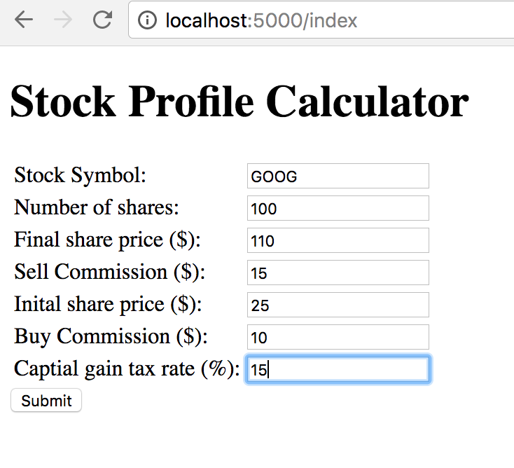

The server will do the calculation and return a result page to the client side, like the following figure.

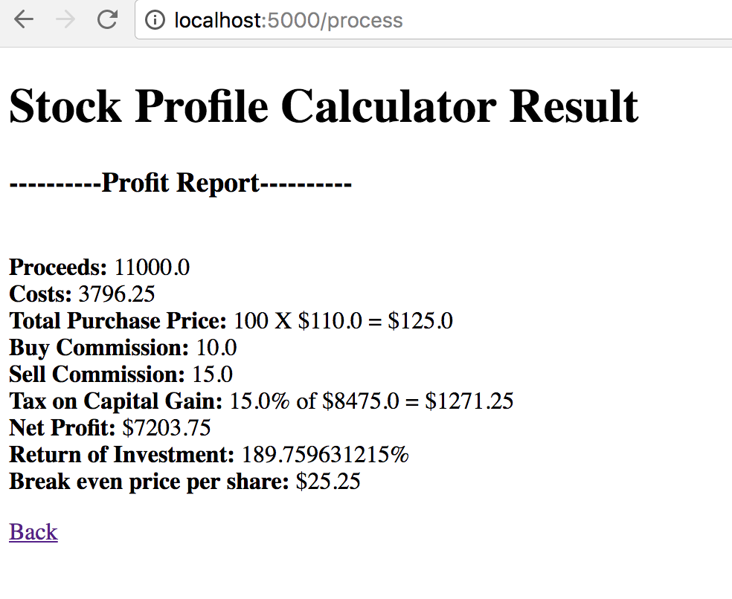

Feel free to click the *back* link to go back to the form page. Let’s take a look at the server side.

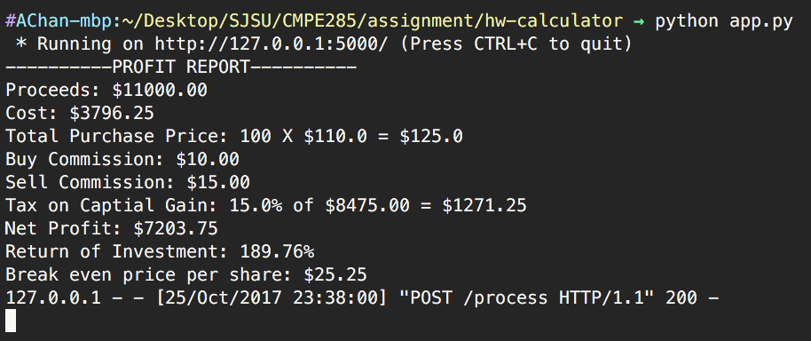

As you can see the server has received the form POST request and spit out the command form of the calculation based on the user’s input.