Alan Chan 010063326

# Python Finance Info – Command line

Environment:

* OS: Mac
* Python Version: 2.7
* Packages needed: click, yahoo_finance

To run the finance info command line will require the following packages – click and yahoo_finance. Use *sudo pip install click* to install the click package and *sudo pip install yahoo_finance* to install the yahoo finance package. Run the following command to run the interactive finance info script:



Here is a normal run with ADBE as a stock symbol. It returns the current time, the company name, the current stock price and the changes in price with percentage.

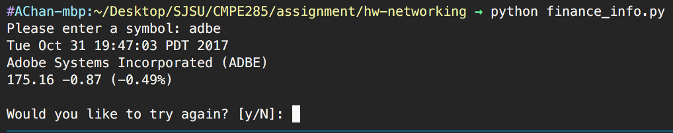

The script will also ask if the user would like to run the script again for another stock symbol, if the user press N, then the script will quit as shown below.

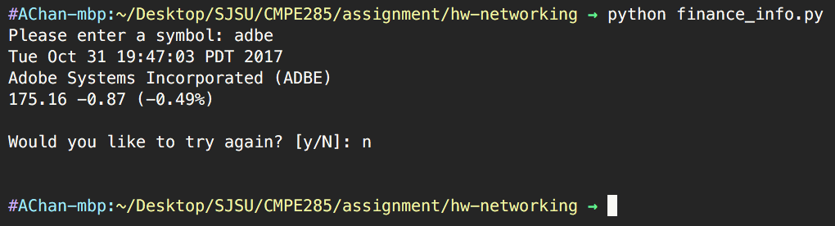

But if the user press Y, the script will take another user input for the stock symbol.

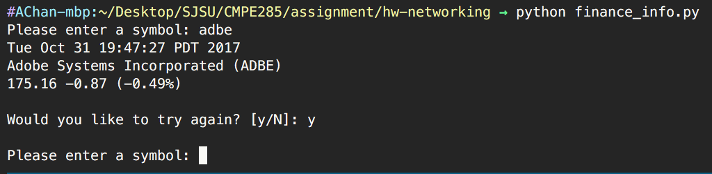

If the user input an invalid stock symbol, the script would return a yellow message telling the user that the given symbol is invalid.

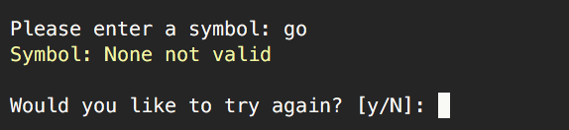

If there is a networking issue, the script will catch the error and tell the user that there is a networking issue and try again later.

