Alan Chan 010063326

Dan Lu 011028589

Yanjun Zang 012419394

# **Lab: Architecture Design Exercise**

## **The design for a simple e-commerce market place**

For our design, we have decided to treat both side of the parties (buyer and seller) as user. As shown in figure 1, user will be required to sign in on the website and is given a choice to go to the buyer portal or the seller portal.

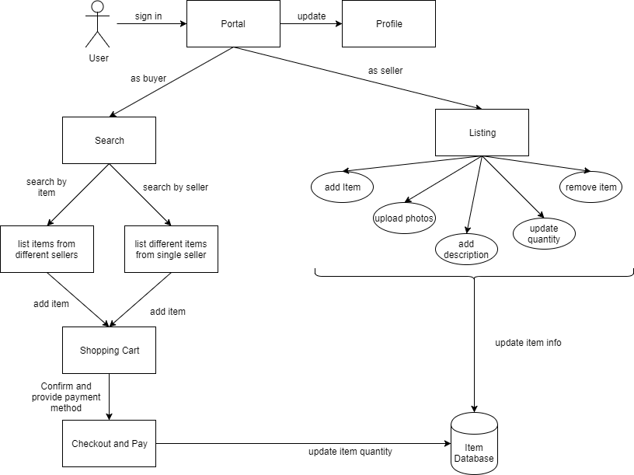

Figure 1: Workflow diagram

After signing in, user (both buyer and seller) can update their profile at the portal. This includes the user’s personal information, including email address, age, gender, home address and more. It will also allow the user to update their security preferences, for example, updating their password.

In the seller portal, user can do their listing to have their product shown on the ecommerce market place. The user will the action add, upload the photos, add description, update the quantity (inventory) of their selling item. The user can also remove the listing of an item all together so that it will not show up in a search. All these actions will directly update the item’s information in the database.

In the buyer portal, user will have a choice to search a specific seller or a specific item. If the user is searching a seller, then a list of different items that are sold by the searched seller will be displayed. If the user is searching for an item, then a list of items that matches the keywords with different sellers would be displayed. Regardless of which method the user used to search, the user can add any of the items that are listed to the shopping cart. Once ready, the user will have to select a method of payment to the seller and checkout. As an atomic transaction, the item quantity will be updated in the database.

## User case 1 – How a seller lists an item

When a user wants to sell an item, they will probably want to take some photos of the item that they are selling. Once ready, the user will sign in on the website, and proceed to the seller’s portal. The seller will select the “post a listing” button to add a new item to the market place. Before actually posting the listing, the seller can upload the photos that were taken earlier and add a detail description of the item. This will hopefully help clarify any possible questions that a potential buyer might have. The seller will have to let the site know the quantity that they can sell for this item. Once the seller hit the post button to finalize the listing, it will add the selling item to the database for search.

## User case 2 – How a buyer buys an item

When a user is in need of a product, they will go to the website and purchase this desired item. The user will sign in on the website, and proceed to the buyer’s portal. The buyer type in the keyword in the search bar. On the right side of the search bar, the buyer can select which the search is for an item or for a seller. The reason the buyer might search for a specific seller is because they had probably made a purchase from this seller and was satisfied with the product or customer service. Regardless of what the buyer is using to search for this item, the buyer will make their choice from the result list that the search engine returns. When the buyer likes the item, they can add the item to the shopping cart. When they are ready, they can proceed to checkout the shopping cart with methods of payment selection. Once they confirm their purchase, the database will update the quantity of the item available and email this purchase confirmation to the user.