Alan Chan 010063326

Dan Lu 011028589

Yanjun Zang 012419394

**Lab: Software Development Process**

Our startup team consist of three people, Alan, Dan and Yanjun. The product of our startup is a mobile application that will help user locate the cheapest restaurants around them given the type of food input. We are funded with 100k USD for this project.

**Role**:

Alan Chan - Product Co-owner, Scrum Master, Infrastructure Software Engineer and Developer

* Design and build the necessary continuous integration infrastructure to develop our core product
* Make product backlog, evaluate the scope and importance of user story
* Estimate velocity of team, evaluate risk and develop mitigation plans
* Manage process, remove blocks
* Core product developer

Dan Lu - Product Co-owner, System Design and Developer

* Design the overall architectural design of our software implementation
* Make product backlog, evaluate the scope and importance of user story
* Estimate story priorities, choose story can be accomplished of each sprint
* Set sprint goal and create sprint backlog
* Core product developer

Yanjun Zang - Product Co-owner, Developer and QA

* Design test plan to ensure our product will be deliver in the best quality
* Make product backlog, evaluate the scope and importance of user story
* Estimate story priorities, choose story can be accomplished of each sprint
* Set sprint goal and create sprint backlog
* Core product developer

**Budgeting**:

We are expecting this project will take us roughly 3 months. We will be using Google App as our main way of communicating and scheduling meetings. We will be using AWS to host our services and store our data. The following table shows the breakdown of our expenses.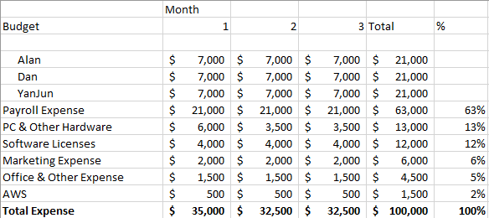

**Development Process**:

As mentioned above, this is a quarter long project. It is not a very long project; without preparing ourselves for the upcoming unexpected changes, it could greatly prevent us from meeting the deadline. Moreover, we are such a small team, only three members. So for this we have chosen to use an agile development process, to be specific, we are going to be using SCRUM.

We will be doing a daily standup meeting to ensure we communicate our roadblock or achievements from the previous day. A bi-weekly meeting will be held to review last two weeks’ progress and plan next sprint’s goal. During each sprint, since the requirements is well-defined in the plan meeting, everyone can focus on coding without being disturbed. With the SCRUM method, we can re-distribute resources quickly to where the help is needed when needed. And if anyone finished their part early, they can pick up the next task easily. Everything will be visible to the whole team and possibly can keep our stakeholders up-to-date with our progress in great details.