Alan Chan 010063326

Dan Lu 011028589

Yanjun Zang 012419394

# Lab – User Interface Design

Use Case: Using the app to select a restaurant and invite a friend to come along.

User will put their username on the user name textbox and password into the password textbox. Once finished, hit the login button to begin using the app.

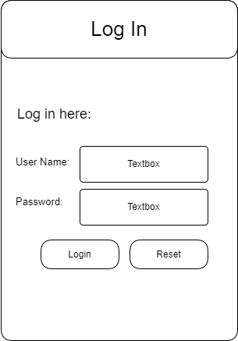

Once logged in, user will input the type of food that they would like to have. Location can be left blank to use the user’s current location or the user can input a location they would like to search around. Hitting continue would show all the possible listing.

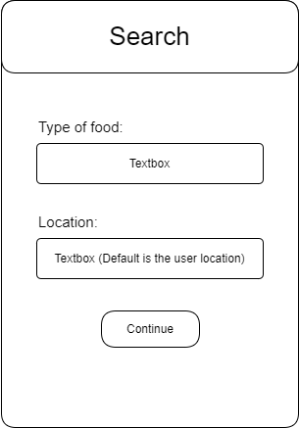

At this stage, the user can toggle between the list view or map view to look at the returned restaurant choices. Clicking on the restaurant would bring the user to a page with more information about the restaurant. Back to search button is available if the user would like to do a search on some other type of food or elsewhere.

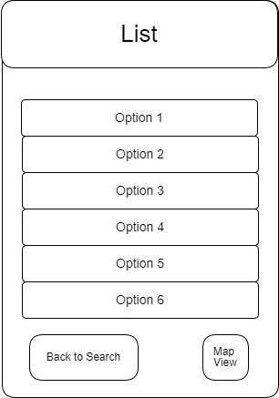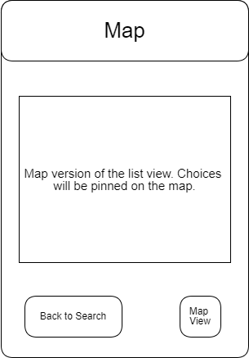

In the info page, it shows information about the restaurant that the user has selected. It has link to the reviews that other users have given, and a link to the restaurant menu. It also has a photo section to see what other users have uploaded. If the user is satisfied with the choice, they can hit the invite friends button to invite their friends, otherwise the user can hit the back button to select another restaurant.

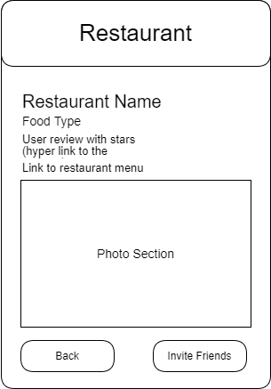

On the friends page, user can select the friends that they would like to invite to eat with them at the selected restaurant. Once selected, the user can hit the Send Invitations button to send invitations to their friends. There is also a button to add a new friend.

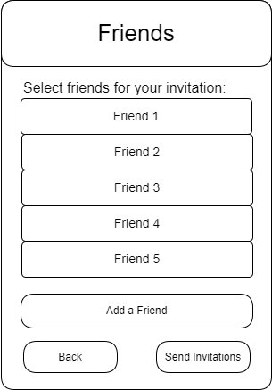

Alternative situation: If the user wants to invite a new friend to a meal, but that new friend is yet on the user’s friend list, the user will need to add their new friend’s username or email to their friend list. Once the friend has accepted the friend request, then the user can invite this new friend to a restaurant.

