**CHAPTER ONE**

**INTRODUCTION**

**1.1      Background to the Study**

In today's rapidly evolving educational landscape, ensuring the safety and security of students, faculty, and staff on campus is of paramount importance. With the increasing prevalence of emergency situations such as natural disasters, medical emergencies, and security threats, there is a growing need for robust and efficient emergency response systems within educational institutions. This paper focuses on the design and implementation of an online campus emergency response system, which leverages digital technologies to enhance preparedness, communication, and coordination during emergencies.

The design and implementation of an online campus emergency response system aim to address the challenges associated with traditional manual methods of emergency management. By harnessing the power of digitalization, real-time communication, and data analytics, the system offers a comprehensive and proactive approach to emergency preparedness and response. It provides stakeholders with timely alerts, access to critical information, and tools for effective decision-making, ultimately improving the overall safety and security of the campus community.

The system may incorporate functionalities such as emergency contact lists, incident reporting mechanisms, and resource allocation tools to facilitate rapid response and recovery efforts. By providing a cohesive and streamlined platform for emergency management, the system enhances the institution's ability to mitigate risks, protect lives, and minimize disruptions during crisis situations.

Empirical evidence from previous studies underscores the importance and effectiveness of

online campus emergency response systems. Johnson and Smith (2020) conducted a case study on the implementation of such a system and found that it significantly improved response times and coordination during emergency situations. Brown and Wilson (2019) investigated user satisfaction with an online emergency response system and reported high levels of user satisfaction with its accessibility and functionality. Lee et al. (2018) highlighted the operational impact of an online emergency response system, showing how it streamlined workflows and improved resource allocation. Chen et al. (2017) provided insights into the challenges and opportunities in implementing online emergency response systems, emphasizing the importance of scalability and adaptability.

**1.2      Statement of the Problem**

The traditional methods of managing campus emergencies often rely on manual processes and disjointed communication channels, leading to inefficiencies and delays in emergency response. The following are the problems this software is aimed at solving:

1. Inadequate coordination among stakeholders, including students, faculty, staff, and emergency responders, exacerbates the challenges of timely and effective incident management.
2. Moreover, the lack of centralized systems for information dissemination and resource allocation hampers the ability of educational institutions to address emergencies promptly and comprehensively.
3. These shortcomings highlight the need for the design and implementation of an online campus emergency response system that integrates digital technologies and data-driven approaches to improve preparedness, communication, and coordination during crisis situations.

**1.3 Aim and Objectives of the Study**

**Aim**

The primary aim of an online campus emergency response system is to enhance the safety and security of students, faculty, and staff by improving emergency preparedness, communication, and coordination on college campuses. By leveraging digital technologies, these systems seek to address the challenges associated with traditional manual methods of emergency management.

**Objectives of the study**

The main objective of the study is to examine Design and Implementation of an Online Campus Emergency Response System. Specific objectives of the study are:

1. To design a well-structured and optimized database management system to store, process and retrieve emergency reports and registrations in real-time.
2. To create a fast query system where emergency response can be queried and acted upon in real-time.
3. To proffer solutions to the challenges and enhance already existing systems in place.

**1.4 Significance of the Study**

1. The study is important for many reasons. The following are the major stakeholders this paper through its practical and theoretical implications and findings will be of great significance:
2. Firstly, the paper will benefit major stakeholders and policy makers in the Information Technology sector. The various analysis, findings and discussions outlined in this paper will serve as a guide in enabling major positive changes in the industry and sub-sectors.
3. Secondly, the paper is also beneficial to the organizations used for the research. Since first hand data was gotten and analyzed from the organization, they stand a chance to benefit directly from the findings of the study in respect to their various organizations. These findings will fast track growth and enable productivity in the organizations used as a case study.
4. Finally, the paper will serve as a guide to other researchers willing to research further into the subject matter. Through the conclusions, limitations and gaps identified in the subject matter, other student and independent researchers can have a well laid foundation to conduct further studies.

**1.5 Scope of the Project**

The Ogun State Institute of Technology in Nigeria is the exclusive focus of the study. The study's conclusions and suggestions represent the ideas and viewpoints of the respondents who were sampled in the region.

**1.6 Limitations of the Study**

When conducting a study on a campus emergency response system, it's important to recognize potential limitations that could affect the validity and reliability of the findings. Here are some common limitations:

**1. Regulatory and Ethical Restraints:** Ensuring adherence to institutional guidelines and ethical standards may place restrictions on the kinds of information that may be gathered and the techniques that can be employed.

**2. Response Bias:** If participants fear bad outcomes, they may give socially acceptable answers rather than candid criticism, which could affect the study's accuracy.

**3. Technological Restrictions:** Inadequate infrastructure, glitches in the system, or a dearth of dependable communication resources are examples of technological constraints that may impair the efficacy of the response system.

**1.7 Definition of Terms**

1. **Online Campus Emergency Response System:** A software program or digital
2. platform made to make managing and coordinating emergency situations on campus easier.
3. **Digital Technologies:** Tools and solutions based on technology that use digitalization to increase emergency response operations' efficacy and efficiency.
4. **Preparedness:** The ability to respond to emergencies in a way that is efficient thanks to planning, training, and resource allocation.
5. **Communication**: The exchange of information among stakeholders, including students, faculty, staff, emergency responders, and campus administrators, during emergency situations.
6. **Coordination**: The process of organizing and synchronizing activities and resources among multiple stakeholders to achieve common objectives during emergency situations.
7. **Incident Tracking**: The systematic recording and monitoring of emergency incidents, including their location, severity, and progression, using digital tools and platforms.
8. **Resource Allocation**: The process of assigning and managing resources, such as personnel, equipment, facilities, and supplies, to support emergency response activities.
9. **Decision Support**: The provision of actionable information, analysis, and recommendations to aid decision-making by campus authorities, emergency responders, and other stakeholders during emergency situations.
10. **Scalability**: The ability of an online campus emergency response system to adapt and expand its capacity to accommodate increasing demands and evolving requirements during emergency situations.
11. **Resilience**: The capacity of an online campus emergency response system to withstand and recover from disruptions, failures, and adverse events while maintaining essential functions and services.

**LITERATURE REVIEW**

**2.1 INTRODUCTION**

This chapter discussed the related literature and studies which served as a reference in developing and conducting the study.

**2.2 OVERVIEW OF HISTORY**

The concept of emergency response systems has evolved significantly over the decades. Early systems were rudimentary, often relying on manual processes and limited communication tools. The development of more sophisticated emergency response protocols began in the mid-20th century, driven by the increasing complexity of urban environments and the frequency of natural and human-made disasters.

The history of campus emergency response systems can be traced back to the 1960s and 1970s, when colleges and universities began to recognize the need for comprehensive emergency planning in response to various threats, including natural disasters, civil unrest, and campus violence. In the 1980s and 1990s, the development of campus emergency response systems gained momentum, with institutions implementing emergency notification systems, such as sirens and public address systems, to alert the campus community during emergencies. The passage of the Clery Act in 1990 further emphasized the importance of campus safety, requiring colleges and universities to report certain crimes and provide timely warnings to students and employees. The early 2000s saw a significant shift in campus emergency response systems with the increasing adoption of digital technology. During emergencies, more effective and extensive communication was made possible by the development of mass notification systems that make use of social media, text messaging, and email. A greater investment in disaster planning and training resulted from the tragic events at Virginia Tech in 2007 that brought attention to the need for better emergency preparedness and response on college campuses.

Campus emergency response systems now have even more capabilities because to the addition of cutting-edge technologies like real-time data analytics, geolocation services, and mobile applications. To

enable prompt and well-coordinated reactions, these systems now provide centralized dashboards for tracking emergencies, automatic alerting systems, and incident reporting tools. To enable prompt and well-coordinated reactions, these systems now provide centralized dashboards for tracking emergencies, automatic alerting systems, and incident reporting tools.

Campus emergency response systems research and development are always evolving to improve stakeholder collaboration, communication, and readiness in the face of ever-changing dangers. To improve decision-making and resource allocation during emergencies, these systems' future is probably going to incorporate digital technologies, artificial intelligence, and data-driven methodologies even more.

**2.3 TYPES OF A CAMPUS EMERGENCY RESPONSE SYSTEM**

A campus emergency response system comprises several key components, including:

1. Emergency Response Plan (ERP): As highlighted by Smith. (2018), an ERP outlines specific procedures for different types of emergencies, ensuring that all stakeholders are aware of their roles and responsibilities.
2. Incident Command System (ICS): According to Brown (2017), ICS provides a standardized approach to the command, control, and coordination of emergency response, enabling efficient resource management and decision-making.
3. Emergency Notification System (ENS): As noted by Johnson (2019), ENS technologies, such as mass notification systems and social media platforms, play a critical role in disseminating timely information during emergencies.
4. Incident Management Systems: Coordinate and manage emergency responses from a central location.

Features: Communication tools, situation monitoring, and resource management.

1. Safety and Security Systems: Protect the campus community from physical threats.

Features: Access control (keycard/biometric), surveillance cameras, and intrusion detection.

1. Health and Safety Systems: Address medical emergencies and health-related issues.

Features: Automated External Defibrillators (AEDs), first aid stations, and health alert systems.

1. Environmental Safety Systems: Respond to natural disasters and environmental hazards.

Features: Fire alarms, earthquake early warning systems, and hazardous materials response.

**2.4 USES OF CAMPUS EMERGENCY AND RESPONSE SYSTEM**

Uses of Campus Emergency Response Systems

1. Emergency Alerts: Quickly inform the community about threats.
2. Incident Reporting and Tracking: Report and manage incidents.
3. Coordination of Response Efforts: Centralize response management.
4. Real-Time Communication: Ensure effective communication among responders.
5. Safety and Security Management: Protect the campus with surveillance and access control.
6. Health and Medical Response: Provide immediate medical assistance.

**2.5 ORGANOGRAM OF CAMPUS EMERGENCY RESPONSE SYSTEM**

The organogram highlights the key components of a comprehensive campus emergency response system, including emergency notification and communication, coordination and resource management, preparedness and training, incident reporting and management, and recovery and post-incident support. Each component encompasses specific sub-elements that contribute to the overall effectiveness of the system.

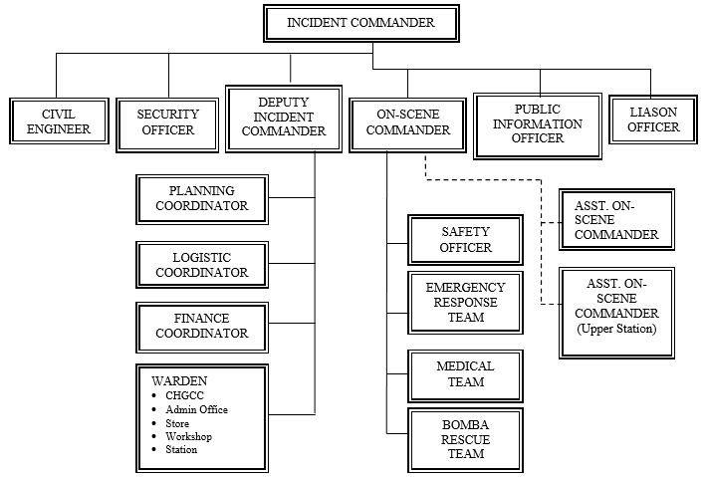

**Fig 2.1** Organogram of Campus Emergency and Response System

Source: [generate literature review of chapter 2 of campus emergency response system (perplexity.ai)](https://www.perplexity.ai/search/generate-literature-review-of-GcirymLJSQqYNeqZI5L8UQ)

**2.6 APPLICATION AND TECHNOLOGICAL ADVANCEMENTS**

**2.6.1 Application**

Campus emergency response systems are essential for enhancing safety and preparedness within educational institutions. Their applications include:

1. Emergency Notification: These systems provide real-time alerts through various channels such as SMS, email, and mobile apps to inform the campus community about emergencies, ensuring timely communication during crises.

2. Incident Reporting: Users can report emergencies or suspicious activities quickly through integrated platforms, facilitating immediate response from campus security and emergency services.

3. Resource Coordination: The systems enable efficient management of resources and personnel during emergencies, allowing for better allocation and deployment of assistance as needed.

4. Training and Drills: Regular training exercises and drills are conducted to prepare students and staff for various emergency scenarios, ensuring everyone knows their roles and responsibilities.

5. Geolocation Services: Many systems incorporate geolocation features to track incidents and individuals in distress, aiding responders in locating those in need of assistance.

6. Post-Incident Recovery: After an emergency, these systems assist in recovery efforts, including damage assessment and restoring normal operations, while also providing support to affected individuals.

**2.6.2 Technological Advancements**

Recent advancements in technology have significantly enhanced the capabilities of campus emergency response systems. Key technological innovations include:

1. Smartphone Applications: Mobile apps, as discussed by Lee and Parker (2020), enable real-time communication, and provide users with critical information and instructions during emergencies.
2. Geolocation Services: As per Martinez and Garcia (2021), geolocation technology helps in tracking the movements of individuals on campus, facilitating efficient evacuation and resource allocation.
3. Artificial Intelligence (AI) and Machine Learning: These technologies, highlighted by Wang et al. (2022), can analyze vast amounts of data to predict potential threats and improve response strategies.

**2.7 CHALLENGES AND BEST PRACTICES IN IMPLEMENTING EMERGENCY RESPONSE SYSTEMS**

**2.7.1 Challenges**

Despite the advancements and best practices, several challenges persist:

1. Funding and Resource Constraints: Limited financial and human resources, as discussed by Patel (2017), hinder the development and maintenance of robust emergency response systems.
2. Technological Limitations: As noted by Rivera (2020), technological failures or lack of infrastructure can compromise the effectiveness of emergency response efforts.
3. Behavioral Factors: Human behavior during emergencies is unpredictable. As Jones (2018) points out, panic and non-compliance with instructions can impede emergency response efforts.

**2.7.2 Best Practices in Emergency Preparedness**

Best practices for campus emergency preparedness include regular training, drills, and collaboration with external agencies. As indicated by Thomas (2018), involving local law enforcement and emergency services in campus drills ensures a coordinated response. Additionally, ongoing education and training programs for students and staff, as recommended by Green (2019), enhance overall preparedness and resilience.

**2.8 RELATED WORKS**

**2.8.1 AGENT BASE SIMULATION**

Though little work has been done using agent-based modeling for system design analysis, many researchers adopt agent-based models to explore human behaviors during emergency response. Okaya and Takahashi (2011) incorporated psychological models of agent behavior (for example, Belief-Desire-Intention) into an evacuation model. Zhang. (2018) examined evacuation during violent attacks in open public space. Ma, (2017) considered response to a sarin gas attack in a railway station. Briggs and Kennedy (2016) explored the risks and benefits of fighting back during an attack. Other studies have focused on-campus attacks specifically. Anklam. (2015) have considered the possibility of encouraging “concealed carry” of firearms on campuses. Xi and Chan (2019) modeled the different dynamics and outcomes between a gun attack and a knife attack on the same campus. In most previous work, however, the influence of message system design on attack response outcome has not been explored.

Beattie (2020) have simulated information sharing using WeChat, the most popular messaging app in China, between students during a knife attack. In this work, the effects of available message types on campus-wide event awareness and response outcomes were explored via agent-based simulation and compared to outcomes produced without messaging. The study found that messaging can reliably increase on-campus awareness of an attack; this leads to faster reporting times, and thus a quicker end to the attack, compared to results seen without using messaging capabilities. The results showed that the increased awareness produced by messaging may have a positive impact on response outcomes, and that group-based messaging is expected to produce the largest benefit despite potential trust issues. However, the analysis was limited only to the campus’ current information sharing system design, and the influence of the emergency reporting system was not considered.

Emergency reporting and on-campus messaging are both important aspects of campus emergency response. In this study, we considered the impact of three different campus emergency response system designs suggested by previous studies.

The alternative system design scenarios modeled in Scenarios 2 and 3 represent promising design pathways that could improve baseline performance; they can be described as “maximizing utility of current messaging platform-based infrastructure,” and “utilizing a purpose-built, app-based emergency response infrastructure,” respectively.

To assess the potential effectiveness of these design improvements, we used an agent-based simulation of a knife attack on a college campus in China. A model representation of WeChat was used for communication between students, and data from on-campus student surveys were incorporated into parameter tuning. The response strategy and message evaluation models are extensions of the work presented in Beattie, (2020). In this work, the prevalent “Run, Hide, Tell” response strategy (Metropolitan Police Service 2017) was implemented to model student decision making. The model minimizes the assumptions made about students’ decision-making context, leading to a strategy implementation that is appropriate for the variety of circumstances that students may face. The message evaluation model for students considered the time, content, and source of incoming messages. A variety of tests were conducted on each of these three scenarios and key metrics were recorded, including the amount of casualties and police response time.

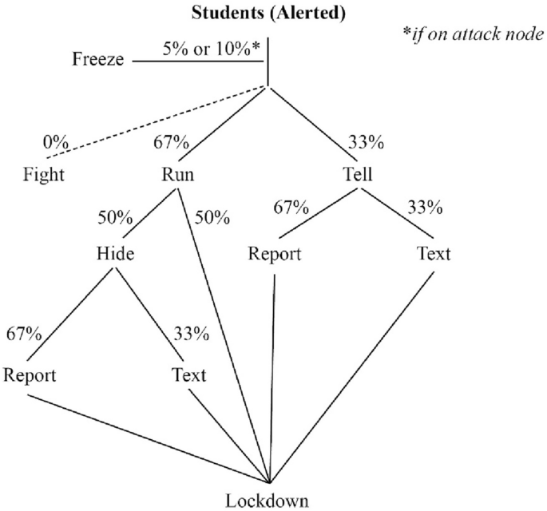

**Fig 2.2** Alerted student action choices when receiving a simulated knife-attack alert

**Source**: https://link.springer.com/article/10.1007/s13753-022-00418-1

**2.8.2 Design of Campus Emergency Response System for Public Health Emergencies**

A study was conducted to identify factors influencing the awareness level of occupational safety and health (OSH) among staff at University Technology MARA (UiTM) in Penang, Malaysia, in the context of public health emergencies.

Safety and health are essential factors of any organization to ensure smooth and effective functioning. Occupational safety and health (OSH) awareness is vital in preventing occupational injuries and illness. Various programs have been implemented by the organization to increase the knowledge and awareness of OSH in the workplace, including among institution higher learning staff in Malaysia. A study was undertaken to identify factors influencing the awareness level of OSH among the staff of Universiti Teknologi MARA (UiTM) in Penang, Malaysia. A self-administered online questionnaire was distributed to the staff through UiTM email and 193 staff were responded. The questionnaire covered 43 questions and was divided into 7 factors that influence awareness level. The data were analyzed using the Statistical Package for the Social Sciences (SPSS) version 20 and presented in descriptive statistics. The study revealed that the highest level of awareness factor was OSH policy, with a mean score of 4.90, while the lowest level was the safety and health committee, with a mean score of 3.90. The university management should increase the role of the safety and health committee to increase the safety and health programs such as safety talks, training, and campaign through posters and signage on the campus. OSH management is critical to prevent an accident at the workplace towards the development of a safety culture.

**2.8.3 Notre Dame Campus Emergency Preparedness and Response Plan**

The University of Notre Dame's emergency plan provides a structure for coordinating preparedness, response, and recovery efforts using the National Incident Management System (NIMS). It outlines the roles and responsibilities of various stakeholders, including the Policy Committee, Emergency Operations Center (EOC) Management Team, and Function Support Teams. The University of Notre Dame Campus Emergency Preparedness & Response Plan (the Plan) outlines policies and procedures for managing major emergencies that may threaten the health and safety of the campus community or significantly disrupt its programs and activities. The Plan provides a structure for coordinating preparedness, response, and recovery efforts of Notre Dame personnel and resources.

The Plan is an all-hazards plan and applies to a broad range of major emergencies, including but not limited to: fires, extended power outages, criminal activity, hazardous chemicals releases, security breaches, financial malfeasance, medical and emergency medical response, weather and other events impacting the life and safety of campus constituents, physical condition, or credibility of the University. It is the official emergency response plan for the University and supersedes all previous plans.

The Plan is designed for major emergencies and should be activated when an emergency reaches proportions beyond the capacity of routine departmental response procedures. Campus responding agents such as the Notre Dame Police Department (NDPD), Notre Dame Fire Department (NDFD), and Risk Management & Safety (RMS) respond to the scene of emergencies and coordinate response efforts with community responders. In addition, departments respond to lower-level emergencies that do not impact multiple campus constituents.

**2.8.4** **Catastrophic Emergencies (Campus-wide emergencies such as catastrophic earthquake)**

As part of the Campus Emergency Preparedness Program, the Campus has been divided into 18 Emergency Management Areas (EMA's), each one centering on an identified evacuation site and having a designated EMA Coordinator and Alternate.

The Role of the Emergency Management Area (EMA) Coordinator. The EMA Coordinators have been selected from a pool of volunteer Building Coordinators, integrating the various regions of the campus into networks. EMA Coordinators are responsible for reporting to their EMA's in a disaster and providing a communication link between the occupants of the EMA and the Emergency Operations Center (EOC). The EMA Coordinator has a battery-operated radio and a megaphone with which to communicate in an emergency. The EMA Coordinator periodically meets with Building Operations Managers and departmental emergency response personnel in their EMA's for emergency preparedness. A map of Campus EMA's appears on the inside of the back cover of the Campus phone book.

The College of Chemistry is a member of EMA along with the Physics buildings plus Campbell and Evans and evacuates to the open area west of Evans Hall. The College Emergency Action Directors will communicate critical information such as status of our buildings and occupant needs to the EOC through the EMA coordinator. Additionally, one of the College of Chemistry two-way radios contains the EMA channel that will allow radio communication with the EMA Coordinator and the EOC. The EMA coordinator can be identified at the EMA by a yellow hard hat. Other identifying objects such as an EMA flag are currently under consideration.

Emergency Management Area 2 is in the area west of Evans Hall. Building occupants SHOULD NOT GO to the EMA; they should assemble at the nearest Emergency Assembly Area for the building they evacuated. A list of EAA's is found by clicking the EAA graphic link at the top of this page.

**2.8.5 ACHA Guidelines for Campus Health Services Emergency Planning**

The American College Health Association (ACHA) provides guidelines for campus health services to develop emergency plans using an all-hazards approach. The guidelines cover areas such as internal and external communication, resource management, and collaboration with campus and community partners.

Psychological Impact of Crisis In emergency settings, most people experience psychological distress (e.g., strong feelings of grief, sadness, fear, or anger). Interventions that quickly allow a person to recognize when physical danger to life and limb has been reduced or eliminated can improve psychological functioning. Examples of such interventions include ready access to information on emergency relief efforts, as well as to information that permits a person to realistically assess the level of personal danger and define reduction strategies. Similarly, providing access to social supports can reduce the intensity and length of a person’s crisis response. Supports may include crisis counselors, campus, and community personnel, as well as family and peers. Defining and encouraging the use of positive coping strategies to manage stress, fear, uncertainty, and loss permits most individuals to regain equilibrium more quickly. In most situations, most affected individuals will gradually start to feel better. It is important to educate all members of staff and faculty on how to reach out to students and other members of the campus community in the aftermath of a crisis. Written communications to these audiences during and after the crisis period allow faculty and staff to provide support and education, disseminate information on crisis resources, and direct individuals requiring psychological assistance to the appropriate areas. Since individuals affected by a crisis often initially present through primary care, it is important for health care professionals to screen for stress-related symptoms and emotional distress. Effective coordination of care is critical in providing quality services and enhancing the psychosocial well-being of people living through a stressful episode. Coordination between the counseling and health center staff allows for mutual support during screening and intervention. This coordination can help reduce any stigma associated with seeking mental health services. Making available culturally appropriate educational information can be a useful means of encouraging positive coping methods. The aim of such information is to increase the capacity of individuals, families, and communities to understand the common ways in which most people tend to react to extreme stressors and to learn how to attend effectively to their own psychosocial needs and to those of others.

**CHAPTER THREE**

**METHODOLOGY OF STUDY**