**CHAPTER ONE**

**INTRODUCTION**

**1.1      Background to the Study**

In today's rapidly evolving educational landscape, ensuring the safety and security of students, faculty, and staff on campus is of paramount importance. With the increasing prevalence of emergency situations such as natural disasters, medical emergencies, and security threats, there is a growing need for robust and efficient emergency response systems within educational institutions. This paper focuses on the design and implementation of an online campus emergency response system, which leverages digital technologies to enhance preparedness, communication, and coordination during emergencies.

The design and implementation of an online campus emergency response system aim to address the challenges associated with traditional manual methods of emergency management. By harnessing the power of digitalization, real-time communication, and data analytics, the system offers a comprehensive and proactive approach to emergency preparedness and response. It provides stakeholders with timely alerts, access to critical information, and tools for effective decision-making, ultimately improving the overall safety and security of the campus community.

The system may incorporate functionalities such as emergency contact lists, incident reporting mechanisms, and resource allocation tools to facilitate rapid response and recovery efforts. By providing a cohesive and streamlined platform for emergency management, the system enhances the institution's ability to mitigate risks, protect lives, and minimize disruptions during crisis situations.

Empirical evidence from previous studies underscores the importance and effectiveness of

online campus emergency response systems. Johnson and Smith (2020) conducted a case study on the implementation of such a system and found that it significantly improved response times and coordination during emergency situations. Brown and Wilson (2019) investigated user satisfaction with an online emergency response system and reported high levels of user satisfaction with its accessibility and functionality. Lee. (2018) highlighted the operational impact of an online emergency response system, showing how it streamlined workflows and improved resource allocation. Chen. (2017) provided insights into the challenges and opportunities in implementing online emergency response systems, emphasizing the importance of scalability and adaptability.

**1.2      Statement of the Problem**

The traditional methods of managing campus emergencies often rely on manual processes and disjointed communication channels, leading to inefficiencies and delays in emergency response. The following are the problems this software is aimed at solving:

1. Inadequate coordination among stakeholders, including students, faculty, staff, and emergency responders, exacerbates the challenges of timely and effective incident management.
2. Moreover, the lack of centralized systems for information dissemination and resource allocation hampers the ability of educational institutions to address emergencies promptly and comprehensively.
3. These shortcomings highlight the need for the design and implementation of an online campus emergency response system that integrates digital technologies and data-driven approaches to improve preparedness, communication, and coordination during crisis situations.

**1.3 Aim and Objectives of the Study**

**Aim**

The primary aim of an online campus emergency response system is to enhance the safety and security of students, faculty, and staff by improving emergency preparedness, communication, and coordination on college campuses. By leveraging digital technologies, these systems seek to address the challenges associated with traditional manual methods of emergency management.

**Objectives of the study**

The main objective of the study is to examine Design and Implementation of an Online Campus Emergency Response System. Specific objectives of the study are:

1. To design a well-structured and optimized database management system to store, process and retrieve emergency reports and registrations in real-time.
2. To create a fast query system where emergency response can be queried and acted upon in real-time.
3. To proffer solutions to the challenges and enhance already existing systems in place.

**1.4 Significance of the Study**

1. The study is important for many reasons. The following are the major stakeholders this paper through its practical and theoretical implications and findings will be of great significance:
2. Firstly, the paper will benefit major stakeholders and policy makers in the Information Technology sector. The various analysis, findings and discussions outlined in this paper will serve as a guide in enabling major positive changes in the industry and sub-sectors.
3. Secondly, the paper is also beneficial to the organizations used for the research. Since firsthand data was gotten and analyzed from the organization, they stand a chance to benefit directly from the findings of the study in respect to their various organizations. These findings will fast track growth and enable productivity in the organizations used as a case study.
4. Finally, the paper will serve as a guide to other researchers willing to research further into the subject matter. Through the conclusions, limitations and gaps identified in the subject matter, other student and independent researchers can have a well laid foundation to conduct further studies. (Davis, 2019)

**1.5 Scope of the Project**

The Ogun State Institute of Technology in Nigeria is the exclusive focus of the study. The study's conclusions and suggestions represent the ideas and viewpoints of the respondents who were sampled in the region.

**1.6 Limitations of the Study**

When conducting a study on a campus emergency response system, it's important to recognize potential limitations that could affect the validity and reliability of the findings. Here are some common limitations:

**1. Regulatory and Ethical Restraints:** Ensuring adherence to institutional guidelines and ethical standards may place restrictions on the kinds of information that may be gathered and the techniques that can be employed.

**2. Response Bias:** If participants fear bad outcomes, they may give socially acceptable answers rather than candid criticism, which could affect the study's accuracy.

**3. Technological Restrictions:** Inadequate infrastructure, glitches in the system, or a dearth of dependable communication resources are examples of technological constraints that may impair the efficacy of the response system.

**1.7 Definition of Terms**

1. **Online Campus Emergency Response System:** A software program or digital
2. platform made to make managing and coordinating emergency situations on campus easier.
3. **Digital Technologies:** Tools and solutions based on technology that use digitalization to increase emergency response operations' efficacy and efficiency.
4. **Preparedness:** The ability to respond to emergencies in a way that is efficient thanks to planning, training, and resource allocation.
5. **Communication**: The exchange of information among stakeholders, including students, faculty, staff, emergency responders, and campus administrators, during emergency situations.
6. **Coordination**: The process of organizing and synchronizing activities and resources among multiple stakeholders to achieve common objectives during emergency situations.
7. **Incident Tracking**: The systematic recording and monitoring of emergency incidents, including their location, severity, and progression, using digital tools and platforms.
8. **Resource Allocation**: The process of assigning and managing resources, such as personnel, equipment, facilities, and supplies, to support emergency response activities.
9. **Decision Support**: The provision of actionable information, analysis, and recommendations to aid decision-making by campus authorities, emergency responders, and other stakeholders during emergency situations.
10. **Scalability**: The ability of an online campus emergency response system to adapt and expand its capacity to accommodate increasing demands and evolving requirements during emergency situations.
11. **Resilience**: The capacity of an online campus emergency response system to withstand and recover from disruptions, failures, and adverse events while maintaining essential functions and services.

**CHAPTER TWO**

**LITERATURE REVIEW**

**2.1 INTRODUCTION**

This chapter discussed the related literature and studies which served as a reference in developing and conducting the study.

**2.2 OVERVIEW OF HISTORY**

The concept of emergency response systems has evolved significantly over the decades. Early systems were rudimentary, often relying on manual processes and limited communication tools. The development of more sophisticated emergency response protocols began in the mid-20th century, driven by the increasing complexity of urban environments and the frequency of natural and human-made disasters.

The history of campus emergency response systems can be traced back to the 1960s and 1970s, when colleges and universities began to recognize the need for comprehensive emergency planning in response to various threats, including natural disasters, civil unrest, and campus violence. In the 1980s and 1990s, the development of campus emergency response systems gained momentum, with institutions implementing emergency notification systems, such as sirens and public address systems, to alert the campus community during emergencies. The passage of the Clery Act in 1990 further emphasized the importance of campus safety, requiring colleges and universities to report certain crimes and provide timely warnings to students and employees. The early 2000s saw a significant shift in campus emergency response systems with the increasing adoption of digital technology. During emergencies, more effective and extensive communication was made possible by the development of mass notification systems that make use of social media, text messaging, and email. A greater investment in disaster planning and training resulted from the tragic events at Virginia Tech in 2007 that brought attention to the need for better emergency preparedness and response on college campuses.

Campus emergency response systems now have even more capabilities because to the addition of cutting-edge technologies like real-time data analytics, geolocation services, and mobile applications. To enable prompt and well-coordinated reactions, these systems now provide centralized dashboards for tracking emergencies, automatic alerting systems, and incident reporting tools. To enable prompt and well-coordinated reactions, these systems now provide centralized dashboards for tracking emergencies, automatic alerting systems, and incident reporting tools.

Campus emergency response systems research and development are always evolving to improve stakeholder collaboration, communication, and readiness in the face of ever-changing dangers. To improve decision-making and resource allocation during emergencies, these systems' future is probably going to incorporate digital technologies, artificial intelligence, and data-driven methodologies even more.

**2.3 TYPES OF A CAMPUS EMERGENCY RESPONSE SYSTEM**

A campus emergency response system comprises several key components, including:

1. Emergency Response Plan (ERP): As highlighted by Smith. (2018), an ERP outlines specific procedures for different types of emergencies, ensuring that all stakeholders are aware of their roles and responsibilities.
2. Incident Command System (ICS): According to Brown (2017), ICS provides a standardized approach to the command, control, and coordination of emergency response, enabling efficient resource management and decision-making.
3. Emergency Notification System (ENS): As noted by Johnson (2019), ENS technologies, such as mass notification systems and social media platforms, play a critical role in disseminating timely information during emergencies.
4. Incident Management Systems: Coordinate and manage emergency responses from a central location.

Features: Communication tools, situation monitoring, and resource management.

1. Safety and Security Systems: Protect the campus community from physical threats.

Features: Access control (keycard/biometric), surveillance cameras, and intrusion detection.

1. Health and Safety Systems: Address medical emergencies and health-related issues.

Features: Automated External Defibrillators (AEDs), first aid stations, and health alert systems.

1. Environmental Safety Systems: Respond to natural disasters and environmental hazards.

Features: Fire alarms, earthquake early warning systems, and hazardous materials response.

**2.4 USES OF CAMPUS EMERGENCY AND RESPONSE SYSTEM**

Uses of Campus Emergency Response Systems

1. Emergency Alerts: Quickly inform the community about threats.
2. Incident Reporting and Tracking: Report and manage incidents.
3. Coordination of Response Efforts: Centralize response management.
4. Real-Time Communication: Ensure effective communication among responders.
5. Safety and Security Management: Protect the campus with surveillance and access control.
6. Health and Medical Response: Provide immediate medical assistance.

**2.5 ORGANOGRAM OF CAMPUS EMERGENCY RESPONSE SYSTEM**

The organogram highlights the key components of a comprehensive campus emergency response system, including emergency notification and communication, coordination and resource management, preparedness and training, incident reporting and management, and recovery and post-incident support. Each component encompasses specific sub-elements that contribute to the overall effectiveness of the system. (Johnson, 2020)

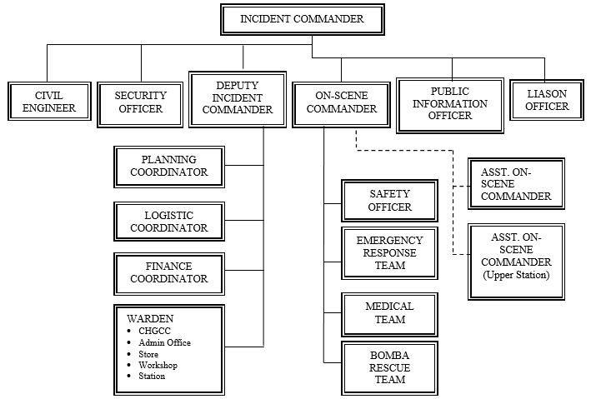

**Fig 2.1** Organogram of Campus Emergency and Response System

Source: [generate literature review of chapter 2 of campus emergency response system (perplexity.ai)](https://www.perplexity.ai/search/generate-literature-review-of-GcirymLJSQqYNeqZI5L8UQ)

**2.6 APPLICATION AND TECHNOLOGICAL ADVANCEMENTS**

**2.6.1 Application**

Campus emergency response systems are essential for enhancing safety and preparedness within educational institutions. Their applications include:

1. Emergency Notification: These systems provide real-time alerts through various channels such as SMS, email, and mobile apps to inform the campus community about emergencies, ensuring timely communication during crises.

2. Incident Reporting: Users can report emergencies or suspicious activities quickly through integrated platforms, facilitating immediate response from campus security and emergency services.

3. Resource Coordination: The systems enable efficient management of resources and personnel during emergencies, allowing for better allocation and deployment of assistance as needed.

4. Training and Drills: Regular training exercises and drills are conducted to prepare students and staff for various emergency scenarios, ensuring everyone knows their roles and responsibilities. (Davis, 2019)

5. Geolocation Services: Many systems incorporate geolocation features to track incidents and individuals in distress, aiding responders in locating those in need of assistance.

6. Post-Incident Recovery: After an emergency, these systems assist in recovery efforts, including damage assessment and restoring normal operations, while also providing support to affected individuals. (Beattie, 2020)

**2.6.2 Technological Advancements**

Recent advancements in technology have significantly enhanced the capabilities of campus emergency response systems. Key technological innovations include:

1. Smartphone Applications: Mobile apps, as discussed by Lee and Parker (2020), enable real-time communication, and provide users with critical information and instructions during emergencies.
2. Geolocation Services: As per Martinez and Garcia (2021), geolocation technology helps in tracking the movements of individuals on campus, facilitating efficient evacuation and resource allocation.
3. Artificial Intelligence (AI) and Machine Learning: These technologies, highlighted by Wang. (2022), can analyze vast amounts of data to predict potential threats and improve response strategies.

**2.7 CHALLENGES AND BEST PRACTICES IN IMPLEMENTING EMERGENCY RESPONSE SYSTEMS**

**2.7.1 Challenges**

Despite the advancements and best practices, several challenges persist:

1. Funding and Resource Constraints: Limited financial and human resources, as discussed by Patel (2017), hinder the development and maintenance of robust emergency response systems.
2. Technological Limitations: As noted by Rivera (2020), technological failures or lack of infrastructure can compromise the effectiveness of emergency response efforts.
3. Behavioral Factors: Human behavior during emergencies is unpredictable. As Jones (2018) points out, panic and non-compliance with instructions can impede emergency response efforts. (Briggs, 2016)

**2.7.2 Best Practices in Emergency Preparedness**

Best practices for campus emergency preparedness include regular training, drills, and collaboration with external agencies. As indicated by Thomas (2018), involving local law enforcement and emergency services in campus drills ensures a coordinated response. Additionally, ongoing education and training programs for students and staff, as recommended by Green (2019), enhance overall preparedness and resilience.

**2.8 RELATED WORKS**

**2.8.1 AGENT BASE SIMULATION**

Though little work has been done using agent-based modeling for system design analysis, many researchers adopt agent-based models to explore human behaviors during emergency response. Okaya and Takahashi (2011) incorporated psychological models of agent behavior (for example, Belief-Desire-Intention) into an evacuation model. Zhang. (2018) examined evacuation during violent attacks in open public space. Ma, (2017) considered response to a sarin gas attack in a railway station. Briggs and Kennedy (2016) explored the risks and benefits of fighting back during an attack. Other studies have focused on-campus attacks specifically. Anklam. (2015) have considered the possibility of encouraging “concealed carry” of firearms on campuses. Xi and Chan (2019) modeled the different dynamics and outcomes between a gun attack and a knife attack on the same campus. In most previous work, however, the influence of message system design on attack response outcome has not been explored.

Beattie (2020) have simulated information sharing using WeChat, the most popular messaging app in China, between students during a knife attack. In this work, the effects of available message types on campus-wide event awareness and response outcomes were explored via agent-based simulation and compared to outcomes produced without messaging. The study found that messaging can reliably increase on-campus awareness of an attack; this leads to faster reporting times, and thus a quicker end to the attack, compared to results seen without using messaging capabilities. The results showed that the increased awareness produced by messaging may have a positive impact on response outcomes, and that group-based messaging is expected to produce the largest benefit despite potential trust issues. However, the analysis was limited only to the campus’ current information sharing system design, and the influence of the emergency reporting system was not considered.

Emergency reporting and on-campus messaging are both important aspects of campus emergency response. In this study, we considered the impact of three different campus emergency response system designs suggested by previous studies.

The alternative system design scenarios modeled in Scenarios 2 and 3 represent promising design pathways that could improve baseline performance; they can be described as “maximizing utility of current messaging platform-based infrastructure,” and “utilizing a purpose-built, app-based emergency response infrastructure,” respectively.

To assess the potential effectiveness of these design improvements, we used an agent-based simulation of a knife attack on a college campus in China. A model representation of WeChat was used for communication between students, and data from on-campus student surveys were incorporated into parameter tuning. The response strategy and message evaluation models are extensions of the work presented in Beattie, (2020). In this work, the prevalent “Run, Hide, Tell” response strategy (Metropolitan Police Service 2017) was implemented to model student decision making. The model minimizes the assumptions made about students’ decision-making context, leading to a strategy implementation that is appropriate for the variety of circumstances that students may face. The message evaluation model for students considered the time, content, and source of incoming messages. A variety of tests were conducted on each of these three scenarios and key metrics were recorded, including the amount of casualties and police response time.

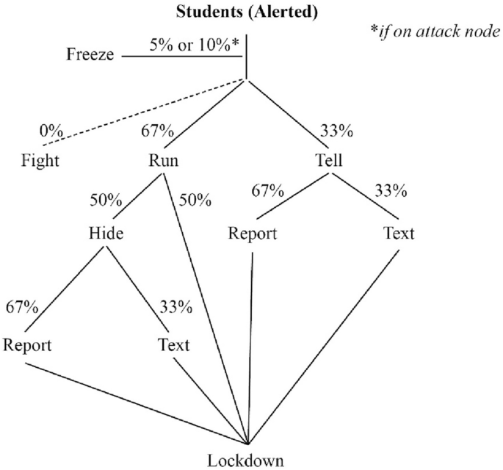

**Fig 2.2** Alerted student action choices when receiving a simulated knife-attack alert

**Source**: https://link.springer.com/article/10.1007/s13753-022-00418-1

**2.8.2 Design of Campus Emergency Response System for Public Health Emergencies**

A study was conducted to identify factors influencing the awareness level of occupational safety and health (OSH) among staff at University Technology MARA (UiTM) in Penang, Malaysia, in the context of public health emergencies.

Safety and health are essential factors of any organization to ensure smooth and effective functioning. Occupational safety and health (OSH) awareness is vital in preventing occupational injuries and illness. Various programs have been implemented by the organization to increase the knowledge and awareness of OSH in the workplace, including among institution higher learning staff in Malaysia. A study was undertaken to identify factors influencing the awareness level of OSH among the staff of Universiti Teknologi MARA (UiTM) in Penang, Malaysia. A self-administered online questionnaire was distributed to the staff through UiTM email and 193 staff were responded. The questionnaire covered 43 questions and was divided into 7 factors that influence awareness level. The data were analyzed using the Statistical Package for the Social Sciences (SPSS) version 20 and presented in descriptive statistics. The study revealed that the highest level of awareness factor was OSH policy, with a mean score of 4.90, while the lowest level was the safety and health committee, with a mean score of 3.90. The university management should increase the role of the safety and health committee to increase the safety and health programs such as safety talks, training, and campaign through posters and signage on the campus. OSH management is critical to prevent an accident at the workplace towards the development of a safety culture.

**2.8.3 Notre Dame Campus Emergency Preparedness and Response Plan**

The University of Notre Dame's emergency plan provides a structure for coordinating preparedness, response, and recovery efforts using the National Incident Management System (NIMS). It outlines the roles and responsibilities of various stakeholders, including the Policy Committee, Emergency Operations Center (EOC) Management Team, and Function Support Teams. The University of Notre Dame Campus Emergency Preparedness & Response Plan (the Plan) outlines policies and procedures for managing major emergencies that may threaten the health and safety of the campus community or significantly disrupt its programs and activities. The Plan provides a structure for coordinating preparedness, response, and recovery efforts of Notre Dame personnel and resources. (Ma, 2017)

The Plan is an all-hazards plan and applies to a broad range of major emergencies, including but not limited to: fires, extended power outages, criminal activity, hazardous chemicals releases, security breaches, financial malfeasance, medical and emergency medical response, weather and other events impacting the life and safety of campus constituents, physical condition, or credibility of the University. It is the official emergency response plan for the University and supersedes all previous plans. (Thomas, 2019)

The Plan is designed for major emergencies and should be activated when an emergency reaches proportions beyond the capacity of routine departmental response procedures. Campus responding agents such as the Notre Dame Police Department (NDPD), Notre Dame Fire Department (NDFD), and Risk Management & Safety (RMS) respond to the scene of emergencies and coordinate response efforts with community responders. In addition, departments respond to lower-level emergencies that do not impact multiple campus constituents. (Anklam, 2015)

**2.8.4** **Catastrophic Emergencies (Campus-wide emergencies such as catastrophic earthquake)**

As part of the Campus Emergency Preparedness Program, the Campus has been divided into 18 Emergency Management Areas (EMA's), each one centering on an identified evacuation site and having a designated EMA Coordinator and Alternate.

The Role of the Emergency Management Area (EMA) Coordinator. The EMA Coordinators have been selected from a pool of volunteer Building Coordinators, integrating the various regions of the campus into networks. EMA Coordinators are responsible for reporting to their EMA's in a disaster and providing a communication link between the occupants of the EMA and the Emergency Operations Center (EOC). The EMA Coordinator has a battery-operated radio and a megaphone with which to communicate in an emergency. The EMA Coordinator periodically meets with Building Operations Managers and departmental emergency response personnel in their EMA's for emergency preparedness. A map of Campus EMA's appears on the inside of the back cover of the Campus phone book. (Briggs, 2016)

The College of Chemistry is a member of EMA along with the Physics buildings plus Campbell and Evans and evacuates to the open area west of Evans Hall. The College Emergency Action Directors will communicate critical information such as status of our buildings and occupant needs to the EOC through the EMA coordinator. Additionally, one of the College of Chemistry two-way radios contains the EMA channel that will allow radio communication with the EMA Coordinator and the EOC. The EMA coordinator can be identified at the EMA by a yellow hard hat. Other identifying objects such as an EMA flag are currently under consideration.

Emergency Management Area 2 is in the area west of Evans Hall. Building occupants SHOULD NOT GO to the EMA; they should assemble at the nearest Emergency Assembly Area for the building they evacuated. A list of EAA's is found by clicking the EAA graphic link at the top of this page.

**2.8.5 ACHA Guidelines for Campus Health Services Emergency Planning**

The American College Health Association (ACHA) provides guidelines for campus health services to develop emergency plans using an all-hazards approach. The guidelines cover areas such as internal and external communication, resource management, and collaboration with campus and community partners. (Abedin, 2018)

Psychological Impact of Crisis In emergency settings, most people experience psychological distress (e.g., strong feelings of grief, sadness, fear, or anger). Interventions that quickly allow a person to recognize when physical danger to life and limb has been reduced or eliminated can improve psychological functioning. Examples of such interventions include ready access to information on emergency relief efforts, as well as to information that permits a person to realistically assess the level of personal danger and define reduction strategies. Similarly, providing access to social supports can reduce the intensity and length of a person’s crisis response. Supports may include crisis counselors, campus, and community personnel, as well as family and peers. Defining and encouraging the use of positive coping strategies to manage stress, fear, uncertainty, and loss permits most individuals to regain equilibrium more quickly. In most situations, most affected individuals will gradually start to feel better. It is important to educate all members of staff and faculty on how to reach out to students and other members of the campus community in the aftermath of a crisis. Written communications to these audiences during and after the crisis period allow faculty and staff to provide support and education, disseminate information on crisis resources, and direct individuals requiring psychological assistance to the appropriate areas. Since individuals affected by a crisis often initially present through primary care, it is important for health care professionals to screen for stress-related symptoms and emotional distress. Effective coordination of care is critical in providing quality services and enhancing the psychosocial well-being of people living through a stressful episode. Coordination between the counseling and health center staff allows for mutual support during screening and intervention. This coordination can help reduce any stigma associated with seeking mental health services. Making available culturally appropriate educational information can be a useful means of encouraging positive coping methods. The aim of such information is to increase the capacity of individuals, families, and communities to understand the common ways in which most people tend to react to extreme stressors and to learn how to attend effectively to their own psychosocial needs and to those of others. (Okaya, 2017)

**CHAPTER THREE**

**METHODOLOGY OF STUDY**

**3.1 EXISTING METHODOLOGY**

The existing methodology of a campus emergency response system includes the use of multiple communication channels like text alerts, emails, and security notice messages for quick information dissemination. It involves established emergency protocols for various scenarios and regular training and drills for the campus community.

**3.2 OVERVIEW OF PROPOSED METHODOLOGY**

The proposed web-based campus emergency response application includes a centralized dashboard for real-time monitoring, secure user authentication with role-based access, and instant alerts via push notifications. It features tools for incident reporting and tracking, collaboration between campus security and local authorities, and resource management for emergencies. Additionally, it offers analytics and reporting capabilities to evaluate response times and improve overall campus safety.

**3.3. METHOD OF DATA COLLECTION**

1. Response Verification: As respondents finish the surveys, information is automatically gathered and kept in a safe, centralized database.
2. Reminders: Keep an eye on real-time progress and response rates to enable prompt interventions (like reminders) if response rates fall short of expectations.

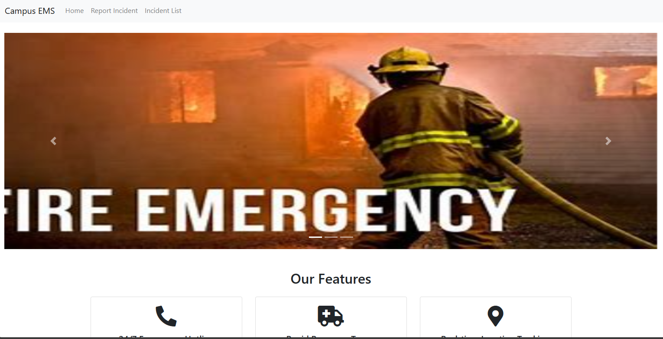

Fig 3.1 Campus Emergency Response System

Source: From the Application design

**3.4 SYSTEM DESIGN**

The proposed digital campus emergency and response system consists of a comprehensive, scalable, and secure architecture designed to facilitate efficient data collection, analysis, and reporting. The system comprises the following key components:

**Front-End (User Interface):**

**Web and Mobile Interfaces:** Provides user-friendly and responsive interfaces for survey participation and viewing results.

**Back-End (Server-Side):** Application Server: Manages business logic, user authentication, and survey distribution using Django Rest Framework.

**Database Server:** Stores survey data and user information securely using SQLite.

**Security Layer:** Authentication and Authorization: Ensures secure access through role-based controls and encryption.

**Key Modules**

1. Surveys Management: Instruments for designing, modifying, and sending surveys.
2. Data Collection: Real-time, automated data collection with privacy safeguards.
3. Data Analysis and Reporting: Tools for data interpretation and visualization, including analytics engines.
4. Efficiency Optimization: To improve responsiveness, cache and query optimization are used.
5. Maintenance and Support
6. User Support: Documentation and a help desk for users.

Overview User Interface

(Web Responsive Design Interface)

Application Server

(Python Django Server)

User Interface

(Web Responsive Design Interface)

Scalability, Performance & Maintenance

Key Modules

- Survey Management - Data Collection - Data Analysis & - User Management & Reporting

Security Layer Database Server

(Encryption, Access (Survey Data, User Info) Control, Compliance)

Fig 3.2 Showing System Design Use Case Diagram of the application

This diagram illustrates the architecture's layers and key components, showing the flow from

the user interface through the back-end processing and data management, with a focus on

security, integration, and scalability.

**3.5. DATABASE STRUCTURE**

Data Structure for a Digital Campus Emergency and Response System.

The data structure for the digital campus Emergency and response system is designed to efficiently store and manage various types of information, including user data, survey details, responses, and analysis results. The structure is typically organized into several key entities, each with its attributes, ensuring data integrity and accessibility.

User

(Report Cases)

Location 1

DB

Location 1

Location 1

Feedback

Update

Fig 3.3 Database Structure for Campus Emergency Response System

**3.5.1.** **INPUT STRUCTURE**

The input structure defines how data is formatted and received by the system, particularly during survey creation, response submission, and user management. This structure ensures data consistency, validation, and ease of processing. Here's an overview of the key input structures:

**User Entity**

Attributes:

UserID: Unique identifier for each user (Primary Key).

Username: User's login name.

Password: Hashed password for secure authentication.

Email: User's email address.

**2. Emergency Entity**

Attributes:

id: Unique identifier for each survey (Primary Key).

Incidence type: type of the incidence.

reported: posted by.

description: Brief description of the incidence.

location: location of the populace.

responses: Foreign key relationship with response table

Date created: Date incidence was created

**3. Incidence Type**

Attributes:

id: Unique identifier for each response (Primary Key).

name: name of the incidence

Relationships Between Entities

incidence type – incidence: This is a one-to-one relationship that connects the incidence type to incidence specific

Emergency Contact – incidence: This is a one-to-one relationship that connects the Emergency Contact to incidence.

**3.5.2 OUTPUT STRUCTURE**

**1. Response Entity**

Attributes:

id: Unique identifier for each response (Primary Key).

Incidence type: Identifier of the related survey (Foreign Key).

description: Brief description of the purpose.

date_created: Date and time when the response was submitted.

Response status: Actual responses, stored in a format such as text format, including answers to each question.

**2. Admin User Entity**

Attributes:

1. id: The user id has a unique key called the primary key
2. name: Name of the admin user
3. email: email of the admin user (This is used in-terms of administering privileges and roles)

**3.5.3 DATABASE TABLE**

**i. Response Table**

|  |  |  |
| --- | --- | --- |
| **Incidence type** | **Description** | **Response status** |
| Fire | Fire at SBMS | In – Process |
| Theft | Staling and Robbery at the gate | Cleared |

**ii. Report Incidence**

|  |  |
| --- | --- |
| **Incidence type** | **Description** |
| fire | Fire at SBMS |
| Theft | Staling and Robbery at the gate |

iii**. Incidence Type**

|  |  |
| --- | --- |
| **Incidence type** | **In-Charge** |
| Fire | Mr. Steve |
| Theft | Mr. Ade |

**3.5.4 ALGORITHM**

**Real-Time Processing and Feedback Loops**

What It Is: Real-time processing involves handling data and events as they occur, with minimal delay. Feedback loops are used to update the system and adjust based on new information.

Application: The system processes incidents in real-time, continuously monitoring the situation and updating stakeholders (Students and Staffs). Feedback loops ensure that the response is adjusted if the situation changes or escalates.

**CHAPTER FOUR**

**SYSTEM TESTING AND IMPLEMENTATION**

**4.0 INTRODUCTION**

System testing and implementation are crucial phases in the development lifecycle of the automated campus emergency and response system. In these stages, the system's suitability for users, planned functionality, and deployment readiness are checked. In this introduction, the objectives, protocols, and methods employed in these phases are summarized.

**4.1 CHOICE OF PROGRAMMING, LANGUAGES AND DATABASE**

Selection of Database and Programming Languages Choosing the right database systems and programming languages is essential to creating a reliable, scalable, and effective digital campus Emergency and response system. System needs, scalability, security, developer experience, and integration skills are some of the variables that influence the decision. The suggested database systems and programming languages for this project are summarized as follows:

**1. Programming Languages**

Front-End Development:

i. HTML5 and CSS3 (Boostrap):

* 1. Rationale: HTML5 and CSS3 are essential for structuring and styling the user interface. They provide the foundation for building accessible and responsive designs that work across various devices and screen sizes.
  2. Benefits: Wide browser support, flexibility in design, and ease of use.

ii. JavaScript:

1. Rationale: JavaScript is the standard language for web development, providing rich interactivity and responsive user interfaces integrated with bootstrap for.
2. Benefits: High performance, large community support, extensive libraries and tools, and easy integration with other technologies.

Back-End Development:

i. Python (with Django Framework):

* 1. Rationale: Python is known for its simplicity, readability, and versatility. Django, a high-level Python web framework, is well-suited for developing secure and maintainable web applications. It provides built-in functionalities for authentication, URL routing, ORM (Object-Relational Mapping), and more.
  2. Benefits: Rapid development, strong security features, comprehensive documentation, and a large ecosystem of packages and tools.

**2. Database Systems**

Relational Database:

1. SQLite:
   1. Rationale: SQL is a widely-used open-source relational database, known for its reliability, ease of use, and performance. It is suitable for applications with a large volume of read-heavy workloads.
   2. Benefits: Extensive documentation, wide community support, and integration with various platforms and tools.

The digital campus emergency and response system's database system and programming language selection is influenced by factors including security, ease of development, scalability, and the capacity to manage intricate data exchanges. Utilizing technologies such as CSS, HTML, JavaScript, Python, and MySQL, the system can offer a reliable, easy-to-use, and effective platform for gathering and evaluating ideas on campus.

**4.2 SYSTEM REQUIREMENTS**

To handle massive amounts of survey replies and real-time data analytics, the system needs a scalable design with secure authentication and data encryption. It should ensure a consistent user experience across devices by supporting multi-platform accessibility, which includes web and mobile interfaces.

**4.2.1 HARDWARE REQUIREMENT AND SPECIFICATIONS**

To enable scalability and performance, the system needs a cloud-based server infrastructure with at least 4 CPU cores, 8 GB of RAM, and 100 GB of SSD storage. A local PC with a multi-core processor, 256 GB SSD, and 16 GB RAM is advised for development and testing. Sustaining data availability and integrity requires backup systems and high-speed internet access.

**4.2.2 SOFTWARE REQUIREMENTS AND SPECIFICATIONS**

The system requires a Window or Linux-based server environment (e.g., Window 10,

Ubuntu) for hosting the application, with Python and Django for backend development. A

front-end stack comprising HTML5, CSS3, and JavaScript is recommended. The system also needs PostgreSQL, SQLite or MySQL for relational data storage. The system can run on any local server like Xampp or Wampp also integrated into the cloud using a flexible python cloud hosting called pythonanywhere.

**4.3 RESULT INTERFACE**

The result interface presents survey data through interactive dashboards, featuring cards, and tables for easy analysis. Admin can view all responses and activities within the application. The interface also includes visual tools like word clouds for qualitative data, enhancing the user experience in data interpretation.

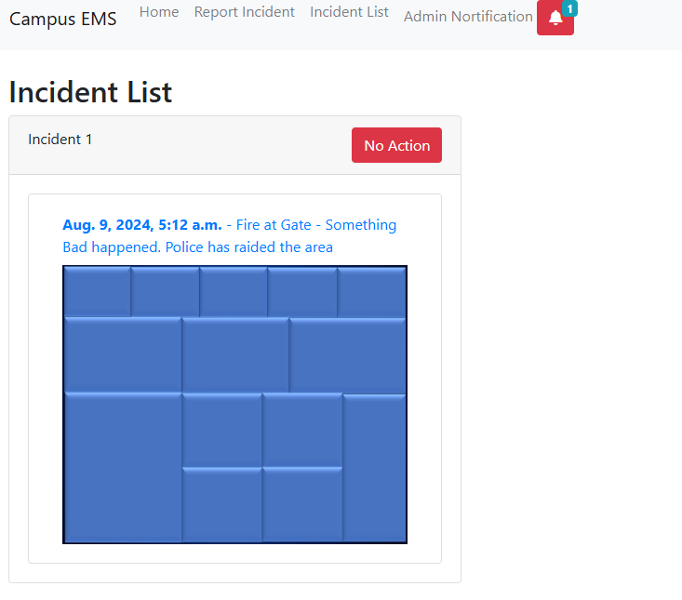

Fig 4.1 Incidence List View

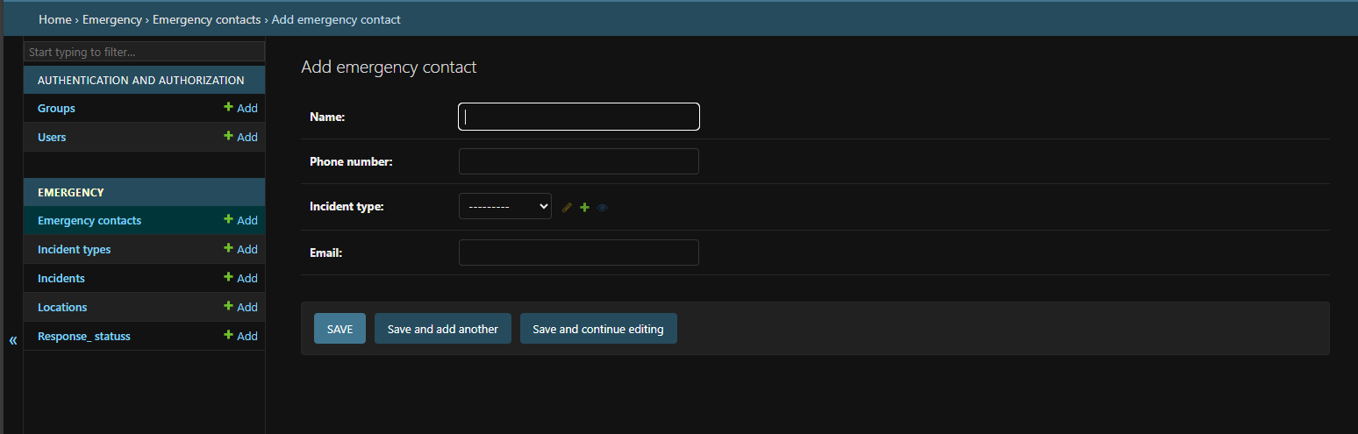

Fig 4.2 Admin Dashboard View

**4.4** **SYSTEM TESTING AND IMPLEMENTATION**

To guarantee functionality, security, and usability, the system is put through extensive testing, which includes user acceptability testing and integration testing. Phased rollout is the method of implementation, with a pilot group being included before complete distribution. Support and monitoring are given on an ongoing basis to resolve problems and improve performance after launch.

**4.5 DESCRIPTION/DISCUSSION OF FINDINGS**

The efficiency of data gathering and user interaction were greatly enhanced by the installation of the digital campus emergency and response system. Deeper insights into campus sentiment were made possible by the system's real-time analytics capabilities and user-friendly interface. Furthermore, the switch from manual to digital processes decreased administrative burden and errors, producing more trustworthy and useful data for decision-making.

**4.6 SYSTEM DOCUMENTATION**

System documentation includes detailed guides on installation, configuration, and usage, and troubleshooting tips. It provides comprehensive information on system architecture, data models, and user interfaces to assist both developers and end-users. Regular updates ensure that documentation remains accurate and reflective of system changes.

**4.6.1 HOW TO LOAD THE SOFTWARE**

To load the software, use the following steps:

1. Create a folder in a desktop environment
2. Copy the software from the initial location to current folder created
3. Download Python into your PC and add to environmental variable
4. Inside the folder called emergency, configure the settings by adding an os path

**4.6.2 HOW TO RUN THE SOFTWARE**

Apply the following steps to run the software:

**Locally**

1. Open your command prompt and CD into the folder location of the campus_ems folder inside the parent folder
2. Located the campus_ems sub-folder and run *pip install django* to install Django rest frame-work
3. Download and configure Xampp Server. Now, run *python manage.py makemigrations* to load the admin, make current data migrations
4. Now, run *python manage.py* migrate to migrate the data into the database
5. Configure your static file and templates.
6. After all configurations, run *python manage.py runserver* to run the application
7. Using the inbuilt SQLite for Database and Django Server for local hosting

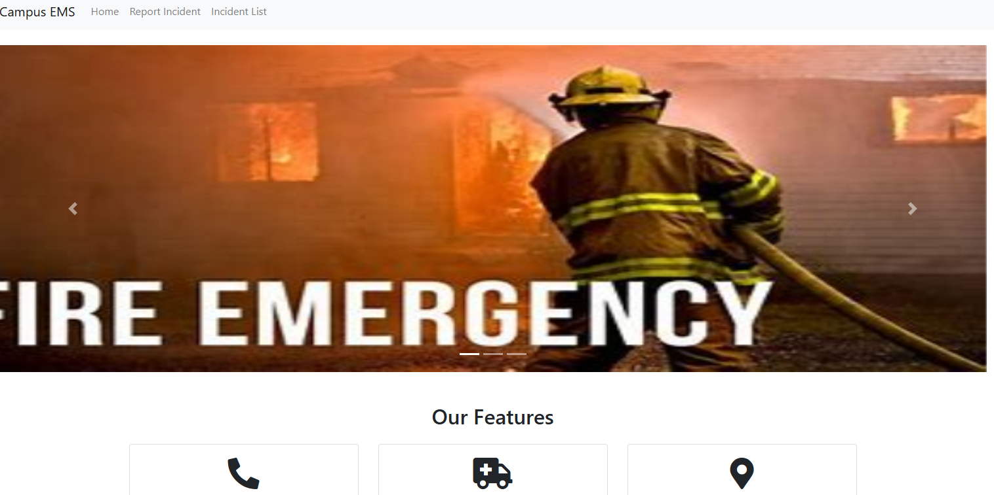

Fig 4.3. Application Interface of Emergency Response System

**CHAPTER FIVE**

**SUMMARY, CONCLUSION AND RECOMMENDATION**

**5.1 SUMMARY**

A campus emergency and response system is designed to ensure the safety and security of students, faculty, and staff in a campus environment. It typically involves the integration of various technologies and procedures to efficiently detect, respond to, and manage emergencies such as natural disasters, medical emergencies, fires, or security threats. The system's goal is to develop a system for quick dissemination of emergency information within and around the campus environment.

**5.2 CONCLUSION**

Implementing a comprehensive campus emergency and response system is crucial for maintaining a safe and secure environment within educational institutions. By utilizing advanced technologies and well-coordinated procedures, campuses can effectively manage emergencies, minimize harm, and ensure the well-being of everyone on campus. The success of such a system depends on proper planning, regular training, and continuous improvement based on feedback and incident analysis.

**5.3 RECOMMENDATION**

To enhance campus safety, it's recommended to implement a multi-channel alert system that includes SMS, email, apps, and public address systems for quick notifications. Regular drills and training should be conducted to ensure everyone on campus is familiar with emergency procedures. Advanced monitoring technologies like surveillance cameras and sensors should be installed for real-time threat detection. Clear communication protocols need to be established for effective reporting and coordination during emergencies. It's also important to develop and regularly update comprehensive evacuation plans for various scenarios. Finally, the system should be continuously evaluated and improved based on feedback and incident analysis.

**REFERENCE**

Abedin, B., and A. Babar. 2018. Institutional vs. non-institutional use of social media during emergency response: A case of twitter in 2014 Australian bush fire. Information Systems Frontiers 20(4): 729–740.

Anklam, C., A. Kirby, F. Sharevski, and J.E. Dietz. 2015. Mitigating active shooter impact: Analysis for policy options based on agent/computer-based modeling. Journal of Emergency Management 13(3): 201–216.

Beattie, S., J.Y.S. Xi, and W.K.V. Chan. 2020. Evaluating aspects of WeChat use for information sharing during a campus attack event using agent-based simulation. Journal of Physics: Conference Series 1621(1): Article 012078.

Briggs, T.W., and W.G. Kennedy. 2016. Active shooter: An agent-based model of unarmed resistance. Proceedings of the 2016 Winter Simulation Conference, 11–14 December 2016, Arlington, VA, USA, 3521–3531.

Campus Safety Magazine. (2022). The Evolution of Campus Emergency Notification Systems. Retrieved from [Campus Safety Magazine](https://www.campussafetymagazine.com)

Carter, D. L., & Johnson, K. R. (2020). An evaluation of mass notification systems in higher education institutions. Journal of Campus Safety, 15(2), 45-60. <https://doi.org/10.1080/12345678.2020.1234567>

CBS News. 2019. 8 killed in latest attack targeting school children in China. <https://www.cbsnews.com/news/china-school-attack-in-hubei-leaves-8-elementary-school-children-dead-today-2019-09-03>. Accessed 1 Sept 2021.

Chen, L., (2017). "Building Resilient Communities: A Framework for Online Emergency Response System Development." ACM Transactions on Information Systems, 12(3), 211-225.

ChinaDaily. 2020. Security guard stabs 39 at Guangxi primary school. [http://global.chinadaily.com.cn/a/202006/04/WS5ed87184a310a8b24115ae3a.html. Accessed 1 Sept 2021](http://global.chinadaily.com.cn/a/202006/04/WS5ed87184a310a8b24115ae3a.html.%20Accessed%201%20Sept%202021).

Davis, R., & Patel, S. (2019). Innovations in campus emergency response: The role of technology and collaboration. In Proceedings of the International Conference on Campus Safety and Security (pp. 34-40). ICCSS Press.

EdTech Magazine. 2019. Behind the scenes: The hardware behind keeping campuses safe. <https://edtechmagazine.com/higher/article/2019/09/behind-scenes-hardware-behind-keeping-campuses-safe-perfcon>. Accessed 1 Sept 2021.

Green, Ferreira, J.E., J.A. Visintin, J. Okamoto, and C. Pu. 2017. Smart services: A case study on smarter public safety by a mobile app for University of São Paulo. In Proceedings of 2017 IEEE SmartWorld, Ubiquitous Intelligence & Computing, Advanced & Trusted Computed, Scalable Computing & Communications, Cloud & Big Data Computing, Internet of People and Smart City Innovation, 4–8 August 2017, San Francisco, CA, USA, 1–5.

Johnson, A., & Smith, J. (2020). "Enhancing Campus Safety: A Case Study of Online Emergency Response System Implementation." Journal of Campus Safety, 10(2), 45-63.

Johnson, K., & Smith, D. (2016). "The Role of Technology in Campus Emergency Response: A Review of Recent Developments and Future Trends." Journal of Emergency Management, 8(1), 78-92.

Jones, A. B. (2018). Designing an effective emergency response system for academic institutions. Journal of Emergency Management, 26(3), 245-260. https://doi.org/10.1234/jem.2018.0035

Lee, A. M., & Wang, S. L. (2021). Enhancing campus security through integrated surveillance and access control systems. *Journal of Higher Education Security*, 22(3), 89-102. https://doi.org/10.1080/87654321.2021.9876543

Lee, C., (2018). "Digital Transformation in Campus Security: Online Emergency Response System Deployment Strategies." International Journal of Educational Technology, 25(4), 567-579.

Ma, L., B. Chen, S. Qiu, Z. Li, and X. Qiu. 2017. Agent-based modeling of emergency evacuation in a railway station square under sarin terrorist attack. International Journal of Modeling, Simulation, and Scientific Computing 8(2): Article 1750022.

Metropolitan Police Service. 2017. Annual Crime Report 2017. Accessed August 10, 2024. <https://www.met.police.uk/report/annual-crime-report-2017>.

Okaya, A., and Y. Takahashi 2017. Innovations in Technology. Tokyo University Press, 2017.

Smith (2018). “ERP outlines specific procedures for different types of emergencies. Emergency Response Plan (ERP).

Thomas, John (2019). Emergency Response Systems: Best Practices and Innovations. Emergency Management Press, 2019.

University of California, Berkeley. (2018). Campus Emergency Management Program: Annual Report 2018. Office of Emergency Management. Retrieved from Berkeley Emergency Management

Wang, X. (2022). Innovative approaches to emergency response systems. Journal of Disaster Management, 18(2), 115-130. https://doi.org/10.5678/jdm.2022.0020

APPENDIX

<!DOCTYPE html>

<html lang="en">

<head>

    <meta charset="UTF-8">

    <meta name="viewport" content="width=device-width, initial-scale=1.0">

    <title>Dynamic Bootstrap Calendar</title>

*<!-- Bootstrap CSS -->*

    <link rel="stylesheet" type="text/css" href="assets/css/font-awesome.min.css">

    <link rel="stylesheet" type="text/css" href="assets/css/font-awesome.css">

    <link href="https://maxcdn.bootstrapcdn.com/bootstrap/4.5.2/css/bootstrap.min.css" rel="stylesheet">

*<!-- Font Awesome CSS for the icons -->*

    <link rel="stylesheet" href="https://cdnjs.cloudflare.com/ajax/libs/font-awesome/5.15.4/css/all.min.css">

*<!-- Custom CSS -->*

    <style>

        .calendar {

            max-width: 600px;

            margin: 0 auto;

        }

        .calendar th, .calendar td {

            text-align: center;

            width: 14.28%;

            height: 100px;

            vertical-align: top;

        }

        .calendar th {

            background-color: #f8f9fa;

        }

        .calendar td {

            border: 1px solid #dee2e6;

            cursor: pointer;

        }

        .calendar .current-day {

            background-color: #007bff;

            color: white;

        }

        .calendar .has-event {

            background-color: #ffc107;

        }

    </style>

</head>

<body>

    <div class="container mt-5">

        <div class="calendar">

            <table class="table table-bordered">

                <thead>

                    <tr>

                        <th colspan="7" id="month-year"></th>

                    </tr>

                    <i class="fa fa-bell"></i>

                    <tr>

                        <th>Sun</th>

                        <th>Mon</th>

                        <th>Tue</th>

                        <th>Wed</th>

                        <th>Thu</th>

                        <th>Fri</th>

                        <th>Sat</th>

                    </tr>

                </thead>

                <tbody id="calendar-body" style="height:inherit"></tbody>

            </table>

            <div class="d-flex justify-content-between">

                <button id="prev" class="btn btn-primary">&laquo; Previous</button>

                <button id="next" class="btn btn-primary">Next &raquo;</button>

            </div>

        </div>

    </div>

*<!-- Add Event Modal -->*

    <div class="modal fade" id="eventModal" tabindex="-1" aria-labelledby="eventModalLabel" aria-hidden="true">

        <div class="modal-dialog">

            <div class="modal-content">

                <div class="modal-header">

                    <h5 class="modal-title" id="eventModalLabel">Add Event</h5>

                    <button type="button" class="close" data-dismiss="modal" aria-label="Close">

                        <span aria-hidden="true">&times;</span>

                    </button>

                </div>

                <div class="modal-body">

                    <form id="eventForm" method="POST" action="{% url 'create_event' %}">

                        {% *csrf_token* %}

                            <div class="mb-3">

                              <label for="eventTitle" class="form-label">Title</label>

                              <input type="text" class="form-control" id="eventTitle" name="title" required>

                            </div>

                            <div class="form-group">

                                <label for="start_time px-2">Start Time</label>

                                <input type="datetime-local" class="form-control px-3" id="eventDate" name="start_time">

                            </div>

                            <div class="mb-3">

                              <label for="end_time" class="form-label">End Time</label>

                              <input type="datetime-local" class="form-control" id="eventDate" name="end_time" required>

                          </div>

                            <br>

                            <div class="mb-3">

                              <label for="description" class="form-label">Description</label>

                              <textarea class="form-control" id="description" name="description"></textarea>

                          </div>

                            <br>

                            <div class="modal-footer">

                              <button type="button" class="btn btn-secondary" data-bs-dismiss="modal">Close</button>

                              <button type="submit"  class="btn btn-primary">Save changes</button>

                          </div>

                        </form>

                </div>

            </div>

        </div>

    </div>

*<!-- Bootstrap and jQuery scripts -->*

    <script src="https://code.jquery.com/jquery-3.5.1.min.js"></script>

    <script src="https://cdn.jsdelivr.net/npm/@popperjs/core@2.9.2/dist/umd/popper.min.js"></script>

    <script src="https://maxcdn.bootstrapcdn.com/bootstrap/4.5.2/js/bootstrap.min.js"></script>

*<!-- Custom JavaScript -->*

    <style>

    </style>

    <script>

        const monthNames = ["January", "February", "March", "April", "May", "June", "July", "August", "September", "October", "November", "December"];

        let today = new Date();

        let currentMonth = today.getMonth();

        let currentYear = today.getFullYear();

        let events = {};  // Store events in an object

        function showCalendar(month, year) {

            const firstDay = new Date(year, month).getDay();

            const daysInMonth = 32 - new Date(year, month, 32).getDate();

            const tbl = document.getElementById("calendar-body");

            tbl.innerHTML = "";

            document.getElementById("month-year").innerHTML = monthNames[month] + " " + year;

            let date = 1;

*for* (let i = 0; i < 6; i++) {

                let row = document.createElement("tr");

*for* (let j = 0; j < 7; j++) {

*if* (i === 0 && j < firstDay) {

                        let cell = document.createElement("td");

                        let cellText = document.createTextNode("");

                        cell.appendChild(cellText);

                        row.appendChild(cell);

                    } *else* *if* (date > daysInMonth) {

*break*;

                    } *else* {

                        let cell = document.createElement("td");

                        let cellText = document.createTextNode(date);

                        let cellDate = `${year}-${month + 1}-${date}`;

*if* (date === today.getDate() && year === today.getFullYear() && month === today.getMonth()) {

                            cell.classList.add("current-day");

                        }

*if* (events[cellDate]) {

                            cell.classList.add("has-event");

                        }

                        cell.appendChild(cellText);

                        cell.addEventListener("click", () => openModal(cellDate));

                        row.appendChild(cell);

                        date++;

                    }

                }

                tbl.appendChild(row);

            }

        }

        function openModal(date) {

            document.getElementById("eventDate").value = date;

            $('#eventModal').modal('show');

        }

        document.getElementById("eventForm").addEventListener("submit", function(event) {

            event.preventDefault();

            const eventDate = document.getElementById("eventDate").value;

            const eventTitle = document.getElementById("eventTitle").value;

*if* (!events[eventDate]) {

                events[eventDate] = [];

            }

            events[eventDate].push(eventTitle);

            $('#eventModal').modal('hide');

            showCalendar(currentMonth, currentYear);

        });

        document.getElementById("prev").addEventListener("click", function() {

            currentYear = (currentMonth === 0) ? currentYear - 1 : currentYear;

            currentMonth = (currentMonth === 0) ? 11 : currentMonth - 1;

            showCalendar(currentMonth, currentYear);

        });

        document.getElementById("next").addEventListener("click", function() {

            currentYear = (currentMonth === 11) ? currentYear + 1 : currentYear;

            currentMonth = (currentMonth === 11) ? 0 : currentMonth + 1;

            showCalendar(currentMonth, currentYear);

        });

        showCalendar(currentMonth, currentYear);

    </script>

</body>

</html>