COUNTRY OF OPERATION:

TANZANIA

SCHOOL COORDINATOR:

HUBERTUS ZANDER

|  |  |
| --- | --- |
| A picture of a winding road and trees  The tech safari 2022  ‘Safari’ is a Swahili word which mean a long journey. The journey to successful technological innovations is very long, the tech safari marks the little step towards that ultimate destination. | Project leaders:  1.IGNAS KAMUGISHA  2.ARBOGAST MAGOMBA |

**Table of Contents**

Section A: Project summary 2

The addressed issue 2

Our impact in long term 4

Quantifying success 4

Expected challenges 5

Section B: Operating Plan 5

Timescales 5

What practically do you think students will gain in such a short timescale? 8

Requesting additional funds than the $1000 cap 8

Section C: About the Team 9

Team leader 1: Ignas Kamugisha (2nd Year) 9

Biography 9

Relevant experience 10

Team leader 2: Arbogast Magomba (1st Year) 10

Biography 10

Relevant experience 11

# Section A: Project summary

The tech safari (translating into the tech Journey) will be an engine to accelerate interests and help aspiring young Tanzanians to realize their talents and potentials in using technology to promote change and solve real life problems in the community. The tech safari team will visit secondary schools and colleges especially in remote areas in Tanzania. with a 5-days stay per school/college students will learn about the practical applications of technology, specifically the intersection between software and hardware.

The project program is designed to cover important aspects of technological innovations within 15 hours, implying a minimum of 3 hours a day.

In the first wave, the tech safari is set to cover up to 6 schools/institutions in different regions of the country within its operating timeframe of 6 weeks. However, our dream is to make this project continuous by collaborating with experienced peers in their gap years to undertake “the tech safari” in future years.

## The addressed issue

Researches have concluded that, the level of technology in a country has a positive correlation with the level of development in a country. Countries with A higher level of development corresponds to a higher level of innovations, the opposite applies to lower innovative countries, Tanzania is no exception.

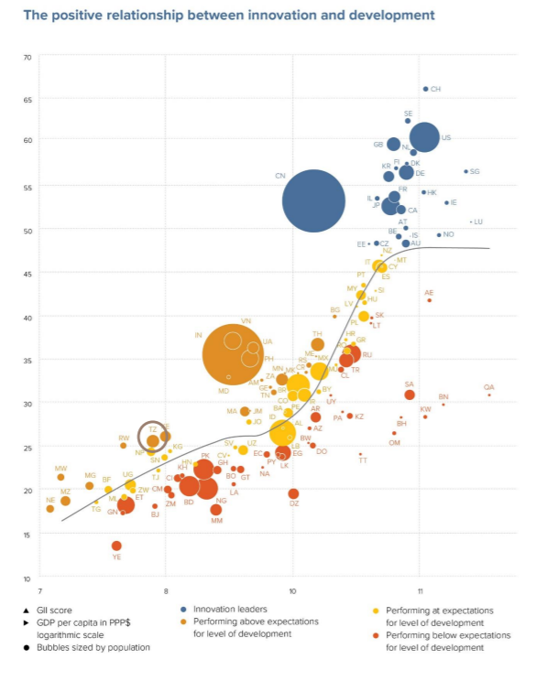

A curve showing a positive relationship between innovation and the level of development in countries.

This implies that, technological innovations will inevitably result long term development in a country.

Tanzania is one of the countries in the lowest innovation percentile, and this is mostly due to lack of realization and motivation of using technological innovations as a tool for change. Many young Tanzanians are hence at a risk of being left behind due to limited access of proper technical education in most regions.

The tech safari will ignite innovative spirits into the young Tanzanians and help to bridge the existing technology gap, addressing a problem that is not visually seen but it has been hindering our society from development - the inability to see technology as a tool that can be used to foster a sustainable development in the long run.

We believe that the small steps made by the tech safari will be the beginning of bigger changes in our communities.

Quoting from Hon UWC Figure Nelson Mandela;

“Education is the great engine of personal development. It is through education that the daughter of a peasant can become a doctor, that the son of a mine-worker can become the head of the mine, that a child of farmworkers can become the president of a great nation."

The technical education provided by the tech safari will prepare the young generation to become the next leaders in innovations, and we think this is how long-term development should be.

## Our impact in long term

Quoting from B.B King, “The beautiful thing about learning, is that nobody can take it away from you”, Once we leave the area the skills, ideas and the innovative spirit planted will remain with them it can’t be consumed or replenished but can be improved as a result of its application, that’s why we think our idea is impactful in a way that we are promoting change by not directly applying our technological knowledge is solving problems in different communities, but by helping the youngsters to learn and realize their potentials in tackling problems in their communities. That way a sustainable impact remains even when we have left the area.

## Quantifying success

The ‘Tech safari’ sessions will involve different analytical challenges to test the conceptual understanding of the participants, our success will be measured in terms of how the participants interacted and tackled the challenges posed to them, including how they show a realization of problems in their community which can be solved by application of technology.

## Expected challenges

* Electricity is still a problem in many parts of the country, for example some parts only get power for a few hours per day, because the program will rely on electricity to power the teaching facilities, we do consider this problem and we plan to have portable power banks to keep us going even in areas where electrical power is a problem.
* Travelling to remote areas in Tanzania will not be easy due to poor infrastructure, going beyond our comfort zone will be crucial in making this project a success, for instance taking buses and motor bikes for long distances in order to reach the targeted destinations.

**Word count:** 856 words

# Section B: Operating Plan

## Timescales

|  |  |  |
| --- | --- | --- |
| Date | Action | Description |
| 1st – 15th June | Preparing our teaching materials and solidifying the project plans | It is during these 16 days period when we will take time to rectify any uncertainty in our plans, this will include making final communications with the targeted institutions, preparing our teaching materials and make bookings for transportation.  To reduce the costs, we will design our own electronics board powered by Arduino that can be easily used by people with little to no experience, we will also prepare special guiding booklets to be distributed in the institutions we visit.  We live a mission for sustainability, so we will collect and recycle unused electronics and reuse them in some parts of the teaching boards.  It is also during this period when we will have to realize any further shortfall in funds and readjust our plans conveniently. |
| 18th – 19th June | Travelling to the first destination | Throughout our project we will mainly use buses due to their environmental efficiency (megajoules per passenger Kilometer) and cost friendly. This implies that we will have to spend most of the weekends travelling, as we have realized travelling from one region to another in  with a bus in Tanzania takes a minimum of 8 hours up to 14 hours. |
| 20th - 24th June | Teaching in the first institution | During this 5-days period we will work with the first school. This will be daily for a minimum of 3 hours per group for 5 days. Students will learn concepts such as Arduino programming in a project-oriented way. In the early days interaction, the participant will learn the art of problem realization in their community and based on that we will work on an Arduino project related to that problem for the rest of the days. |
| 25th – 26th June | Reflecting on our progress and travelling to the next destination. | At the end of our week in an institution, we will take time to reflect on our progress and we will also use this weekend to travel to the next destination. |
| 27th June – 1st July | Working with the second institution | During this week will continues the ‘tech safari’ in the second institution. |
| 2nd – 3rd July | Reflecting and travelling to the next destination. |  |
| 4th – 8th July | Running the tech safari workshop in the third institution. | (7th of July will be a public holiday and we plan compensate for this day by increasing our teaching pace slightly) |
| 9th – 10th July | Reflecting and travelling to the next destination |  |
| 11th – 15th July | Working with the fourth institution. |  |
| 16th – 17th July | Travelling |  |
| 18th – 22th | Working with the fifth institution |  |
| 23rd – 24th | Travelling |  |
| 25th – 29th July | Working with sixth and the last institution. |  |
| 30th July – 4th August | Finishing the “tech safari” and documenting our project | This will be the last week of the project, during this period we will document our journey and launch a website which we will be already working on throughout.  Documentation will include our successes and challenges the impact, connection created, what we could be better or what should be unchanged for the next wave of the ‘Tech safari’ |
| 5th August - | Going back to our homes as we celebrate the difference, we have made. |  |

## What practically do you think students will gain in such a short timescale?

Our project targets students with little to zero knowledge about technology and innovations especially between the age of 14 and 19. To put it into perspective most students in Tanzania do not have access to a computer/laptop until the university level (their 20s).

So, the problem in not only lack of skills and facilities to pursue technological innovations but awareness about such possibility is simply non-existent.

During the one-week period we aim at helping the participants realize the unlimited possibilities of technological innovation and ignite interests in the field, that is why our delivery method will be more focused on understanding where a certain concept can be applied instead of strictly understanding a concept itself, for example instead of deep diving into teaching a programming language we will teach on how you can implement a solution by using pseudocode -*an informal way of programming description that does not require any strict programming language syntax or underlying technology considerations.* This way participants will learn how to devise innovative solutions and present them in a systematic way, a skill which can be gained during the period. While this is not enough to create a practical solution it is enough to stem curiosity and interest in further exploring the field.

## Requesting additional funds than the $1000 cap

Our project is meant to operate in the country at least twice every year. The additional funding will enable our project “the tech safari” to expand and reach more regions in the country, as one of us takes a gap year the project will continue later on even after its GoMAD timeline is over. The additional funding will hence serve as a long-term investment for the “tech safari” to continue with its operation in more institutions.

The additional funding is mainly directed to the purchase of the laptops which will be used during our technology workshops, this is because most Tanzanians do not have laptops and also many educational institutions also does not have computer labs which could be used as an alternative, without the laptops it will be very challenging to conduct the project in the long term, otherwise we will be forced to only visit a few schools which have computer labs. One of our goals is to bridge the gap in accessing technical education which is mostly big in remote areas so these areas are the one with the great need, having portable computers/laptops will allow us to reach these areas where a difference made will be huge.

In a case that the funds won’t be enough for this, our plan is to start with the few schools/institutions where they already have computers, and over time to raise money through campaigns and donations to fund this.

# Section C: About the Team

## Team leader 1: Ignas Kamugisha (2nd Year)

## Biography

My passion for creativity has been evident from a very early age, would play with small circuits scavenged from old electronics, I would visit a local repair shop with my few coins in a hope of getting any damaged electronic components in return.

Later I was selected to join a special technical school in Tanzania. There, my spirit for innovation was further ignited after a contact with ambassadors from TME education. Since then, I have designed various systems which solved real world problems not only in my school. My dream is to see more young Tanzanians realizing their potentials in innovations.

## Relevant experience

It is for my burning passion for innovation that I got an opportunity to join A UWC school that lives a mission of sustainability, here I have kept my dream going by founding a mechatronics club where I help my peers interested in technology to learn more and develop innovative solutions.

I have led various tech-based one-week projects in my school where I shared my passion for innovations with my peers in a one-week camp, for instance last semester we build a prototype for a digital system which will manage and keep track of bikes in our college.

Currently I am leading a project week where we will design a digital system to automate the process of checking out books in the library, this aims at serving as sustainable solution by reducing unnecessary paper waste.

The “Tech safari” will provide an opportunity for me to make a difference in my country through my passion in innovations, my previous experience in leading projects will play a great role in making the tech safari successful. This project will further give me an opportunity to further develop my skills and shape my future career as a mechatronics engineer.

## Team leader 2: Arbogast Magomba (1st Year)

## Biography

I started engaging myself in technology at the age of 8 when my parents got me a laptop, I was mesmerized by the functionality of computers and my interests in learning more increased as the days went by. Until the age of 13, I was making small tech projects and at that point I got inspired in the world of programming, innovation and general tech knowledge. As a young programmer and innovator, I realized that I can help my community through my innovations and technology.

## Relevant experience

This project will allow me to learn more interesting things that will benefit my future as a tech entrepreneur and innovator. In the past years I have involved myself in various innovative projects. One of the projects was a device that I designed to help people with impaired vision to navigate easily with the aid of the device and avoid any obstacle through signals from the device. Intellectually challenging myself through such projects equipped me with creative skills and lately I was working to integrate Artificial intelligence system such that visually impaired people will be able know exactly what objects is in their surrounding through intelligent processing of vision into speech.

I am not only limited to technical skills, my social skills and the drive to connect with new people and ideas, will play a part in making this project a success. Tracing back, it was through my social skills that I got an internship in a small lab in Tanzania where I met ‘Ignas’ even before we knew we will be in the same school a year later. I believe this project will further develop my collaboration skills with other new people who will participate in the tech safari.

*“Technical education is a way for a self sufficient and developed nation, it is a long-term investment”*

*-The tech safari 2022-*