Assignment No. 3

Name: Om Mhasalkar

PRN: 22311037

Roll No.: 333030

Q. Write a program to implement optimal storage tape using greedy approach.

Aim
To write a program to implement the Optimal Storage Tape problem using a Greedy Approach, in order to minimize the total retrieval time of storing files on a magnetic tape.

Theory
In the Optimal Storage Tape problem, a set of files with different lengths are to be stored on a magnetic tape. Since a magnetic tape is a sequential access storage device, the time required to retrieve a file depends on the total length of all files stored before it, including its own length.
Because of this sequential nature, the arrangement of files on the tape directly affects the overall retrieval time. If larger files are placed at the beginning, they increase the waiting time for all the files that follow. Therefore, the objective is to arrange the files in such a way that the Mean Retrieval Time (MRT) is minimized.
To achieve this, files are stored in ascending order of their lengths. Placing smaller files first ensures that they contribute less to the cumulative retrieval time of other files. This arrangement produces the minimum possible average retrieval time.

Greedy Strategy Used
This problem is solved using a Greedy Algorithm.
At each step:
• The smallest available file is selected first.
• Files are arranged in increasing order of their sizes.
• Cumulative sums are calculated to determine total retrieval time.
This strategy is optimal because choosing the smallest file at every step reduces the total waiting time contributed to subsequent files. The locally optimal choice (smallest file first) results in a globally optimal solution (minimum mean retrieval time).

Data Structure Used
An array is used to store file sizes.
The array is sorted using an efficient sorting method (such as Arrays.sort() in Java) to arrange files in ascending order.
Sorting ensures that the greedy choice condition is satisfied.

Algorithm (Greedy Approach)
- Read the number of files n.
- Store all file sizes in an array.
- Sort the file sizes in ascending order.
- Initialize cumulative time and total retrieval time as 0.
- For each file:
o Add its length to cumulative time.
o Add cumulative time to total retrieval time.
- Compute Mean Retrieval Time by dividing total retrieval time by n.
- Display the total retrieval time and mean retrieval time.
- minimum cost.

Time Complexity
The time complexity depends mainly on sorting.
- Sorting the file lengths takes O(n log n) time.
- Computing cumulative sums takes O(n) time.
Therefore, the overall time complexity is:
O(n log n)

Space Complexity
An array is used to store file lengths, which requires O(n) space.
If sorting is done in-place, no extra significant memory is required.
Thus, the space complexity is:
O(n)

Code:

public class OptimalStorageTape {
public static void main(String[] args) {
Scanner sc = new Scanner(System.in);

System.out.print("Enter the numberof files going ot be executed: ");
int n = sc.nextInt();
int[] files = new int[n];

for(int i=0;i<n;i++){
System.out.print("Enter the length of programm no "+(int)(i+1)+" : ");
files[i] = sc.nextInt();
}

Arrays.sort(files);

int totaltime = 0;
System.out.print("Files are going to be executed as: ");
for(int i=0;i<n;i++){
System.out.print(" "+(files[i])+" ");
totaltime += files[i];
}
int rettime = totaltime / files.length;System.out.println("");
System.out.println("Cummulative time required to execute all: "+totaltime);
System.out.println("Mean retrival time: "+rettime);

sc.close();
}
}

O/p :
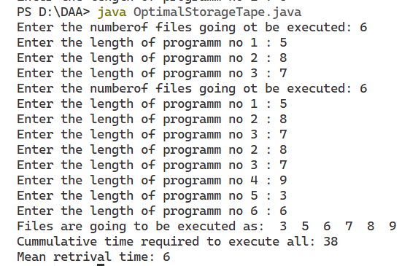

Conclusion
The Optimal Storage Tape problem can be efficiently solved using a Greedy Algorithm. By always merging the two smallest files first and using a priority queue, the total storage cost is minimized. This approach ensures optimal performance with a time complexity of O(n log n) and is widely used in real-world applications like file merging and data compression.

