**Debugging Documentation**

This document is for recording the errors or abnormal simulation results found in the tests, I will try to make some updates per month, and also provide some possible solutions.

**Feb 6, 2023**

The problems found in the first update probably not up-to-date, it is my first time to publish a document officially in GitHub, so this might record all the key issues found in the past few months.

1. Large number of segments error for EBA/EBR

There are a lot of interesting things we can do to the simulation package, for beginners, we can try to learn the structure of the codes by adjusting the geometry factors of the arm first, and then change the type and magnitude of the input force or pressure. However, when number of segments is increasing (usually this will happen when the number is over 3), there will be some errors pop up in the command window as shown in the figure below.

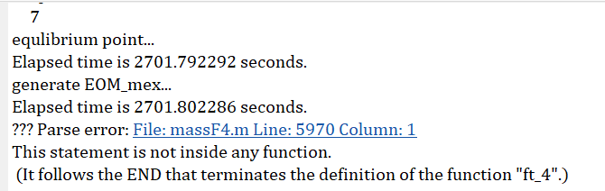

**Fig. U1-1** The screen shot for the error when setting the number of segments so large

When this kind of error emerged related to the derivation of EOMs, we have to switch the option in the following figure from “full_system” to “no”.

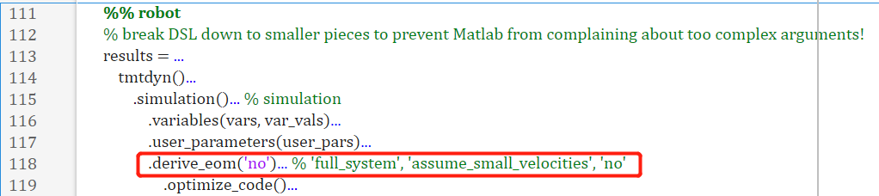

**Fig. U1-2** The mode switch to decide whether to rederive the EOMs or not

And then we can delete the redundant “end” in the functions which have been indicated by MATLAB, if we do not switch the mode to “no”, the EOMs will be derived again and again, what we just saved will be overwritten and I remembered that I modified 12 times for number of segments was set as 3, it could be more times for 4, 5 and so on.

1. Large shear force error for ROM

This error will only emerge when the geometry factors are set to be not so reasonable, when the external force or the pressure input was set to be too large, the errors will be like below.

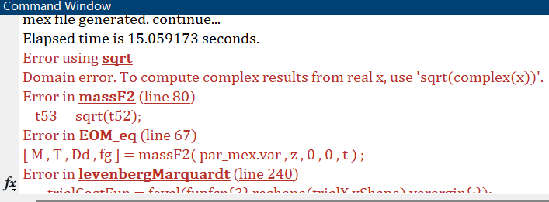

**Fig. U1-3** The error emerged for ROM with large input

The solution for dealing with this kind of issue is similar to what has been described in previous chapter, we have to modify the sqrt( ) into sqrt(complex( )) for 4 times in the EOMs, in this case there will not be any errors even for larger inputs.

Unfortunately the specific parameter settings have already gone with the update of the simulation package, I was trying to duplicate the scenario last week, it failed, now I’m still analysing the reasons behind (the only difference was I updated my MATLAB from 2022a 5 to 2022a 6 last week), the following settings might work, if you have interest, you can take a try. The simulations I performed was to add a linearly increasing force input in x or y or z direction only, there weren’t any error for 10 N, 20 N, 30 N and 40 N, however, for 50 N, error emerged.

**Table U1-1.** The possible parameter settings for error

|  |  |
| --- | --- |
| **Parameter Name** | **Value** |
| Number of segments (n_p) | 2 |
| Manipulator length (l_s) | 600 mm |
| Manipulator outer radius (r_s2) | 40 mm |
| Manipulator inner radius (r_s1) | 32 mm |
| Pressure chamber outer radius (r_p2) | 10.5 mm |
| Pressure chamber inner radius (r_p1) | 8.5 mm |
| Offset angle of each chamber (phi_o) | 0 |
| Density (sigma_s) | 253.5127 ${kg}/{m^{3}}$ |
| Young’s Modulus (E_s) | $$480 GPa$$ |

1. Abnormal displacement in y direction

Another issue that hasn’t been figured out is that no matter for applying input in x or z direction (for force, the exerted position is on the tip of SRA), there always will be an additional displacement in y direction, it could be due to the setting of step size in the ODE solvers.