**OBJECTIVES**

1. Appointment booking.

1. Display of all the necessary information regarding the hospitals including no. of (doctors, nurses, support staffs, beds, ICUs, OTs, Casualties), Emergency/Required contact numbers.
2. Doctors specialties.
3. Reminder messages/emails for appointments.
4. A chat box where doctors and patients can update each other if needed.
5. Personal folder for all the documents
6. Upload/View Medical Documents/Reports.
7. Book appointment from any doctor

**PROJECT METHODOLOGY**

## Admin

## Admin will have the full-fledged details of patients and doctors. He will verify and add only the valid doctors which substantiates the authenticity.

## Sort out appointments

## View the feedback form

## Approve only the authorized user

## Provide an overview and reminders via emails/calls to both the doctor and the patient

## Enlist the availability of OTs, hospital beds, casualties etc.

## 

## For Patients

## Patients will have to create a profile by filling out all the necessary details and essentials.

## The tasks he can perform are:

## Fill up medical history

## Upload/View various medical reports (ex. MRI, CT- Scan, X-ray reports, blood test reports, etc.)

## Book appointment for online consultation.

## View all the emergency/Required contact number.

* Ask any query to doctors.

## 

## For Doctors

## A Doctor can upload his/her qualification by creating a profile Once the admin confirms and verifies the authenticity of the documents, then he will declare him/her as a valid doctor.

## View appointments

## Upload/view necessary documents (ex. Prescription, approval letters etc.) Of patients.

## Provide online consultation

## Have a personalized timetable with reminders

## Answer any query or ask one query to patient.

## 

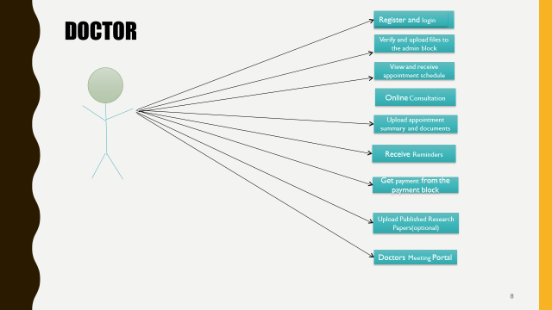

**EXPECTED OUTCOME**

## Hello Doctor will be able to Sort out appointments , View the feedback form , Approve only the authorized user , Provide an overview and reminders via emails/calls to both the doctor and the patient , Enlist the availability of OTs, hospital beds, casualties etc. , Fill up medical history , Upload various medical reports (ex. MRI, CT- Scan, X-ray reports, blood test reports, etc.) , Book appointment for online consultation , View appointments , upload necessary documents (ex. Prescription, approval letters etc.) , Provide online consultation , Have a personalized timetable with reminders , quick chat system .