* MLE for $û$; argmax $ϴ$ $P_{ϴ}\left(D\right)$ = argmax $ϴ log ($ $P_{ϴ}\left(D\right))$
 $ϴ=\{µ\}$

 $D$ + ={$y_{1},…, y_{n}$}
$P_{ϴ}\left(D\right)=\prod_{i=0}^{n}{ϴ^{\sum_{i=1}^{n_{1}}{{y_{i}}^{ }}}({1-ϴ}^{n-\sum_{i=1}^{n_{1}}{{y_{i}}^{ }}})}\prod_{i=0}^{n}{ϴ^{\sum_{i=1}^{n_{1}}{{y_{i}}^{ }}}({1-ϴ}^{n-\sum_{i=1}^{n_{1}}{{y_{i}}^{ }}})}$

$P_{ϴ}\left(D\right)=\log\left(ϴ^{\sum_{i=1}^{n_{1}}{{y_{i}}^{ }}}\left({1-ϴ}^{n-\sum_{i=1}^{n_{1}}{{y_{i}}^{ }}}\right)\right)$

$= {log⁡(ϴ}^{\sum_{i=1}^{n_{1}}{{y_{i}}^{ }}}\left({1-ϴ}^{n-\sum_{i=1}^{n_{1}}{{y_{i}}^{ }}}\right))$

${=log\left(ϴ\right)*\sum_{i=1}^{n_{1}}{{y_{i}}^{ }}}^{ }* \log\left(1-ϴ\right)*(n-\sum_{i=1}^{n_{1}}{{y_{i})}^{ }}$

* ${\log\left(ϴ\right)*\sum_{i=1}^{n_{1}}{{y_{i}}^{ }}}^{ }* \log\left(1-ϴ\right)*(n-\sum_{i=1}^{n_{1}}{{y_{i})}^{ }}$ dy
* = $\frac{\sum_{i=1}^{n_{1}}{{y_{i}}^{ }}}{ϴ}- \frac{n-\sum_{i=1}^{n_{1}}{{y_{i}}^{ }}}{1-ϴ}=\frac{\left(1-ϴ\right)\sum_{i=1}^{n_{1}}{{y_{i}}^{ }}-ϴn+ϴ\sum_{i=1}^{n_{1}}{{y_{i}}^{ }}}{ϴ\left(1-ϴ\right)}= \frac{\sum_{i=1}^{n_{1}}{{y_{i}}^{ }}-ϴn}{ϴ\left(1-ϴ\right)}$

$ϴ=$ $\frac{\sum_{i=1}^{n_{1}}{{y_{i}}^{ }}}{n}$

MLE $ϴ=\{ µ \}$ = { $µ= \frac{\sum_{i=1}^{n_{1}}{{y_{i}}^{ }}}{n}$}



argmax $Y$ $p\left(y|x\right)$ = argmax $Y$ $\frac{p\left(x|y\right)p\left(y\right)}{p\left(x\right)}$ by bays rule

= argmax =

=

=

=

)

=

* 1. log PΘ(D) = log Πn i=1p(xi , yi) = log Πn i=1p(xi |yi)p(yi).

$$\log{(}p\left(y_{i}|x_{i}\right)p\left(y_{i}\right)) =log⁡\prod_{i=0}^{n}{ \frac{1}{{\left(2π\right)}^{\frac{d}{2}}{\left|Γ\right|}^{\frac{1}{2}}}\exp\left(-\frac{1}{2}{\left(x_{i}-µ_{i}\right)}^{T} Γ^{-1}\left(x_{i}- µ_{i}\right)\right)* φ^{y_{i}} {\left(1 – φ\right)}^{1-y_{i}}}$$

$$= log⁡\prod_{i=0}^{n}{\frac{1}{{\left(2π\right)}^{\frac{d}{2}}{\left|Γ\right|}^{\frac{1}{2}}}}log⁡\prod_{i=0}^{n}{\exp\left(-\frac{1}{2}{\left(x_{i}-µ_{i}\right)}^{T} Γ^{-1}\left(x_{i}- µ_{i}\right)\right)* log⁡\prod_{i=0}^{n}{φ^{y_{i}} {\left(1 – φ\right)}^{1-y_{i}}}}$$

log PΘ(D) $dφ$

= $\log{\prod_{i=0}^{n}{φ^{y_{i}} {\left(1 – φ\right)}^{1-y_{i}}}}$ = $\sum_{i=1}^{n}{\log\left(φ^{y_{i}} {\left(1 – φ\right)}^{1-y_{i}}\right)dφ}=$

$=\sum_{i=1}^{n}{ y_{i}(\log{φ})+(1-y_{i})\left(log⁡(1 – φ\right)))dφ= }$ $\sum_{i=1}^{n}{\frac{y_{i}}{φ}+\frac{1-y_{i}}{\left(φ-1\right)} }$ = $\sum_{i=1}^{n}{\frac{\left(1-y_{i }\right)φ+y*(φ-1)}{\left(φ-1\right)φ} }$

$=\left(1 – φ\right)φ\sum_{i=1}^{n}{\left(1-y_{i }\right)φ+y*(φ-1) }$ = $\sum_{i=1}^{n}{\left(φ-y_{i }φ\right)+φy_{i }-y_{i } }$

= $\sum_{i=1}^{n}{φ }-y_{i }= \sum_{i=1}^{n}{φ }-\sum_{i=1}^{n}{{y_{i } }_{ } }=nφ-\sum_{i=1}^{n}{{y_{i } }_{ } }$

= $nφ-\sum_{i=1}^{n}{ 1\{y_{i}= 1\}}$

log PΘ(D) $respect to µ_{i}$

= $\log{\prod_{i=0}^{n}{\exp\left(-\frac{1}{2}{\left(x_{i}-µ_{yi}\right)}^{T} Γ^{-1}\left(x_{i}- µ_{yi}\right)\right)dµ_{i}{ }}}$

= $\sum_{i=1}^{n}{log⁡(\exp\left(-\frac{1}{2}{\left(x_{i}-µ_{yi}\right)}^{T} Γ^{-1}\left(x_{i}- µ_{yi}\right)\right))}{dµ}_{i}$

= $\sum_{i=1}^{n}{\left(-\frac{1}{2}{\left(x_{i}-µ_{i}\right)}^{T} Γ^{-1}\left(x_{i}- µ_{i}\right)\right) }dµ_{i}$ = $-\frac{1}{2}\sum_{i=1}^{n}{\left(2 \left(x_{i}- µ_{i}\right)\right) }=nu_{i}-\sum_{i=1}^{n}{x_{i} }$

$$nu_{1}-\frac{\sum_{i=1}^{n}{ 1\left\{y_{i}= 1\right\}}x}{\sum_{i=1}^{n}{ 1\left\{y_{i}= 1\right\}}} , nu_{0}-\frac{\sum_{i=1}^{n}{ 1\left\{y_{i}= 0\right\}}x}{\sum_{i=1}^{n}{ 1\{y_{i}= 0\}}}$$

log PΘ(D) $respect to Γ$

= $\log{\prod_{i=0}^{n}{\frac{1}{{\left(2π\right)}^{\frac{d}{2}}{\left|Γ\right|}^{\frac{1}{2}}}}\log{\prod_{i=0}^{n}{\exp\left(-\frac{1}{2}{\left(x_{i}-µ_{i}\right)}^{T} Γ^{-1}\left(x_{i}- µ_{i}\right)\right) d}Γ}}=\sum_{i=1}^{n}{(\log\left(\frac{1}{{\left(2π\right)}^{\frac{d}{2}}{\left|Γ\right|}^{\frac{1}{2}}}\right)) }{+}\sum_{i=1}^{n}{log⁡(\exp\left(-\frac{1}{2}{\left(x_{i}-µ_{i}\right)}^{T} Γ^{-1}\left(x_{i}- µ_{i}\right)\right))}$



$$= \sum_{i=1}^{n}{(log⁡(2}π)d+log⁡(\left|T\right|))/2 +\sum_{i=1}^{n}{\left(-\frac{1}{2}{\left(x_{i}-µ_{i}\right)}^{T} Γ^{-1}\left(x_{i}- µ_{i}\right)\right) dΓ }$$

$$= \sum_{i=1}^{n}{\frac{1}{2Γ}} -{n\left(x_{i}-µ_{i}\right)}^{T}\left(x_{i}- µ_{i}\right)\sum_{i=1}^{n}{\left(\frac{1}{2Γ^{2}} \right)=\frac{n}{2Γ}-\sum_{i=1}^{n}{{\left(x_{i}-µ_{i}\right)}^{T}\left(x_{i}- µ_{i}\right)}*\frac{n}{2Γ^{2}} }= Γ- \sum_{i=1}^{n}{{\left(x_{i}-µ_{i}\right)}^{T}\left(x_{i}- µ_{i}\right)}$$

# Add code to plot the trend of the total number of people being tested as days progressed.

# X axis -> dates('Dates')

# Y axis -> number of people tested.('People_tested')

### STUDENT: Start of Code ###

x = dates.to_numpy()

y= data['People_tested'].to_numpy()

plt.plot(x,y)

plt.title("People Tested per Day " )

plt.ylabel("People Tested", fontsize=14, color='blue')

plt.xlabel('Days', fontsize=14, color='blue')

plt.show()

### End of code ####

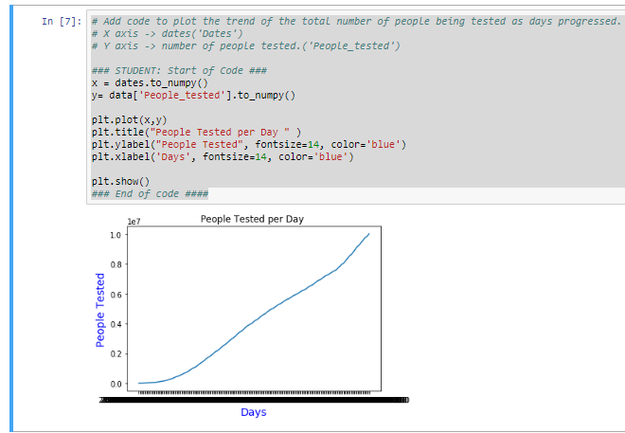

# Add code to plot the trend of total deaths as days progressed.

# X axis -> dates ('Dates')

# Y axis -> number of deaths ('Deaths')

### STUDENT: Start of Code ###

x = dates.to_numpy()

y= data['Deaths'].to_numpy()

plt.plot(x,y)

plt.title(" Number of Deaths " )

plt.ylabel("Number Dead", fontsize=14, color='blue')

plt.xlabel('Days', fontsize=14, color='blue')

### End of code ####

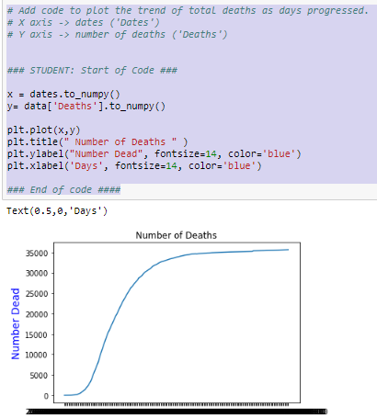

### STUDENT: Start of Code ###

x = dates.to_numpy()

y= data['New_positive_cases'].to_numpy()

plt.plot(x,y)

plt.title("New Positive Cases " )

plt.ylabel("New Positive Cases", fontsize=14, color='blue')

plt.xlabel('Days', fontsize=14, color='blue')

### End of code ####

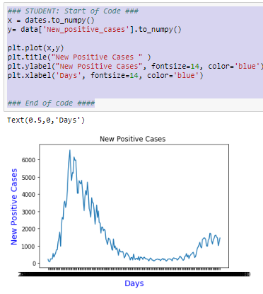



def predict_output(feature_matrix, weights):

# Inputs:

# feature_matrix: a numpy matrix containing the features as columns (including the intercept),

# and each row corresponds to a data point

# weights: a numpy array for the corresponding regression weights (including the intercept)

# Output:

# a numpy array that contains the predicted outputs (according to the provided weights)

# for all the data points in the feature_matrix

# STUDENT: Start of code ####

predictions=[]

sum = 0

rowSum = 0;

max_value = 0;

#get dot product for each row

for i in range(len(feature_matrix)):

rowSum = 0

#dot

for j in range(len(feature_matrix[i])):

rowSum =rowSum + (feature_matrix[i][j]*weights[j])

#for normalization

if(rowSum>max_value):

max_value = rowSum

#list of predictions from dot product

predictions.append(rowSum)

#normalize

for i in range(len(predictions)):

predictions[i]=(predictions[i]+1)/(max_value+1)

return predictions

## end of code

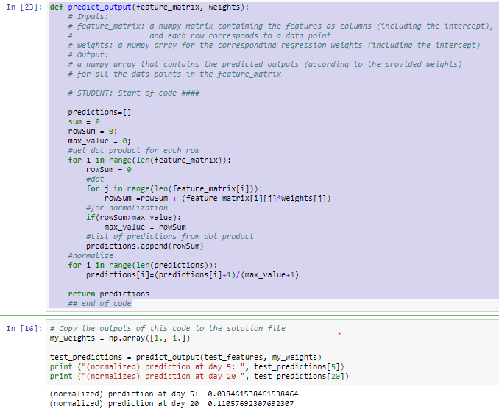



def weight_derivative(weights, feature_matrix, labels):

# Input:

# weights: weight vector w, a numpy vector of dimension d

# feature_matrix: numpy array of size n by d, where n is the number of data points, and d is the feature dimension

# labels: true labels y, a numpy vector of dimension d

# Output:

# Derivative of the regression cost function with respect to the weight w, a numpy array of dimension d

## STUDENT: Start of code ###

sum = 0

#get array of normalized dot produts

dot_product=predict_output(feature_matrix,weights)

#sum the diffrence between dot and true value

for i in range(len(feature_matrix)):

diffrence = labels[i] - dot_product[i]

sum = sum + diffrence

#finsh derive ative of regressive cost function

return sum/(len(feature_matrix))*2

# End of code ###

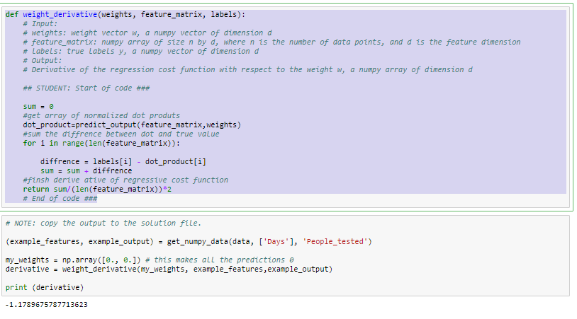



def regression_gradient_descent(feature_matrix, labels, initial_weights, step_size, tolerance):

# Gradient descent algorithm for linear regression problem

# Input:

# feature_matrix: numpy array of size n by d, where n is the number of data points, and d is the feature dimension

# labels: true labels y, a numpy vector of dimension d

# initial_weights: initial weight vector to start with, a numpy vector of dimension d

# step_size: step size of update

# tolerance: tolerace epsilon for stopping condition

# Output:

# Weights obtained after convergence

converged = False

weights = np.array(initial_weights) # current iterate

i = 0

while not converged:

i += 1

# STUDENT: Start of code: your impelementation of what the gradient descent algorithm does in every iteration

# Refer back to the update rule listed above: update the weight

# Compute the gradient magnitude:

weight_deriv = weight_derivative(weights[i-1], feature_matrix,labels)

temp_gradient = [0]*len(weights[i-1])

for a in range(len(weights[i-1])):

weight_deriv= weight_deriv*step_size

temp_gradient[a] = weights[i-1][a] - weight_deriv

gradient_magnitude = temp_gradient

#size of gradient magnitude

gradient_size = 0

for a in gradient_magnitude:

gradient_size += pow(a,2)

gradient_size = pow(gradient_size,1/2)

#reasign weights

for j in range(len(weights[i])):

weights[i][j]=gradient_magnitude[j]

#weights[i][j]=temp_gradient[j]

# Check the stopping condition to decide whether you want to stop the iterations

if (gradient_size>=tolerance): # STUDENT: check the stopping condition here

converged = True

if (i>=len(weights)-1): # STUDENT: check the stopping condition here

converged = True

# End of code

print ("Iteration: ",i,"gradient_magnitude: ", gradient_magnitude) # for us to check about convergence

return(gradient_magnitude)

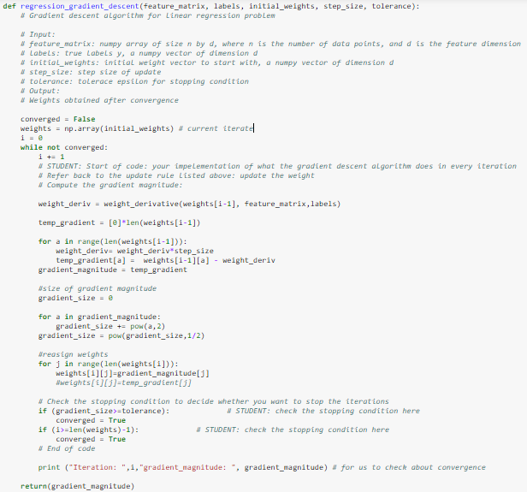



simple_features = ['Days']

my_output = 'People_tested'

# Use get_numpy_data method to calculate the feature matrix and output.

(simple_feature_matrix, output) = get_numpy_data(train_data, simple_features, my_output)

#Initialize the weights, step size and tolerance

# Start of code

#STUDENT: Specify the initial_weights, step_size, and tolerance

temp_weights = np.array([0.]*2*len(simple_feature_matrix))

initial_weights = temp_weights.reshape(len(simple_feature_matrix),2)

step_size = 0.05

tolerance = 1

# end of code

# Use the regression_gradient_descent function to calculate the gradient decent and store it in the variable 'final_weights'

final_weights = regression_gradient_descent(simple_feature_matrix, output, initial_weights, step_size, tolerance)

# end of code

print ("Here are the final weights after convergence:")

print (final_weights)

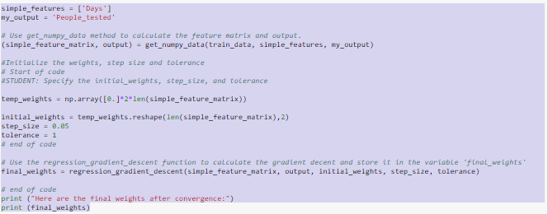

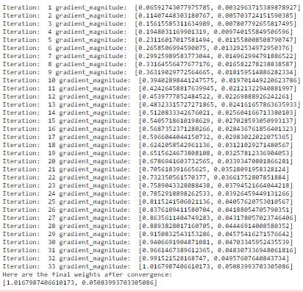



# Calculate the test error

# STUDENT: Start of code

test_error = 0;

size = len(test_predictions)

#print (test_output)

#print(test_predictions)

for i in range(size):

diff= test_output[i]-test_predictions[i]

test_error+=pow(diff,2)

print(test_error/size)

#end of code

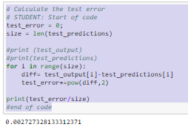



model_features = ['Intensive_care','New_positive_cases','Days']

my_output = 'People_tested'

#call the get_nupy_data method to calculate the feature matrix and output. Store them in the variables "multi_feature_matrix" & "output"

(multi_feature_matrix, output) = get_numpy_data(data, model_features, my_output)

# Initialize the weights, step size and tolerance

# STUDENT: Start of code

# STUDENT: Specify the initial_weights, step_size, and tolerance

#print(len(multi_feature_matrix))

temp_weights = np.array([0.]*4*len(multi_feature_matrix))

initial_weights = temp_weights.reshape(len(multi_feature_matrix),4)

#print(initial_weights)

step_size = 0.05

tolerance = 1

#print(multi_feature_matrix)

#print(output)

# end of code

weight_2 = regression_gradient_descent(multi_feature_matrix, output, initial_weights, step_size, tolerance)

print ("Here are the final weights after convergence:")

print (weight_2)

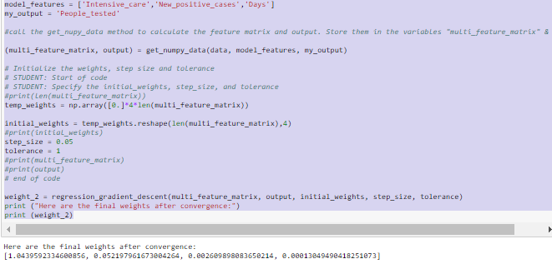



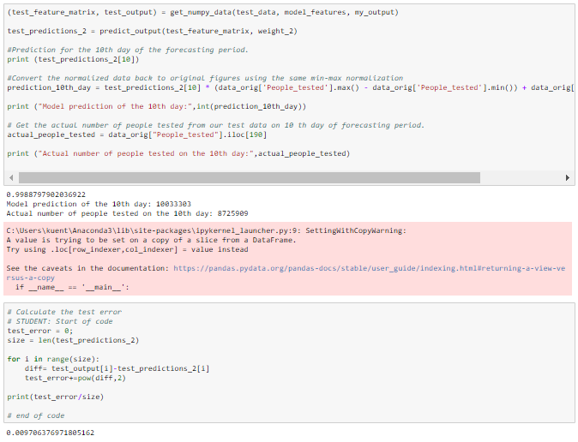



# Explore an aspect of the model that interests you

### STUDENT: Start of code

model_features = ['Intensive_care','New_positive_cases','Days']

my_output = 'People_tested'

#call the get_nupy_data method to calculate the feature matrix and output. Store them in the variables "multi_feature_matrix" & "output"

(multi_feature_matrix, output) = get_numpy_data(data, model_features, my_output)

# Initialize the weights, step size and tolerance

# STUDENT: Start of code

# STUDENT: Specify the initial_weights, step_size, and tolerance

temp_weights = np.array([0.]*4*len(multi_feature_matrix))

step_size = 0.05

tolerance = 1

while tolerance < 20:

print ('tolerance: ', end = ' ')

print(tolerance)

initial_weights = temp_weights.reshape(len(multi_feature_matrix),4)

weight_2 = regression_gradient_descent(multi_feature_matrix, output, initial_weights, step_size, tolerance)

(test_feature_matrix, test_output) = get_numpy_data(test_data, model_features, my_output)

test_predictions_2 = predict_output(test_feature_matrix, weight_2)

test_error = 0;

size = len(test_predictions_2)

print('test_error: ', end = ' ')

for i in range(size):

diff= test_output[i]-test_predictions_2[i]

test_error+=pow(diff,2)

print(test_error/size)

tolerance +=2

### End of code

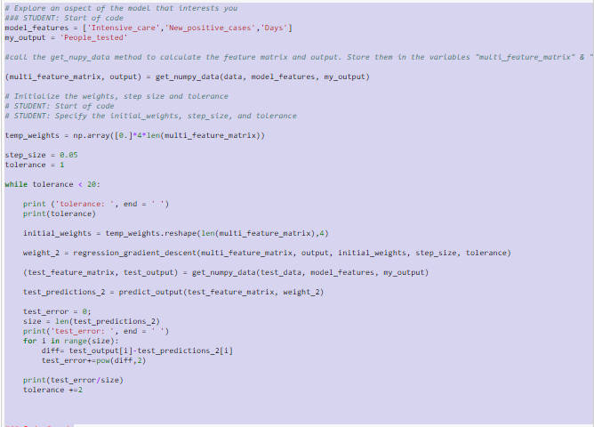

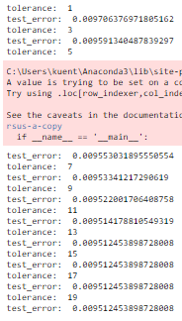

NOTE: to get this output I removed the only print statement from regression_gradient_descent. This function tests the tolerance error. As we can see, the lower the tolerance, the more incorrect the guess is. The error seems to converge to its lowest point when it has a tolerance of 13