$x^{t}[A]x < 0$ the matrix not semidefinite

$x^{t}[A]x = \sum_{i=1}^{d}{ }\sum_{j=1}^{d}{ }A^{(i,j)}x^{(i)}x^{(j)}$ =

$x^{t}[\begin{matrix}1 & 2 \\ 2 & 1\end{matrix} ]x = \begin{matrix}x^{(1)} \\ x^{(2)}\end{matrix}\left[\begin{matrix}1 & 2 \\ 2 & 1\end{matrix}\right]\begin{matrix}x^{(1)} & x^{(2)}\end{matrix} ={(x^{(1)} )}^{2 }+4x^{(1)}x^{(2)}+{(x^{(2)} )}^{2 }$

If $x^{(1)}$ = 0 and $x^{(2)}$ =2 then $x^{t}[A]x$ would be < 0 so it would not be positive semidefinite

Consider A to be $\left[\begin{matrix}2 & 1 \\ 1 & 2\end{matrix}\right]$ then $x^{t}[A]x = \begin{matrix}x^{(1)} \\ x^{(2)}\end{matrix}\left[\begin{matrix}2 & 1 \\ 1 & 2\end{matrix}\right]\begin{matrix}x^{(1)} & x^{(2)} \end{matrix}$ =

${4(x^{(1)} )}^{2 }+x^{(1)}x^{(2)}+{4(x^{(2)} )}^{2 }$ which would be >0 for all values of $x^{(1)}{and x}^{(2)}$ so our new A would be PSD

* 1. =

A taking the 2d derivative $\frac{d^{2}}{{dϴ}_{p}dϴ_{q}}$ where p!=q we can see that taking the derivative of any of the above with any theta value not already used in the simplification of the problem would result in 0



$-f(ϴ) = g (ϴ) = {-n}_{1}log\left(ϴ_{y=1}\right)-\left(n-n1\right)log\left(1-ϴ_{y=1}\right)-\sum_{j=1}^{d}{\left[r_{0}^{j}*log\left(ϴ_{j|0}\right)+\left(n-n_{1}-r_{0}^{j}\right)log\left({1-ϴ}_{j|0}\right)+r_{1}^{j}*log\left(ϴ_{j|1}\right)+\left(n-n1-r_{1}^{j}\right)log\left({1- ϴ}_{j|1}\right)\right]}$

$$\sum_{j=1}^{d}{\left[{ r}_{1}^{j}/ϴ_{j|1} +\left( n_{1}- r_{1}^{j}\right)/\left({1- ϴ}_{j|1}\right) \right]} dϴ_{j|1}$$

$\left[{ r}_{1}^{j}/{(ϴ}_{j|1})^2 +\left( n_{1}- r_{1}^{j}\right)/\left({1- ϴ}_{j|1}\right)^2 \right] \frac{d(2)}{dϴ_{j|1}(2)}$ ≤ 0 => g($ϴ)$ ≥ 0

$$\sum_{j=1}^{d}{\left[{ r}_{0}^{j}/ϴ_{j|0} -\left( {n- n}_{1}- r_{1}^{j}\right)/\left({1- ϴ}_{j|0}\right) \right]} dϴ_{j|0}$$

${ -r}_{0}^{j}/{(ϴ}_{j|0})^2 - \left( {n- n}_{1}- r_{1}^{j}\right)/\left({1- ϴ}_{j|0}\right)^2 \frac{d(2)}{dϴ_{j|0}(2)}$ ≤ 0 => g(≥ 0

≤ 0 => g(≥ 0

1. 1. = = ->
   2. = =||x||^2 which is greater than or equal to 0 for all x so the function is psd so it is convex

#####################################################################################

1. data_mat=np.insert(data_mat,0,1.,axis =1)

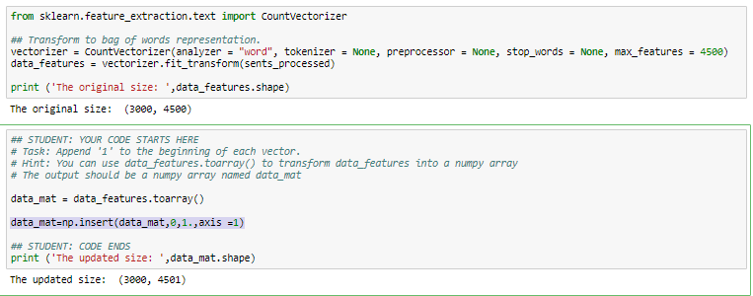



## STUDENT: Start of code ###

# - yx

# ____________

# ((e^yθ^Tx)+1)

#initialize ld(theta)

derivatives=np.zeros(weights.size)

for i in range(labels.size):

#dot product of weigths with each column of feature matrix

column_product=np.dot(weights,feature_matrix[i,:])

temp=labels[i]*column_product

value = 1/(1+np.exp(temp))

#take the sum for every road

derivatives = derivatives+(- labels[i]*feature_matrix[i,:]*value)

return derivatives

# End of code ###

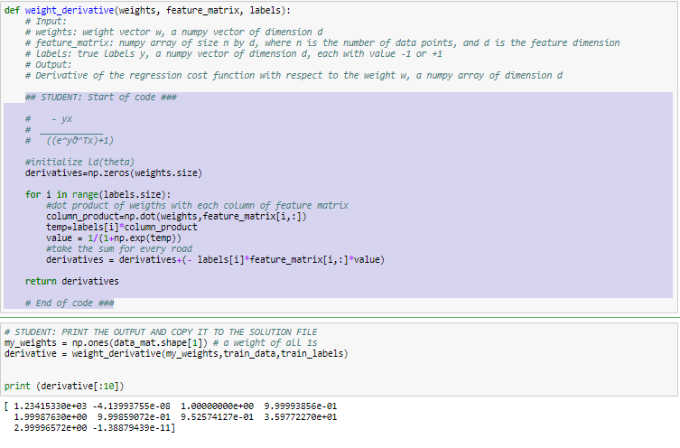



temp_weight = [0.5]*(len(train_data[0]))

initial_weights = np.array(temp_weight)

#print(initial_weights)

step_size = 5

tolerance = 2

# end of code

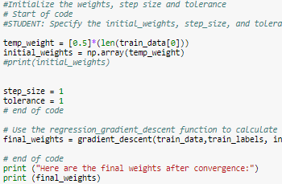

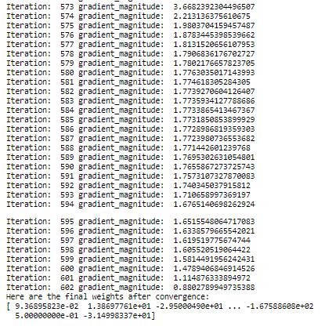



## STUDENT: CODE STARTS HERE

## Pull out the parameters (theta_0, theta) of the logistic regression model

theta = final_weights #gradient_descent(train_data,train_labels, initial_weights, step_size, tolerance)

theta0 = theta[0]

theta = np.delete(theta,0)

## STUDENT: CODE ENDS HERE



## STUDENT: YOUR CODE HERE

predict_array = []

for i in range(len(feature_matrix)):

dot = np.dot(feature_matrix[i],weights)

z = -1*dot

predict = 1/(1+pow(np.e,z))

predict_array.append(predict)

return np.array(predict_array)

## STUDENT: CODE ENDS

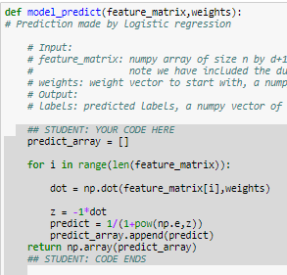

#not test error did not work as written so I wrote my own

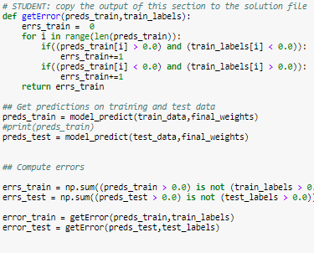

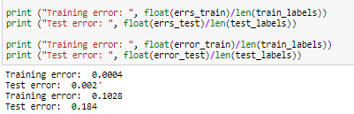

## STUDENT: YOUR CODE HERE

model_predict_arr = model_predict(feature_matrix, weights)

count =0;

for i in range(len(model_predict_arr)):

if (model_predict_arr[i]>0) and (model_predict_arr[i]<1):

if(model_predict_arr[i]<0.5-gamma) or (model_predict_arr[i]>0.5+gamma):

count+=1

return count

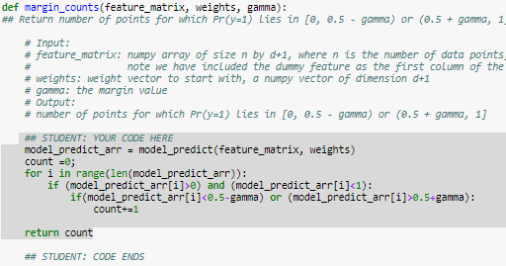

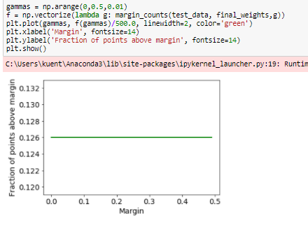



## STUDENT: YOUR CODE HERE

model_predict_arr = model_predict(feature_matrix, weights)

denominator=len(feature_matrix)

numerator = 1

for i in range(len(model_predict_arr)):

if (model_predict_arr[i]>0) and (model_predict_arr[i]<1):

if(model_predict_arr[i]<(0.5-gamma)) or (model_predict_arr[i]>(0.5+gamma)):

denominator+=1

if(labels[i]<(0.5-gamma)) and (model_predict_arr[i]<(0.5-gamma)):

numerator+=1

if(labels[i]>(0.5+gamma)) and (model_predict_arr[i]>(0.5+gamma)):

numerator+=1

return numerator/denominator

## STUDENT: YOUR CODE ENDS

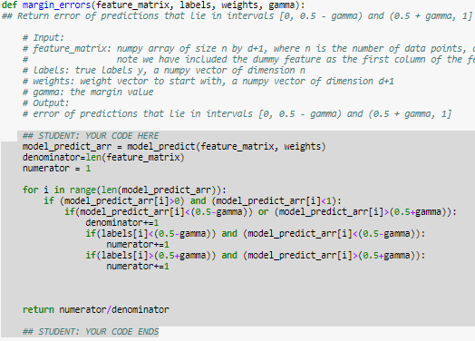

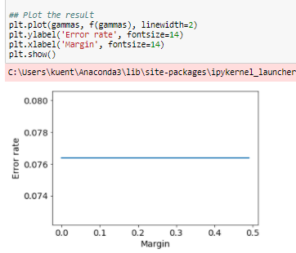



## STUDENT: YOUR CODE HERE

#the first index is the larges value and the last index is the smallest value

#the value that is going to be excluded firrst from the array is in the back

weights= np.delete(final_weights,0)

print(len(weights))

large_positive = []

small_negative = []

for i in range(len(weights)):

#initialize array

if (len(large_positive)<10):

large_positive.append([vocab[i],weights[i]])

small_negative.append([vocab[i],weights[i]])

else:

#larger than smallest value in array

if (final_weights[i]>large_positive[0][1]):

#remove small add large

large_positive.pop(0)

large_positive.append([vocab[i],weights[i]])

large_positive.sort(key=lambda x: x[1])

#smaller than largest value in array

if (final_weights[i]<small_negative[9][1]):

#remove large add small

small_negative.pop(9)

small_negative.append([vocab[i],weights[i]])

small_negative.sort(key=lambda x: x[1])

#remove weights from print statement

final_positive = []

final_negative = []

for i in range(10):

final_positive.append(large_positive[i][0])

final_negative.append(small_negative[i][0])

print('Top Ten')

print(large_positive)

print('Bottom Ten')

print(small_negative)

## STUDENT: CODE ENDS

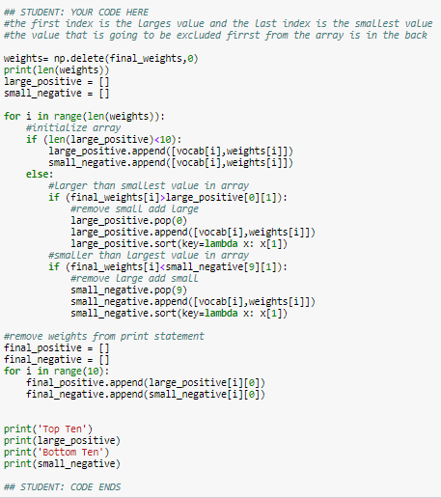

Each is accompanied with their theta value

