|  |  |  |  |  |  |
| --- | --- | --- | --- | --- | --- |
| $$x_{i}$$ | $$µ_{1}$$ | $$µ_{2}$$ | $${distance}_{1}$$ | $${distance}_{2}$$ | Nearest Cluster |
| (1, 2) | (1,2) | (−1, 5) | 0 | 5 | $$µ_{1}$$ |
| (2, 2) | (1,2) | (−1, 5) | 1 | 6 | $$µ_{1}$$ |
| (2, 1) | (1,2) | (−1, 5) | 2 | 7 | $$µ_{1}$$ |
| (−1, 5) | (1,2) | (−1, 5) | 5 | 0 | $$µ_{2}$$ |
| (−2, −1) | (1,2) | (−1, 5) | 6 | 7 | $$µ_{1}$$ |
| (−1, −1) | (1,2) | (−1, 5) | 4 | 6 |  |

|  |  |  |  |  |  |
| --- | --- | --- | --- | --- | --- |
|  |  |  |  |  | Nearest Cluster |
| (1, 2) | $(2/5, 3/5)$ | (−1, 5) | 2 | 5 | $$µ_{1}$$ |
| (2, 2) | $(2/5, 3/5)$ | (−1, 5) | 3 | 6 | $$µ_{1}$$ |
| (2, 1) | $(2/5, 3/5)$ | (−1, 5) | 2 | 7 | $$µ_{1}$$ |
| (−1, 5) | $(2/5, 3/5)$ | (−1, 5) | 6.8 | 0 | $$µ_{2}$$ |
| (−2, −1) | $(2/5, 3/5)$ | (−1, 5) | 5 | 7 | $$µ_{1}$$ |
| (−1, −1) | $(2/5, 3/5)$ | (−1, 5) | 4 | 6 | $$µ_{1}$$ |

$µ_{1} = (2/5, 3/5)$

$µ_{2} = (-1,5)$

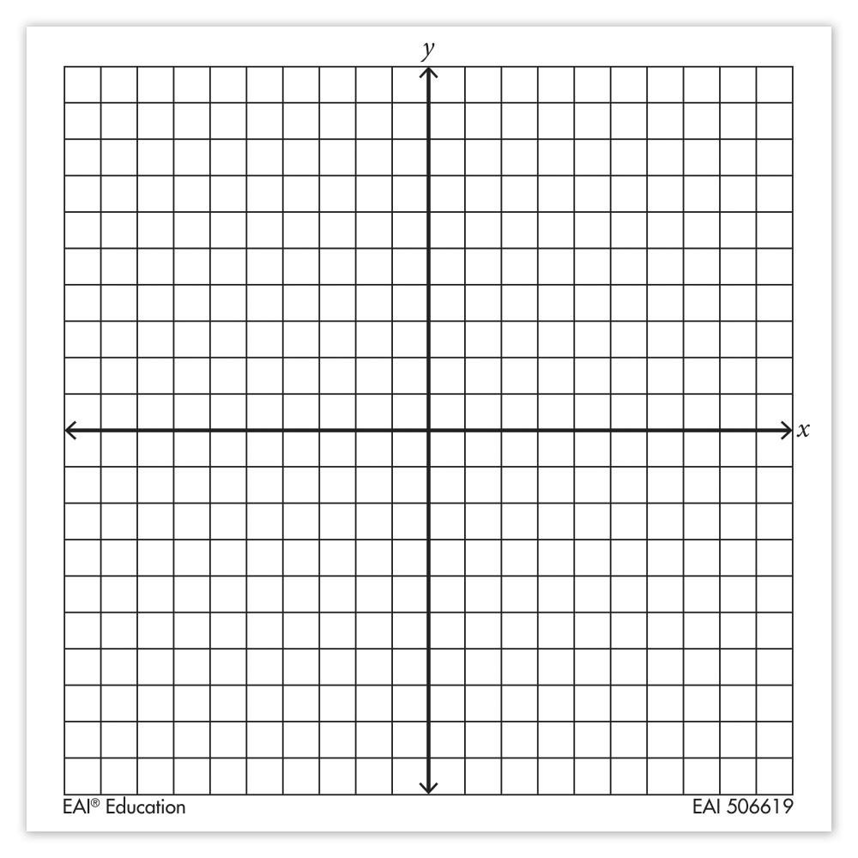

x

x

|  |  |  |  |  |  |
| --- | --- | --- | --- | --- | --- |
| $$x_{i}$$ | $$µ_{1}$$ | $$µ_{2}$$ | $${distance}_{1}$$ | $${distance}_{2}$$ | Nearest Cluster |
| (1, 2) | (1,2) | (−2, -1) | 0 | 6 | $$µ_{1}$$ |
| (2, 2) | (1,2) | (−2, -1) | 1 | 7 | $$µ_{1}$$ |
| (2, 1) | (1,2) | (−2, -1) | 2 | 5 | $$µ_{1}$$ |
| (−1, 5) | (1,2) | (−2, -1) | 5 | 7 | $$µ_{1}$$ |
| (−2, −1) | (1,2) | (−2, -1) | 6 | 0 | $$µ_{2}$$ |
| (−1, −1) | (1,2) | (−2, -1) | 4 | 1 |  |

|  |  |  |  |  |  |
| --- | --- | --- | --- | --- | --- |
|  |  |  |  |  | Nearest Cluster |
| (1, 2) | $$(1, 5/2)$$ | $(-3/2,-1)$ | 1/2 | 11/2 | $$µ_{1}$$ |
| (2, 2) | $$(1, 5/2)$$ | $(-3/2,-1)$ | 3/2 | 13/2 | $$µ_{1}$$ |
| (2, 1) | $$(1, 5/2)$$ | $(-3/2,-1)$ | 5/2 | 11/2 | $$µ_{1}$$ |
| (−1, 5) | $$(1, 5/2)$$ | $(-3/2,-1)$ | 9/2 | 13/2 | $$µ_{1}$$ |
| (−2, −1) | $$(1, 5/2)$$ | $(-3/2,-1)$ | 13/2 | 1/2 | $$µ_{2}$$ |
| (−1, −1) | $$(1, 5/2)$$ | $(-3/2,-1)$ | 11/2 | 1/2 | $$µ_{2}$$ |

$µ_{1} = (1, 5/2)$

$µ_{2} = (-3/2,-1)$

P1.

## STUDENT: Your code here

# words: a python list of unique words in the document my_word_stream as the vocabulary

# totals: a python dictionary, where each word is a key, and the corresponding value

# is the number of times this word appears in the document my_word_stream

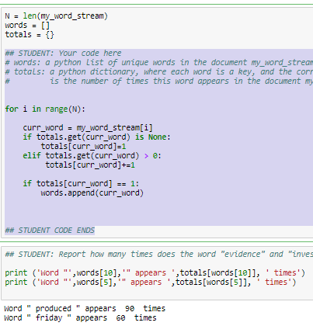

for i in range(N):

curr_word = my_word_stream[i]

if totals.get(curr_word) is None:

totals[curr_word]=1

elif totals.get(curr_word) > 0:

totals[curr_word]+=1

if totals[curr_word] == 1:

words.append(curr_word)

## STUDENT CODE ENDS

P2. ## STUDENT: Your code here

vocab_words = [] # a list of words whose occurances (totals) are > 19

context_words = [] # a list of words whose occurances (totals) are > 99

for i in range(len(words)):

if (words[i]=='fact') :

print(totals[words[i]])

if (totals[words[i]]>99):

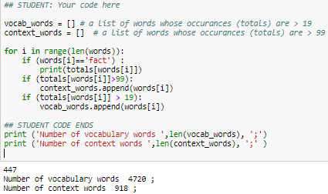 context_words.append(words[i])

if (totals[words[i]] > 19):

vocab_words.append(words[i])

## STUDENT CODE ENDS

P3.

counts = {}

a = 0

for w0 in vocab_words:

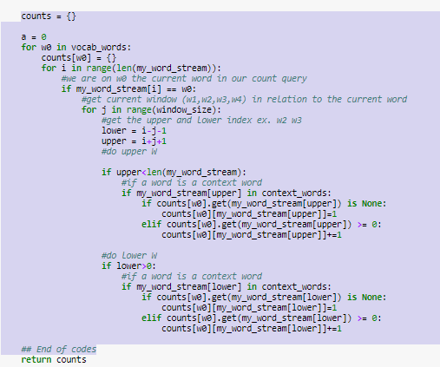 counts[w0] = {}

for i in range(len(my_word_stream)):

#we are on w0 the current word in our count query

if my_word_stream[i] == w0:

#get current window (w1,w2,w3,w4) in relation to the current word

for j in range(window_size):

#get the upper and lower index ex. w2 w3

lower = i-j-1

upper = i+j+1

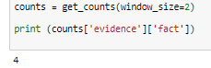 #do upper W

if upper<len(my_word_stream):

#if a word is a context word

if my_word_stream[upper] in context_words:

if counts[w0].get(my_word_stream[upper]) is None:

counts[w0][my_word_stream[upper]]=1

elif counts[w0].get(my_word_stream[upper]) >= 0:

counts[w0][my_word_stream[upper]]+=1

#do lower W

if lower>0:

#if a word is a context word

if my_word_stream[lower] in context_words:

if counts[w0].get(my_word_stream[lower]) is None:

counts[w0][my_word_stream[lower]]=1

elif counts[w0].get(my_word_stream[lower]) >= 0:

counts[w0][my_word_stream[lower]]+=1

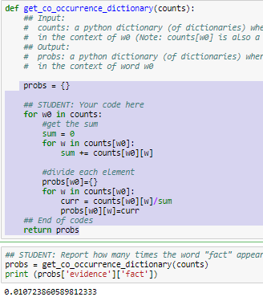 ## End of codes

P4.

probs = {}

## STUDENT: Your code here

for w0 in counts:

#get the sum

sum = 0

for w in counts[w0]:

sum += counts[w0][w]

#divide each element

probs[w0]={}

for w in counts[w0]:

curr = counts[w0][w]/sum

probs[w0][w]=curr

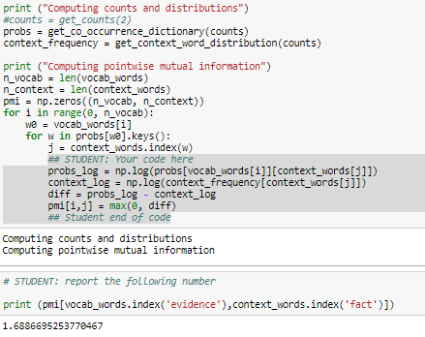 ## End of codes

return probs

P5.

## STUDENT: Your code here

probs_log = np.log(probs[vocab_words[i]][context_words[j]])

context_log = np.log(context_frequency[context_words[j]])

diff = probs_log - context_log

pmi[i,j] = max(0, diff)

## Student end of code

P6. ## Student: your code here

K = 10 ##K nearest neighbors number

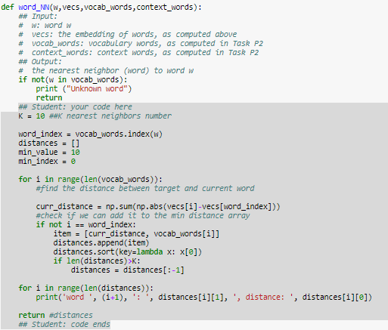

word_index = vocab_words.index(w)

distances = []

min_value = 10

min_index = 0

for i in range(len(vocab_words)):

#find the distance between target and current word

curr_distance = np.sum(np.abs(vecs[i]-vecs[word_index]))

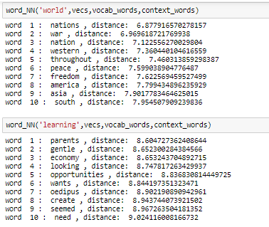 #check if we can add it to the min distance array

if not i == word_index:

item = [curr_distance, vocab_words[i]]

distances.append(item)

distances.sort(key=lambda x: x[0])

if len(distances)>K:

distances = distances[:-1]

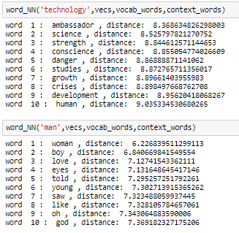

for i in range(len(distances)):

print('word ', (i+1), ': ', distances[i][1], ', distance: ',

distances[i][0])

return #distances

## Student: code ends

P7.

def find_analogy(A,B,C,vecs,vocab_words,context_words):

## Input:

# A, B, C: words A, B, C

# vecs: the embedding of words, as computed above

# vocab_words: vocabulary words, as computed in Task P2

# context_words: context words, as computed in Task P2

## Output:

# the word that solves the analogy problem

## STUDENT: Your code here

## STUDENT: your code ends

K = 10 ##K nearest neighbors number

A_index = vocab_words.index(A)

B_index = vocab_words.index(B)

C_index = vocab_words.index(C)

#this i the target analogy we are trying to find

#i.e find the same distance

analogy_vector = vecs[A_index] - vecs[B_index]

distances = []

analogys = []

min_value = 10

min_index = 0

## Student: your code here

print('word C :', C)

word_NN(C,vecs,vocab_words,context_words)

#print

print('##find the closest analogy word')

for i in range(len(vocab_words)):

#find the distance between target and current word

#check if we can add it to the min distance array

if not ((i == A_index) or (i == B_index) or (i == C_index)):

temp_distance = (vecs[i]-vecs[C_index]) - (vecs[A_index] - vecs[B_index])

curr_distance = np.sum(np.abs(temp_distance))

item = [curr_distance, vocab_words[i]]

distances.append(item)

distances.sort(key=lambda x: x[0])

if len(distances)>K:

distances = distances[:-1]

#alalogy vector

print('Analogy Vector')

for i in range(len(distances)):

print('word ', (i+1), ': ', distances[i][1], ', distance: ', distances[i][0])

return

