CprE 381, Computer Organization and Assembly-Level Programming, Fall 2018

Lab 2 Report

Lab Partners ____________________Logan Woolery_____________

______________________________________________

______________________________________________

Section /Lab Time ______________________M___

Refer to the highlighted language in the lab 2 instruction for the context of the following questions.

- [Part 1] Note down the endian-ness (big or little) and total number of instructions executed for each program using the table below. Also, for each test program, attach a screenshot of the terminal output from which you get the [# instructions].

Test Program | # instructions | Endian-ness
Fmath | 53459 | Little
Fprintf | 1813891 | Little
Lawlr | 8877 | Little
Llong | 29642 | little

- [Part 2 Section i] Compare # instructions using the table below. Also, find the % reduction in # instructions. For each different level of optimization, attach a screenshot of the terminal output from which you get the [# instructions].
Program | Optimization level 0  Number of instructions | Optimization level 3  Number of instructions
Math | 2813818 | 1013799
% reduction in the number of instructions:1-(1013799/2813818)*100= ~64% reduction

- [Part 2 Section ii] Compare # instructions using the table below. Also, find the % reduction in # instructions. For each different level of optimization, attach a screenshot of the terminal output from which you get the [# instructions]. Also, submit your code as well.
  - CODE :
-bash-4.2$ cat ~/sort.c
#include <stdio.h>
#include <stdlib.h>
int comp (const void * elem1, const void * elem2)
{
int f = *((int*)elem1);
int s = *((int*)elem2);
if (f > s) return 1;
if (f < s) return -1;
return 0;
}
int main(int argc, char* argv[])
{
// int x[] = {4,5,2,3,1,0,9,8,6,7};
int x[50] = {};
int i =0;
for (i = 0; i < 50; i++){
x[i] = rand();
}

qsort (x, sizeof(x)/sizeof(*x), sizeof(*x), comp);

for ( i = 0 ; i < 10 ; i++)
printf ("%d ", x[i]);

return 0;
}

Program | Optimization level 0  Number of instructions | Optimization level 3  Number of instructions
Sort | 51746 | 47718
% reduction in the number of instructions:1-(47718/51746)*100= ~7.8%

- [Part 3 Section i] Report the CPI and # instructions that you get. Attach a screenshot of the terminal output from which you get [CPI] and [# instructions].
  - CPI: 1.9016
  - INS: 420623
  - 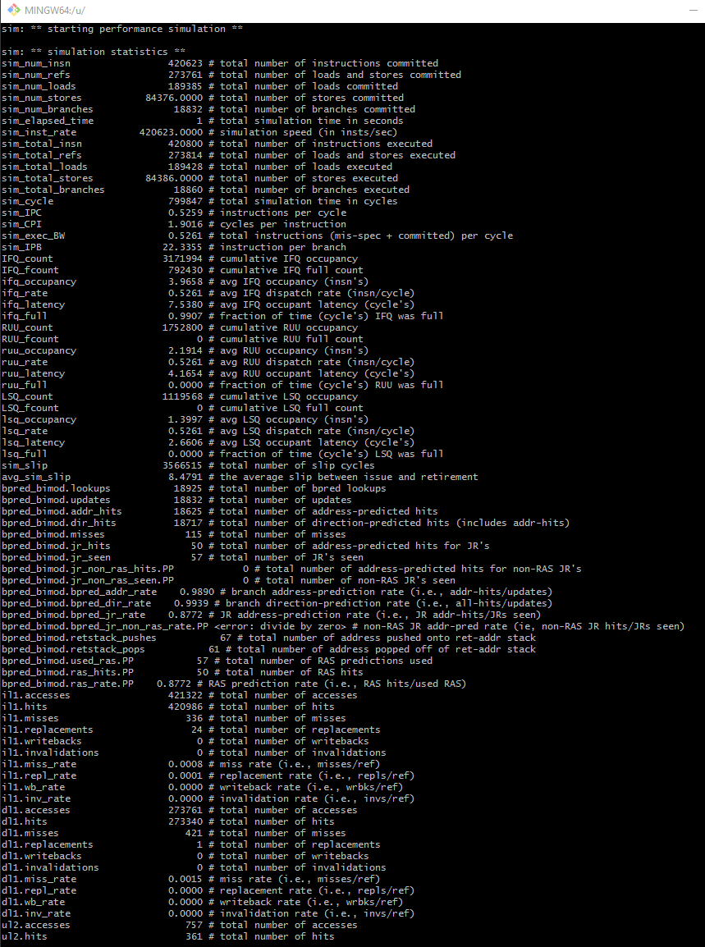

- [Part 3 Section ii] From your understanding of the code in hardware.c, make appropriate changes to the values in config_out file (do not go beyond 8) and report the best CPI.
  - BEST CPI: 1.8993
  - Relevant config:
# total number of integer ALU's available
-res:ialu 4

# total number of integer multiplier/dividers available
-res:imult 4

# total number of memory system ports available (to CPU)
-res:memport 2

# total number of floating point ALU's available
-res:fpalu 4

# total number of floating point multiplier/dividers available
-res:fpmult 4

