|  |
| --- |
| California Lutheran University |
| Assessing the Federal Funds Rate Target |
| ECON 531: Macroeconomic Theory 2  Matthew Fienup  Summer 2025 |

|  |
| --- |
| Shaun Levenson  8-15-2025 |

**Assessing the Federal Funds Target Rate**

**Introduction**

In 2025, the US Federal Funds Rate Target remains at the center of economic debate. Following one of the most rapid tightening cycles in decades, the federal funds rate is sitting around 4.33%, even as inflation has declined from its peak in 2022 at over 9% headline CPI or 7.25% headline PCE. The goal of this policy report is to assess whether the current federal funds rate is too restrictive, too loose, or just right. To do so, we will be looking into the current economic climate, explore professional perspectives on the causes of the peak inflation rate and then competing arguments for and against lowering the interest rate target, then I will base my opinion on theory and rules based policy.

**Motivation**

The federal funds rate matters because it reaches far beyond banks and Wall Street—it shapes the cost of borrowing for just about everyone. A change in this rate can nudge up or pull down the interest on mortgages, car loans, credit cards, and even the modest yield on a savings account. In doing so, it influences whether people decide to spend freely, tighten their belts, or stash money away, and whether businesses push ahead with new projects or hold back. It’s one of the Fed’s most direct levers for steering the broader economy. When the Fed cuts rates, borrowing suddenly looks more attractive. Families are more likely to buy homes or cars, and companies may take on new investments they’d otherwise skip. This extra activity fuels demand, supports hiring, and pushes inflation toward the Fed’s goal—just what’s needed in a slump. Raising rates works in reverse: it makes credit more expensive, cools spending, and reins in inflation before it runs too hot. The tricky part is timing. Monetary policy doesn’t snap into place overnight; it seeps into the economy over months, sometimes years. That means the Fed is always aiming at a moving target, acting on where it believes the economy is headed rather than simply reacting to the moment. Right now, with inflation stubbornly high and the Fed raising rates to cool things down, the federal funds rate has become a key factor shaping how people and businesses navigate the challenges ahead.

**Economic Climate**

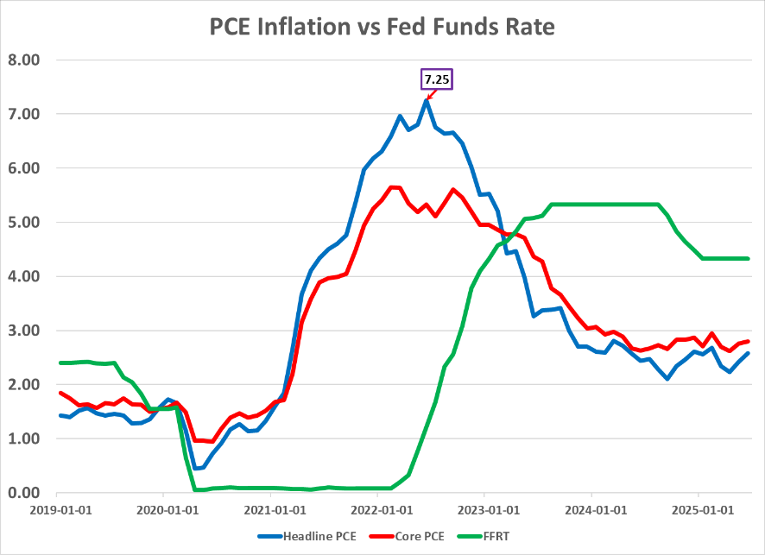 The U.S. economy in 2025 looks steady on the surface, but there’s more going on underneath. The Fed’s target rate is holding between 4.25% and 4.50%—not as high as last year, but definitely tighter than before COVID. There’s still a ton of money sloshing around: M2 came in at $21.960 trillion this June, way higher than what we were used to pre-pandemic, and has actually just reached levels higher than the peak of the pandemic, which was $21.864 trillion in March of 2022. Inflation has cooled off a lot since 2022, but seems to be rising again—core sits at 2.79% up from 2.75%, headline at 2.58%, up from 2.42%—so we’re getting close to the Fed’s long-run 2% goal, but we’re not quite there yet, and losing downward momentum. Unemployment ticked down to 4.1%, down from 4.2% in May, so the labor market’s starting to tighten a little. As for growth, the first quarter of 2025 went negative, with annualized GDP down 0.5%, mostly due to tariff scares. Quarter 2 brought it back to 3%, so averaging it out, we get 1.2% growth over the two quarters; pretty slow.

**Fed Tools**

Pre-2008 Tools

Before 2008, the Federal Reserve’s control over the federal funds rate rested on a relatively lean set of tools, chief among them open market operations. By buying or selling short-term Treasury securities, the Fed could add or drain reserves from the banking system, nudging the funds rate in its desired direction. Reserve requirements—generally set around ten percent of deposits—were meant to ensure that banks kept a buffer of liquidity. These reserves earned no interest, which meant banks had little incentive to hold more than they were obliged to, keeping the system finely balanced. The discount rate, meanwhile, served as a kind of safety valve: it was the rate banks paid to borrow directly from the Fed, a source of emergency funding that also set a de facto ceiling on the federal funds rate. In this era, open market operations did the heavy lifting, while reserve requirements and the discount rate stood as quiet but essential supporting pillars of the Fed’s monetary framework.

Post-2008 Tools

After 2008, the Federal Reserve shifted from relying on small-scale open market operations to a strategy centered on Quantitative Easing (QE) and Interest on Reserves (IOR). Through QE, the Fed purchased massive amounts of long-term securities, injecting trillions into the banking system and creating abundant reserves. Unlike traditional OMOs, these assets were not actively sold to drain reserves but allowed them to mature and roll off the balance sheet over time. As reserves roll off the balance sheet, a portion is reinvested into short-term maturities to decrease the average yield to maturity in the balance sheet. With reserves no longer scarce, small adjustments in supply lost their influence over rates, rendering the old framework ineffective. To maintain control, the Fed began paying interest on reserves, setting a floor under the federal funds rate since banks would not lend at rates below the risk-free return offered by the Fed.

**Causes of Current Inflation Rate**

ZIRP

One of the central drivers behind the post-pandemic surge in inflation—and the elevated interest rates that have followed—was the Federal Reserve’s extraordinary policy response to the crisis. In the face of deep uncertainty, the Fed moved swiftly to adopt a Zero Interest Rate Policy (ZIRP), pushing its target rate to near zero in an effort to make borrowing exceptionally cheap and to prod households and businesses into spending and investing. This was meant to keep the economy afloat through the worst of the disruption. The expectation at the time was that inflation would remain well-behaved, but the Fed misjudged how quickly the money supply would swell and how much additional pressure would come from snarled global supply chains and unprecedented fiscal stimulus.

Quantitative Easing and Money Supply Growth

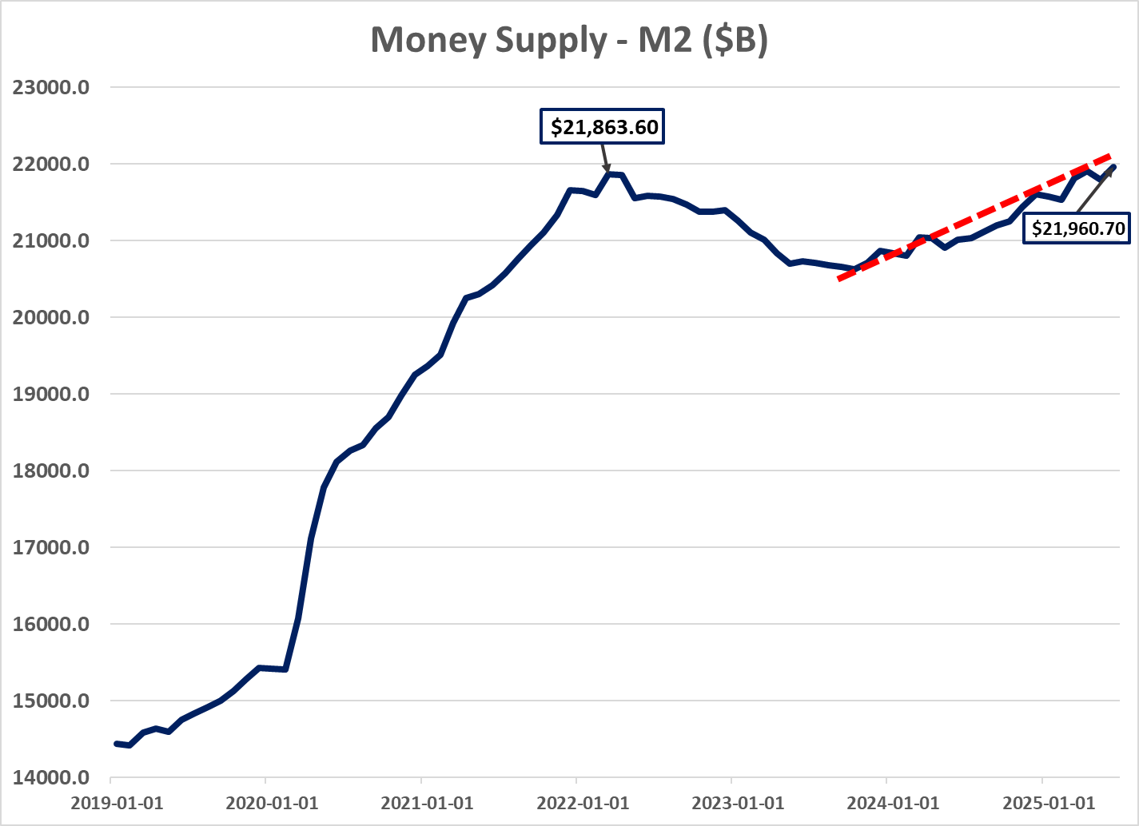Aggressive quantitative easing after ZIRP fueled a sharp increase in money supply, directly contributing to post-pandemic inflation. These purchases supercharged the growth of the M2 money supply—cash, checking deposits, and other easily spendable assets—adding roughly $7 trillion since the onset of the pandemic, a staggering increase of about 47%. This flood of liquidity stoked higher spending and investment, which in turn added fuel to inflation. Notably, the apex of the money supply boom coincided with inflation’s peak at about 9% in mid-2022. As the Fed began to wind down its asset purchases, money supply growth slowed, easing some inflationary heat—but inflation has yet to fully retreat to the Fed’s target.

Delayed Response to Inflation

A big part of the recent inflation story comes down to the Fed’s slow reaction as prices started climbing. In the early stages of the recovery, policymakers believed the spike in inflation would be short-lived—mostly the result of tangled supply chains and other pandemic hangovers—and their forecasts reflected that optimism. Banking on the idea that these pressures would ease on their own, they kept interest rates low for longer than, in hindsight, was wise. That extra time gave inflation more room to take root, making it harder to rein in once they did start tightening. It’s a reminder of how tricky it is for the Fed to move quickly when the economy is sending mixed signals.

**Literature Review**

With the backdrop of today’s economic climate, the Fed’s policy tools, and the factors that set the stage for our current situation in mind, we can now turn to what economists and market watchers are saying—both about driving inflation and about the case for and against bringing interest rates down.

Opinions on 2022 Inflation

Economists have plenty of theories about what drove inflation to its 9% peak in 2022, but a lot of them start with the same point: demand was running too hot. John Cochrane, Betsy Vereckey, John Greenwood, and Steve Hanke argue that big government spending packages, combined with easy money from the Fed, pumped far more cash into the economy than it could handle, pushing prices higher. Scott Sumner makes a similar case, pointing to consumers flush with stimulus checks and enjoying years of rock-bottom interest rates who kept spending at a pace the economy couldn’t match. From a Quantity Theory of Money perspective, Greenwood, Hanke, and Cochrane say it was simple math—when the money supply races ahead of what the economy produces, inflation is inevitable. Most don’t dismiss the role of supply problems like jammed ports and worker shortages, but Cochrane and Sumner insist those would’ve caused only a short-lived bump in prices without the Fed’s loose stance. Cameron Maddock takes the opposite POV, seeing those supply chain breakdowns and logistical snarls as the spark that really set things off.

Arguments for Holding Steady

Michael Wolf makes the case for holding interest rates steady to keep inflation under control, keep inflation expectations in check, and support financial markets and the dollar. He warns that cutting rates too soon could cause inflation to flare up again and damage the Fed’s hard-earned credibility—especially with all the uncertainty around trade and government spending. Diccon Hyatt’s take on Fed Chair Jerome Powell’s approach lines up with that. Despite political pressure and easing inflation, Powell is holding off on rate cuts because tariffs on goods like steel, cars, and possibly pharmaceuticals and chips are still rolling out, and their full impact on prices hasn’t hit yet. Businesses have been slow to pass those costs to consumers, so it’s unclear when inflation might pick up again. Plus, with unemployment low and the job market still strong, the Fed doesn’t feel rushed to ease. Both Wolf and Hyatt stress that the Fed is playing the long game here, watching how tariffs and inflation unfold before making any moves, trying not to repeat the mistakes from earlier in the pandemic when acting too quickly caused problems.

Arguments for Rate Cuts

Both Goldman Sachs and Stoykov argue that there are growing reasons to consider cutting rates. Goldman Sachs points to signs of a softening labor market—with job openings becoming harder to fill and factors like seasonal data shifts and changes in immigration policy likely to slow payroll growth further. Meanwhile, Stoykov highlights that inflation has dropped sharply and is now near the Fed’s target, suggesting that the historically high federal funds rate may be more restrictive than necessary to keep growth in check. Both also note that the effects of past rate hikes are still working their way through the economy, while inflation expectations remain well-anchored, reflecting the Fed’s credibility. Goldman Sachs emphasizes that the monetary environment remains tight, especially with ongoing balance sheet reductions, increasing the risk that holding rates too long could lead to an unnecessary economic slowdown. Together, they make the case that the Fed should be ready to ease policy soon—though the central bank remains cautious, waiting for clearer signals amid uncertainty over the June dot plot and possible new leadership shaping the future rate outlook.

**Assessment**

I am thoroughly convinced that the Fed made the right decision by holding rates steady, and I will explain why through several economic frameworks. First, I will discuss the Quantity Theory of Money to illustrate the link between money supply growth and inflation. Then, I will explore the Fiscal Theory of the Price Level, which emphasizes the role of government deficits and debt sustainability in determining prices. I will also compare Keynesian and Monetarist perspectives on money demand to show how interest rates and liquidity preferences shape inflationary pressures. Finally, I will bring in the concept of the neutral rate of interest to assess whether current policy is restrictive or accommodative. Together, these perspectives reinforce my view that cutting rates now would have been premature and potentially destabilizing.

Quantity Theory of Money

One of these reasons aligns with the Austrian point of view, the Quantity Theory of Money Supply. The QTM explains that the amount of money in an economy is directly linked to the price level of goods and services and is represented by the equation:

$$M*V=P*Y$$

Where:

* M is the money supply.
* V is the velocity of money.
* P is the price level.
* And Y is output.

This theory assumes that velocity and output are constant in the short term (i.e. set equal to 1). As such, changes in the money supply are directly proportional to changes in prices. Stated alternatively, more money with stead output and velocity means higher prices (inflation) and less money means lower prices.

As shown in the earlier graph, the money supply has been steadily rising since mid-2023, with the latest data point from early June confirming this upward trend. The current money supply has not only returned to its 2022 peak but has actually surpassed it, suggesting—based on the quantity theory of money—that we can expect upward pressure on prices moving forward.

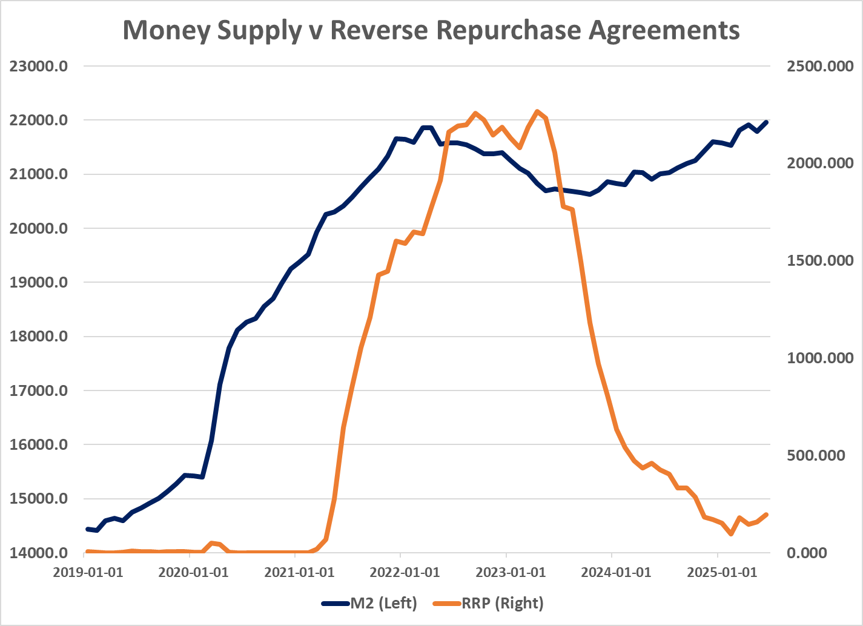

***Money Supply Phenomenon***

**Most of the time, money supply is positively correlated with the federal reserve balance sheet. Interestingly, we have recently been seeing money supply growth *despite* quantitative tightening (the reduction of the Fed’s balance sheet) AND rate cuts! So, what could be causing this?**

**A likely cause is the massive reduction in overnight repurpose agreements held by the Fed. The Fed’s Overnight Reverse Repo (ON RRP) facility is essentially a massive overnight parking lot for cash, where money market funds, banks, and other eligible institutions can deposit cash with the Fed in exchange for Treasury securities as collateral and a guaranteed interest rate. The next day, the cash is returned with interest, and the securities go back to the Fed. At its peak of $2.4 trillion, the facility acted like a “cash vacuum,” pulling large amounts of money out of the financial system each night and temporarily locking it away, reducing liquidity in the banking system and broader economy.**

**Since August 2023, the Fed has reduced their RRP balance from $1.8T down to just under $200B, indicating a $1.6T liquidity injection into the market. This amount is just about consistent with the rise in money supply, with $300B not yet being accounted for in M2.**

Fiscal Theory of the Price Level

The Fiscal Theory of the Price Level is an alternative to the traditional monetary view of inflation. Instead of focusing primarily on the money supply, FTPL emphasizes the role of government fiscal policy—specifically the relationship between government debt, deficits, and future primary surpluses—in determining the price level. In this framework, the price level adjusts to ensure that the real value of government debt equals the present value of expected future surpluses. If the fiscal stance is unsustainable, the adjustment happens through higher inflation rather than through changes in interest rates or money supply alone.

Under the weak form of FTPL, monetary policy still plays the primary role in determining the price level in the short and medium term. Fiscal policy matters, but mainly as a long-run constraint—persistent fiscal imbalances may eventually require inflationary financing, yet in normal circumstances, central banks retain control over inflation through interest rate policy. This is the version most consistent with the past several decades in advanced economies, where credible monetary authorities have been able to manage inflation even in the presence of budget deficits.

The strong form of FTPL asserts that fiscal policy is the dominant force in setting the price level, regardless of the stance of monetary policy. In this view, if the government runs persistent and unsustainable deficits without credible plans to generate future surpluses, the price level must rise to reduce the real value of debt. Monetary policy is essentially subordinate—interest rate changes cannot offset fiscal-driven inflation unless the fiscal stance itself changes. This version is more relevant in situations where fiscal dominance prevails, such as during episodes of high debt monetization or loss of market confidence.

With this distinction in mind, examining the recent trends in the fiscal deficit provides valuable insight into whether current conditions align more closely with the weak or strong form of FTPL.

The recent combination of a rising fiscal deficit alongside falling inflation expectations suggests that the U.S. is currently operating under the weak form of the Fiscal Theory of the Price Level (FTPL). Under this view, fiscal policy can influence prices, but monetary policy remains the primary anchor for inflation. Markets appear to believe that, despite the larger deficit, the government will eventually implement the fiscal adjustments needed to stabilize debt, whether through higher future taxes, lower spending, or other credible measures. As a result, the deficit is not translating into higher inflation expectations, in contrast to the strong form of FTPL, where persistent deficits without credible adjustment plans would lead to a direct and sustained rise in expected inflation.

This divergence between fiscal trends and market-based inflation expectations is telling. Expectations serve as a forward-looking gauge of how investors and consumers believe prices will evolve—and they play a critical role in shaping actual inflation outcomes. Understanding why these expectations have declined, even in the face of widening deficits, is essential for interpreting both current policy credibility and the balance of risks for future inflation.

Inflation Expectations

(1 Year Ahead Inflation Expectations – University of Michigan)

(1 Year Ahead Inflation Expectations – New York Fed)

As we see above, despite differing degrees of estimated inflation expectations, expectations are falling. Despite the growing deficit, inflation expectations are dropping steadily, sitting around 3% according to the New York Fed, and around 4.5% according to the University of Michigan, indicating that the fed is getting some public trust back. Because inflation expectations are falling despite rising fiscal deficits, the immediate risk of the fed being forced into dropping rates due to fiscal pressures is low. If expectations were unanchored, meaning the public expected inflation to rise as a way to deal with deficits, the fed would face pressure to respond with lower rates to ensure solvency. However, because expectations remain above the target rate, the Fed has not fully brought back their trust. As a result, holding the FFRT steady reinforces the message that the Fed should be sending about their seriousness regarding returning to a 2% inflation rate. Choosing to cut rates now would undermine confidence, leading consumers and businesses to expect higher inflation again.

Money Demand

Keynesian theory breaks down money demand into three reasons people hold cash: for everyday transactions, to cover unexpected expenses, and for speculative purposes—like holding cash instead of assets when interest rates are low. As incomes rise, people want more money on hand, but when interest rates go up, holding cash becomes more expensive, so demand falls. That’s why when the Fed raises rates—as it has recently—households and businesses tend to hold less money, which helps keep inflation pressures in check. If rates were cut too soon, though, more money might be demanded, fueling spending and pushing prices up.

On the other hand, Monetarists like Milton Friedman see money demand as pretty stable over time. They focus on the idea that inflation happens when the money supply grows faster than what people and businesses actually want to hold. This is captured by the Quantity Theory of Money equation, MV = PY, which highlights a steady link between money supply, velocity, prices, and output. Given today’s high money supply, if demand doesn’t keep pace, there’s a real risk inflation could bounce back if rates are lowered too quickly. For Monetarists, the key is to align money supply growth with real economic growth, watching overall liquidity carefully to avoid future price spikes.

Neutral Rate

The neutral rate is essentially the real interest rate that keeps the economy balanced—neither pushing it to grow faster nor holding it back. When the Federal Funds Rate is at this level, monetary policy isn’t adding any extra stimulus or restriction, letting things run at a steady, sustainable pace. We can’t see the neutral rate directly; economists have to estimate it, and it shifts over time as key factors like productivity growth, demographics, long-term GDP trends, global savings and investment balances, and fiscal policy change. Central banks watch this number closely because it helps them decide whether current interest rates are too tight, too loose, or just right for the economy’s health.

To understand where the neutral rate stands today, it helps to look at the main forces that drive it. These include how fast our population is growing, trends in labor productivity, signals from financial markets like the spread between short- and long-term interest rates, and the government’s fiscal position. Let’s walk through these key indicators and see what they reveal about the current economic backdrop and how they might be shaping the neutral rate now. We already have seen rising deficits, so we’ll look through the remaining drivers.

**Population Growth Rate:**Declining fairly rapidly but remains positive for now

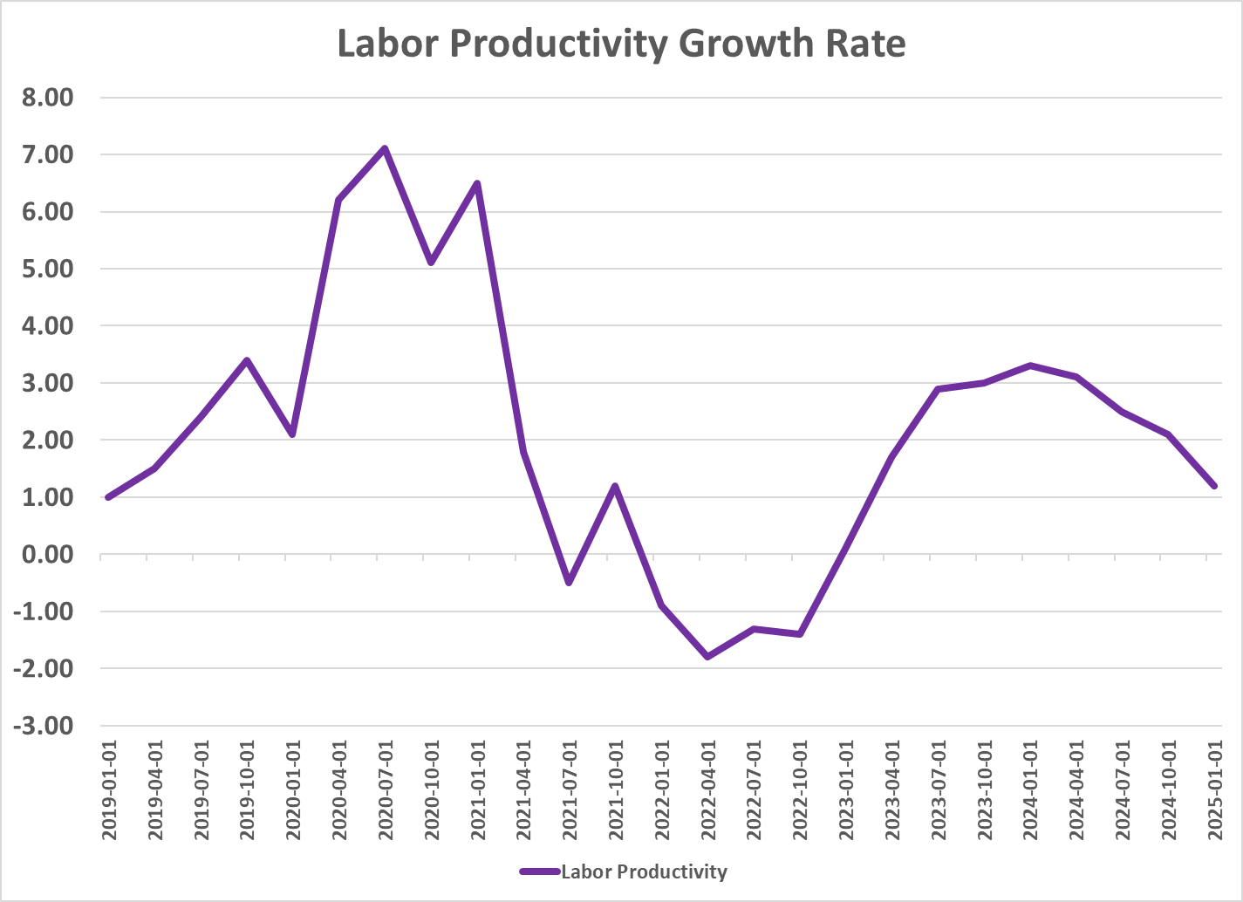

**Labor Productivity Growth:**

Also declining.

**Risk Premia:**

The term structure of interest rates yield curve is fairly flat, if not completely so, indicating little change in interest rates or inflation over near and medium term.

***10 Year Treasury Phenomenon***

**In normal scenarios, the yield of a security should fall in response to rate cuts. However, here we see that as the Fed Funds Rate started to get cut, the 10-year treasury yield began to rise. Why might this be?**

**Insight into the recent rise in the 10-year Treasury yield can be gleaned by examining both the 10-year breakeven inflation rate and the yield on 10-year Treasury Inflation-Protected Securities (TIPS). Since the Fed’s rate cuts in September 2024, both these measures have moved higher. The rising breakeven rate signals that investors expect higher inflation over the next decade, reflecting growing concerns about price pressures in the longer term. Meanwhile, the increasing TIPS yield indicates that real interest rates are climbing, reflecting expectations of stronger economic growth or tighter monetary policy ahead. Together, these trends explain why the nominal 10-year Treasury yield has risen despite recent rate cuts.**

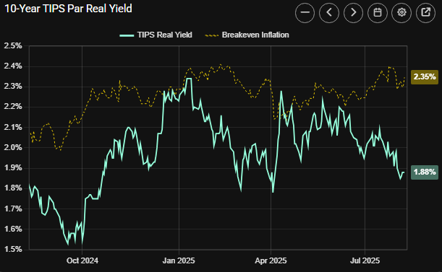

Neutral Rate Summary

Several key factors are shaping the neutral rate today. While the effect of time preference remains uncertain, most other drivers suggest the neutral rate is lower than in the past. Both population growth and productivity growth are slowing, which tends to push the neutral rate down. Treasury yields have stayed fairly stable and close to the policy rate, indicating little recent impact from risk premia. Although rising fiscal deficits might put upward pressure on the neutral rate, current economic fundamentals suggest they haven’t yet shifted it significantly. Taken together, these influences point to a neutral rate that is stable or gently declining, supporting the case for a moderately restrictive Fed policy.

To wrap up, the neutral rate serves as the economy’s “sweet spot” for interest rates—where growth is steady and inflation remains stable. The New York Fed estimates the real neutral rate at about 1.37%.When you add the current core PCE inflation rate of 2.79%, this implies a nominal neutral rate near 4.16%. This means the Fed’s policy rate needs to be around this level to neither speed up nor slow down the economy. Understanding this helps explain why the Fed might be holding rates relatively high right now—to keep monetary policy appropriately balanced between controlling inflation and supporting growth.

**Fed Funds Rate Rules**

Taylor Rule

The Taylor Rule is an economic rule developed in 1993 by John Taylor to guide how the central bank should set short-term interest rates, like the Federal Funds rate. The base Taylor Rule equation is as follows:

$$r=p+\frac{1}{2}\left(p-2\right)+2$$

Where:

* $r$ is the Federal Funds Rate
* And $p$ is the inflation rate

Using this, we get a recommended Federal Funds Rate of 5.185%. While the Taylor Rule doesn’t factor in tools like quantitative easing or other unconventional monetary policies, it still provides a solid benchmark for where the Fed’s target rate should roughly stand based on inflation and economic output. It offers a useful ballpark estimate that helps policymakers gauge whether current rates are too high, too low, or about right, even if real-world decisions also weigh additional factors beyond the rule’s simple framework.

**Conclusion**

To conclude, after weighing the recent trends in productivity, population growth, Treasury yields, and fiscal policy, it’s evident that the neutral rate isn’t trending upward and may even be drifting lower. By keeping the policy rate above this neutral level, the Fed is carefully walking a tightrope—restraining inflation without squeezing the economy too hard. Given that inflation expectations remain elevated and fiscal expansion continues, there’s still a risk that easing monetary policy too soon could reignite inflation. Holding the federal funds rate steady, therefore, is the prudent choice—firm enough to maintain price stability, yet flexible enough to support ongoing economic momentum.

Looking at policy guidelines, the Taylor Rule suggests a target federal funds rate around 5.185%, while the nominal neutral rate, based on the New York Fed’s real neutral rate and current inflation, sits near 4.16%. Together, these figures provide a reasonable range that supports the Fed’s current stance: rates are elevated enough to keep inflation in check but not so high as to unnecessarily hinder growth. This balanced approach aligns with the data and economic theory, reinforcing why the Fed’s measured patience is warranted at this stage.

That said, the Fed must continue to closely monitor inflation trends and inflation expectations, ready to respond swiftly if significant changes arise. Maintaining this vigilance is crucial to prevent any surprises that could derail the delicate balance between fostering economic growth and ensuring price stability.

**Appendix 1 – References**

Bennett, R. (2023, May 1). *2023 Banking Crisis: Silicon Valley Bank’s Collapse And A Timeline Of The Financial Fallout That Followed*. Bankrate. https://www.bankrate.com/banking/bank-failures-latest-updates-silicon-valley-signature-bank/#failure-fallout

Board of Governors of the Federal Reserve System. (2024, July 19). *The Fed - How does monetary policy influence inflation and employment?* Board of Governors of the Federal Reserve System. https://www.federalreserve.gov/faqs/money_12856.htm

Board of Governors of the Federal Reserve System (US). (2001, July 31). *1-Month Treasury Constant Maturity Rate*. FRED, Federal Reserve Bank of St. Louis. https://fred.stlouisfed.org/series/DGS1MO

CNBC. (2025). *US TREASURY-CURRENT 10 YEAR’s stock price (US10Y) in real time*. CNBC. https://www.cnbc.com/quotes/US10Y

Cochrane, J. H. (2025, January 4). *Inflation and the Macroeconomy*. Grumpy-Economist.com; The Grumpy Economist. https://www.grumpy-economist.com/p/inflation-and-the-macroeconomy

Evans, M. (2025, March 31). *What Happened to Silicon Valley Bank?* Investopedia. https://www.investopedia.com/what-happened-to-silicon-valley-bank-7368676

Fiscal Data. (2025). *Fiscal Data Explains the National Deficit*. Fiscaldata.treasury.gov. https://fiscaldata.treasury.gov/americas-finance-guide/national-deficit/

FRED. (2019). *Assets: Total Assets: Total Assets (Less Eliminations From Consolidation): Wednesday Level*. Stlouisfed.org. https://fred.stlouisfed.org/series/WALCL

FRED. (2020). *M2 Money Stock*. Stlouisfed.org. https://fred.stlouisfed.org/series/M2SL

FRED. (2024). *Consumer Price Index for All Urban Consumers: All Items*. Stlouisfed.org. https://fred.stlouisfed.org/series/CPIAUCSL

FRED. (2025a). *10-Year Treasury Constant Maturity Rate*. FRED, Federal Reserve Bank of St. Louis. https://fred.stlouisfed.org/series/DGS10

FRED. (2025b). *Effective Federal Funds Rate*. Stlouisfed.org. https://fred.stlouisfed.org/series/FEDFUNDS

Greenwood, J., & Hanke, S. H. (2021, July 20). *Too Much Money Portends High Inflation*. Wall Street Journal. https://www.wsj.com/opinion/money-supply-inflation-friedman-biden-federal-reserve-11626816746

Hyatt, D. (2025). *4 Reasons The Fed Isn’t Cutting Interest Rates*. Investopedia. https://www.investopedia.com/four-reasons-the-fed-isn-t-cutting-interest-rates-11757580

Jefferson, P. N. (2024). *Speech by Vice Chair Jefferson on monetary policy during periods of uncertainty*. Board of Governors of the Federal Reserve System. https://www.federalreserve.gov/newsevents/speech/jefferson20240416a.htm

Laurion, H., & Bhagat, S. (2024, January 31). *Silicon Valley Bank Demise: Causes and the Path Forward*. The Harvard Law School Forum on Corporate Governance. https://corpgov.law.harvard.edu/2024/01/31/silicon-valley-bank-demise-causes-and-the-path-forward/

Maddock, C. (2024, November 27). *An Analysis of Pandemic-Era Inflation – Michigan Journal of Economics*. Umich.edu. https://sites.lsa.umich.edu/mje/2024/11/27/an-analysis-of-pandemic-era-inflation/

McMaken, R. (2025, April 12). *The Money Supply Keeps Growing as the Fed Backs Off Monetary “Tightening.”* Mises Institute. https://mises.org/mises-wire/money-supply-keeps-growing-fed-backs-monetary-tightening

*Overnight Reverse Repurchase Agreements: Treasury Securities Sold by the Federal Reserve in the Temporary Open Market Operations*. (2025). Stlouisfed.org. https://fred.stlouisfed.org/series/RRPONTSYD/

Selyukh, A. (2025, July 29). *Are prices going up because of tariffs? Here’s what we know*. NPR. https://www.npr.org/2025/07/29/nx-s1-5477470/prices-trump-tariffs

Stoykov, N. (2025, February 19). *Alaric Securities*. Alaric Securities. https://alaricsecurities.com/the-fed-funds-rate-increase-history-and-inflation/

*StreetStats*. (2025). Streetstats.finance; StreetStats. https://streetstats.finance/rates/tips

Sumner, S. (2024, September 19). *Why the Experts are Wrong about Inflation - Econlib*. Econlib. https://www.econlib.org/why-the-experts-are-wrong-about-inflation/

*Survey of Consumer Expectations - FEDERAL RESERVE BANK of NEW YORK*. (n.d.). Www.newyorkfed.org. https://www.newyorkfed.org/microeconomics/sce#/inflexp-1

U.S. Bureau of Labor Statistics. (1948, January 1). *Business Sector: Labor Productivity (Output per Hour) for All Employed Persons*. FRED, Federal Reserve Bank of St. Louis. https://fred.stlouisfed.org/series/PRS84006091

Vereckey, B. (2024, July 22). *Federal spending was responsible for the 2022 spike in inflation, research shows | MIT Sloan*. Mitsloan.mit.edu. https://mitsloan.mit.edu/ideas-made-to-matter/federal-spending-was-responsible-2022-spike-inflation-research-shows

*Why the Fed May Cut Rates Earlier than Expected*. (2025, July 7). Goldmansachs.com. https://www.goldmansachs.com/insights/articles/why-the-fed-may-cut-rates-earlier-than-expected

Wolf, M. (2025, March 25). *United States Economic Forecast*. Deloitte Insights; Deloitte. https://www.deloitte.com/us/en/insights/topics/economy/us-economic-forecast/united-states-outlook-analysis.html

(2019, August 20). Tradingeconomics.com; TRADING ECONOMICS. https://tradingeconomics.com/united-states/inflation-expectations