|  |
| --- |
| California Lutheran University |
| Targeting Emissions: Comparing California Climate Policy Impacts |
| ECON 555: Environmental Economics  Matthew Fienup  Summer 2025 |

|  |
| --- |
| Shaun Levenson  8-15-2025 |

**Targeting Emissions: Comparing California Climate Policy Impacts**

**Introduction**

Greenhouse gas emissions impose serious social and environmental costs, making effective reduction policies increasingly urgent. While AB-32 has reduced emissions in California’s power sector, broader impacts have been limited, and equity concerns persist—particularly in low-income and minority communities facing localized pollution increases (Boyce, 2018; Lessman, 2024). This brief evaluates three major climate policy tools—RPS, LCFS, and Cap-and-Trade—across four criteria: unit effectiveness, cost effectiveness, efficiency, and equity. It concludes with recommendations to strengthen both the impact and fairness of AB-32.

**Motivation**

Economists and policymakers have a critical role to play in addressing environmental challenges, particularly those related to greenhouse gas emissions. These emissions represent a significant negative externality, imposing widespread costs on ecosystems, public health, agricultural productivity, and long-term economic stability. Because these damages are not reflected in market prices, individuals and firms tend to emit more than is socially optimal, resulting in excessive pollution. This market failure leads to a substantial loss of social welfare.

Social Economic Costs – Negative Externality

To understand why emissions policy matters, we must first consider the concept of externalities—costs or benefits from economic activities that affect people not directly involved in those activities. Negative externalities occur when activities, such as greenhouse gas emissions, create costs for others—for example, air pollution imposes health and property damages on society. By contrast, positive externalities provide benefits beyond the immediate actors, as with vaccination that improves public health at large.

These external effects result in market failure because market prices do not capture all spillover costs or benefits. As a consequence, goods with negative externalities like fossil fuel emissions tend to be overproduced, while those with positive externalities are underproduced. In the context of climate change, the competitive equilibrium—where supply meets demand—ignores external costs, leading to an inefficiently high level of pollution. When we factor in the social cost—the full cost to society—the supply curve shifts, reducing the optimal quantity produced and raising the socially efficient price. The deadweight loss that results from this gap represents real welfare losses: society bears unnecessary harm or foregoes potential benefits simply because the market outcome does not reflect the true costs.

To address this inefficiency, economists use the idea of the social cost of greenhouse gases: the estimated dollar value of the climate damage caused by emitting just one additional ton of greenhouse gases. According to EPA estimates at a 2% discount rate, a ton of carbon dioxide (CO₂) causes about $190 in damages, while methane (CH₄) and nitrous oxide (N₂O) are far more potent—resulting in costs of roughly $1,600 and $54,000 per ton, respectively. These values are expected to climb by 2025, reaching approximately $210 for CO₂, $2,000 for CH₄, and $60,000 for N₂O. Using these EPA estimates and projected U.S. emissions, the total social cost of U.S. emissions in 2025 is estimated to be about $1.22 trillion.

To solve these problems, policies must be designed to align private incentives with social costs, internalizing the externalities and leading to more efficient outcomes.

**Background**

Major Sources of Greenhouse Gases

Greenhouse gases consist of 4 main gases/categories: Carbon Dioxide (), Methane (), Nitrous Oxide (), and Fluorinated gases (. Refer to **Appendix 1** for a table that presents the 2022 source breakdown data as reported by the Environmental Protection Agency (EPA).

US vs California Comparison

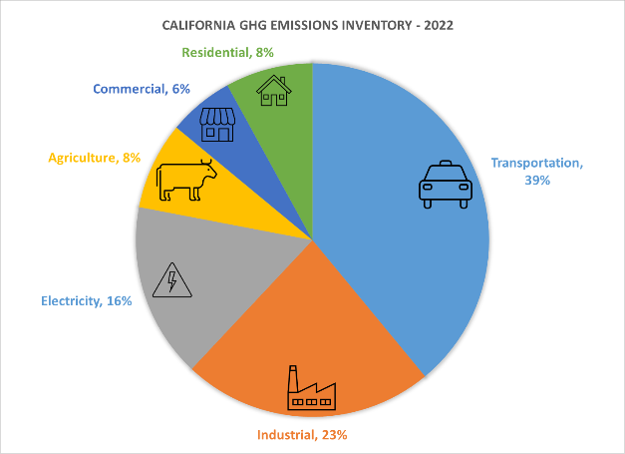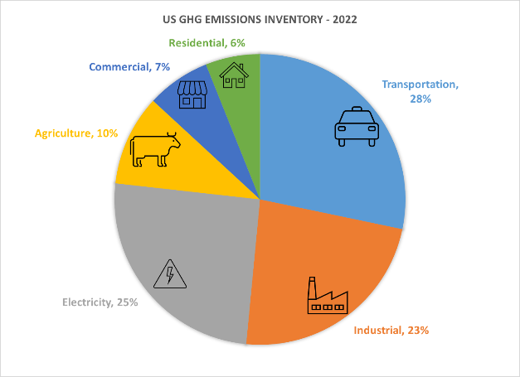

The greenhouse gas emission profiles of California and the U.S. differ notably by sector. In 2022, transportation accounted for about 39% of California’s emissions—significantly higher than the national average of 28%. Industry contributed roughly 23% in both cases, while power generation made up a much smaller share of California’s total emissions. This reflects California’s cleaner electric grid compared to the U.S. as a whole.

These differences have important policy implications. California’s much higher transportation share suggests that decarbonizing this sector is a particularly pressing challenge. This prominence likely results from a combination of factors, such as the state’s car-centric urban layout, economic activity, and population density. Meanwhile, the success of policies targeting electricity generation is evident in the sector’s reduced emissions share relative to the national average—highlighting the unit effectiveness of renewable portfolio standards and related initiatives in California.

**Policy Overview**

This section provides an overview of key climate policies, focusing on their design, implementation, and impacts. For each policy, the underlying mechanisms will be described alongside analysis from existing research evaluating their unit effectiveness, cost effectiveness, efficiency, and equity implications. By examining these dimensions, the goal is to better understand how well each policy achieves emissions reductions and whether those outcomes are delivered in a cost-effective and socially equitable manner.

Renewable Portfolio Standards

The Renewable Portfolio Standard (RPS) requires utilities—electricity providers responsible for delivering power to customers—to ensure a growing share of their electricity comes from renewable sources like wind, solar, and hydro. Utilities prove compliance by acquiring Renewable Energy Certificates (RECs), each representing one megawatt-hour of renewable electricity generated. If they fall short, utilities must buy extra RECs or face penalties. This policy helps internalize the social costs of fossil fuel generation, aligning private utility decisions with public environmental goals. Under California’s AB-32, the RPS targets 60% renewable electricity by 2030 and 100% carbon-free by 2045. Complementing the RPS, feed-in tariffs offer guaranteed, above-market prices to renewable energy producers—especially small or independent generators—encouraging investment by providing stable returns. Together, these tools drive renewable energy growth, reduce emissions, and support California’s clean energy transition.

*Prior Research*

Renewable Portfolio Standard (RPS) programs have been effective in significantly increasing renewable energy adoption and reducing CO₂ emissions from coal-fired power plants. These programs contribute to broader environmental benefits, including improved air quality and reduced water usage (Lyon, 2017; Wiser et al., 2017; Greenstone & Nath, 2021). However, their effectiveness can be constrained by overlapping or poorly coordinated policies (Lyon, 2017; Goulder & Stavins, 2011; Goulder et al., 2012; Moore et al., 2010). A notable challenge of RPS programs is the land use intensification associated with large-scale wind and solar deployment, which requires significant land area to generate substantial renewable electricity (Holland et al., 2015). Additionally, some research suggests that RPS policies risk displacing cleaner but more expensive energy sources like natural gas, rather than replacing cheaper and higher-emitting sources such as coal (Palmer et al.). Political factors also influence RPS adoption: states with more liberal ideologies are more likely to implement RPS policies, whereas conservative states or those with significant fossil fuel industries tend to resist adoption (Lyon, 2016). From a cost perspective, states with RPS policies experience electricity prices approximately 20% higher than those without, with annual price increases about 5% greater (Kydes, 2007). While higher energy prices can be an intentional policy tool to reduce greenhouse gas emissions, they may disproportionately affect lower-income households, for whom electricity expenses represent a larger share of income, raising equity concerns.

Low Carbon Fuel Standards

The Low Carbon Fuel Standard requires fuel providers to decrease the average carbon intensity of transportation fuels over time. Each year, a lower carbon intensity (CI) target is set, pushing fuel suppliers to use or blend in more low-carbon options like biofuels, electricity, or hydrogen. For every unit of low-carbon fuel sold, credits are earned, while selling fuels above the target incurs deficits. Providers of high-carbon fuels must either blend cleaner alternatives or purchase credits from those who exceed the standard. By making low-carbon fuels more valuable and high-carbon fuels more costly, LCFS internalizes some of these broader social and environmental costs, providing a direct incentive for private companies to innovate and reduce emissions.

The LCFS, part of AB-32 since 2011, requires fuel providers to annually lower the average carbon intensity (CI) of transportation fuels based on a full life-cycle assessment. Fuels with CI below set benchmarks earn credits; those above generate deficits. Providers meet obligations by blending low-carbon fuels or purchasing credits. The program covers fuels like biofuels, electricity, and hydrogen, and includes credit provisions for zero-emission vehicle infrastructure. Its targets aim for a 20% CI reduction by 2030 relative to 2010 levels.

*Prior Research*

The effectiveness of California’s Low Carbon Fuel Standard (LCFS) in reducing transportation-sector CO₂ emissions has been supported by both empirical evidence and regulatory data, though its success varies depending on policy design and market dynamics. According to CARB (2024), the LCFS has resulted in a cumulative reduction of over 320 million metric tons of CO₂ since its inception. In 2021 alone, LCFS policies were credited with cutting emissions by approximately 20 million tons (Saddler, 2023). Despite these gains, the effectiveness of the LCFS is highly dependent on its stringency and the responsiveness of fuel markets. In regions with inelastic demand for high-carbon fuels, emission reductions may be limited or even reversed (Huseynov, 2022; Holland, Hughes & Knittel, 2009). Additionally, while the policy is designed to encourage fuel-switching, its impact is uneven across regions due to differences in baseline fuel mixes and infrastructure (Huseynov, 2022). There are also concerns about unintended environmental consequences, such as land use intensification and indirect emissions, that may offset some of the intended GHG benefits (Holland et al., 2015). The high cost of abatement under LCFS has been a consistent critique—Holland (2007) estimates the average cost of CO₂ reduction across firms at $307 to $2,272 per ton, significantly higher than other carbon reduction strategies. To improve both effectiveness and cost-efficiency, researchers advocate for a standardized life-cycle assessment (LCA) framework that captures the full emissions profile of fuels, including extraction, processing, transportation, refining, and distribution—not just tailpipe combustion (Saddler, 2023). This would help ensure that the policy supports truly low-carbon fuels and avoids favoring those that appear clean only under narrow metrics.

Carbon Cap and Trade

The Carbon Cap and Trade program imposes a firm limit, or "cap," on the total greenhouse gas emissions allowed from covered entities, such as power plants and industrial facilities. A set number of emission allowances are issued, each permitting the holder to emit one ton of CO₂ or equivalent greenhouse gases. Companies must hold enough allowances to cover their emissions. If they emit less, they can sell or trade their excess allowances to others who need more. This creates a market price for carbon emissions. By capping total emissions and making allowances a scarce, tradable commodity, the policy directly puts a price on carbon pollution—the negative externality not accounted for in unregulated markets. This incentivizes companies to reduce emissions where it is most cost-effective, internalizing the societal costs of climate change and pollution.

*Prior Research*

Carbon cap-and-trade systems are widely recognized as cost-effective and efficient mechanisms for reducing greenhouse gas emissions. Multiple studies suggest that their overall costs are relatively minor (Peace & Juliani, 2009; Holland et al., 2015). When well-designed, these systems lower compliance costs, drive innovation, and generally outperform alternatives such as the Renewable Portfolio Standard (RPS) and Low Carbon Fuel Standard (LCFS) by offering stronger incentives and more accurate emissions accounting (Holland et al., 2015; Schmalensee & Stavins, 2015).

Cap-and-trade programs also avoid many of the environmental drawbacks associated with RPS and LCFS policies. For example, they do not cause land use intensification, making them more environmentally sustainable in that regard (Holland et al., 2015). They also tend to achieve emissions reductions more rapidly than other regulatory tools (Schmalensee & Stavins, 2015).

However, cap-and-trade systems are not without challenges. One key issue is price volatility, especially in thin markets or when rules around banking and borrowing are ambiguous (Schmalensee & Stavins, 2015). Another challenge lies in the design of the emissions cap: if set too high, it fails to generate meaningful reductions; if set too low, compliance costs can become excessive and politically untenable (Schmalensee & Stavins, 2015).

Political compromises often result in free allowance allocations, which can generate windfall profits for certain industries and raise concerns about equity and fairness (Grainger & Costello, 2015). Moreover, overlapping policies can dilute the price signals that cap-and-trade relies on, thus reducing its cost-effectiveness (Schmalensee & Stavins, 2015; Breetz et al., 2005). Effective implementation also requires robust administrative oversight to prevent evasion and ensure compliance.

Finally, although cap-and-trade systems address emissions at an aggregate level, they can give rise to local "hot spots"—areas where pollution intensifies rather than declines. Hathaway (2018) finds that the market-driven allocation of emissions permits can concentrate pollution in lower-income **A truck with a tanker trailer
**communities, as firms shift emissions-heavy operations to areas with lower compliance costs or higher allocation volumes. Relatedly, emissions leakage can occur when emissions reductions in one region are offset by increases elsewhere, particularly when geographic or sectoral coverage is incomplete.

Summary

|  |  |  |  |
| --- | --- | --- | --- |
| **Dimension** | **RPS** | **LCFS** | **Cap and Trade** |
| Unit Effectiveness | - Leads to significant renewable energy adoption and CO₂ reductions, especially from coal. - Less effective where policies overlap or political resistance exists. - May displace cleaner fuels like natural gas. | - Moderately effective in reducing transportation emissions. - Effectiveness depends on fuel diversity and credit market strength. - Works best in combination with other policies. | - Proven to deliver substantial, economy-wide GHG reductions when cap is binding. - Can drive faster emissions cuts than RPS or LCFS. |
| Cost Effectiveness | - Increases electricity costs (~20% higher in RPS states). - Does not minimize cost due to tech mandates. - Higher compliance costs. | - High marginal abatement costs for each unit of GHG reduced. - Cost varies based on fuel market conditions. - Risk of driving up fuel prices. | - Most cost-effective due to flexible, market-based structure. - Lowers overall abatement cost by allowing cheapest reductions first. |
| Efficiency | - Less efficient than alternatives like carbon pricing. - Mandates specific technologies, increasing total system cost. - Doesn't optimize reduction location. | - Less efficient due to fragmented crediting system and lack of direct pricing. - Market complexity increases cost of achieving targets. | - Highly efficient relative to RPS and LCFS. - Allows emitters to respond flexibly, reducing at lowest cost across sectors and locations. |
| Equity | |  | | --- | |  |  |  | | --- | | - Higher electricity prices burden low-income households disproportionately. - Adoption correlates with political ideology and income levels. | | - Potentially regressive if fuel price increases are passed on to consumers. - Equity outcomes depend on credit flows and vehicle access. | - Risks of hot spots and leakage can disproportionately affect low-income communities. - Free allowance allocations may favor incumbent polluters. |

**Policy Proposal**

Problem 1

A major concern with AB-32 is the broad, uniform scope of its cap-and-trade system. By setting a single statewide carbon cap, the program overlooks regional disparities in pollution burden, industrial activity, and community vulnerability. While this design supports administrative simplicity and market liquidity, it can lead to emissions “hot spots” in areas like the Central Valley and South Coast air basin—regions that often host lower-income communities. As a result, these communities may face persistently high or even increased pollution levels alongside higher energy costs, raising serious equity concerns due to the regressive nature of these impacts. I propose the introduction of nested regional sub-caps within the existing statewide market. Under this design, the total statewide emissions cap would remain intact, but a portion of allowances would be allocated into regional sub-caps. These sub-caps would apply to areas with particularly high industrial emissions or vulnerable populations. Allowances within each sub-cap would be tradable only within that region, while the rest of the market would remain fully statewide.

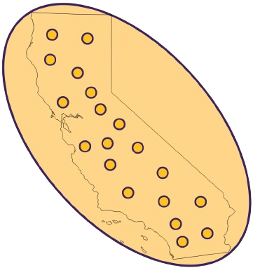This hybrid approach would: A) Allow regions with large industrial footprints to feel a stronger price signal, encouraging localized mitigation. B) Create space for more place-based environmental justice solutions, without fragmenting the entire market. And C) Preserve the core strengths of AB-32—cost-effectiveness, statewide coordination, and administrative efficiency. Admittedly, setting up regional sub-caps would introduce some additional complexity and cost, especially in emissions tracking and allowance administration. But these costs could be minimized by building on the existing CARB infrastructure and emissions reporting system. And importantly, the benefits—more targeted pollution reduction, stronger local air quality improvements, and greater fairness—could make California’s climate policy a more equitable and scalable model for others to follow.

Problem 2

Another limitation of AB-32 is that it gives no explicit consideration to nuclear energy, despite its potential as a low-carbon, reliable power source. Public opposition—often rooted in misconceptions about safety, waste, and environmental impact—has limited nuclear’s role in California’s decarbonization strategy. Addressing this gap will require targeted public education on the actual risks and benefits of nuclear power, especially in comparison to fossil fuels and even certain renewable alternatives, to ensure policy decisions are informed by evidence rather than perception.

**Appendix 1 – Charts and Tables**

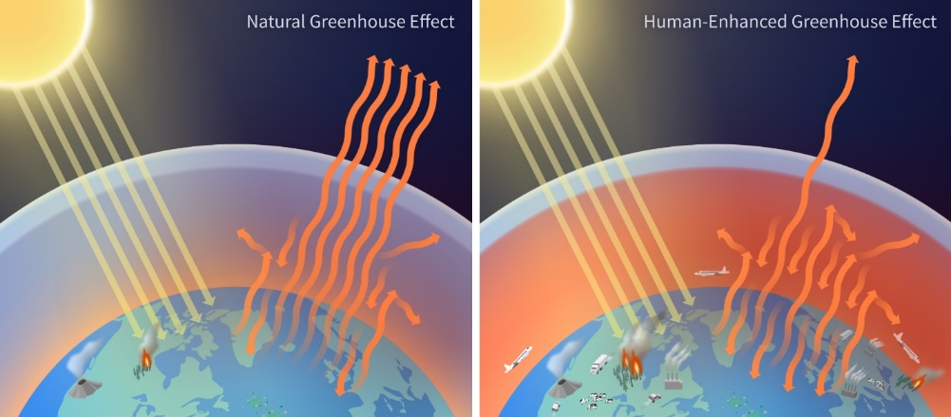Greenhouse gases absorb heat in the Earth’s atmosphere, trapping energy and warming the planet—a process known as the greenhouse effect. Human activities, especially burning fossil fuels, have increased the concentration of these gases, intensifying global warming and driving climate change. Greenhouse gases are atmospheric gases that trap heat by absorbing and re-emitting infrared radiation—a process known as the **greenhouse effect**. During the day, sunlight passes through the atmosphere and warms the Earth’s surface. At night, the planet cools by releasing that energy in the form of infrared radiation. While most of this radiation escapes into space, greenhouse gases such as carbon dioxide (CO₂), methane (CH₄), and nitrous oxide (N₂O) absorb a significant portion of it. Unlike abundant gases like oxygen and nitrogen, which do not interact with infrared radiation, greenhouse gases retain heat and re-radiate it back toward the Earth’s surface. This natural warming cycle is essential for maintaining a livable climate. However, when human activities—such as burning fossil fuels, agriculture, and industrial processes—significantly increase greenhouse gas concentrations, the result is excessive heat retention resulting in an imbalance that contributes to global warming and broader climate disruptions that threaten ecosystems, economies, and human well-being.

|  |  |  |  |
| --- | --- | --- | --- |
| **Type** | **% Share** | **Source** | **% Share Source** |
| Carbon Dioxide ( | 79.7 |  |  |
|  |  | Transportation | 35 |
|  |  | Electricity | 30 |
|  |  | Industrial | 16 |
|  |  | Residential and Commercial Buildings | 12 |
|  |  | Other | 5 |
|  |  | Non-Energy Use of Fuels | 2 |
| Methane () | 11.1 |  |  |
|  |  | Natural Gas and Petroleum Systems | 28 |
|  |  | Enteric Fermentation | 25 |
|  |  | Landfills | 16 |
|  |  | Manure Management | 9 |
|  |  | Coal Mining | 6 |
|  |  | Flooded Land | 6 |
|  |  | Other | 9 |
|  |  | Land Use, Land Use Change, and Forestry | 2 |
| Nitrous Oxide ( | 6.1 |  |  |
|  |  | Agricultural Soil Management | 75 |
|  |  | Stationary Combustion | 6 |
|  |  | Wastewater Treatment | 7 |
|  |  | Manure Management | 4 |
|  |  | Transportation | 4 |
|  |  | Land Use, Land Use Change, and Forestry | 2 |
|  |  | Other | 2 |
| Fluorinated Gases | 3.1 |  |  |
|  |  | Substitution of Ozone Depleting Substances | 90 |
|  |  | Fluorochemical Production | 4 |
|  |  | Electrical Equipment | 3 |
|  |  | Electronics Industry | 2 |
|  |  | Production and Processing of Aluminum and Magnesium | 1 |

**Appendix 2 – References**

2023 Report on the Social Cost of Greenhouse Gases: Estimates Incorporating Recent Scientific Advances. US EPA.

American Institute of Physics. "Global Warming Timeline." Updated April 2025. Available at: https://history.aip.org/climate/timeline.html

Ansar, Jasmin, and Barry Vesser. “Reforming California’s Cap and Trade Program.” The Climate Center, 25 Apr. 2025. https://theclimatecenter.org/climate-targets/reforming-californias-cap-and-trade-program-policy-brief/

Axsen, J., & Wolinetz, M. (2023). What does a low-carbon fuel standard contribute to a policy mix? An interdisciplinary review of evidence and research gaps. Transport Policy, 133, 54–63. https://doi.org/10.1016/j.tranpol.2023.01.008

Bracmort, K. (2021). A Low Carbon Fuel Standard: In Brief. Congressional Research Service.

California Air Resources Board. “CARB Updates the Low Carbon Fuel Standard to Increase Access to Cleaner Fuels and Zero-Emission Transportation Options.” https://ww2.arb.ca.gov/news/carb-updates-low-carbon-fuel-standard-increase-access-cleaner-fuels-and-zero-emission. Accessed 15 July 2025.

California Climate Policy Fact Sheet: Renewables Portfolio Standard. Center for Climate and Energy Solutions, n.d.

CLG-P2-ES3-Greenhouse Effect Diagram. (2024). NOAA Climate.gov. https://www.climate.gov/media/16408

EPA Energy and Environment Guide to Action Renewable Portfolio Standards Policy Description and Objective Summary. (n.d.).

EPA. (2025, January 16). Overview of Greenhouse Gases. US Environmental Protection Agency. https://www.epa.gov/ghgemissions/overview-greenhouse-gases

Fischer, C., & Newell, R. G. (2008). Environmental and technology policies for climate mitigation. Journal of Environmental Economics and Management, 55(2), 142–162.

Greenstone, M., & Nath, I. (2019). Do Renewable Portfolio Standards Deliver? SSRN Electronic Journal. https://doi.org/10.2139/ssrn.3374942

Hathaway, Madison. (2018). Exploring Cap-and-Trade: A California Case Study. Portland State University, 9-12.

Holland, S. P., Hughes, J. E., & Knittel, C. R. (2009). Greenhouse Gas Reductions under Low Carbon Fuel Standards? American Economic Journal: Economic Policy, 1(1), 106–146.

Holland, S. P., Knittel, C. R., & Hughes, J. E. (2007). Greenhouse Gas Reductions Under Low Carbon Fuel Standards? SSRN Electronic Journal. https://doi.org/10.2139/ssrn.987759

Holland, S., Hughes, J., Knittel, C., & Parker, N. (2015). Unintended Consequences of Carbon Policies: Transportation Fuels, Land-Use, Emissions, and Innovation. The Energy Journal, 36(3), 35–74. https://doi.org/10.5547/01956574.36.3.sho!

Huseynov, S., & Palma, M. (2017). Does California’s Low Carbon Fuel Standards reduce carbon dioxide emissions?

International Chamber of Commerce (ICC). (2022). Critical Design Features for Effective Carbon Pricing: A Business Perspective. ICC Global Environment and Energy Commission & ICC Global Taxation Commission.

Johnson, E. P. (2014). The cost of carbon dioxide abatement from state renewable portfolio standards. Resource and Energy Economics, 36, 332–350.

Kikuchi, R. (2008). Reconsideration of climate change from the viewpoints of greenhouse gas types and time scale. Energy & Environment, 19(5), 691–705.

Lee, H. (2023). CLIMATE CHANGE 2023 Synthesis Report A Report of the Intergovernmental Panel on Climate Change.

Logan, Tracy, and Elizabeth Stuart. (2011). California Energy Incentive Programs: An Annual Update on Key Energy Issues and Financial Opportunities for Federal Sites in California. U.S. Department of Energy, Federal Energy Management Program, Dec.

Lopez, Briana, et al. (2021). NRDC California Cap-and-Trade 2021 Senior Practicum Report. Natural Resources Defense Council and UCLA Institute of the Environment and Sustainability.

Lyon, T. P. (2016). Drivers and Impacts of Renewable Portfolio Standards. Annual Review of Resource Economics, 8(1), 141–155. https://doi.org/10.1146/annurev-resource-100815-095432

Mandegari, M., Ebadian, M., & Saddler, J. (John). (2023). The need for effective life cycle assessment (LCA) to enhance the effectiveness of policies such as low carbon fuel standards (LCFS’s). Energy Policy, 181, 113723. https://doi.org/10.1016/j.enpol.2023.113723

Manning, M., & Reisinger, A. (2011). Broader perspectives for comparing different greenhouse gases. Philosophical Transactions of the Royal Society A: Mathematical, Physical and Engineering Sciences, 369(1943), 1891–1905.

Murphy, Colin. (2023). Making Policy in the Absence of Certainty: Biofuels and Land Use Change. ITS, 25 Oct. https://its.ucdavis.edu/blog-post/making-policy-in-the-absence-of-certainty-biofuels-and-land-use-change/

Nyberg, Michael. (2024). 2023 Total System Electric Generation. California Energy Commission. https://www.energy.ca.gov/data-reports/energy-almanac/california-electricity-data/2023-total-system-electric-generation

Palmer, K., & Burtraw, D. (2005). Cost-effectiveness of renewable electricity policies. Energy Economics, 27(5), 873–894.

Peace, J., & Juliani, T. (2009). The coming carbon market and its impact on the American economy. Policy and Society, 27(4), 305–316. https://doi.org/10.1016/j.polsoc.2009.01.002

Petek, Gabriel. (2025). Assessing California’s Climate Policies—Residential Electricity Rates in California. Legislative Analyst’s Office, Jan.

Re-Radiation of Heat. (2020). Understanding Global Change, UC Berkeley, 5 Oct. https://ugc.berkeley.edu/background-content/re-radiation-of-heat/

Schmalensee, R., & Stavins, R. N. (2015). Lessons Learned from Three Decades of Experience with Cap-and-Trade. SSRN Electronic Journal. https://doi.org/10.2139/ssrn.2690441

Schmalensee, R., & Stavins, R. N. (2015). Lessons learned from three decades of experience with cap-and-trade. Fondazione Eni Enrico Mattei (FEEM) Nota di Lavoro 107.2015.

Schopp, Anne, and Karsten Neuhoff. (2012). Can banking CO₂ allowances ensure inter-temporal efficiency? German Institute for Economic Research (DIW Berlin), Discussion Paper 1196.

Shea, Daniel. (2023). Nuclear Power and the Clean Energy Transition. National Conference of State Legislatures. Updated June 22, 2025.

Supplementary Material for the Regulatory Impact Analysis for the Final Rulemaking… (2023). EPA Report on the Social Cost of Greenhouse Gases. https://www.epa.gov/system/files/documents/2023-12/epa_scghg_2023_report_final.pdf

Thombs, R. P., & Jorgenson, A. K. (2020). The political economy of renewable portfolio standards in the United States. Energy Research & Social Science, 62, 101379.

United States Environmental Protection Agency. (2024). U.S. Emissions and Energy System Baselines. Retrieved July 11, 2025. https://www.epa.gov/system/files/documents/2025-01/2024-btr-summary.pdf

Wiser, R., et al. (2017). Assessing the costs and benefits of US renewable portfolio standards. Environmental Research Letters, 12, 94023. https://doi.org/10.1088/1748-9326/aa87bd

Yoon, Beomseok; Filipski, Mateusz; Landry, Craig E.; Yoo, Seung Jick. (2024). Endowment effects, expectations, and trading behavior in carbon cap and trade. Energy Economics, 139, 107927.