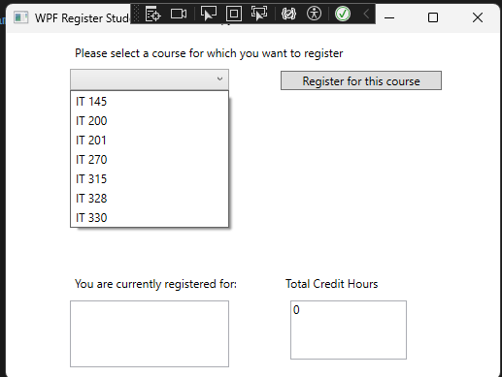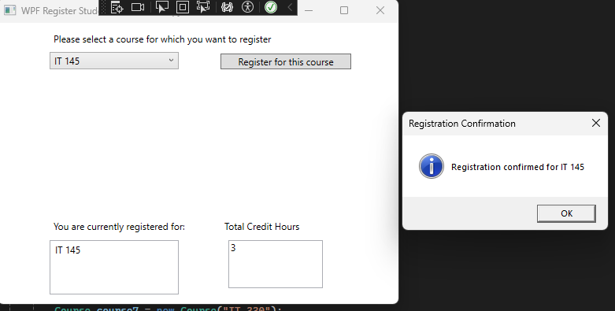

Application Main Menu First Class Registration

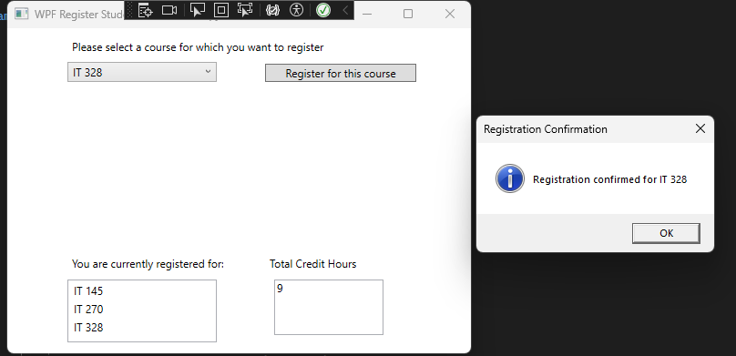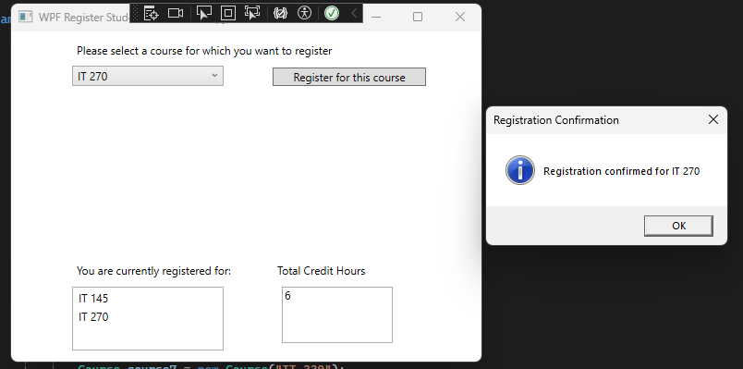Third Class Registration Second Class Registration

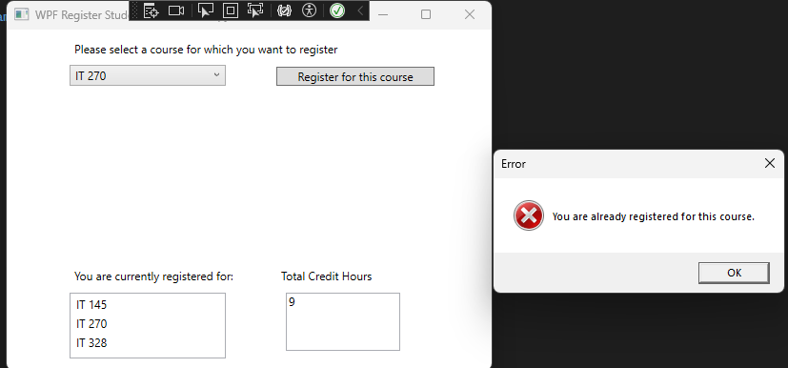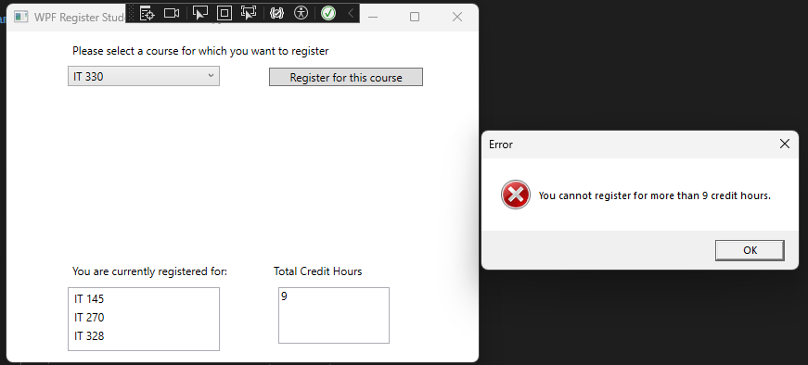

Input Validation Input Validation : 9 hours

Source Codes for WPF Register Student

MainWindow.xaml Source Code

<Window x:Class="WPFRegisterStudent.MainWindow"

xmlns="http://schemas.microsoft.com/winfx/2006/xaml/presentation"

xmlns:x="http://schemas.microsoft.com/winfx/2006/xaml"

xmlns:d="http://schemas.microsoft.com/expression/blend/2008"

xmlns:mc="http://schemas.openxmlformats.org/markup-compatibility/2006"

xmlns:local="clr-namespace:WPFRegisterStudent"

mc:Ignorable="d"

Title="WPF Register Student - Teacher's Copy" Height="395.902" Width="525" Loaded="Window_Loaded">

<Grid>

<ComboBox x:Name="comboBox" HorizontalAlignment="Left" Margin="66,37,0,0" VerticalAlignment="Top" Width="164" IsDropDownOpen="True"/>

<Button x:Name="button" Content="Register for this course" HorizontalAlignment="Left" Margin="283,39,0,0" VerticalAlignment="Top" Width="166" Click="Button_Click"/>

<ListBox x:Name="listBox" HorizontalAlignment="Left" Height="69" Margin="66,276,0,0" VerticalAlignment="Top" Width="164"/>

<TextBox x:Name="textBoxCreditHours" HorizontalAlignment="Left" Margin="293,276,0,0" VerticalAlignment="Top" Width="120" IsReadOnly="True" Height="61"/>

<Label x:Name="label" Content="Please select a course for which you want to register" HorizontalAlignment="Left" Margin="66,7,0,0" VerticalAlignment="Top" Width="383"/>

<Label x:Name="label1" Content="You are currently registered for:" HorizontalAlignment="Left" Margin="66,245,0,0" VerticalAlignment="Top" Width="176"/>

<Label x:Name="label2" Content="Total Credit Hours" HorizontalAlignment="Left" Margin="283,245,0,0" VerticalAlignment="Top" Width="106"/>

<Label x:Name="label3" Content="" HorizontalAlignment="Left" Margin="66,213,0,0" VerticalAlignment="Top" Width="383" Foreground="#FFEE0E0E"/>

</Grid>

</Window>

MainWindow.xaml.cs Source Code

using System;

using System.Windows;

namespace WPFRegisterStudent

{

public partial class MainWindow : Window

{

private Course choice;

public MainWindow()

{

InitializeComponent();

}

private void Window_Loaded(object sender, RoutedEventArgs e)

{

// Initialize courses

Course course1 = new Course("IT 145");

Course course2 = new Course("IT 200");

Course course3 = new Course("IT 201");

Course course4 = new Course("IT 270");

Course course5 = new Course("IT 315");

Course course6 = new Course("IT 328");

Course course7 = new Course("IT 330");

// Add courses to ComboBox

comboBox.Items.Add(course1);

comboBox.Items.Add(course2);

comboBox.Items.Add(course3);

comboBox.Items.Add(course4);

comboBox.Items.Add(course5);

comboBox.Items.Add(course6);

comboBox.Items.Add(course7);

// Clear text boxes

textBoxCreditHours.Text = "";

textBoxCreditHours.Text = "0";

}

private void Button_Click(object sender, RoutedEventArgs e)

{

// Validate if a course is selected

if (comboBox.SelectedItem == null)

{

MessageBox.Show("Please select a course to register.", "Error", MessageBoxButton.OK, MessageBoxImage.Error);

return;

}

choice = (Course)comboBox.SelectedItem;

// Check if the course is already registered

if (choice.IsRegisteredAlready())

{

MessageBox.Show("You are already registered for this course.", "Error", MessageBoxButton.OK, MessageBoxImage.Error);

return;

}

// Check if registering this course will exceed credit hours limit (9 credit hours)

int totalCreditHours = CalculateTotalCreditHours();

if (totalCreditHours + 3 > 9)

{

MessageBox.Show("You cannot register for more than 9 credit hours.", "Error", MessageBoxButton.OK, MessageBoxImage.Error);

return;

}

// If all validations pass, register the course

choice.SetToRegistered();

// Update UI: Add the course to the listBox and update total credit hours textbox

listBox.Items.Add(choice.GetName());

textBoxCreditHours.Text = CalculateTotalCreditHours().ToString();

MessageBox.Show("Registration confirmed for " + choice.GetName(), "Registration Confirmation", MessageBoxButton.OK, MessageBoxImage.Information);

}

private int CalculateTotalCreditHours()

{

int totalCreditHours = 0;

// Iterate through each course to calculate total credit hours

foreach (var item in comboBox.Items)

{

Course course = (Course)item;

if (course.IsRegisteredAlready())

{

totalCreditHours += 3;

}

}

return totalCreditHours;

}

}

}

Course.cs Source code

using System;

using System.Collections.Generic;

using System.Linq;

using System.Text;

using System.Threading.Tasks;

namespace WPFRegisterStudent

{

class Course

{

private string name = "";

private bool isRegisteredAlready = false;

public Course(string name)

{

this.name = name;

}

public void SetName(string name)

{

this.name = name;

}

public string GetName()

{

return name;

}

public bool IsRegisteredAlready()

{

return isRegisteredAlready;

}

public void SetToRegistered()

{

isRegisteredAlready = true;

}

public override string ToString()

{

return GetName();

}

}

}