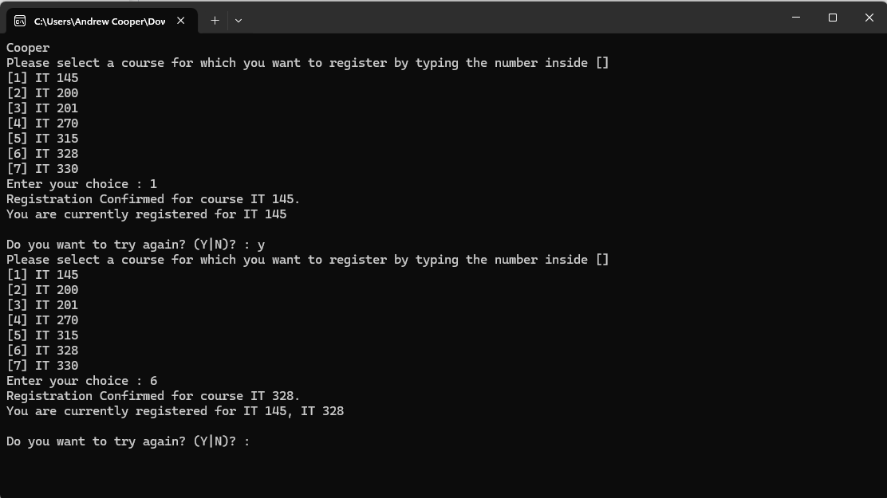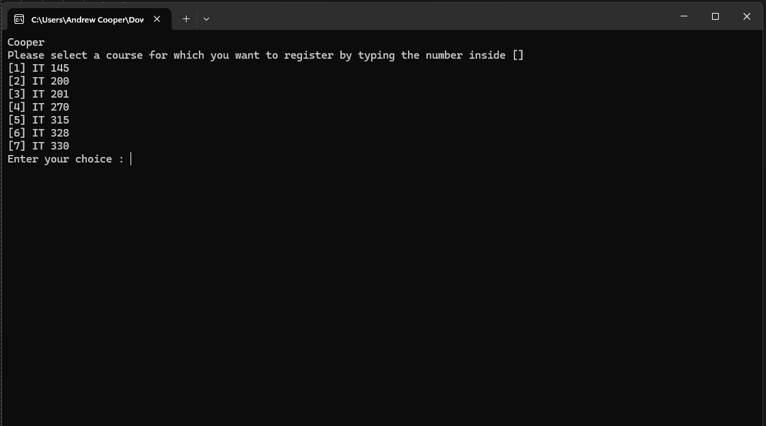

Third Class Registration Application Main Menu

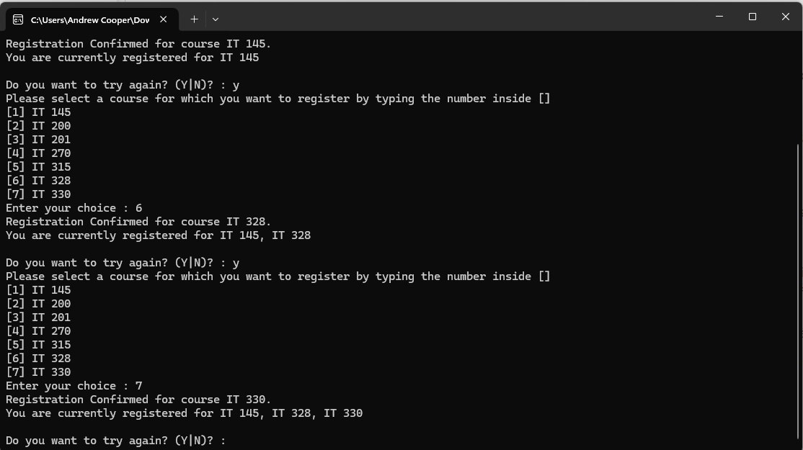Second Class Registration First Class Registration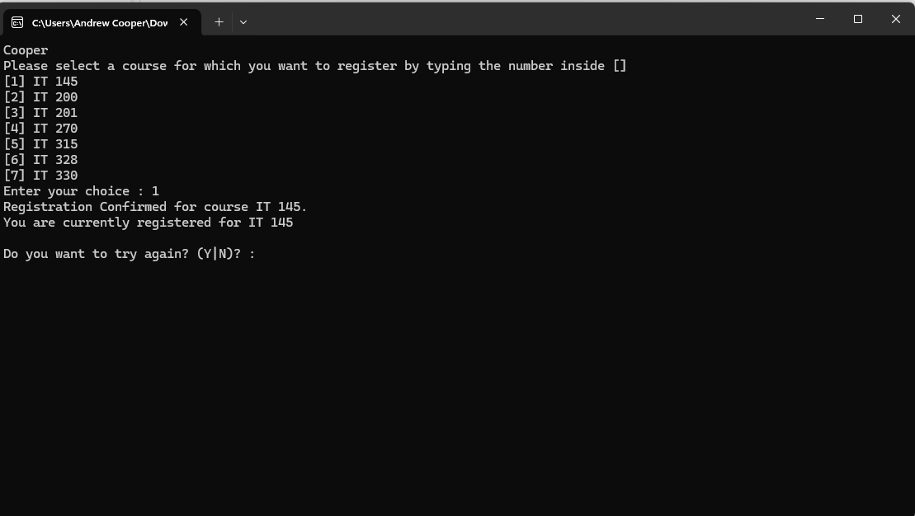

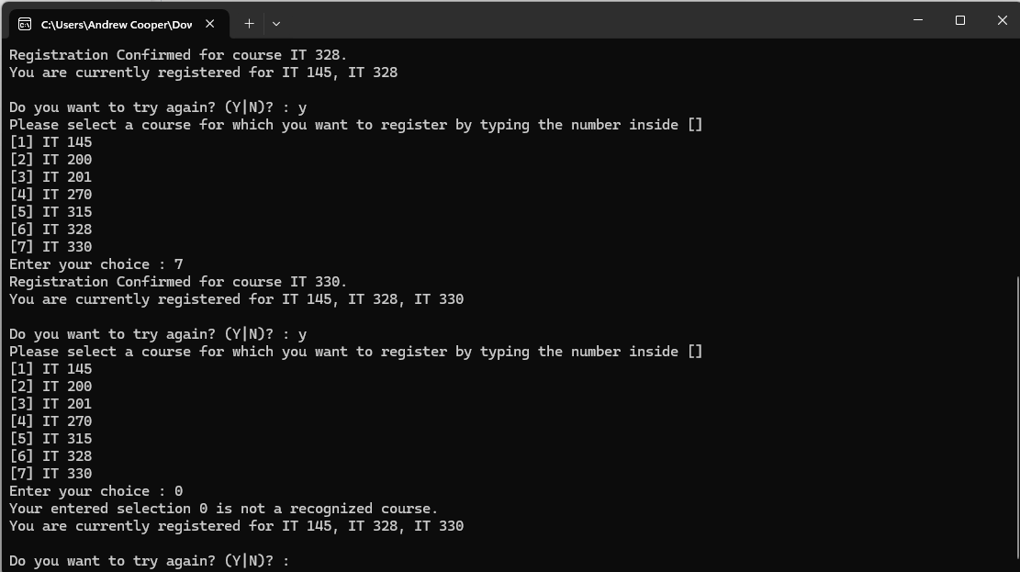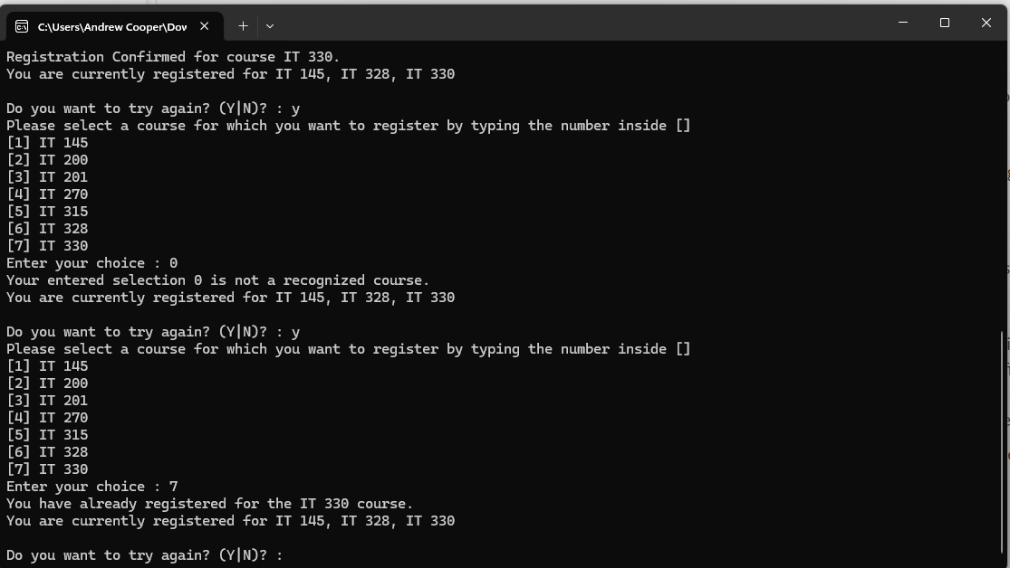

Input Validation for Input Selection Validation for Register

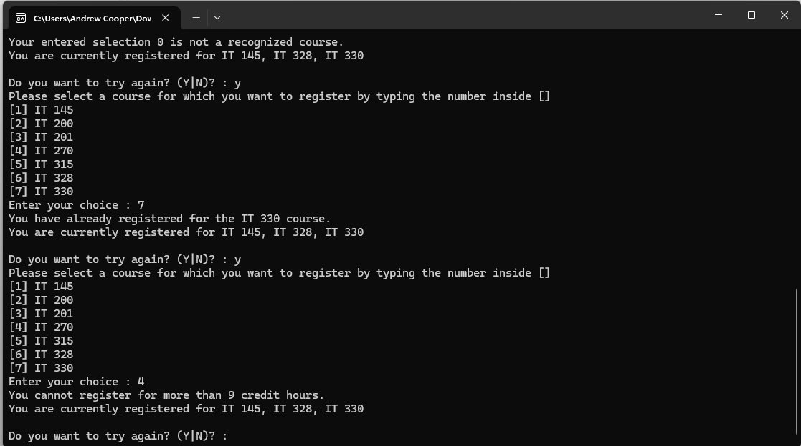

Input Validation for Course Hours

Source Code for Console Register Student

using System;

namespace ConsoleRegisterStudent

{

class Program

{

static void Main(string[] args)

{

(new Program()).Run();

}

void Run()

{

int choice;

int firstChoice = 0, secondChoice = 0, thirdChoice = 0;

int totalCredit = 0;

string yesOrNo;

Console.WriteLine("Cooper");

do

{

WritePrompt();

choice = Convert.ToInt32(Console.ReadLine());

switch (ValidateChoice(choice, firstChoice, secondChoice, thirdChoice, totalCredit))

{

case -1:

Console.WriteLine("Your entered selection {0} is not a recognized course.", choice);

break;

case -2:

Console.WriteLine("You have already registered for the {0} course.", ChoiceToCourse(choice));

break;

case -3:

Console.WriteLine("You cannot register for more than 9 credit hours.");

break;

case 0:

Console.WriteLine("Registration Confirmed for course {0}.", ChoiceToCourse(choice));

totalCredit += 3;

if (firstChoice == 0)

firstChoice = choice;

else if (secondChoice == 0)

secondChoice = choice;

else if (thirdChoice == 0)

thirdChoice = choice;

break;

}

WriteCurrentRegistration(firstChoice, secondChoice, thirdChoice);

Console.Write("\nDo you want to try again? (Y|N)? : ");

yesOrNo = Console.ReadLine().ToUpper();

} while (yesOrNo == "Y");

Console.WriteLine("Thank you for registering with us");

}

void WritePrompt()

{

Console.WriteLine("Please select a course for which you want to register by typing the number inside []");

Console.WriteLine("[1] IT 145\n[2] IT 200\n[3] IT 201\n[4] IT 270\n[5] IT 315\n[6] IT 328\n[7] IT 330");

Console.Write("Enter your choice : ");

}

int ValidateChoice(int choice, int firstChoice, int secondChoice, int thirdChoice, int totalCredit)

{

if (choice < 1 || choice > 7)

return -1;

else if (choice == firstChoice || choice == secondChoice || choice == thirdChoice)

return -2;

else if (totalCredit + 3 > 9)

return -3;

return 0;

}

void WriteCurrentRegistration(int firstChoice, int secondChoice, int thirdChoice)

{

if (firstChoice == 0)

Console.WriteLine("You are currently not registered for any courses.");

else if (secondChoice == 0)

Console.WriteLine("You are currently registered for {0}", ChoiceToCourse(firstChoice));

else if (thirdChoice == 0)

Console.WriteLine("You are currently registered for {0}, {1}", ChoiceToCourse(firstChoice), ChoiceToCourse(secondChoice));

else

Console.WriteLine("You are currently registered for {0}, {1}, {2}", ChoiceToCourse(firstChoice), ChoiceToCourse(secondChoice), ChoiceToCourse(thirdChoice));

}

string ChoiceToCourse(int choice)

{

switch (choice)

{

case 1: return "IT 145";

case 2: return "IT 200";

case 3: return "IT 201";

case 4: return "IT 270";

case 5: return "IT 315";

case 6: return "IT 328";

case 7: return "IT 330";

default: return "Unknown";

}

}

}

}