Code:

import tkinter as tk

from tkinter import ttk, messagebox

from googletrans import Translator, LANGUAGES

# Initialize the translator

translator = Translator()

# Function to perform translation

def translate_text():

    try:

        src_text = input_text.get("1.0", tk.END).strip()

        if not src_text:

            messagebox.showwarning("Input Required", "Please enter text to translate.")

            return

        src_lang = lang_from.get()

        dest_lang = lang_to.get()

        src_lang_code = [code for code, lang in LANGUAGES.items() if lang == src_lang.lower()]

        dest_lang_code = [code for code, lang in LANGUAGES.items() if lang == dest_lang.lower()]

        if not src_lang_code or not dest_lang_code:

            messagebox.showerror("Language Error", "Invalid source or target language.")

            return

        result = translator.translate(src_text, src=src_lang_code[0], dest=dest_lang_code[0])

        output_text.delete("1.0", tk.END)

        output_text.insert(tk.END, result.text)

    except Exception as e:

        messagebox.showerror("Translation Error", f"An error occurred:\n{e}")

# Create main window

root = tk.Tk()

root.title("Language Translator App")

root.geometry("600x400")

# Input Text Box

tk.Label(root, text="Enter Text", font=('Arial', 12)).pack()

input_text = tk.Text(root, height=5)

input_text.pack(padx=10, pady=5, fill=tk.X)

# Language selectors

lang_frame = tk.Frame(root)

lang_frame.pack(pady=10)

tk.Label(lang_frame, text="From:").grid(row=0, column=0, padx=5)

lang_from = ttk.Combobox(lang_frame, values=list(LANGUAGES.values()), width=20)

lang_from.set("english")

lang_from.grid(row=0, column=1)

tk.Label(lang_frame, text="To:").grid(row=0, column=2, padx=5)

lang_to = ttk.Combobox(lang_frame, values=list(LANGUAGES.values()), width=20)

lang_to.set("spanish")

lang_to.grid(row=0, column=3)

# Translate Button

tk.Button(root, text="Translate", command=translate_text, bg="blue", fg="white", font=('Arial', 12)).pack(pady=10)

# Output Text Box

tk.Label(root, text="Translated Text", font=('Arial', 12)).pack()

output_text = tk.Text(root, height=5)

output_text.pack(padx=10, pady=5, fill=tk.X)

# Start the GUI

root.mainloop()

Flowchart:

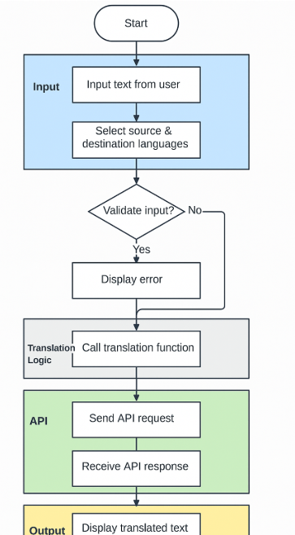

Screenshot:

